Short-Term Trading Strategy based on Volatility and Technical Indicators

Osama Iqbal
iqbal.osama@icloud.com

Abstract
The project aims to establish a trading system in which the user creates a portfolio of stocks by entering a ticker or by uploading data through a file. A signal filter is then generated using Technical Indicators such as SMA, ADX, RSI, Bollinger Bands etc. These indicators are then used in a short term trading strategy in combination. For example, ADX-MACD-RSI-BB strategy, where the indicators from the signal filter are used in combination.

Keywords: Technical Analysis, Trading System, RSI, Bollinger Bands, MACD, ADX

1. Introduction
The aim of the project is to create a Trading System that consists of a Short Term strategy. For performing short term trading, we use Technical Indicators in order to generate signal filters, upon which strategies could be devised. In essence, the step by step procedure to achieve this is as follows.
- Get ticker/s from user as an entry, or from a file source. Only stocks are permitted to be used. (Scope change, only allow the user to enter tickers rather than custom data, as much exception handling is required in terms of erroneous data)
- Generate a portfolio based on the tickers that have been entered, and gather the data (EoD) from a source
- Plot the outlier stocks based on volatility
- Generate a signal filter based on SMA, ADX, RSI, BB, MACD
- Devise a strategy using ADX-MACH-RSI-BB
- Calculate and plot Key Performance Indicators such as Drawdown, Win-to-Loss Ratio, Gain-to-Pain Ratio and other factors such as Number of trades etc.

2. Main Program Entry and Stock Data Gathering
The main program, or ‘main.py’ is the main entry to the entire system. This consists of the ‘__main__’ function that drives the logic. Essentially, the main program performs the following steps:
- Allow the user to enter the stock combinations
- Fetch the historical data (EoD) for the combinations
- Identify the volatile stocks (work in progress)
- Run strategy and plot results (work in progress)

At this point in time, the main program consists of only prompting the user to use a mode to enter the data, and gathering of historical data
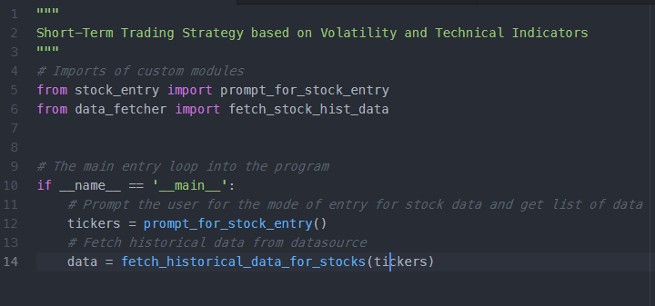

3. Gathering ticker data from user
The function prompt_for_stock_entry() within the module stock_entry, consist of a prompt indicating the user to enter data based on stocks that are available on SnP500 for now. If the user has a file of data, he or she can press the ‘F’ key, which will then take the data from the file or the ‘T’ key that will allow the user to enter tickers instead. After the user has entered the tickers, he must decide upon the number of stocks that need to be used in his/her portfolio for every ticker entered. This is prompted to the user.

4. Fetching of Historical Data
Historical Data is fetched from Yahoo Finance, using a module called as Fix Yahoo Finance, since Yahoo discontinued their API service in 2017. This means that this additional third-party module must be included in order to fetch the data. The data is fetched in the form of a DataFrame which is then loaded into a dictionary. This dictionaries’ keys are nothing but the ticker symbols. I do this instead of fetching it in a panel since it’s easier for me to use conventional python than pandas’ iteritems() etc. Plus, visualizing a dictionary is easier in PyCharm than a Panel.
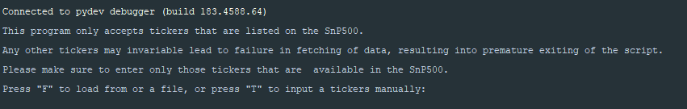

5. Plotting of outliers based on Volatility
The following step calculates the daily change measure of each stock in the portfolio. It then calculates the volatility of each stock. If the volatility and the daily change varies greatly, then plot as outliers. Volatility is calculated as (High – Low)/Close, while daily change is nothing but the difference in close price between business dates. The daily change measure is calculated as the square root of the mean of squares of daily change.
An outlier mask is then created if the daily change measure is less than 95% and volatility is less than 98%. Based on this masks the stocks in the portfolio are filtered and removed.
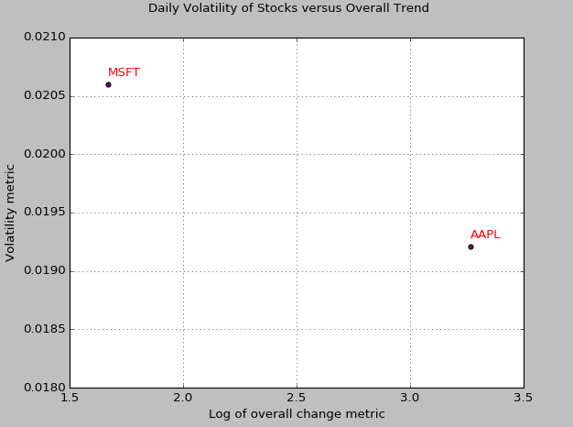

6. Signal Generation
The signals are generated by using a third-party library called as ‘ta-lib’ that gives us easier options to get SMA, ADX, Bollinger bands etc. This information is gathered and stored for future use in order to generate the strategy.
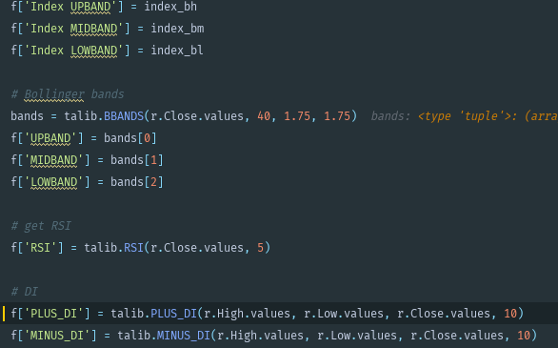

6. Derive Strategy
From the information derived by ta-lib calculations, we generate a short term strategy. The strategy is as follows:
1. If RSI crosses 30 from Below and
1.1 MACD cosses Signal from above and
1.2 Both Stock and Broad Market ADX is above 25 and
1.3 Close is less than Lower Bollinger Band
1.4 Go Long
2. If RSI crosses 70 from Above and
2.1 MACD cosses Signal from below and
2.2 Both Stock and Broad Market ADX is above 25 and
2.3 Close is greater than Upper Bollinger Band
3.4 Go Long
3. Exit trades when price touches the opposite band
4. Stop loss if Price rises or falls above or below 5% of its own value
5. Exit when we reach the end

7. Plot Indicators and Display KPIs
Calculate KPIs (Key Performance Indicators) and plot indicators, such as
- Max Drawdown
- Gain to Pain Ratio
- Win/Loss Ratio
- CAGR (Compound Annual Growth Rate)
- Long/Short Positions etc.
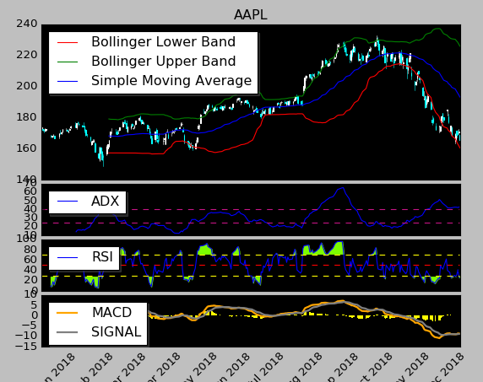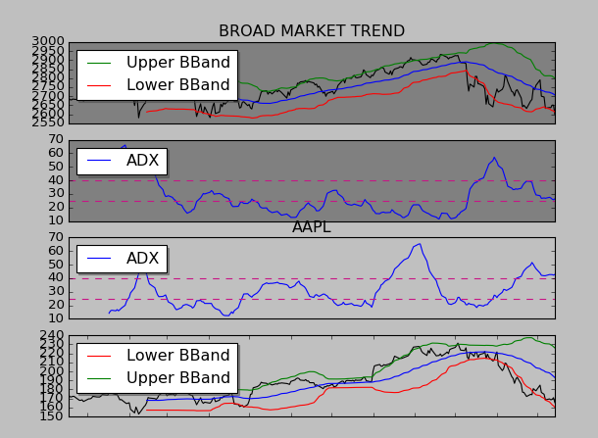

References
- https://www.investopedia.com/terms/m/macd.asp
- https://www.bollingerbands.com/bollinger-bands
- https://www.investopedia.com/terms/a/adx.asp
- https://www.fidelity.com/learning-center/trading-investing/technical-analysis/technical-indicator-guide/RSI
- https://www.ta-lib.org/function.html

