**Black Sholes Model**

The Black-Scholes model is an option pricing model that is used in calculation of Option Pricing. Unlike BOPM, this is an Analytical solution, based on continuous time (BOPM is based on discrete time, that is, it takes timely snapshots to price Options). Black-Scholes cannot be used for American styled options. For the given example in the attached Excel, PV(K) is taken as K. The present value could have been found out with something such a EXP(-risk-free rate * t) * K, but since the sample sheet contained an example that directly takes the Strike Price, it was used instead.

For the MSFT data example, the Strike price and the Stock price happen to be the same, sine the instructions were to use Strike price equal to the stock price, which was the closing day price. The historical volatility is calculated using 20 days Daily HV.

Formulas:

For European Call Option:



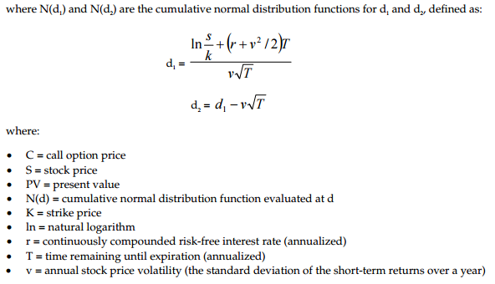

And for European put option:



**Binomial Option Pricing**

This is a discrete time variant for Option Pricing, and is more computational than its Black-Scholes variant. Here, a tree with probable upward and downward movements is constructed, along with price of the underlying asset at that moment (up or down). The Tree is then traversed back in order to get the results

Formulas:

Up Movement (u) = exp^(sig * sqrt(t)

Down Movement (d) = 1 /u

Probability of u (pu) = e^(r*t) – d / u – d

Probability of d (pd) = 1 – Pu

Stock Price considering up movement = S * u

Stock Price considering down movement = S * d

Payoff for up movement (for call option) = max(0,up movement stock price – k)

Payoff for down movement (for call option) = max(0,down movement stock price– k)

Payoff for up movement (for put option) = max(0,k – up movement stock price)

Payoff for down movement (for put option) = max(0,k – down movement for stock price)

**Oil Prices**

1. Factors influencing oil prices in the past 2 years are as follows:

a) Demand is low due to weak economic activities in China and all over the world in general.

b) Political upsets and conflicts in Iraq and Libya—two big oil producers with nearly 4m barrels a day combined

c) America has become the world’s largest oil producer. Thanks to the oilmen of North Dakota and Texas. They have set about extracting oil from shale formations previously considered un-viable through a relatively new technology-Fracking.

d) The Saudis have decided not to sacrifice their own market share to curb the falling prices of oil. Seeing that the main benefits of such a restoration process would go to countries they detest such as Iran and Russia.

2. For this given example, I took the year 2014-01-01 as the start and the end as 2015-12-31 as the end date, while my future forecast then consist of all the dates after that till today (One year).

My strategy would be to simply follow the SMA 30 day average, which shows movements where on the short term, prices have reached its average. While on the longer run, there have been the aforementioned four factors that have led to drastic reduction in prices, but if one fundamentally analyses the prices, by drawing a polynomial line, one observers the it shows a steep descent, with a small rise. That rise, though will not take the prices to its former glory, will however, be useful.

Further confirming the theory is the fact that in 2016, even though oil does hit an all-time low, it has risen over the duration to complete the ‘smile’ of the polynomial line more. Also, contributing to the factors are Political Scenarios stabilizing, China having better economic activities etc.

References:

1. Note on Option Valuation – George Chacko et. al.

2. <http://www.investopedia.com/university/optionvolatility/>

3. <http://onlinelibrary.wiley.com/doi/10.1002/9781118531976.app1/pdf>

4. <http://adamhgrimes.com/blog/how-do-you-calculate-volatility-in-excel/>

5. <https://www.quora.com/What-are-the-reasons-why-oil-prices-are-getting-lower-day-by-day-in-the-international-market>

6. <https://www.nytimes.com/interactive/2016/business/energy-environment/oil-prices.html?_r=0>

7. <http://www.tradinggeeks.net/2014/05/technical-analysis-in-excel-part-i/#Simple_Moving_Average>