**List of Workbooks:**

1. **WQU_609.xlsm:** This consists of all the tasks for final project

2. **BS_Alternate.xlsm:** This consists of an alternative way of performing Black-Scholes, where the spot price is derived from F, and used in the formula, instead of using F (Thereby making it Black Model or Balck-76 Model)

List of Sheets:

1. **Dividend Discount Model:** This contains Part – I of Final project, where DDM must be calculated

2. **Single Index Model – Data:** This worksheet consists of the Data used for performing the Single Index Model Analysis

3. **Single Index Model – Analysis:** This worksheet consists of the Regression output, used on the Data given in ‘Single Index Model Data’. This is where the Single Index Model is implemented

4. **Black Scholes Model – I:** This consists of the 1st part of BSM model, where f=49 and k=49

5. **Black Scholes Model – II:** This consists of the 2nd part of the BSM model, where f=50, k = 45

**Dividend Discount Model (DDM)**

The dividend discount model (DDM) is a procedure for valuing the price of a stock by using the predicted dividends and discounting them back to the present value. If the value obtained from the DDM is higher than what the shares are currently trading at, then the stock is undervalued.

This model is applied to companies that are consistently paying dividends.  This payment allows investors to put a value on the stock.  The formula is as follows:

PVcs =    D1__  
             kcs- g

Where:

**PVcs**= Common stock value  
**D1**= dividend in year 1  
**Kcs** = required rate of return  
**g** = growth rate

In our example, we have the following data points:

We have D(0) with us, which is given as 100. Using D(0), we calculate D(1) using the formula D1 = D0(1+g). This way, D(1) = 100 * (1+0.02) = 102

After getting D(1), we calculate PVcs using the aforementioned formula, and get the value to be 5.1k. I assume the dividends to be in cents, therefore, the final amount is 5.1 dollars.

**Single Index Pricing Model (SIM)**

**Background:**

Single Index Pricing Model is based on Markowitz’s model. Here, Markowitz tries to find what he calls ‘Optimally Risky Portfolio’. This model is a full covariance model. That is, it requires a large number of data estimates, which is of the factor n*(n-1)/2. The single index model reduces the number of data inputs required. This ease comes at a cost. It sacrifices accuracy.

The return of a security, ri, consists of an expected part E(ri) and an unexpected part ei. Ei is assumed to have 0 mean with std as sigma. A common macro-economic factor, m, is going to cause the change in the returns of the securities in the universe. Therefore,

Ri = E(ri) + m + ei

The mean for macro-economic factors will 0 out over time, and the std. dev. Is sigm. M and ei are un-correlated. m is known as systematic factor and ei is known as unsystematic factor. Therefore, variance of ri is nothing but a sum of variances of systematic and unsystematic factors.

Covariance is going to arrive from the uncertain part of the equation, that is, m+ei for ith security and m+ej for jth security. Since e’s are uncorrelated, we have cov(I,j) = sigm = variance of macro-economic factor.

Beta is the sensitivity co-efficient. Therefore ri = E(ri) + beta(i)m + ei. This is the **single factor model**. For variance of ith security, we have var(i) = beta(i)^2 * var(m) + var(ei). Var(ei) is known as residual variance or firm specific risk. Therefore cov(i,j) will be beta(i) * beta(j) * var(m).

Giving a contextual name to our macro-economic factor, we have, m as SnP500, which is a market index being used as a proxy.

The single index model is simply arrived at by regressing excess market returns on excess security returns. Therefore, E(ri) – rf = Ri, and for our market, it would be E(rm) – rf = Rm

Single index model at time period t would be, R(I at t) = alpha(i) + b(i) * Rm at t+ e(it), where the alpha is our intercept, the slope is beta, and e(it) is the error. Alpha gives excess returns when market return is 0. Beta gives us the sensitivity coefficient while measuring the systematic part of the risk. The error term represents the firm specific surprise element.

**Steps:**

The following steps were performed for single index model.

1. Fetch the data for IBM and Snp500 for 5 years (2012-2017) from yahoo finance

2. Calculate the daily returns

3. Calculate the monthly returns

4. Calculate the excess returns (here, assume the risk free rate of return to be any arbitrary number. I have considered it to be 0.044)

5. Regress the values obtained from 4

**Explanation:**

|  |  |
| --- | --- |
| *Regression Statistics* | |
| Multiple R | |  | | --- | | 0.549175558 | |
| R Square | 0.301593794 |
| Adjusted R Square | 0.289552308 |
| Standard Error | 0.002042655 |
| Observations | 60 |

Multiple R indicates that IBM tracks SnP500 fairly closely, that is, around 54% close.

Co-efficient of determination or R-Squared tells us that 30% of variation in IBMs index is represented by SnP500. The adjusted R is adjusting for estimates

Standard Error is the standard deviation of the residual return.

R2 = % of variability of IBM that is explained by variability in sp500. Here, it's 30%. Sharpe's rule of thumb is that the typical stock has an R2 of 30%. Estimate of SD(e(t)). This is the typical size of e(t).

|  |  |
| --- | --- |
|  | *Coefficients* |
| |  | | --- | | Intercept | | -0.000560651 |
| SnP | 1.02275801 |

Here the intercept is alpha and the slope is the beta

|  |  |  |  |  |
| --- | --- | --- | --- | --- |
| *Standard Error* | *t Stat* | *P-value* | *Lower 95%* | *Upper 95%* |
| 0.000841636 | -0.66614 | 0.50796 | -0.002245369 | 0.001124067 |
| 0.20436275 | 5.004621 | 5.53E-06 | 0.613681521 | 1.431834499 |

Standard Error column consists of SE(a hat) and SE(b hat) and lower and upper 95% confidence interval = estimate +/- 2*SE

|  |  |
| --- | --- |
| *Predicted IBM* | *Residuals* |
| -0.003467634 | 0.002351794 |
| -0.0060116 | -0.001343947 |
| -0.004875899 | -0.000577323 |
| -0.004674211 | 0.000686165 |
| -0.002642914 | 0.001093727 |
| -0.004435142 | -0.000510617 |

Predicted Y = predicted return = a hat + b hat*Rm,t

Resisual = actual return - predicted return

= Ribm,t - a hat - b hat *Rm,t

= e hat, t

For **expected returns**, I’ve plotted a chart instead of substituting in a formula and finding out the answer

Regression output is created using Tools/Data Analysis Regression. The y variable is there return on IBM and the x variable is the return on the S&P500.

The estimated single index model is Ribm = -0.00056 + 1.02275*Rsnp500

(0.00084) (0.20436)

where the SE values are in parentheses beneath the estimates. The R2 of the regression is 0.30. This is illustrated by the wide scatter about the regression line. 1 - R2 = 0.70 so that 70% of IBM's return is not explained by the market. This is the percentage of diversifiable risk. The standard error of the regression (SD of e(t)) is 0.0020. This is the typical distance of a dot from the regression line.

**Black-Scholes-Merton Model (BSMM)**

***Note to professor:***

There are a few estimates here. Black Scholes model speaks of underlying spot price. However, the Black Model or the Black-76 Model is similar to BSM, just that instead of using the Spot Price, one uses the Forward Price. One can derive the Spot price from the forward rate, using the given formula:

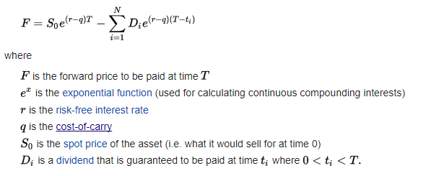

Here, we assume cost of carry to be 0, and that there is no dividend, therefore the substation becomes 0. Hence, our spot price becomes:

S0 = F/e^(r)T

I then use this spot price to calculate call and put using BSM Model. I present the answers of this method in the alternative workbook. This was done because there was a confusion w.r.t. what would be accepted as the correct answer, and personally, I didn’t want loss of marks, therefore both of them are presented.

**Theory:**

The Black-Scholes/Merton approach compensates for the main limitation of the binomial model: its relatively slow calculation speed. To calculate a thousand node points is unwieldy with the binomial model—but the Black-Scholes model can give a result in a second. As we will see, however, the Black-Scholes model has another limitation: it works primarily for European call and put options, with limited use for American calls and none at all for American puts.

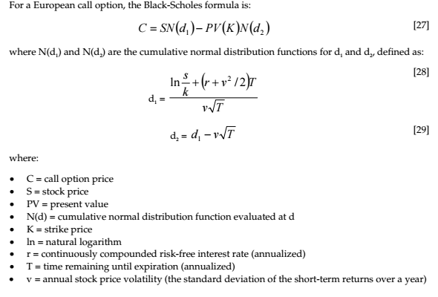

Based on put-call parity, the Black-Scholes formula for a European put option, P, can be derived from the European call formula above:

