**Assignment 1:**

**Installation**

1. To install all the relevant python packages, use the command on the command prompt as ‘pip install –r requirements.txt’ after extracting the zip folder
2. To run the file, on a command prompt type ‘python a1.py’
3. NOTE: Sometimes yahoo finance bugs out and returns an empty dataframe. This is a known bug. Please rerun the program by uncommenting line number 58, while commenting line number 57.

**Explanation**

1. Scrape Data From Wikipedia to get list of stocks

The following function scrapes data from Yahoo Finance

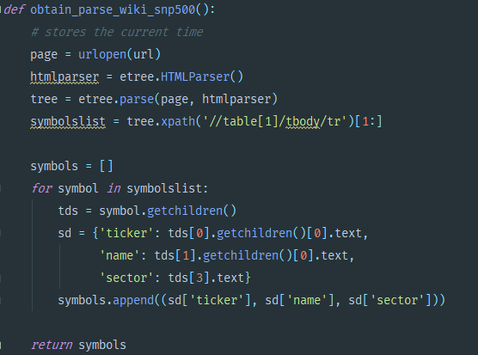

It then stores it in a DB in a SQLite file. This is an intermediate step.

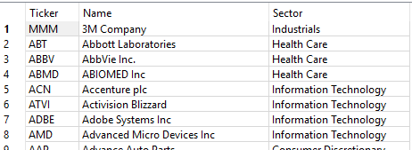

1. This list of Tickers is then used to query Yahoo Finance, to get Price data for that date (which is today) and it’s volume

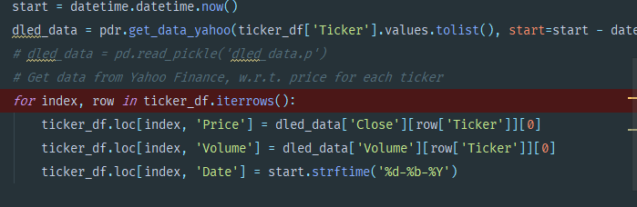

This is then stored in the same DB previously made.

