**Assignment 2:**

**Installation**

1. To install all the relevant python packages, use the command on the command prompt as ‘pip install –r requirements.txt’ after extracting the zip folder
2. To run the file, on a command prompt type ‘python a2.py’

**Explanation**

1. Download and load the data in the program

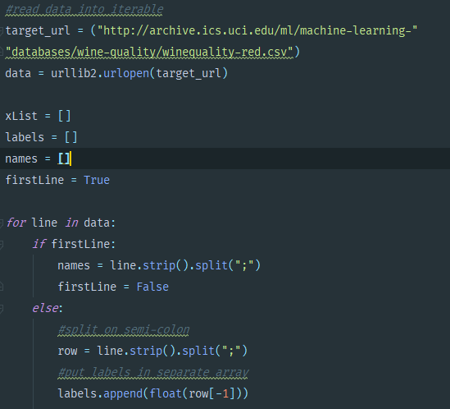

Data is loaded from a URL (which is the same data in the CSV as provided on the Project’s page). This data is then cleaned within the For loop

1. Calculate Mean and Variance, and use it to normalize xList

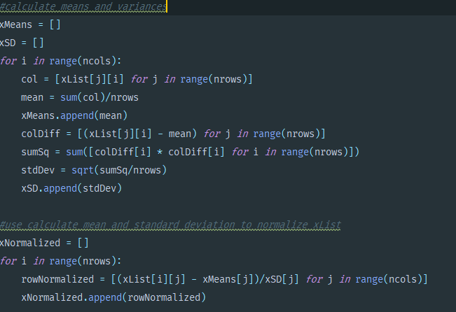

1. Normalize the labels

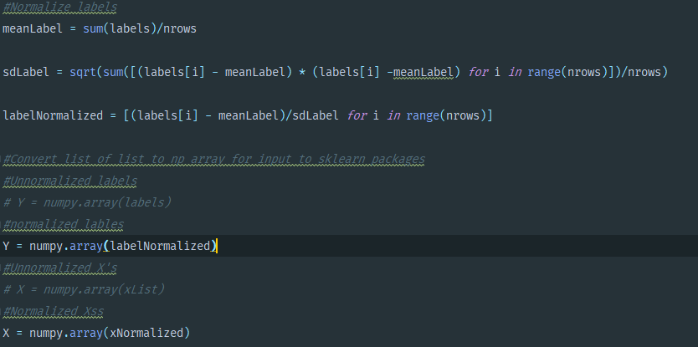

1. Cross Validate with 10, and call LassoCV, and fit it



1. Display Results in the form of a Graph

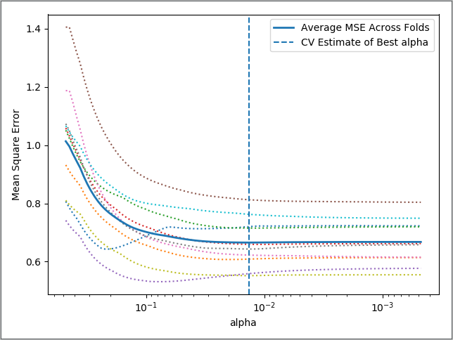

1. The Value of alpha that minimizes CV error

