**Assignment 4:**

**Installation**

1. To install all the relevant python packages, use the command on the command prompt as ‘pip install –r requirements.txt’ after extracting the zip folder
2. To run the file, on a command prompt type ‘python a4.py’

**Explanation**

1. K-nearest neighbors is a classification algorithm which is supervised in nature. You have a list of things already classified into groups, and your goal would be to assign a new thing into the group it is closest to. Here 'k' is the number of the closest things you would check before classifying the new thing.
2. So the input variables are:

Longitude

Latitude

City name

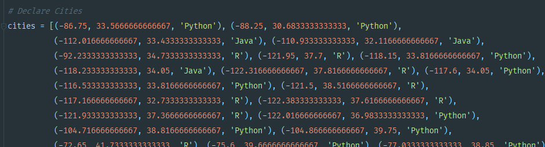

1. We combine long-lat to a list, and keep the language separate



1. Loop over 1,3,5,7, for correct classification as Python

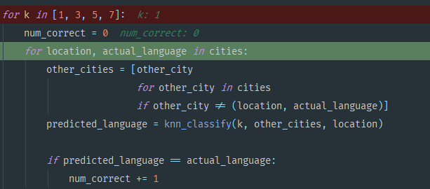

1. Classify by ordering distance from nearest to farthest

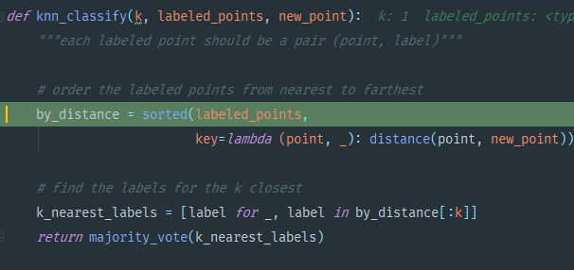

1. Get the Majority Vote

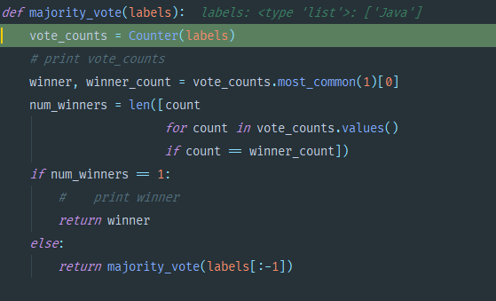

1. Output of KNN Classification

