**Assignment 5:**

**Installation**

1. To install all the relevant python packages, use the command on the command prompt as ‘pip install –r requirements.txt’ after extracting the zip folder
2. Do another pip install by typing the following command ‘pip install https://download.lfd.uci.edu/pythonlibs/l8ulg3xw/basemap-1.1.0-cp27-cp27m-win_amd64.whl’
3. To run the file, on a command prompt type ‘python a5.py’

**Explanation**

1. The dataset used is **cadata.txt**, that is, Califronia House Pricing data. We do some initial data cleaning on the dataset, by putting some labels and loading the data

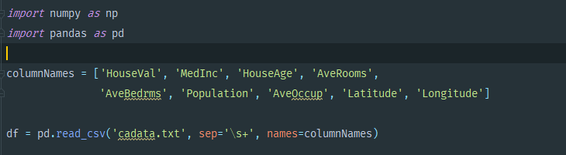

1. Split the dataset into test and train

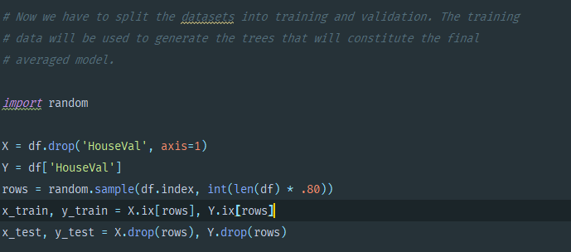

1. Train and fit the Gradient Boosted Tree

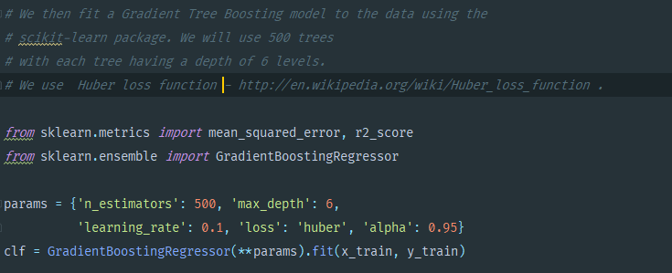

1. Get the R2 and MSE

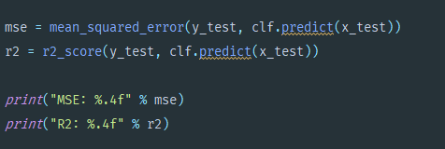



1. Plot the data

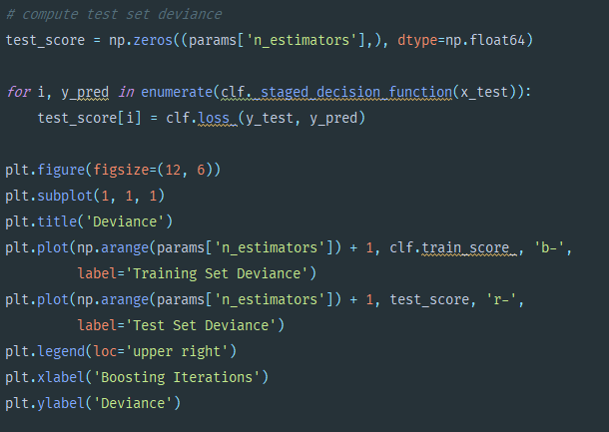

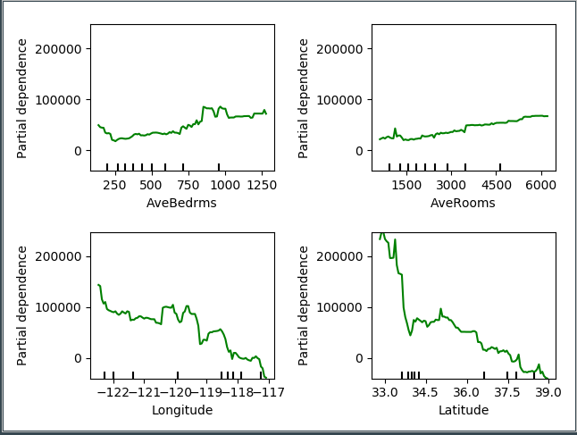

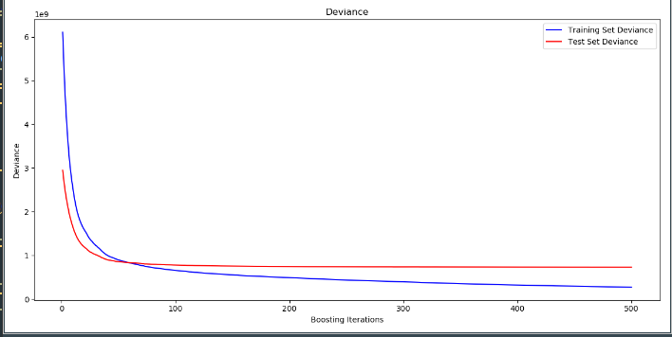

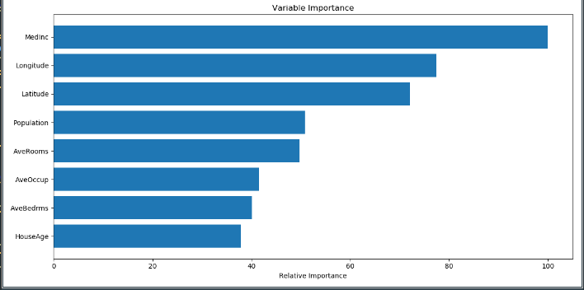

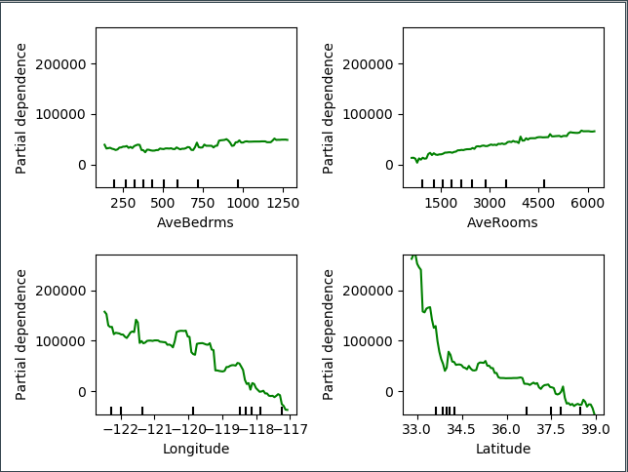

1. Perform a Scatter plot on the map of California to indicate places where prices are high

