1. Yahoo Finance API was used. This was done because it is easier to connect with PDR and YF fix package to retrieve the data. There were problems connecting to Google Finance, but the YF fix shines and retrieves data correctly. Plus it has additional methods to replace the close with adj. close etc.

2. 1 Month data is downloaded with the assumption that it’s going to take previous 1 month’s data. This data is retrieved by taking today’s date, subtracting a month and fetching data upto that point.

3. There are no options, and there is only one data source provider, that is, yahoo

4. Logging has been implemented, though not enabled. Enabling logging in a later version would allow log files to be created on the user’s PC in temp folder, and hence, help in case of debugging if the user gets back to the author

5. Interpolation is nothing but filling the missing data points. Liner interpolation would give more of a straight line between the plotted points, while the quadratic and cubic ones give a curve

6. The smoothness of the interpolation depends upon the number of data points that are used in the linspace() function. The more the points the better the curve

Here is a demonstration of the IBM stock:

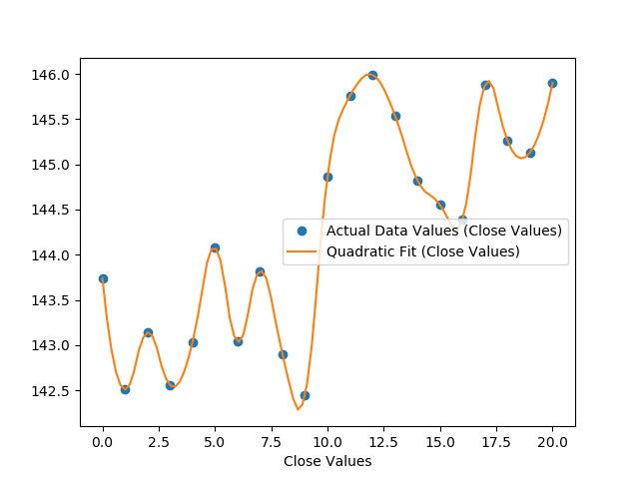

7. Optimization helps find the line of best fit. Error bars help in realizing the deviation of the data points from the optimization

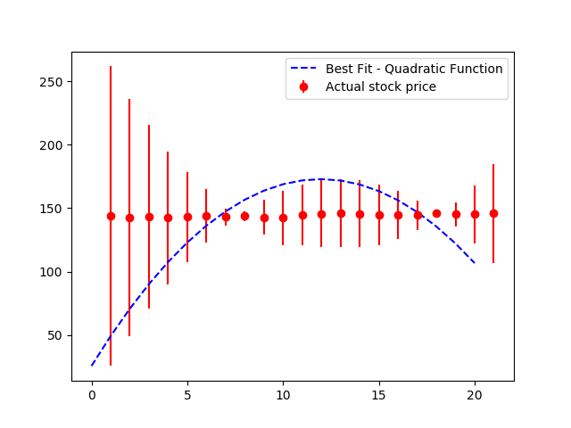

The error bars show how much away are the points from the best fit. The best fit depends upon the equation and the guesses. Tried changing the guesses, but didn’t result into much concreteness. Both the data points are on the stock IBM. With the above optimization technique, we can give a quick glance and see whether an equation is bet fit for the data set or not. The equation used was a simple ax^2 + bx