The Case Study utilizes an external R library called as ‘quantmod’. The first line of the script which has been commented is the one that performs the installation of ‘quantmod’ package. Therefore, in order to execute this homework, one will require to install the quantmod package as follows:

> install.packages('quantmod')

For further instructions on installation of quantmod package, please check:  
<http://www.quantmod.com/download/>

See the help ?install.packages on how to install packages manually, in the case that a firewall is blocking the default install.packages() installation

1. **How is the daily returns of NASDAQ distributed? Does it follow a normal distribution?**

Let’s have a look at the chart, where we have 25 bins.

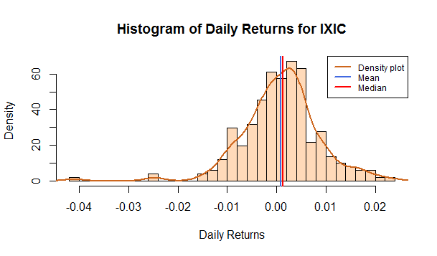

As one can observe, there seems to be some outliers in the data, which add to the skewness, these happen to be in the -0.04 and -0.01 range. Therefore, follows a **skewed left** pattern, that is, the distribution is skewed towards the left side, and that the data is normalised towards the right. Therefore, by removing the values that lie as outliers, we can get a histogram plot that follows normal distribution. Therefore, after removal of the outliers, (that is, by reducing the number of bins slightly, from 25 to 20), we have the following image:

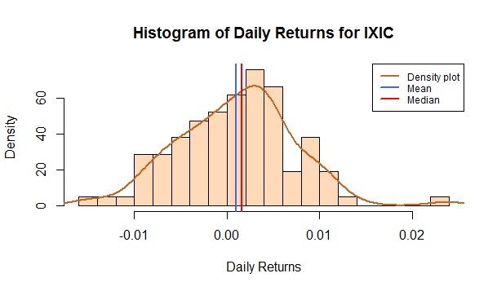

Here, the data is normally distributed in a bell-shaped cure. Therefore, this can also be seen as a case of **misrepresentation of data** when a large number of bins are taken into consideration.

**2. Are any obvious trends visible in movement of NASDAQ prices for the period under study?**

Let us observe the chart:

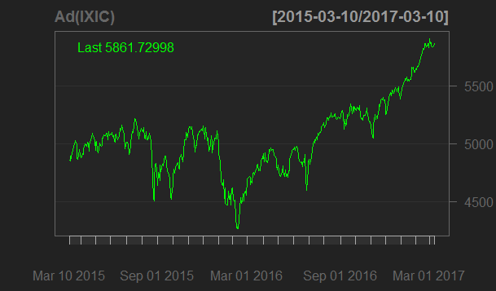

There seems to be sharp declines in the month of August 2015 followed by a quick recovery and a similar crash by the end of September 2015. The markets then seem to be gaining pace slowly, until they keep falling from January 2016 all the way up to February 2016, where it reaches its lowest. After which there seems to be a general upward trend all the way up until the present date (with a slight fall in June 2016 end, beginning of July 2016). The most obvious visibile movement is the past year, where NASDAQ COMPOSITE index grew from 4200 to 5800, a serious increase of 1600 points.

**3.  Analyze the measures of central tendency calculated and offer opinion on the overall risks and possible rewards associated with investing in the NASDAQ index for the period under study.**

The central tendency (here, Standard Deviation) tends to show that the daily returns seemed to be clubbed around the 1% mark, therefore, one can assume that the daily rewards will be little. The risks involved in can be seen with the help of the line graph, indicating that there can be sharp falls, though the index has been relatively stable over the past year.