**1. Pick two separate corporations and from www.nasdaq.com, pick the “historical quote” option and randomly select 30 opening stock prices for the last two years. Place the data into an Excel spreadsheet and outline your sampling method in the main Word document for the project.**

* For the aforementioned step, I chose stocks from a single sector, and which can be as closely related as possible. Therefore, I ended up choosing AAPL (Apple) and MSFT (Microsoft). I could have considered any other Technology behemoth, such as say AMZN and CSCO. However, both can be classified as Technology companies, but their operations differ. One deals in Hardware while the other focuses on Software and Operations. The given two companies which were chosen have their operations closely replicated.
* The Sampling that I had applied is as follows:

1. Gather Data from NASDAQ for AAPL and MSFT for a **3 year** period between **07-Apr-2017 to 07-Apr-2014**
2. Calculate the Daily Returns of the Stock. This is done following LN(S(t)/S(t-1)) [This formula for calculation of Daily Returns was explained in a comprehensive manner in the email for 603 statistics after Case Study I]. **Note:** For the first element, the %Daily return is LN(close/open) so that we cover all data points and don’t have NA values for missing data points.
3. Calculate the Daily Return in % format (Multiply by 100)
4. Create a Marker. This marker will be used to get the 30 Data Points that are necessary for this problem. The total count of elements is 758. Therefore, 30 points were needed, hence 758 / 30 is nearly equal to 25. Hence, calculate MOD(ROW(),25) for each row, thereby setting the marker for each row
5. Get a randomly generated number from the set of numbers present in the marker, that is, {0,1,2…24}  
   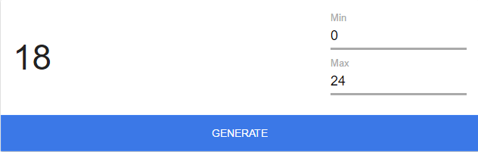
6. Use this number to fetch the 30 elements for both the stocks under study, that is, AAPL and MSFT. This gets 30 Daily returns in % format for MSFT and AAPL

**2. Determine a claim (prior to analyzing the descriptive statistics) based on two population means/samples.**

The claim is as follows:

**Claim:** **AAPL gives better returns on a daily basis than MSFT**

**3. Calculate the descriptive statistics for the two separate corporations. The distribution shape should be analyzed to determine the appropriate descriptive statistics to use (mean/standard deviation versus median/IQR). The graph should be included in the main Word document for the project. Find the appropriate descriptive statistics and place this in the Word document noting any outliers or any irregularities discovered.**

AAPL Daily Returns Histogram.

MSFT Daily Returns Histogram

NOTE: AAPL had an outlier of 4% on a particular day.

Both AAPL and MSFT have a bell shaped curve, and therefore, look like **Normal Distribution**. Therefore, I chose **Mean** and **Standard Deviation** as the descriptive statistic.

* Mean of AAPL = 0.0512
* Standard Deviation of AAPL = 1.382
* Mean of MSFT = -0.2972
* Standard Deviation of MSFT = 1.1261

**4. Conduct the hypothesis test based on the claim from item 2. Outline all the specifics in the Word document describing your conclusion. Note any possible reasons for the results. This might include some research on the corporations chose in item 1.**

**Claim:  
AAPL gives better returns on a daily basis than MSFT**

u_AAPL > u_MSFT

where,  
alpha = 0.05

Therefore,  
let d_bar = u_AAPL – u_MSFT

**H0 : mu_difference = 0**  
**H1: mu_difference > 0**

**n : 30 (**Number of Trails)

**df:** Degrees of Freedom (df) = n – 1 = 29

Therefore, calculating **CV** at df = 29, using a **T-Distribution** table, we have the following:

(T- Dist table found at <http://www.sjsu.edu/faculty/gerstman/StatPrimer/t-table.pdf>)

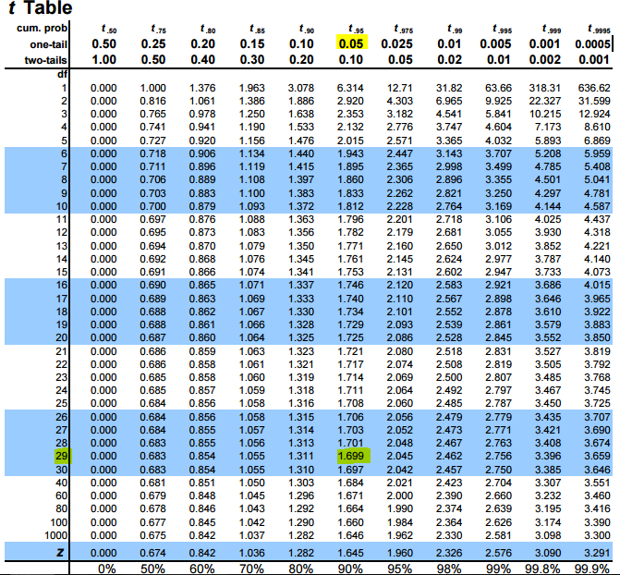

Therefore,

Our **CV is 1.699** for **df = 29 and alpha = 0.05**

**Mean of differences** of daily returns between is d_bar, which is given by the formula,  
u_AAPL – u_MSFT, that is, 0.0512 – (-0.2972)

Therefore, **u_difference =** 0.3484

**Standard deviation** (**d_sd**) of **difference between AAPL and MSFT Returns** = 1.915

Therefore,  
Our test statistic TS = (d_bar – mu_d) / (d_sd / sqrt(n))

= (0.3484 – 0) / (1.915 / sqrt(30))

= 0.9964

**Therefore,**

**TS < CV that is, 0.9964 < 1.699**

**Conclusion: Failed to Reject H0. Reject H1. Hence, Reject the Claim that AAPL provides better daily returns than MSFT on a daily basis.**

There could be a possibility that for an eyeball check, it seems that AAPL has made better gains than MSFT in the resultant period. However, AAPLs gains have been more volatile, and concentrated in particular regions, while MSFTs growth has been more steady and stable. AAPL seems to have more negative returns too, as compared to MSFT. AAPLs histogram also shows a lot of concentration around the 0.7 mark, while MSFT concentrates on better returns. Hence, from a layman point-of-view, just a random quick check of the figures may make on believe that AAPL has performed better, but in reality a statistical check proves otherwise.