**Plot of Standard Deviation, which is used as a proxy for Risk, to the Sample size**

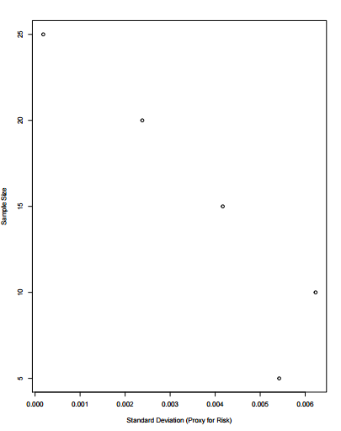

**1. What all factors account for the tracking error of the constructed portfolios?**

The factors affecting the tracking error of the constructed portfolios are the Sample Size of the portfolio (primarily) and the underlying stocks of the sample size, to be more specific, the closeness of the standard deviation and mean of the underlying composites in the portfolio to that of the DJIA index.

**2: What is the relationship between tracking error and portfolio sample size?**

The tracking error in general (after a few runs of the code to observe) tends to decrease with the increase in the number of portfolio size. Though there can be outliers where the number of stocks (say in the 10 stock portfolio) have returns that do not closely follow the index, while the 5 stock portfolio can have underlying stocks that closely follow the mean and standard deviation of the index. This happens due to the fact that the stocks in the portfolio are chosen on a random basis. To prove the aforementioned point, I did a few runs, and at times, the ones with lesser number of stocks had less tracking error (though the general trend was more the number of stocks, less the tracking error). Attached are a few plots

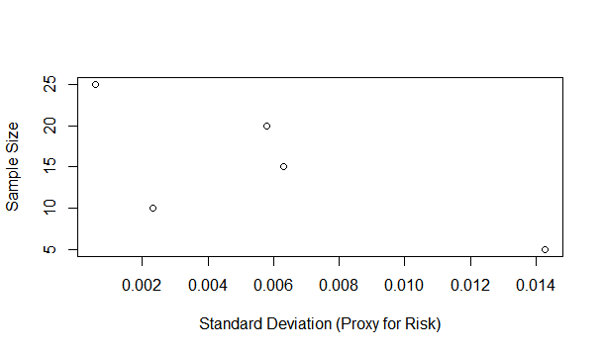

Here, the 10 stock portfolio has the least amount of tracking error when compared to say, 15 stock portfolio and 20 stock portfolio.

**3: What might be the most optimal way to decrease tracking error without having to construct a full portfolio matching the entire index?**

By choosing a bunch of stocks whose mean returns are closer to the return of the Index, we can closely follow the index and reduce the tracking error. As seen in the plot for Q2, we can observe that the tracking error for 10 stock portfolio is the least, because the mean of the underlying stocks closely follows the return of the index.