**Plots:**

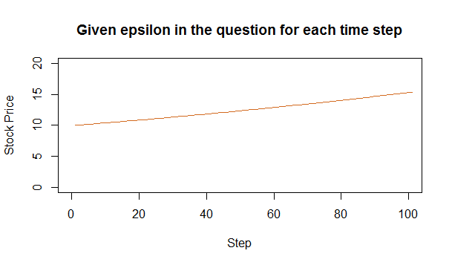

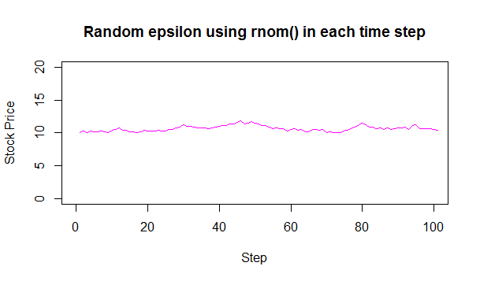

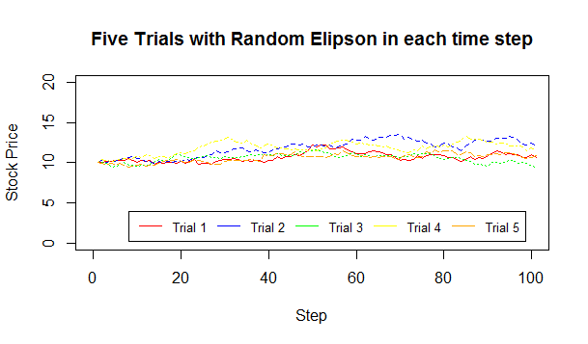

**1. How wide a variance is noticeable in the final year-end price of the stock for the 5 separate trials performed through steps IV and V? Analyze and draw your conclusions.**

The variance on the final year-end price for the 5 separate trials is not much, that is, it is not noticeable. Which means that they have low variance. This may be due to the fact that the epsilon is an affecting factor. When the epsilon was a constant, we got a straight line. But when the epsilon was random, our plot was random too. But the fact that we used rnom() as a function to get random values, we will have a normally distributed curve, that means that the initial price would not be far off from the year-end price.

**2. How wide a variance is noticeable in the final year-end price of the stock for the 5 separate trials performed through steps IV and V? Analyze and draw your conclusions.**

The variance for the year-end stock price would surely be higher if we would have used a rand() function instead of a normally distributed random number, because due to the randomness not being normally distributed, there will always be a good chance that the numbers will increase or decrease sharply. Therefore, the variance will be high in the year-end prices if a rand() function was used.