**Question 1: Huffman Encoding Proof**  
   
Prove:  
For two symbols A and B with probabilities P(A) >= P(B), then in the resultant representation sequence according to Huffman encoding procedure, the length of symbol A is no longer than that of symbol B.  
  
Assume:

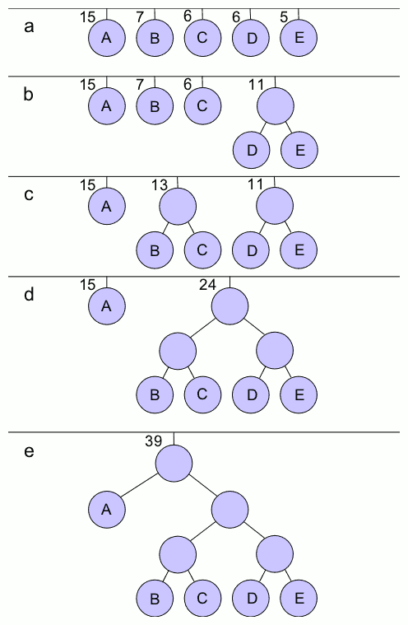



The binary representation of each given symbol is determined by the path that must be traversed to get to the leaf node.

A B C D E

0 100 101 110 111

The length of a symbol is determined by the depth at which the leaf nodes lies in the optimal tree. In example but examination we can see that

$P(A) >= P(B) : 15 ≥ 7 and the corresponding lengths are 1 ≤ 3$

Let’s assume S is the set of all symbols and S’ is the set of all symbols with probability less than symbol A

$S∈\{A,B,C,D,E\}$

$S' ∈∀i P(i) <= P(a) therefore S' ∈\{B,C,D,E\}$

We can generalize the argument to $P(A) >= P({S'}_{i})$ we can take any symbol on the right hand side of the tree and it’s length in binary will always be larger than P(A)

Base case: where H has only two symbols we can see that P(a) >= P(b) let’s assume that a and b have equal probability the length of A and B will be both 1, with their paths equal to 1 respectively 0 , 1. In the nth case where all probabilities are equal, P(A,B,C,D..N) = 1/n where N is odd we can look at the case where 3. We can see that P(A)>=P(B)>=P(C) the lengths respectively are 1<=2<=2.

