CST8333 Programming Language Research Project
Practical Project Part 3—Project Review 2

By

Ahmad Al-Jabbouri

041068196
2024-03-29

Evidence of Learning
In Practical Project Part 3, I augmented my project to incorporate database connectivity, replacing the reliance on File I/O with a database-driven approach. The class ‘DataStore’ handles database operations using the sqlite3 library. Below are the code figures that illustrate the implementation of database connectivity.
import sqlite3

class DataStore():
"""
A class representing a data store. Use pyPika to build and pass Query to execute!
"""

def __init__(self, db_path: Path = None):
self.connection: sqlite3.Connection = None
if db_path:
self.connect(db_path)

def connect(self,db_path: Path) -> None:
"""Connects to database and configures connection"""

try:
self.connection = sqlite3.connect(database=db_path)
self.connection.row_factory = sqlite3.Row # .execute() will now return Rows instead of tuples. Rows work similar to dict
for value in self.connection.execute("SELECT sqlite_version()").fetchone():
info(f"Successfully connected to SQLite version {value}")
except Exception as e:
exception(f"Failed connection: {e}")

I used sqlite3’s connect method and pass in the path to the database file and establish the connection. To make sure the connection is successful, I use execute() to execute a simple query to fetch the database’s version. If ‘3.43
def execute(self,sql: Query, rowid = True) -> "Report":
try:
con = self.connection
rep = self.Report(sql=sql)
sql = str(sql).replace('SELECT','SELECT rowid AS id,') if rowid else str(sql)
rows = con.execute(sql).fetchall()
if rows == []:
table = self.get_table_name(rep.sql)
rows = con.execute(f"SELECT rowid AS id, * FROM {table}").fetchall()
rep.rows = self.reveal(rows)
except sqlite3.Error as sql_e:
rep.error = sql_e
except Exception as ex:
rep.error = ex
finally:
return rep

Instead of implementing insert, update, and delete functions separately, I decided to implement a single execute() function to modify the behavior of a normal SQLite3 execute. The advantage of this is that the execute() function provides more flexibility in handling various types of SQL queries and commands, reducing code redundancy and improving maintainability.
To convert a Query object to a string is straightforward: str(). Additionally, any columns fetched by SELECT will also include the row id built-in in SQLite, unless rowid is set to False.
In addition to SQLite3, I will also be utilizing PyPika to build and pass query objects instead of raw strings. PyPika provides a fluent interface for constructing SQL queries dynamically, enhancing readability and minimizing the risk of SQL injection attacks. This approach ensures more robust and secure interaction with the database within the application.
To demonstrate how the code is used, I'll provide an example scenario where the Controller and View classes are used to interact with the database. Let's say we have a database containing information about otoliths, and we want to perform various operations such as selecting, inserting, updating, and deleting records.
from business.controller import Controller
from view import View

# Establish connection to the database
Controller.establish_connection("path_to_your_database.db")

# Choose a table to work with
selected_table = View.choose()
Example 1: Establishing connection to SQLite database and choosing table

from view import View
from business.controller import Controller

# Selecting records from the chosen table
selected_columns = ['latin_name', 'english_name', 'year']
records = Controller.process(View.operations.SELECT, selected_table, selected_columns)

# Inserting a new record into the chosen table
new_record = ['Pseudopleuronectes americanus', 'Winter flounder', 2023]
Controller.process(View.operations.INSERT, selected_table, new_record)

# Updating a record in the chosen table
update_data = {'id': 3, 'target': 'year', 'value': 2024}
Controller.process(View.operations.UPDATE, selected_table, update_data)

# Deleting a record from the chosen table
row_id_to_delete = 5
Controller.process(View.operations.DELETE, selected_table, row_id_to_delete)

# Committing changes to the database
Controller.process(View.operations.COMMIT)
Example 2: Performing operations

from business.controller import Controller

# Prompt user to paste SQL script
script = """
CREATE TABLE IF NOT EXISTS new_table (
id INTEGER PRIMARY KEY,
name TEXT NOT NULL
);
INSERT INTO new_table (name) VALUES ('New record');
"""
Controller.execute_script(script)
Example 3: Running SQL Script

from view import View
from business.controller import Controller

# Start console loop for user interaction
View.start("path_to_your_database.db")
Example 4: Viewing Data

In this example, we first establish a connection to the database and choose a table to work with. Then, we perform various operations such as selecting, inserting, updating, and deleting records. We also demonstrate running a SQL script and viewing data through the console interface provided by the View class.

Program Changes
In organizing my code, I've kept things tidy and easy to understand. I've structured my files into logical folders, making it clear where each part of the code belongs. Looking at the folders, you can see where the data, logic, models, and presentation components are stored. This separation helps me find and manage different aspects of my project efficiently.
Table 1: Folder structure used in this project
src
│ .gitignore
│ .log
│ config.ini
│ main.py
│
├───business
│ │ controller.py
│ │
│ └───models
│ │ otolith.py
│ │
│ └───mappers
│ otolith_mapper.py
│
├───persistence
│ │ datastore.py
│ │
│ └───datasource
│ │ otolith.db
│ │ script.sql
│ │
│ └───backup
│ data-dictionary.csv
│ NAFO-4T-Yellowtail-Flounder-otoliths.csv
│ otolith.db
│
├───presentation
│ └view.py
│
└───utils-submodule

In my project, the advanced programming concept of database connectivity using SQLite and PyPika is split between the Persistence layer and the Controller layer. Here's how it's organized:
Persistence Layer:
- The DataStore class, located in the persistence folder, serves as the interface for database operations. It handles database connectivity, query execution, and transaction management using the SQLite library.
- Within the DataStore class, raw SQL queries are executed using SQLite. This class is responsible for managing the connection to the database and performing CRUD operations.
- The DataStore class encapsulates the low-level database interactions, abstracting away the details of the database implementation from the rest of the application.
Controller Layer:
- The Controller layer, represented by the Controller class in the business folder, utilizes PyPika for query construction and manipulation.
- PyPika allows for the dynamic generation of SQL queries in a fluent and readable manner. The Controller class constructs queries using PyPika and then passes them to the DataStore class for execution.
- This separation of concerns ensures that query construction and database interaction logic are decoupled, promoting better code organization and maintainability.
Integration:
- Queries constructed in the Controller layer are sent to the Persistence layer for execution through the DataStore class. This integration ensures that the Controller layer remains responsible for business logic and query construction, while the Persistence layer handles the actual database interactions.
- The DataStore class receives queries from the Controller layer, executes them using SQLite, and returns the results back to the Controller layer as needed.
Impact on Layered Architecture:
- This division of responsibilities aligns with the principles of a layered architecture, where each layer has distinct responsibilities and communicates with adjacent layers in a controlled manner.
- The separation of concerns between the Controller and Persistence layers facilitates code maintainability and scalability. Changes to database schemas or query logic can be made independently within each layer without affecting the overall system architecture.
Refactoring and Testing:
- The Controller layer, responsible for query construction, can be refactored independently to accommodate changes in business requirements or query optimization strategies.
- Unit tests can be written for both the Controller and Persistence layers, allowing for comprehensive testing coverage. Mocking can be utilized to isolate components for unit testing, ensuring that changes made to one layer do not inadvertently affect the functionality of other layers.

Program Demonstration via Screen Shots
Upon launch, user is greeted by main menu. User should use the keyboard arrows to navigate the menu, and ENTER key to confirm choice.

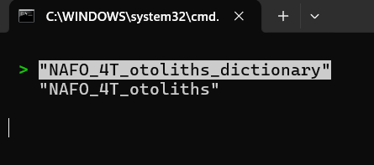Figure 1: Main menu

On the secondary menu, user may choose to SELECT, INSERT, UPDATE, DELETE, COMMIT, RUN_SCRIPT, or EXIT

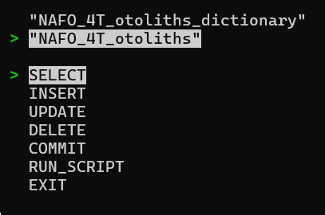Figure 2: Secondary menu

I converted NAFO_4T_otoliths.csv into an SQL script you will find in src/persistence/datasource/backup/. Copy and paste the content of the script in the terminal after selecting the RUN_SCRIPT menu option.
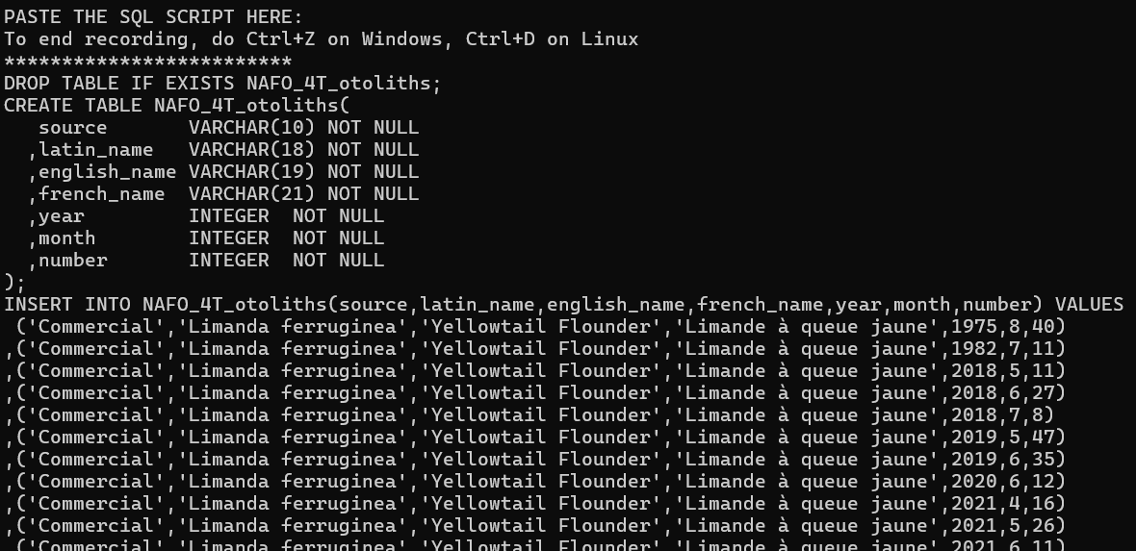Figure 3: Populating database with SQL script

User may select which columns to display with a minimum of 1.
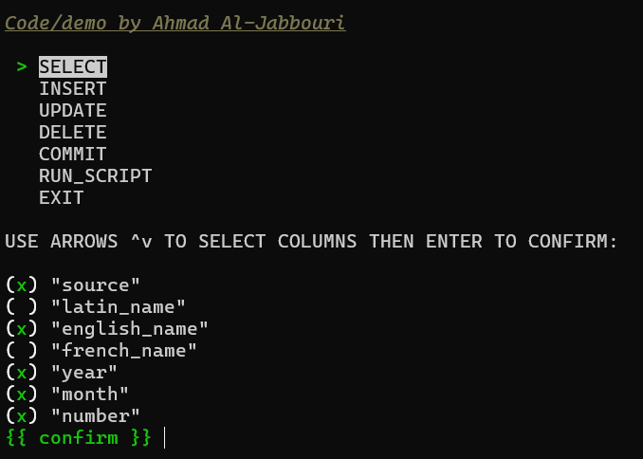Figure 4: SELECTing using cutie module

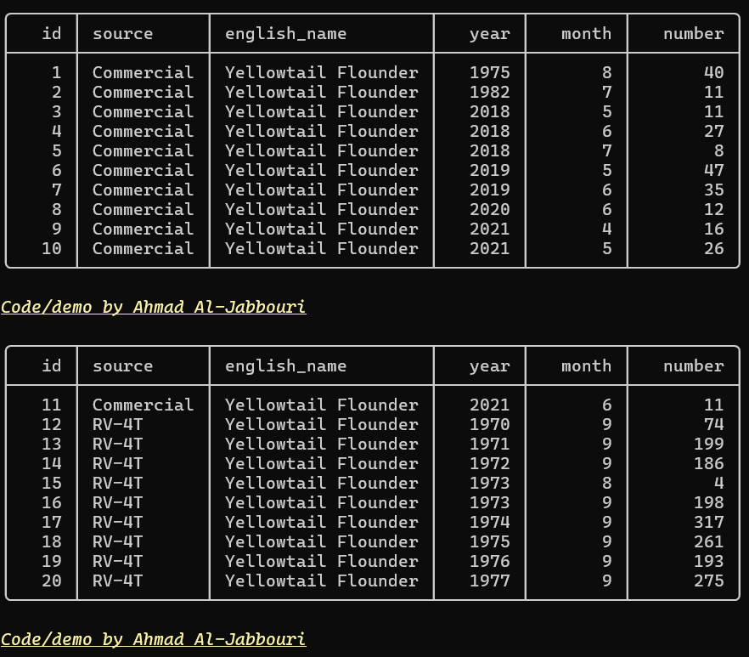Figure 5: Result of SELECT

User may insert a row.
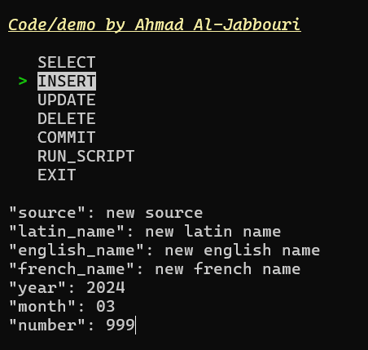Figure 6: INSERTing

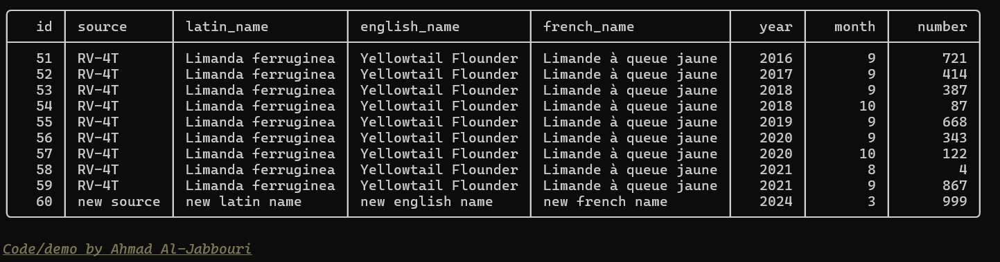Figure 7: Result of INSERT

User may update a row
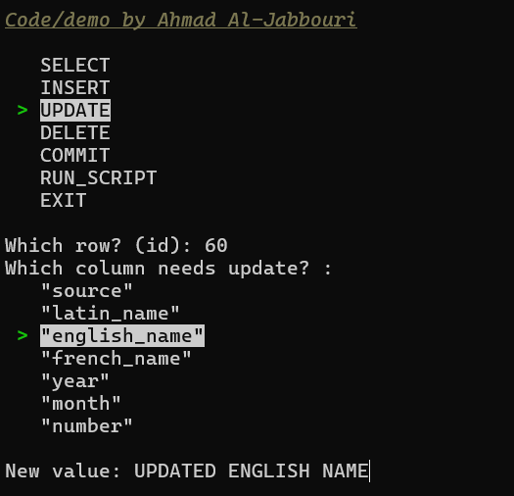Figure 8: UPDATing

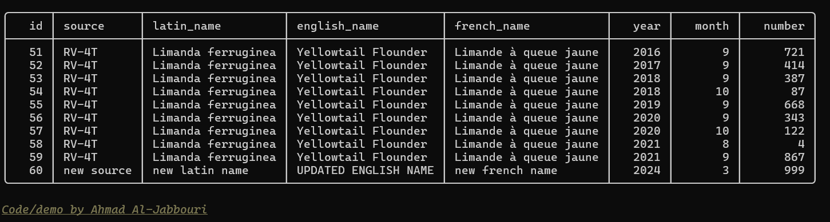Figure 9: Update result

User may delete a row.

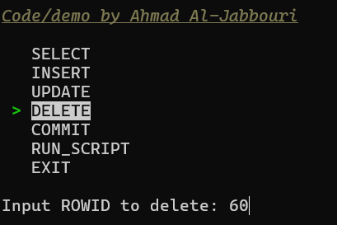Figure 10: DELETing

No change is persisted to database unless COMMIT menu option is chosen.

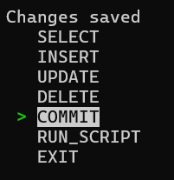Figure 11: COMMITing

Unit Testing Demonstration via Screen Shots
  - Include screen shot(s) of your running unit test(s), this may either be within an IDE or run from a console. Your full name must appear within the screen shot(s).
  - Your unit test should test the new feature implemented where possible (GUI frameworks are an exception); minimally this must test your own code and not duplicate the same test from the previous Practical Project Part 2.

Source Code Commenting Example

main.py

Presentation Layer
Class 1
Class 2
Class 3

Business Layer
Class 1
Class 2
Class 3

Persistence Layer
Class 1
Class 2
Class 3

All code presented is original and my own.

