CST8333 Programming Language Research Project
Practical Project Part 2 - Project Proof of Concept

By

Ahmad Al-Jabbouri

041068196
2024-02-18

Evidence of Learning
The following code snippets exemplify the use of essential programming constructs, providing a comprehensive illustration of my learning journey.

1. Variables
Variables serve as foundational elements in programming, allowing for the storage and manipulation of data. In the Otolith class, the initialization method showcases the use of variables to represent attributes of an otolith:

class Otolith:
def __init__(self, source: str, latin_name: str, english_name: str, french_name: str, year: int, month: int, number: int):
self.source = source
self.latin_name = latin_name
self.english_name = english_name
self.french_name = french_name
self.year = year
self.month = month
self.number = number
(Otolith.py, line 1)

Here, source, latin_name, english_name, and others are variables encapsulating different attributes of an otolith.

2. Loop Structure
Loop structures are pivotal for iterating over data or executing a block of code repeatedly. In the FishConsoleView class, a while loop is employed to continuously prompt the user for commands until an exit signal is received:

@classmethod
def start(cls):
try:
exit = False
while not exit:
user_input = input("\nEnter your command (type 'help' for available commands)\n\n> ")
info(f"User entered \"{user_input}\"")

processed_input = cls.process(user_input)
if processed_input.get("action") is not None:
exit = cls.execute_action(processed_input)
except:
exception("What happened?")
(FishConsoleView.py, line 20)

This loop structure ensures the continuous execution of the program until the user decides to exit.

3. Decision Structure
Decision structures enable the execution of different code paths based on specified conditions. Within the FishService class, a match statement is used to determine the appropriate action based on the user's command:

@classmethod
def execute_action(cls, action_set) -> DisplayInfo:
try:
action = action_set.get("action").upper()
index = action_set.get("arg")
match action:
case "SELECT" | "GET":
return cls.select(index)
case "INSERT" | "ADD":
return cls.insert()
case "UPDATE" | "MOD":
col = action_set["column"]
new = action_set["new_value"]
return cls.update(index, col, new)
case "DELETE" | "DEL":
return cls.delete(index)
case _:
logging.error("\033[31mNO SUCH COMMAND, RETURN\033[0m")
return DisplayInfo(error=True, error_msg="\033[31mERROR\033[0m")
except Exception as e:
logging.exception("ERROR IN FishService.execute_action")

(FishService.py, line 27)

This decision structure ensures that the appropriate action is taken based on the user's input.

4. File-IO against the Dataset
File Input/Output (File-IO) is crucial for reading from and writing to files. In the DataStore class, the load_dataframe method demonstrates reading data from a CSV file:

@classmethod
def load_dataframe(cls) -> None:
if cls.DATA_SOURCE is None:
cls.connect_database()
pd.options.display.max_rows = cls.MAX_ROWS # Will not display more than 100
cls.dataframe = pd.read_csv(cls.DATA_SOURCE)
cls.DATA_FIELDS = list(cls.dataframe.columns)
(DataStore.py, line 29)

5. Exception Handling
Exception handling is implemented to gracefully manage errors and prevent program crashes. In various parts of the code, try, except, and finally blocks are utilized to handle exceptions. For instance, in the FishConsoleView class:

@classmethod
def select(cls, index: Union[int, str]) -> DisplayInfo:
di = DisplayInfo()
try:
if index == '*':
di = cls.prepare_display_info(cls.entity_map)
elif index.isdigit():
index = int(index)
di = cls.prepare_display_info({index: cls.entity_map[index]})
else:
raise ValueError
except ValueError as ve:
logging.error(f"{index} IS NOT ACCEPTED AS ARGUMENT")
di = DisplayInfo(error=True)
except Exception as e:
logging.exception("ERROR IN select:" + e)
di = DisplayInfo(error=True)
finally:
return di
(FishService.py, line 58)

This structure captures and logs exceptions, ensuring the program remains robust even in the face of unexpected errors.

6. Use of an API Library
The DataStore class leverages Pandas functionalities to interact with CSV files, demonstrating proficiency in handling data operations efficiently.

@classmethod
def insert(cls, data: List[List]) -> None:
try:
new_df = pd.DataFrame(data, columns=list(cls.dataframe.columns))
cls.dataframe = pd.concat([cls.dataframe, new_df])
cls.dataframe.to_csv(cls.DATA_SOURCE, index=False)
cls.load_dataframe()
except Exception as e:
pass
(DataStore.py, line 101)

7. Lists
Arrays or similar data structures are essential for organizing and managing collections of data. In the prepare_display_info method of the FishService class, a PrettyTable is used to organize data for display, which requires careful manipulation of lists:

@classmethod
def prepare_display_info(cls, data: Dict[int, Otolith]) -> DisplayInfo:
pt = PrettyTable()
pt.field_names = ["id"] + list(data.values())[0].get_fields()

count = 0
for key, otolith in data.items():
pt.add_row([key] + otolith.get_attributes())
count += 1

return DisplayInfo(is_table=True,row_count=count,pretty_table=pt)
(FishService.py, line 162)

Here, data is organized in a tabular format for better presentation.

8. Unit Tests
In this Pytest test, I use fixtures to set up a sample FishService instance (sample_fish_service) for testing. The test_select_method function then checks whether the FishService.select method produces the expected output in the form of a DisplayInfo object. The test covers aspects such as the returned data structure, table attributes, index, and error flags.
import pytest
from presentation.DisplayInfo import DisplayInfo
from services.FishService import FishService

@pytest.fixture
def sample_fish_service():
# Set up a sample instance of FishService for testing
return FishService()

def test_select_method(sample_fish_service):
# Simulate the FishService.select method with a sample input
action_set = {"action": "SELECT", "arg": "1"}
result = sample_fish_service.select(action_set)

# Ensure the result is an instance of DisplayInfo
assert isinstance(result, DisplayInfo)

# Validate the expected attributes of DisplayInfo
assert result.is_table is True

(FishService.py, line 162)

Program Architecture
In organizing my code, I've kept things tidy and easy to understand. I've structured my files into logical folders, making it clear where each part of the code belongs. Looking at the folders, you can see where the data, logic, models, and presentation components are stored. This separation helps me find and manage different aspects of my project efficiently.
Table 1: Folder structure used in this project
root
│ .log
│ config.ini
│ launcher.py
│
├───data
│ │ data-dictionary.csv
│ │ NAFO-4T-Yellowtail-Flounder-otoliths.csv
│ │
│ └───backup
│ NAFO-4T-Yellowtail-Flounder-otoliths.csv
│
├───logical
│ │
│ └─── FishService.py
│
├───model
│ │
│ └─── Otolith.py
│
├───modules
│ │
│ └─── my_module.py
│
├───persistence
│ │
│ └─── DataStore.py
│
└───presentation
│
│─── DisplayInfo.py
└─── FishConsoleView.py

In organizing my code, I've employed an N-layer architecture to enhance modularity and maintainability. This architectural style involves organizing code into distinct layers, each serving a specific purpose.
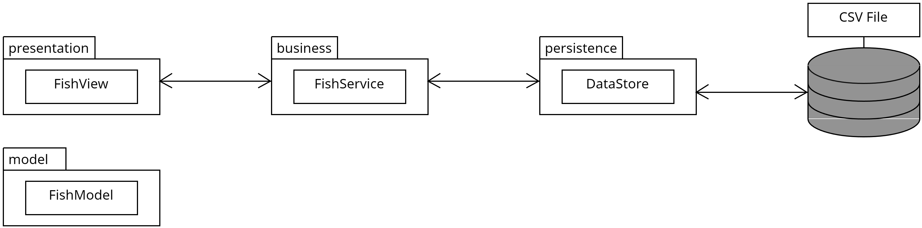Figure 1: N-Layer Architecture used in this project
Presentation Layer (presentation folder):
This layer is responsible for user interface and interaction.
In my FishConsoleView class, located in the presentation folder, I manage user input and display information. It acts as the interface between the user and the underlying logic.
Logical or Service Layer (logical folder):
This layer contains the core business logic of the application.
The FishService class in the logical folder handles actions based on user input. It acts as an intermediary between the presentation and persistence layers.
Persistence Layer (persistence folder):
This layer deals with data storage and retrieval.
The DataStore class, situated in the persistence folder, manages the connection to the data source, reads and writes data, and performs database operations.
Model Layer (model folder):
This layer represents the data structures and entities used in the application.
The Otolith class in the model folder defines the structure of the data entity, representing an otolith.
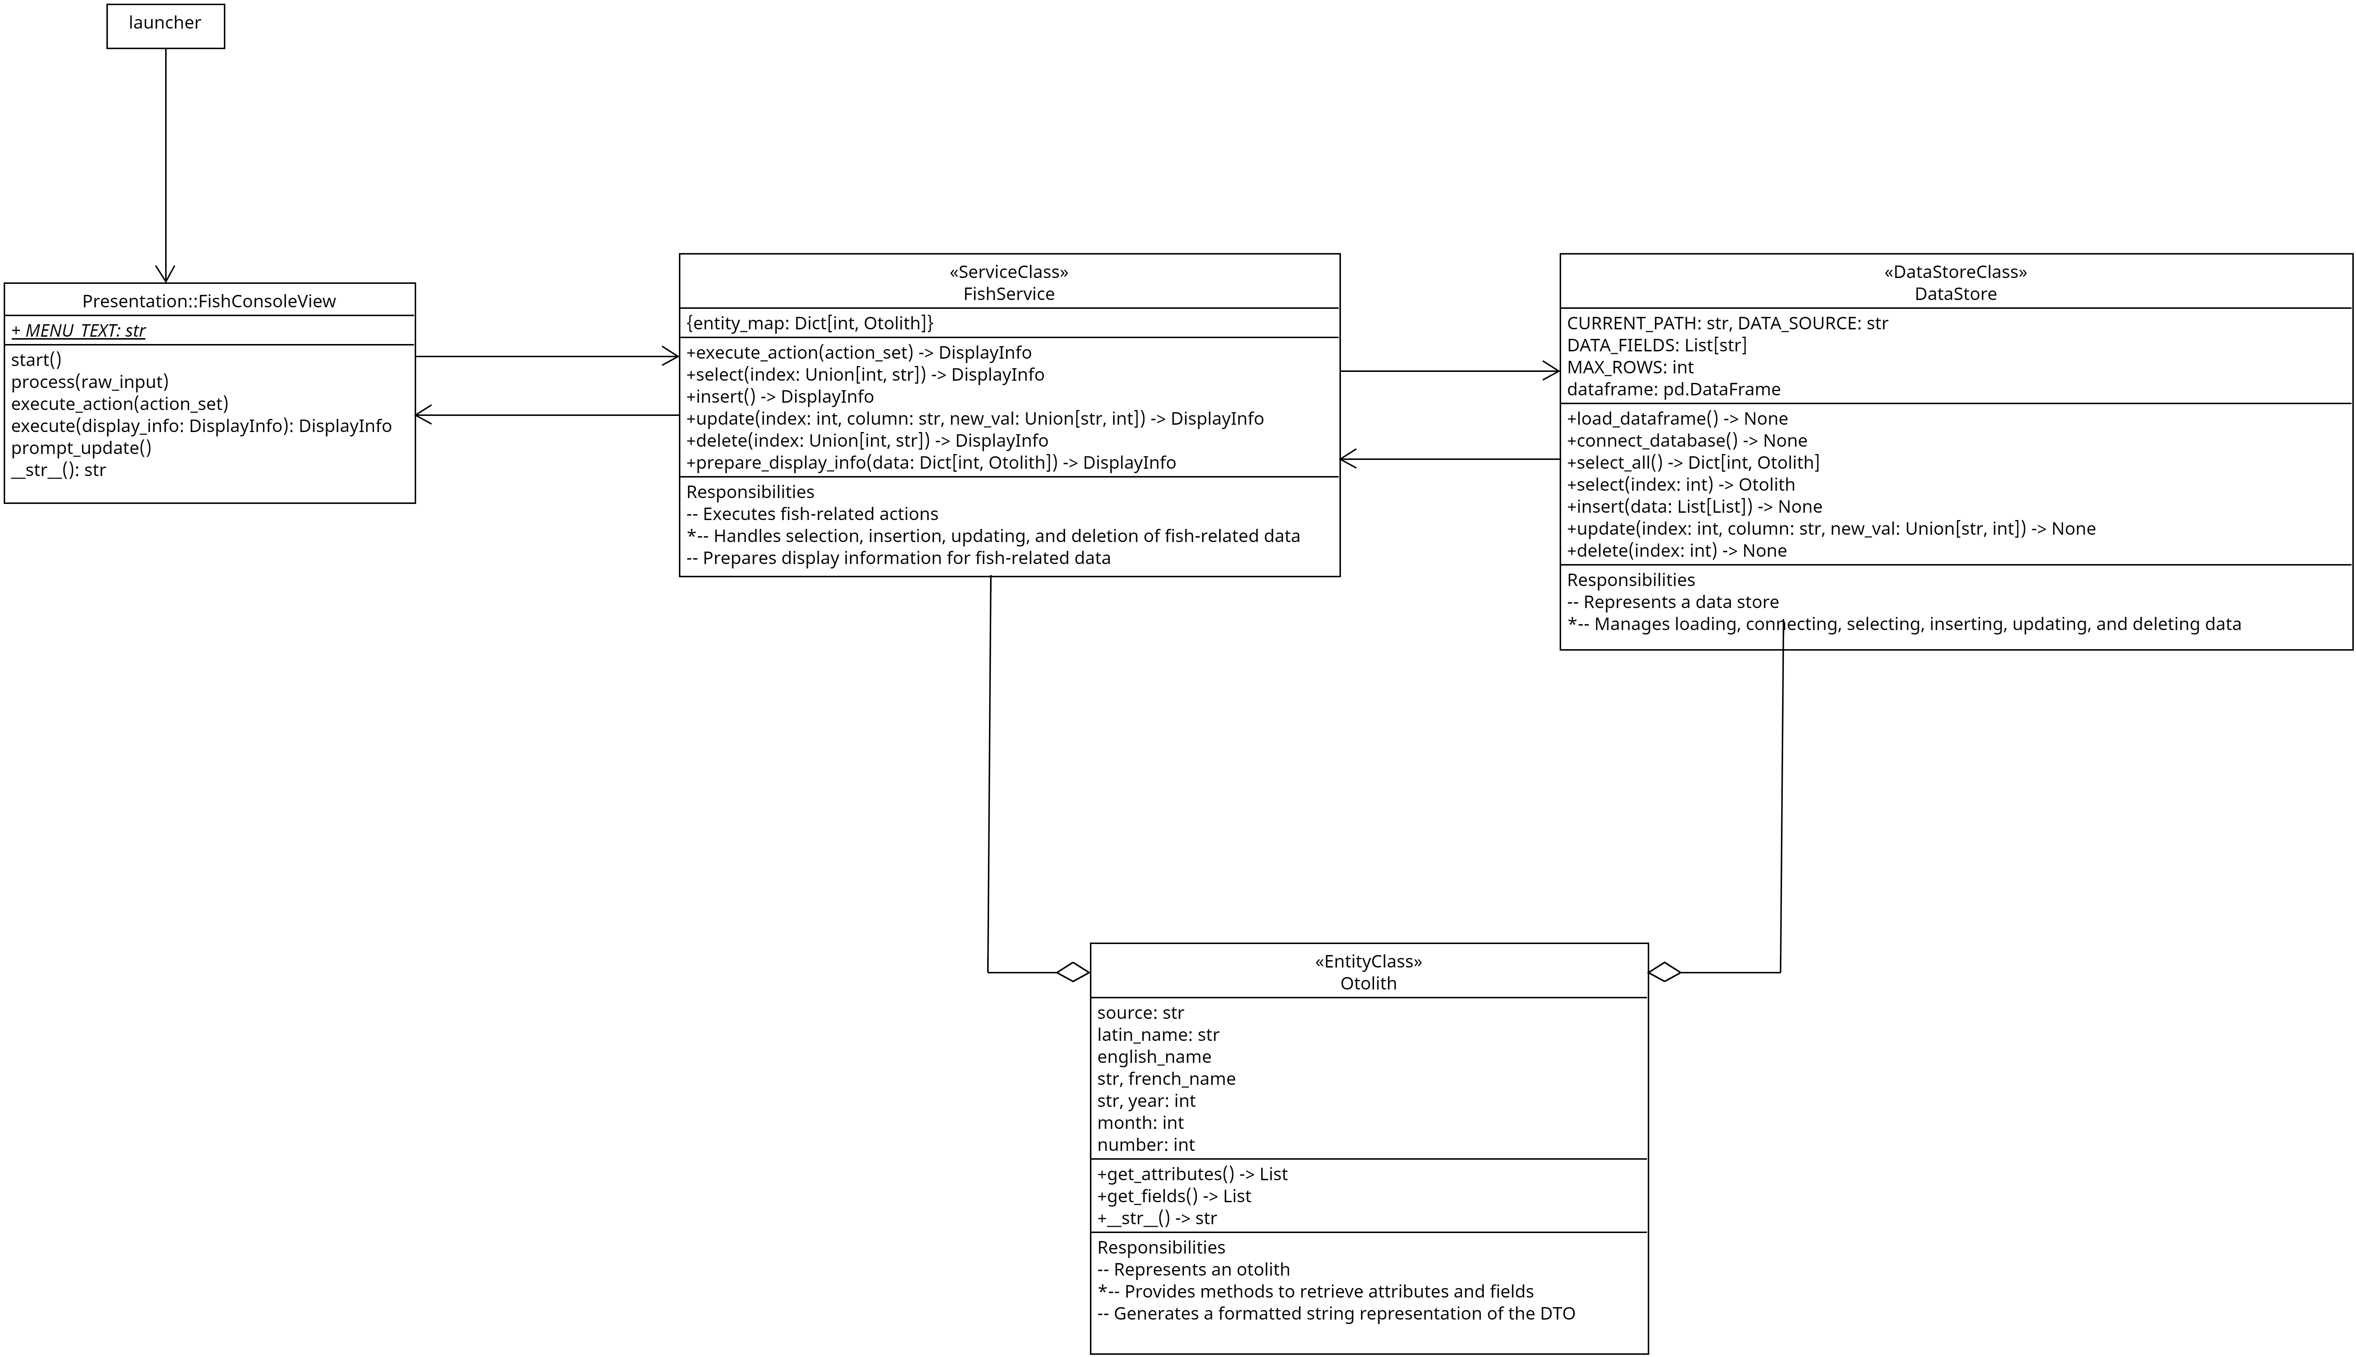
By organizing my code in this way, I've separated concerns, making it easier to understand and maintain. The layers communicate with each other in a structured manner, following a clear flow of data and logic. This architectural design also facilitates testing, as each layer can be tested independently, contributing to the overall robustness of the application. The UML diagrams provide a visual representation of these interactions, aiding in comprehending the overall structure of the N-layer architecture.

Program Demonstration via Screen Shots
Your full name must appear within the screen shots. Include screen shots of your running program; I should see records from the data set displayed, as well as creating, updating, deleting records and re-loading and saving records via user interaction with the program.
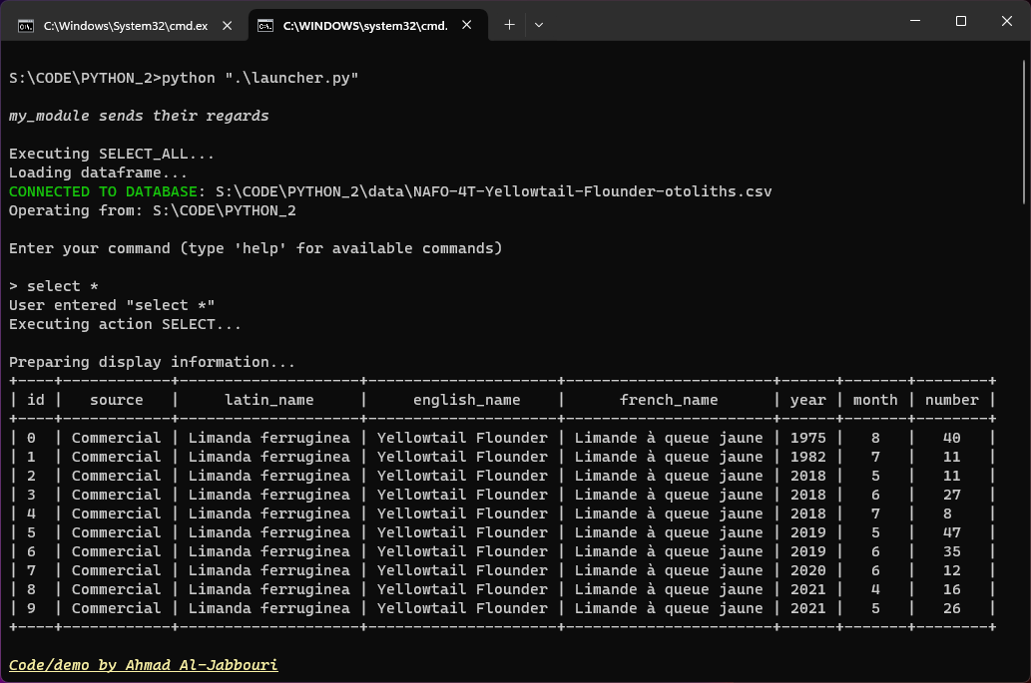Figure 2: Select ALL
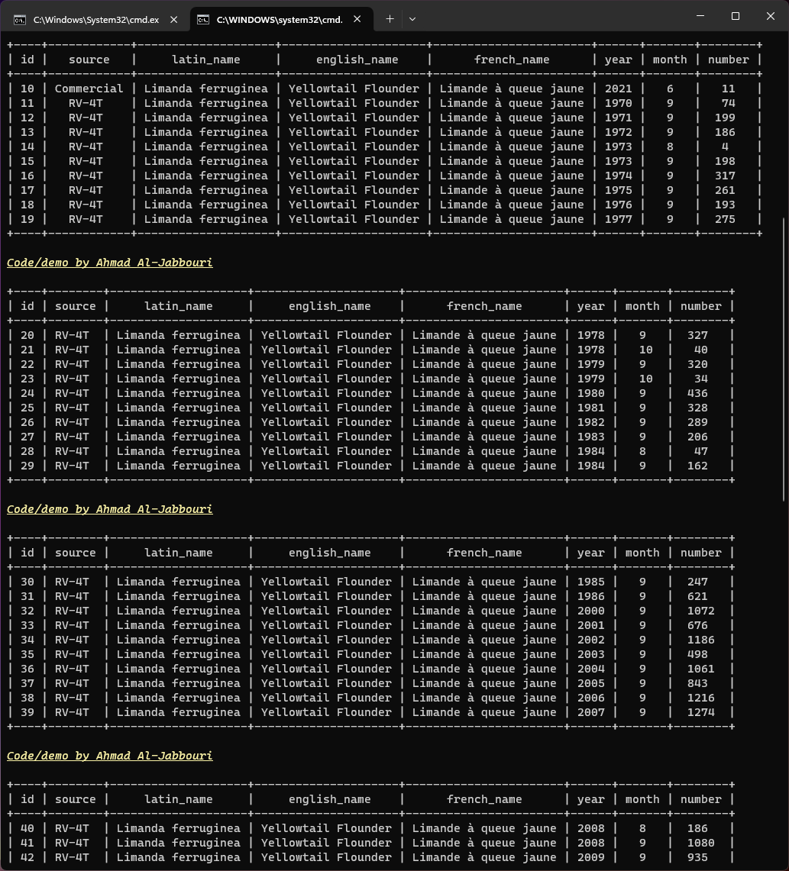Figure 3: select ALL (continued)
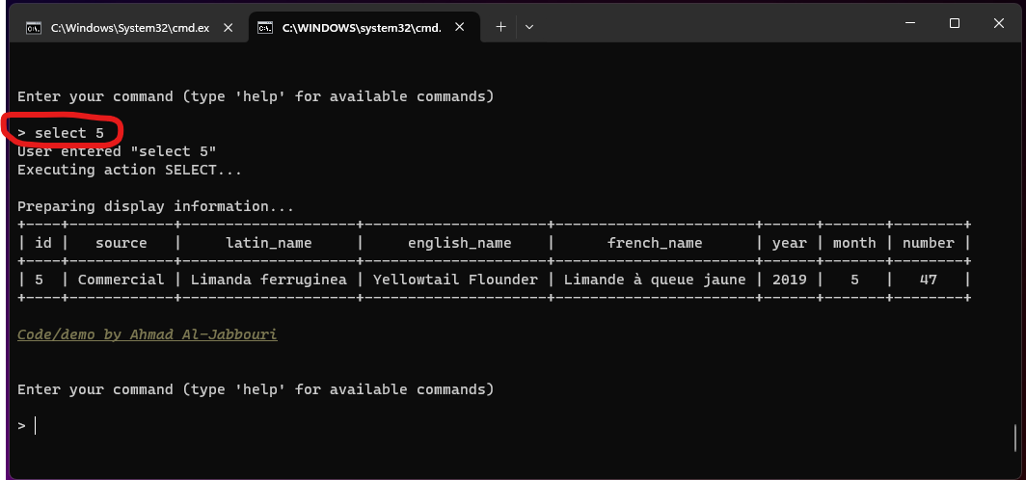Figure 4: select ONE
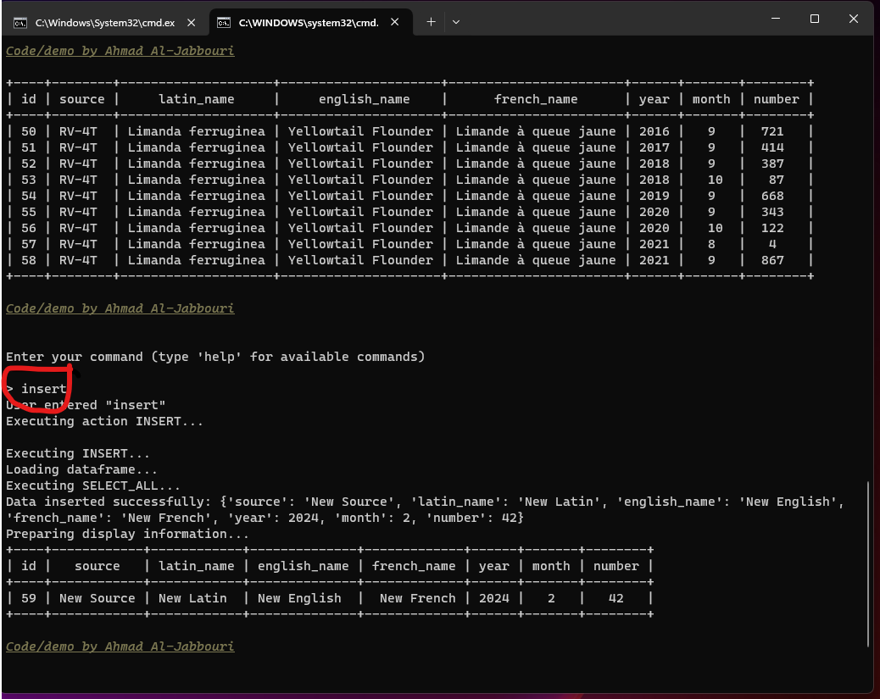Figure 5: Creating a record
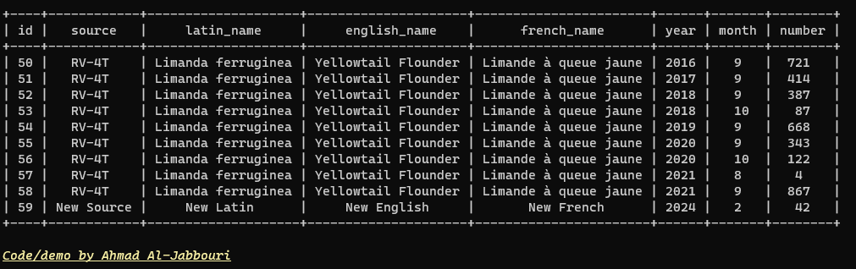Figure 6: Creating a record (continued)
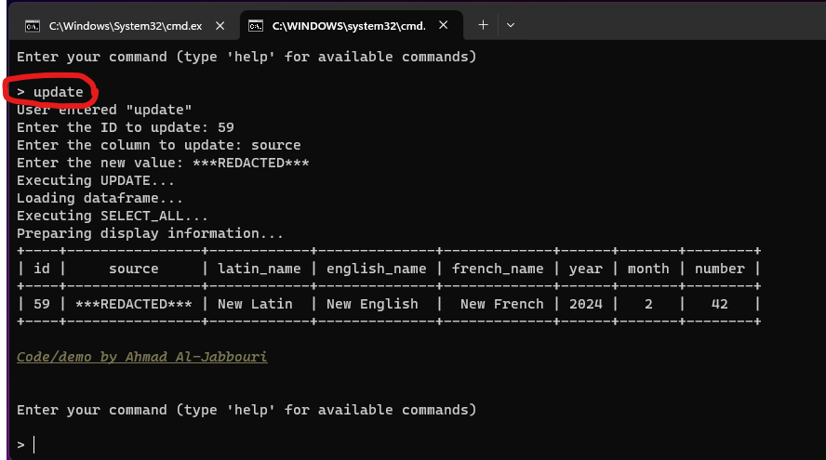Figure 7: Updating a record

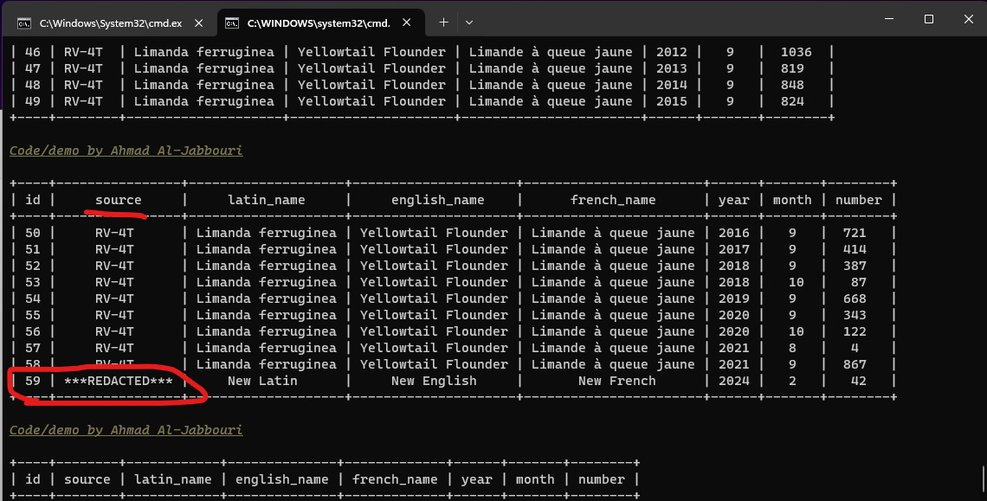Figure 8: Updating a record (continued)
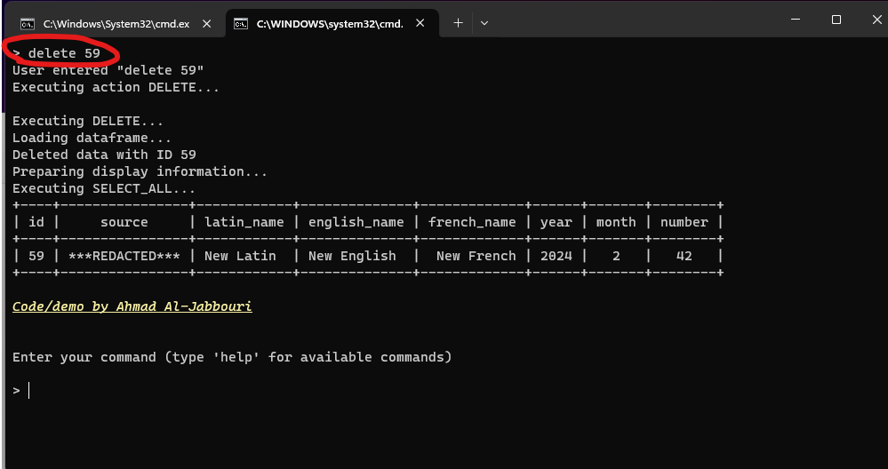Figure 9: Deleting a record
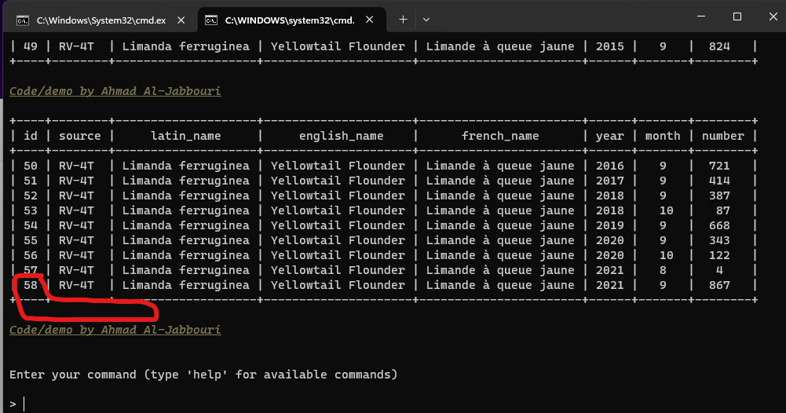Figure 10: Deleting a record (continued)

Source Code Commenting Example

launcher.py
# Code by Ahmad Al-Jabbouri

#todo This package requires to be at the top level lest all imports will fail!

from os import getcwd
from logging import info
from modules.my_module import *
from presentation.FishConsoleView import *

# get current path
current_path = getcwd()
info(f"Operating from: {current_path}")

# call consoleview
FishConsoleView.start() # loop
info("Program closed")

# signature
sign()
print(f"\033[2mSee logs at: {current_path}\\.log\033[0m\n")

282c34
Presentation layer
from logging import info, exception, error
from prettytable import PrettyTable
from logical.FishService import FishService
from modules.my_module import sign
from presentation.DisplayInfo import DisplayInfo

class FishConsoleView:
"""
Console view for interacting with FishService.
"""

MENU_TEXT = """
- SELECT <id> | * (displays table)
- INSERT (inserts dummy record)
- UPDATE <id> (launches update wizard)
- DELETE <id>
- exit (terminates program)
"""

@classmethod
def start(cls):
"""
Begin the console loop for user interaction.
"""
try:
exit = False
while not exit:
# os.system('cls')
user_input = input("\nEnter your command (type 'help' for available commands)\n\n> ")
info(f"User entered \"{user_input}\"")

processed_input = cls.process(user_input)
if processed_input.get("action") is not None:
exit = cls.execute_action(processed_input)
except:
exception("What happened?")

@classmethod
def process(cls, raw_input):
"""
Take raw input, refine it, and extract action and id where id could be null.
"""
action_set = {
"action": None,
"arg": None
}
try:
refined_input = raw_input.strip().lower().split()
action_set["action"] = refined_input[0]
action_set["arg"] = refined_input[1]
except IndexError:
if action_set["action"] is None:
error("\033[31mERROR: CANNOT BE EMPTY, SEEK HELP\033[0m")
else:
pass
except:
exception("ERROR: SEEK HELP") # Send exception info to both file AND console
finally:
return action_set

@classmethod
def execute_action(cls, action_set):
"""
Execute the action based on user input.
"""
exit = False
try:
action = action_set.get("action")
match action:
case "exit":
exit = True
case "help":
print(cls.MENU_TEXT)
case "update":
cls.prompt_update()
case _:
info(f"Executing action {action.upper()}...\n")
display_info = FishService.execute_action(action_set) # The only connection to FishService
cls.execute(display_info) # Either PrettyTable or string, both printable
except ValueError:
pass
except Exception as e:
exception("ERROR IN FishConsoleView.execute_action")
finally:
return exit

@classmethod
def execute(cls, display_info: DisplayInfo):
"""
Execute based on the display information.
"""
if display_info.is_table:
pt = display_info.pretty_table
row_count = display_info.row_count
i = 0
while True:
print(pt.get_string(start=i, end=i + 10))
sign()
if i > row_count - 10:
break
else:
i += 10

@classmethod
def prompt_update(cls):
"""
Prompt the user for input to update data.
"""
try:
index = input("Enter the ID to update: ")
column = input("Enter the column to update: ")
new_value = input("Enter the new value: ")

action_set = {"action": "update", "arg": index, "column": column, "new_value": new_value}
display_info = FishService.execute_action(action_set)
cls.execute(display_info)
except Exception as e:
exception("ERROR IN prompt_update")

@classmethod
def __str__(cls):
"""
String representation of the class.
"""
return f"{cls}"
from typing import Self
from prettytable import PrettyTable

class DisplayInfo:
def __init__(
self,
is_table: bool = True,
row_count: int = 0,
pretty_table: PrettyTable = None,
index: int = 0,
error: bool = False,
error_msg: str = "") -> Self:
"""
Initialize DisplayInfo object.

Parameters:
- is_table (bool): Indicates whether the data should be displayed as a table.
- row_count (int): Number of rows in the table.
- pretty_table (PrettyTable): PrettyTable object representing the tabular data.
- index (int): Index of the data.
- error (bool): Indicates if an error occurred.
- error_msg (str): Error message.

Returns:
- DisplayInfo: Instance of DisplayInfo.
"""
self.error: bool = error
self.error_msg: str = error_msg
self.is_table: bool = is_table
self.row_count: int = row_count
self.pretty_table: PrettyTable = pretty_table
self.index: int = index
# add more instructions for ConsoleView as needed
Logical layer
from typing import Union, Dict
from prettytable import PrettyTable
from model.Otolith import Otolith
from persistence.DataStore import DataStore
import logging

from presentation.DisplayInfo import DisplayInfo

class FishService:
"""
Service class for fish-related operations.

Attributes:
entity_map (Dict[int, Otolith]): A dictionary of key-values, where the key is an integer and the value is an Otolith.

Methods:
execute_action(action_set) -> DisplayInfo: Executes a fish-related action based on the provided action set.
select(index: Union[int, str]) -> DisplayInfo: Selects fish-related information based on the provided index.
insert() -> DisplayInfo: Inserts new fish-related data into the datastore.
update(index: int, column: str, new_val: Union[str, int]) -> DisplayInfo: Updates fish-related data in the datastore.
delete(index: Union[int, str]) -> DisplayInfo: Deletes fish-related data from the datastore.
prepare_display_info(data: Dict[int, Otolith]) -> DisplayInfo: Prepares display information for fish-related data.
"""

entity_map: Dict[int, Otolith] = DataStore.select_all()

@classmethod
def execute_action(cls, action_set) -> DisplayInfo:
"""
Executes a fish-related action based on the provided action set.

Args:
action_set (dict): A dictionary containing information about the action to be executed.

Returns:
DisplayInfo: An object containing information for display.
"""
try:
action = action_set.get("action").upper()
index = action_set.get("arg")
match action:
case "SELECT" | "GET":
return cls.select(index)
case "INSERT" | "ADD":
return cls.insert()
case "UPDATE" | "MOD":
col = action_set["column"]
new = action_set["new_value"]
return cls.update(index, col, new)
case "DELETE" | "DEL":
x = cls.delete(index)
cls.entity_map = DataStore.select_all()
return x
case _:
logging.error("\033[31mNO SUCH COMMAND, RETURN\033[0m")
return DisplayInfo(error=True, error_msg="\033[31mERROR\033[0m")
except Exception as e:
logging.exception("ERROR IN FishService.execute_action")

@classmethod
def select(cls, index: Union[int, str]) -> DisplayInfo:
"""
Selects fish-related information based on the provided index.

Args:
index (Union[int, str]): The index or identifier for the fish-related information.

Returns:
DisplayInfo: An object containing information for display.
"""
di = DisplayInfo()
try:
if index == '*':
di = cls.prepare_display_info(cls.entity_map)
elif index.isdigit():
index = int(index)
di = cls.prepare_display_info({index: cls.entity_map[index]})
else:
raise ValueError
except ValueError as ve:
logging.error(f"{index} IS NOT ACCEPTED AS ARGUMENT")
di = DisplayInfo(error=True)
except Exception as e:
logging.exception("ERROR IN select:" + e)
di = DisplayInfo(error=True)
finally:
return di

@classmethod
def insert(cls) -> DisplayInfo:
"""
Inserts new fish-related data into the datastore.

Returns:
DisplayInfo: An object containing information for display.
"""
try:
new_data = {"source": "New Source", "latin_name": "New Latin", "english_name": "New English",
"french_name": "New French", "year": 2024, "month": 2, "number": 42}

DataStore.insert([list(new_data.values())])
cls.entity_map = DataStore.select_all()

print(f"Data inserted successfully: {new_data}")
return cls.prepare_display_info({len(cls.entity_map) - 1: cls.entity_map[len(cls.entity_map) - 1]})
except Exception as e:
logging.exception("ERROR IN insert")
return DisplayInfo(error=True, error_msg=str(e))

@classmethod
def update(cls, index: int, column: str, new_val: Union[str, int]) -> DisplayInfo:
"""
Updates fish-related data in the datastore.

Args:
index (int): The index or identifier for the fish-related information.
column (str): The column to be updated.
new_val (Union[str, int]): The new value to be assigned.

Returns:
DisplayInfo: An object containing information for display.
"""
try:
if str(index).isdigit():
index = int(index)
DataStore.update(index, column, new_val)
cls.entity_map = DataStore.select_all()
return cls.prepare_display_info({index: cls.entity_map[index]})
else:
raise ValueError("Invalid index format")
except ValueError as ve:
logging.error(f"{index} IS NOT ACCEPTED AS ARGUMENT")
return DisplayInfo(error=True)
except Exception as e:
logging.exception("ERROR IN update:" + str(e))
return DisplayInfo(error=True, error_msg="Error in update")

@classmethod
def delete(cls, index: Union[int, str]) -> DisplayInfo:
"""
Deletes fish-related data from the datastore.

Args:
index (Union[int, str]): The index or identifier for the fish-related information.

Returns:
DisplayInfo: An object containing information for display.
"""
try:
index = int(index)
if index is not None:
DataStore.delete(index)
print(f"Deleted data with ID {index}")
return cls.prepare_display_info({index: cls.entity_map[index]})
else:
print("Please provide an ID for deletion.")
return DisplayInfo(error=True, error_msg="Please provide an ID for deletion.")
except Exception as e:
logging.exception("ERROR IN delete")
return DisplayInfo(error=True, error_msg=str(e))

@classmethod
def prepare_display_info(cls, data: Dict[int, Otolith]) -> DisplayInfo:
"""
Prepares display information for fish-related data.

Args:
data (Dict[int, Otolith]): A dictionary containing fish-related data.

Returns:
DisplayInfo: An object containing information for display.
"""
logging.info("Preparing display information...")

pt = PrettyTable()
pt.field_names = ["id"] + list(data.values())[0].get_fields()

count = 0
for key, otolith in data.items():
pt.add_row([key] + otolith.get_attributes())
count += 1

return DisplayInfo(
is_table=True,
row_count=count,
pretty_table=pt
)
Persistence layer
# Code by Ahmad Al-Jabbouri

import configparser
from logging import info, exception, error, debug
import os
from typing import *
import pandas as pd
from model.Otolith import Otolith

class DataStore():
"""
A class representing a data store.

Attributes:
- CURRENT_PATH (str): The current working directory.
- DATA_SOURCE (str): The path to the CSV file as the data source.
- DATA_FIELDS (List[str]): Aliases for fields.
- MAX_ROWS (int): The maximum number of rows to display.
- dataframe (pd.DataFrame): The DataFrame containing the data.
"""

CURRENT_PATH: str = os.getcwd()
DATA_SOURCE: str = None
DATA_FIELDS: List[str] = None # aliases for fields
MAX_ROWS: int = 100
dataframe: pd.DataFrame = None

@classmethod
def load_dataframe(cls) -> None:
"""
Load DataFrame from the CSV file.
"""
info("Loading dataframe...")
if cls.DATA_SOURCE is None:
cls.connect_database()
pd.options.display.max_rows = cls.MAX_ROWS # Will not display more than 100 records
cls.dataframe = pd.read_csv(cls.DATA_SOURCE)
cls.DATA_FIELDS = list(cls.dataframe.columns)

@classmethod
def connect_database(cls) -> None:
"""
Connect to the data source.
"""
try:
config = configparser.ConfigParser()
config.read('config.ini')
cls.DATA_SOURCE = config.get('database', 'csv_path')
except FileNotFoundError:
error("\033[31mconfig.ini NOT FOUND! Place one next to launcher.py\033[0m")
except:
exception("\033[31mERROR: Something went wrong attempting to read [database] from config.ini\033[0m")
else:
info(f"\033[92mCONNECTED TO DATABASE\033[0m: {cls.CURRENT_PATH}\\{cls.DATA_SOURCE}")

@classmethod
def select_all(cls) -> Dict[int, Otolith]:
"""
Execute SELECT_ALL operation.

Returns:
- Dict[int, Otolith]: A dictionary containing selected data.
"""
try:
info("Executing SELECT_ALL...")
if cls.dataframe is None:
cls.load_dataframe()
dataset = {}
for i in range(len(cls.dataframe.index)):
dataset[i] = cls.select(i)
return dataset
except Exception as e:
exception(e)

@classmethod
def select(cls, index: int) -> Otolith:
"""
Execute SELECT operation.

Parameters:
- index (int): The index of the data to select.

Returns:
- Otolith: An instance of the Otolith class.
"""
try:
debug("Executing SELECT...")
series = cls.dataframe.loc[index]
return Otolith(
source=series.loc[cls.DATA_FIELDS[0]],
latin_name=series.loc[cls.DATA_FIELDS[1]],
english_name=series.loc[cls.DATA_FIELDS[2]],
french_name=series.loc[cls.DATA_FIELDS[3]],
year=series.loc[cls.DATA_FIELDS[4]],
month=series.loc[cls.DATA_FIELDS[5]],
number=series.loc[cls.DATA_FIELDS[6]]
)
except Exception as e:
pass

@classmethod
def insert(cls, data: List[List]) -> None:
"""
Execute INSERT operation.

Parameters:
- data (List[List]): The data to be inserted.
"""
try:
info("Executing INSERT...")
new_df = pd.DataFrame(data, columns=list(cls.dataframe.columns))
cls.dataframe = pd.concat([cls.dataframe, new_df])
cls.dataframe.to_csv(cls.DATA_SOURCE, index=False)
cls.load_dataframe()
except Exception as e:
pass

@classmethod
def update(cls, index: int, column: str, new_val: Union[str, int]) -> None:
"""
Execute UPDATE operation.

Parameters:
- index (int): The index of the data to be updated.
- column (str): The column to be updated.
- new_val (Union[str, int]): The new value to set in the specified column.
"""
try:
info("Executing UPDATE...")
cls.dataframe.loc[index, column] = new_val
cls.dataframe.to_csv(cls.DATA_SOURCE, index=False)
cls.load_dataframe()
except Exception as e:
pass

@classmethod
def delete(cls, index: int) -> None:
"""
Execute DELETE operation.

Parameters:
- index (int): The index of the data to be deleted.
"""
try:
info("Executing DELETE...")
cls.dataframe = cls.dataframe.drop(index)
cls.dataframe.to_csv(cls.DATA_SOURCE, index=False)
cls.load_dataframe()
except Exception as e:
pass
Model : Otolith
from typing import List

class Otolith:
"""
Represents an otolith.

Attributes:
source (str): The source of the otolith data.
latin_name (str): The Latin name of the fish.
english_name (str): The English name of the fish.
french_name (str): The French name of the fish.
year (int): The year of the otolith data.
month (int): The month of the otolith data.
number (int): The number of otoliths.

Methods:
__str__(): Returns a formatted string representation of the DTO.
"""
def __init__(self, source: str, latin_name: str, english_name: str, french_name: str, year: int, month: int, number: int):
"""
Initializes an Otolith instance with the provided attributes.
"""
self.source = source
self.latin_name = latin_name
self.english_name = english_name
self.french_name = french_name
self.year = year
self.month = month
self.number = number

def get_attributes(self) -> List:
"""
Returns a list of attribute values.

Returns:
List: A list containing attribute values.
"""
return list(vars(self).values())

def get_fields(self) -> List:
"""
Returns a list of attribute names.

Returns:
List: A list containing attribute names.
"""
return list(vars(self).keys())

def __str__(self) -> str:
"""
Returns a formatted string representation of the DTO.

Returns:
str: A string representation of the DTO.
"""
return f"Otolith(source={self.source}, latin_name={self.latin_name}, " \
f"english_name={self.english_name}, french_name={self.french_name}, " \
f"year={self.year}, month={self.month}, number={self.number})"

All code presented is original and my own.

