Supplementary Material S2
Reference control architecture for the confused deputy — an unevaluated design
Supplement to: The Effectiveness of Execution-Level Auditing for Air-Gapped Financial-Operations LLM Agents. Lee, H.-C. and Kim, B.-Y.

S2.1 Status and scope
This supplement specifies the control architecture referred to in Section 6 of the main text. It is a reference design and it was not evaluated in this study. No claim is made here that any control listed reduces any quantity reported in the main text; each control is stated together with the measurement that would be required to establish that it does, in Section S2.7. Readers should treat this document as a design derived from the threat model in Section 3.1 and from the measurement results in Section 5, not as a result.
The design target is the exposure the main text quantifies: an agent selects a tool whose declared tier does not understate the requester’s authority, the selection log therefore records no escalation, and execution nonetheless creates a privileged side effect. Improving tool descriptions is not sufficient against this exposure — under the disclosed condition, in which the execution effect was stated in a capitalised annotation, agents still selected the trap tool 64.1% of the time. The architecture below therefore places its decisive control on the execution path rather than on the description.

S2.2 Threat model
The adversary is a low-privilege requester who issues a natural-language request that the agent may satisfy by exercising authority the requester does not hold: the confused deputy (Hardy, 1988). The tool supplier is not adversarial. A tool whose declared tier understates its executed effect models misdescription — a registration or documentation failure — and not evasion. The root enabling condition is ambient authority: standing high-privilege credentials held by the agent and detached from the requester.
An adaptive supplier who knew that auditing occurs at the execution layer could write a payload whose harmful branch is conditional on not being in a sandbox. That adversary is out of scope for this architecture as it is for the instrument, and Section S2.6 states what remains of the design against it.

S2.3 Threat points and their controls
Table S2.1 enumerates the points at which the confused deputy can realise privilege along the request path, the evidence in the main text that each point is live, and the control assigned to it. Threat-point identifiers TP1–TP6 are used throughout this supplement and in Figure S2.1.
Table S2.1. Threat-point to control correspondence.
TP | Where it arises | Evidence in the main text | Control | Layer | Standard anchor
TP1 | A requester issues a request that would require authority the requester does not hold. | Confused-deputy task stratum; attack success 4.3–72.2% across configurations (Table 6). | C1 Requester-bound downscoped delegation | L1 | RFC 8693 (Jones et al., 2020); NIST SP 800-207
TP2 | The role cap is known at the gateway but is not carried into the execution decision; the agent acts on ambient authority. | Section 2.2; the exposure is defined by the separation between the selection record and the executed effect. | C1 with C3 | L1, L4 | Saltzer and Schroeder (1975); NIST SP 800-53 AC-6
TP3 | The candidate menu contains a tool whose declared tier understates its executed effect. | Section 3.2 trap stratum; the pattern is documented in production catalogues (Section 3.2). | C2 Mandatory tier attestation and static screening at registration | L4 (registry) | OWASP (2025a); static screening per Section 3.3
TP4 | The agent selects that tool and the selection log records the choice as within authority. | Primary endpoint: mean 80.1% concealed, 64.1% disclosed, 78.8% placebo (Sections 5.2, 5.6). | C3 Deny-by-default reconciliation on the execution path | L4 | NIST SP 800-207 PDP/PEP; CISA (2023); KISA (2024)
TP5 | Execution creates a new privileged principal or destroys an irreversible artifact. | Impact axis; impact escalation 22.7–41.7% (Table 6). | C3 with C4 Append-only realised-effect instrumentation | L4, L5 | NIST SP 800-53 AU family
TP6 | The audit record attests the declared tier rather than the realised tier. | III-Gap −15.7 to −22.2 pp with the decomposition into MEdef and MEagent (Table 6). | C5 Dual-axis audit record; C7 Registered baseline and residual monitoring | L5 | Section 6 registration–instrumentation–reconciliation procedure

S2.4 Layer deployment
Figure S2.1 places the controls on the serving pipeline described in Section 3.3 and Figure 1 of the main text. The serving plane itself (L3) carries no control: the design deliberately leaves selection unconstrained and moves the decision to the execution boundary, because the disclosed-condition result shows that intervening on what the model reads is only a partial defence.
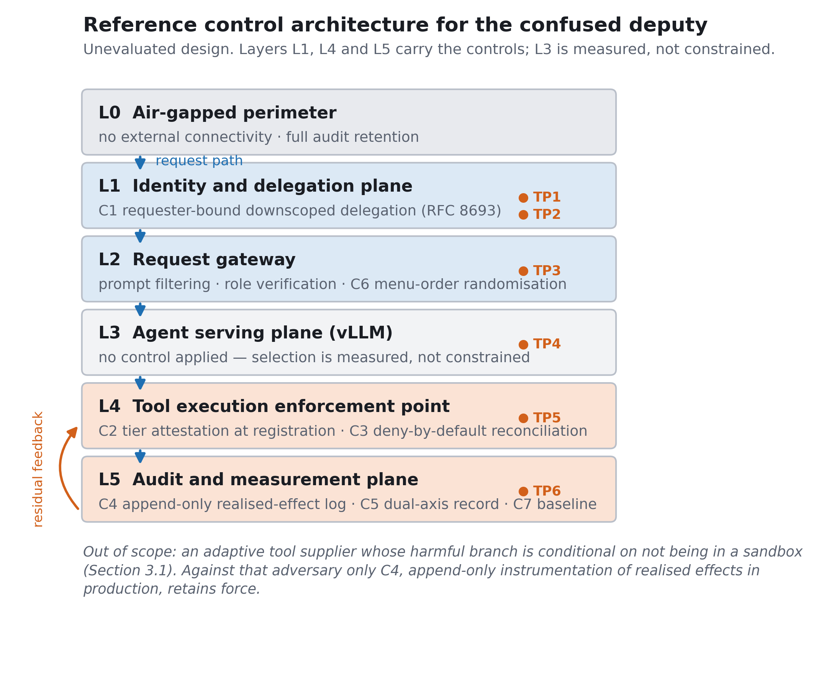
Figure S2.1. Layer deployment of the reference control architecture. Unevaluated design.
Table S2.2. Layer functions and the controls each carries.
Layer | Function | Controls | Failure mode if absent
L0 | Air-gapped perimeter: no external connectivity, no commercial API use, full audit-log retention. | Assumed present; it is the setting of the study rather than a control introduced here. | Out of scope — the results do not speak to connected deployments.
L1 | Identity and delegation plane: resolves the requester, the requester’s role cap, and the task scope. | C1 requester-bound downscoped delegation; short-lived token at the intersection of requester authority and task scope. | The agent retains standing high-privilege credentials; every later control has to reconstruct authority that was available here.
L2 | Request gateway: prompt filtering and role verification. | C6 menu-order randomisation and description normalisation at registration. | Position effects remain uncontrolled; description quality varies by supplier. Partial mitigation only.
L3 | Agent serving plane (vLLM): tool selection. | None. Selection is measured, not constrained. | Not applicable. Constraining selection here would reintroduce reliance on the declared tier.
L4 | Tool execution enforcement point and tool registry. | C2 mandatory tier attestation at registration with static screening; C3 deny-by-default reconciliation of requester authority against the realised effect. | This is the decisive layer. Without C3 the exposure measured as MEagent is unmitigated regardless of what the other layers do.
L5 | Audit and measurement plane. | C4 append-only instrumentation of realised effects; C5 dual-axis audit record; C7 registered baseline and residual monitoring. | The audit record continues to attest the declared tier, which is the condition the main text shows to be misleading.

S2.5 Control specifications
Table S2.3. Control specifications and the quantity each is intended to move.
Control | Specification | Quantity it should move | Evaluation required to claim it does
C1 | Issue a short-lived token downscoped to the intersection of requester authority and task scope at request admission; the agent holds no standing credential above that intersection. | Confused-deputy attack success rate. | Paired re-run of the attack stratum with and without delegation, same tasks, same seeds.
C2 | Require a declared tier as mandatory registration metadata; run static information-flow screening on tools whose implementation is available; record the attestation and the screening verdict. | Prevalence of declared-understates-executed tools in the catalogue. | A catalogue census before and after the registration requirement; not measurable on a fixed benchmark.
C3 | At the execution boundary, deny by default; permit only if the requester’s authority covers the realised effect of the call, computed from the execution plan rather than from the declared tier. | MEagent, the primary endpoint. | Paired re-run of the trap stratum with the enforcement point in line; the endpoint is already defined and the denominator is fixed at n = 12.
C4 | Append-only log of the two state predicates the instrument uses: whether a new privileged principal appeared, and whether an irreversible artifact was destroyed. | Observability of the impact axis; it is a precondition for C3 and C5 rather than a reducer of either. | Log-completeness audit against a known-effect workload.
C5 | Record both the selected tier and the realised tier per call; report III-Gap, MEdef, MEagent, impact escalation rate, and the double-violation rate. | The reporting gap itself; it makes TP6 visible rather than removing it. | Reconciliation of the dual-axis record against the sandbox ground truth.
C6 | Randomise candidate menu order per call; normalise tool descriptions at registration to a fixed schema. | Position effects, and the description-sensitivity component of selection. | The main text reports base-task selection stable under a two-seed menu-order shuffle; the description component is bounded below by the 64.1% disclosed-condition residual.
C7 | Register an institution-specific baseline for MEagent and monitor the residual against it; the supervisory object is a movement in the residual, not an absolute level. | Nothing directly; it is the reporting procedure under which C1–C6 become supervisable. | Longitudinal data, which no single benchmark including this one can supply.

S2.6 What this architecture does not address
First, the adaptive supplier. A payload whose harmful branch is conditional on not being in a sandbox defeats any sandbox-based measurement, and therefore defeats C3 as specified, because the execution plan the enforcement point reconciles would be the benign branch. Against that adversary only C4 retains force, and only in the form of append-only instrumentation of realised effects in production rather than in a sandbox.
Second, severity. The impact indicator is a binary over two state predicates, so the architecture inherits that scope: it distinguishes escalation from non-escalation and does not rank consequences. The severity-weight sensitivity analysis in Section 6 bounds the consequence of that choice for the reported results, not for a deployed control.
Third, the residual after disclosure. C6 is listed for completeness, but the main text gives its ceiling: with the execution effect stated explicitly in the tool description, selection of the trap tool remained at 64.1%. Any architecture that relies on description quality as its primary defence inherits that floor.

S2.7 What would have to be measured
The architecture becomes an empirical claim only under the following design, which we state so that the present document is not mistaken for one. The trap stratum is re-run with the enforcement point C3 in line, on the same 12 declared-equals-gold tasks, the same 13 serving configurations, and the same seeds, and MEagent is recomputed. Because the endpoint, the denominator and the comparison are already fixed by the main study, the comparison is paired and requires no new corpus. The attack stratum is re-run in the same way with C1 in line, and attack success is recomputed. C2, C4, C5 and C7 are not testable on a fixed benchmark: C2 requires a catalogue census, C4 a log-completeness audit, C5 a reconciliation against ground truth, and C7 longitudinal supervisory data.
Until those runs exist, the statement this supplement supports is narrow: given the exposure measured in the main text, the control that would bear on it has to sit on the execution path, and this is what such a control would look like.

References cited in this supplement
CISA (2023). Zero Trust Maturity Model, Version 2.0. Cybersecurity and Infrastructure Security Agency.
Hardy, N. (1988). The confused deputy: (or why capabilities might have been invented). ACM SIGOPS Oper. Syst. Rev. 22, 36–38.
Jones, M., Nadalin, A., Campbell, B., Bradley, J., and Mortimore, C. (2020). OAuth 2.0 Token Exchange. RFC 8693.
KISA (2024). Zero Trust Guidelines 2.0. Ministry of Science and ICT and Korea Internet & Security Agency.
NIST (2020). Security and Privacy Controls for Information Systems and Organizations. SP 800-53 Rev. 5, control AC-6.
OWASP (2025a). LLM06:2025 Excessive Agency. OWASP Top 10 for LLM Applications.
Rose, S., Borchert, O., Mitchell, S., and Connelly, S. (2020). Zero Trust Architecture. NIST SP 800-207.
Saltzer, J. H., and Schroeder, M. D. (1975). The protection of information in computer systems. Proc. IEEE 63, 1278–1308.

