User manual

Spek10 version 1.0

Created by
Dag Robøle and Jon Drefvelin

NRPA 2011

Getting started 4
Installing the software 4
Using Spek10 6
Preparing the environment 6
Administration 6
System configuration 7
Default nuclide library and default detection limit library 7
Default QA background and default QA reference nuclide library 7
Use default printer if available 7
Maestro 7
Maestro setup 8
Job scripts 9
Genie 9
Genie setup 10
Beaker configuration 11
Create new beaker 12
Name 12
Radius and Height 12
Marinelli beaker 13
Inner radius and Inner height 13
Min. fill height and Max. fill height 13
Manufacturer 13
Comment 13
Detector configuration 13
Name 14
Software 14
Type 14
Active 14
Connected 14
Maestro ID 14
Record length 14
Channel count 14
Comment 14
Format 15
FWHMPS 15
FWHMAN 15
ICA (ECAL) 15
BSTF 15
ETOL 15
LOCH 15
ENFILE 15
BKGFILE 15
Beaker and Pef/Tef 15
Defining the default energy file 15
Defining the default background file 16
Create dummy detector 16
Main menu 16
Operating the detectors 16
Starting a measurement 17
Density and volume 18
Stopping a measurement and running the analysis 19
Running the analysis without stopping the measurement 20
Using the Archive 21
Show history 21
Search archive 21
Create journal 22
Reanalyse 22
Show LIS 22
Show INP 22
Show Spectrum 22
Print Analysis 23
Create background 23
Log 24
Appendix: 24
Appendix 1: Importing old analysis data from spek.exe 24
Appendix 2: Run fixchn.exe in each spectrum folder 24
Appendix 3: Dummy detector 25
Appendix 4: Analysing an external spectrum 26
Appendix 5: Sample input parameters 26
Detector 26
Year 27
Spectrum nr. 27
Sample Id/Type 27
Sample place 27
Beaker 27
Height (mm) 27
Weight (g) 27
Quantity 27
Quantity uncertainty 27
Quantity unit 27
Sampling start 27
Sampling stop 27
Comment 27
Reference time 28
Nuclide library 28
Detection limit lib. 28

Getting started

Installing the software
Double-click on the Spek10.msi file to start the installation, and follow the instructions.

The software is dependent on Microsoft .NET Framework 4.0, and you will be asked to install this if it is not already installed on the computer. This package should natively be part of Windows 7 and newer.

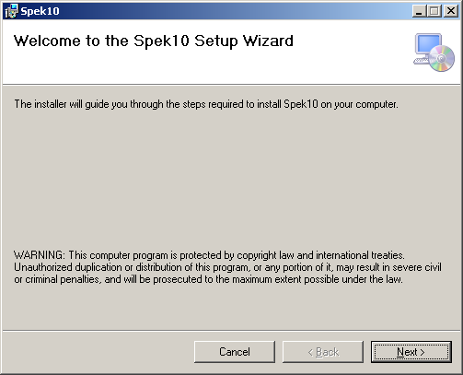
Figure 1: Installation screen 1

Click Next.

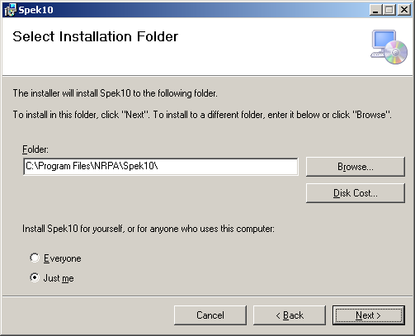
Figure 2: Installation screen 2

Select the installation folder, and click Next.

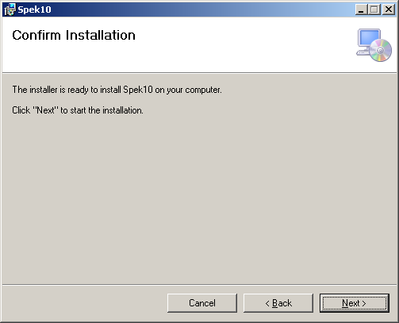
Figure 3: Installation screen 3

Click Next.

The installation starts.

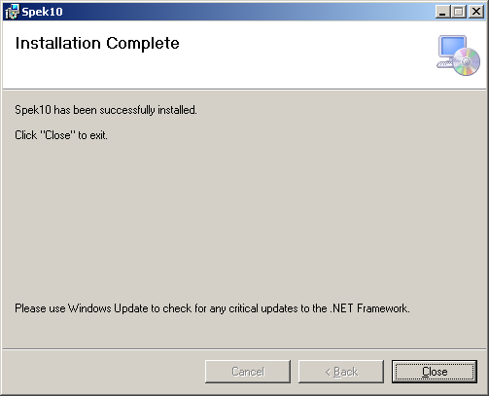
Figure 4: Installation screen 4

Click Close to exit the installation procedure.

After installation, the SPEK10 software is accessible from the Windows Start menu under the folder NRPA.

Using Spek10

Preparing the environment

The first time Spek10 is started it will ask the user to select a folder where the program will store spectrum data.

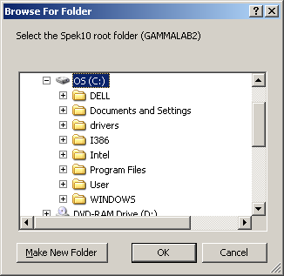
Figure 5: Select the Spek10 root directory

Select or create a new empty folder for this purpose.

Note: This directory should not be the same directory used by the old spec software.

Once spek10 has started, the following directories are created under the new directory.
BIN, CFG, LOG, SPEC

To import LIB, BGR, PEF and TEF files from the old spec software, copy these files to the BIN directory.

To import Spectrum files from the old spec software, see Appendix 1.

Administration
The administration menu is available by clicking File and then Administration. Note that this section of the software should only be accessed by operators who have the proper competence.

The administration window has 5 tabs. These are System configuration, Detector configuration, Beaker configuration, Maestro and Genie. Each sub-window is described separately in this section.

System configuration

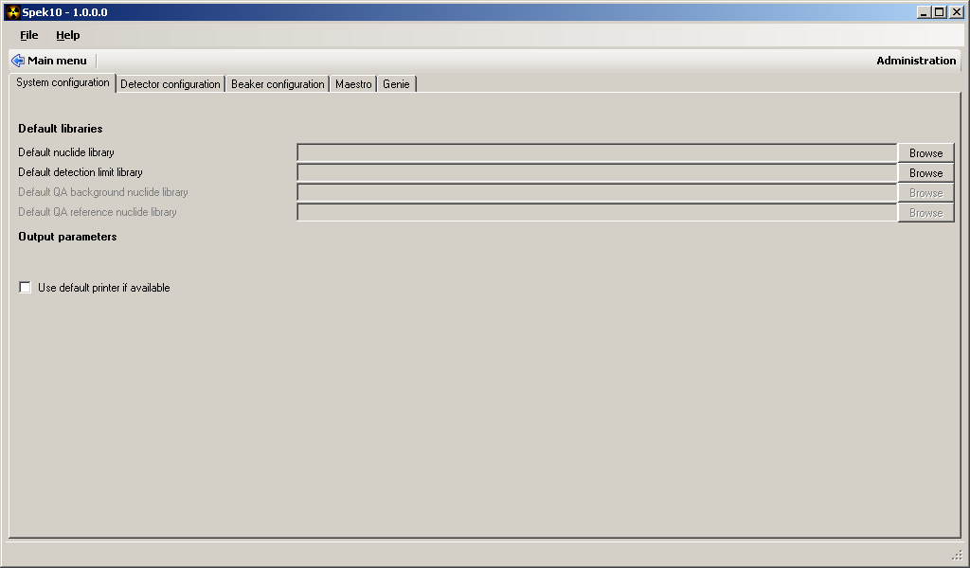
Figure 6: System configuration window

The System configuration window gives the operator the opportunity to change the basic settings for the software environment and the common settings for all the detectors.

Default nuclide library and default detection limit library
These fields define the default nuclide library and detection limit library to be used for all detectors in the system.

Default QA background and default QA reference nuclide library
Not implemented yet.

Use default printer if available
This is a checkbox for selecting whether the default printer (set in Windows) is to be used for printing purposes. If this is not checked, the operator will get the opportunity to select the printer manually.

Maestro

If Spek10 is not to be used with Maestro, the rest of this chapter can be ignored.

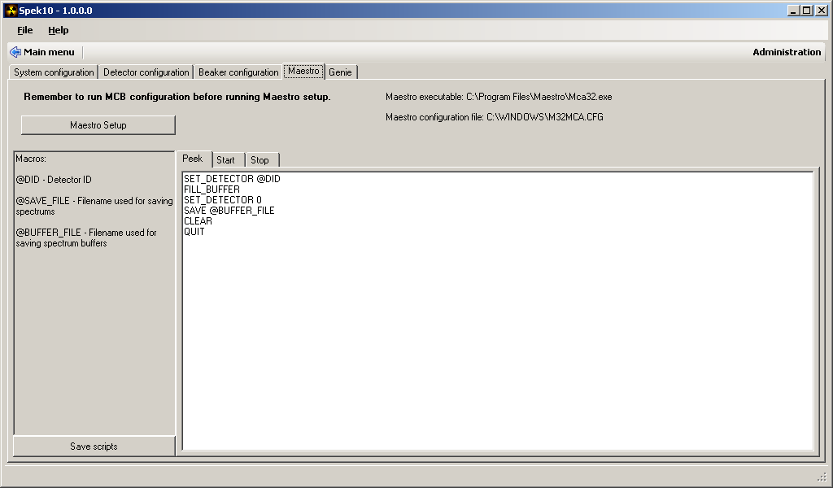
Figure 7: Maestro tab

Maestro setup
If the Maestro software is not already installed on the computer, install it before continuing. If the detectors are not already configured in Maestro, this must also be done.
See the Maestro manuals on how to define and configure detectors.

Note: Detectors used by Spek10 must have a unique two-character name (G1, G2 ….)

Run the Maestro program once after MCB configuration to update the configuration files.
This must be done after any changes to the hardware settings, so that the configuration files are updated with the latest changes.

After running the Maestro configuration programs described above click the button Maestro setup to start the setup. This setup will try to locate the Maestro executable file and the Maestro configuration file. If any of these files are not found in their default locations, the user will be asked to select them manually.

If any new detectors are detected during setup, the user will be asked to fill in the default detector parameters.

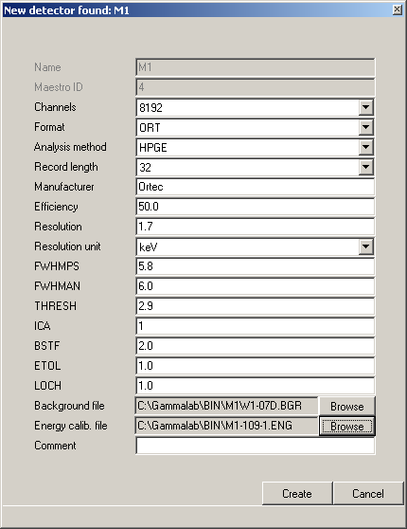
Figure 8: Defining default parameters for a detector

See the chapter Detector configuration for a detailed description of the parameters.

If any changes have been made to either the hardware or the Maestro configuration, this setup must be re-run to update Spek10.

Job scripts
Job scripts are used to instruct Maestro to do specific operations. The software uses three different job scripts for Maestro. These are Buffer (peek), Start and Stop. The specific texts in the job scripts are editable, but should only be done by operators with proper competence.

If changes are made to the scripts, make sure to press the Save button before exiting, or else the changes will be lost.

Genie

If Spek10 is not to be used with Genie, the rest of this chapter can be ignored.

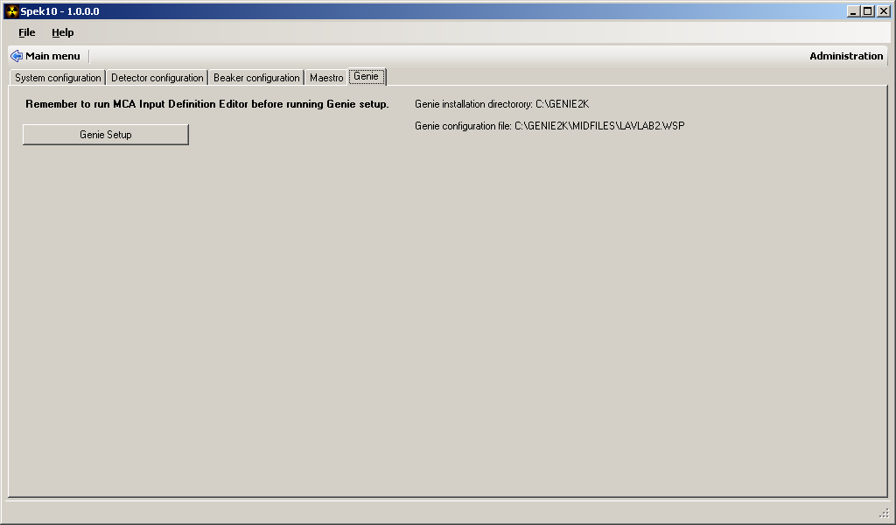
Figure 9: Genie tab

Genie setup
If the Genie software is not already installed on the computer, install it before continuing. If the detectors are not already configured in Genie, this must also be done.
See the Genie manuals on how to define and configure detectors.

Note: Detectors used by Spek10 must have a unique two-character name (G1, G2 ….)

The Genie Setup button will start the setup to detect any Genie installations and configurations.
This setup will try to locate the Genie installation folder. If this folder is not found in the default location, the user will be asked to select it manually.

If any new detectors are detected during setup, the user will be asked to fill in the default detector parameters.

Figure 10: Defining default parameters for a detector

See the chapter Detector configuration for a detailed description of the parameters.

If any changes have been made to either the hardware or the Genie configuration, this setup must be re-run to update Spek10.

Beaker configuration
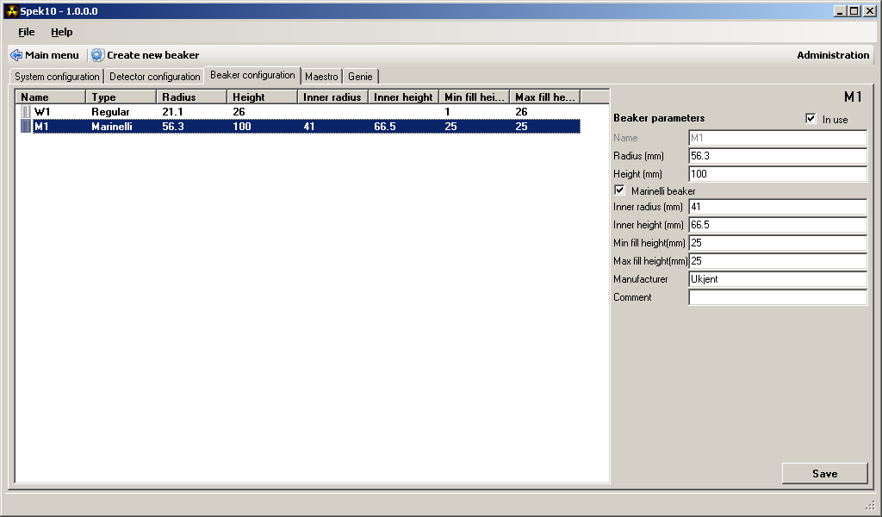
Figure 11: Beaker configuration window

This window gives the operator the opportunity to edit existing beaker configurations. Choose the beaker to be edited from the pick list, edit the fields in the right panel and click Save.

Note that when selecting Beaker configuration, the top menu changes to the one shown in figure 12.

Figure 12: Beaker configuration menu

Create new beaker
Clicking the Create new beaker button will trigger the window shown in figure 13.

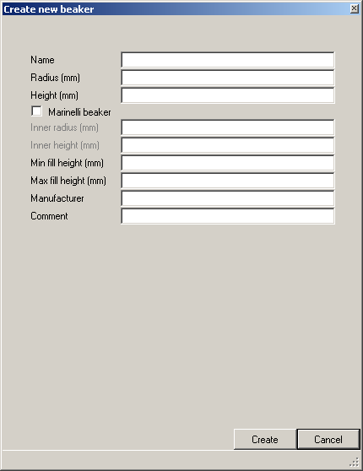
Figure 13: Create new beaker

This option is used to add new beakers to the system.

Name
The name of the beaker must be exactly 2 characters long.

Radius and Height
Radius and Height describes the inner radius and height of the beaker. These values will be used in the volume and density calculation which again will affect the activity calculations.

Marinelli beaker
A checkbox indicating if this is a Marinelli or a regular beaker.

Inner radius and Inner height
Inner radius and inner height is the same as Radius and Height mentioned above, except that it describes the inner measurements of a Marinelli beaker. These values will be used in the volume and density calculation which again will affect the activity calculations.

Min. fill height and Max. fill height
Min. fill height and Max. fill height can be set by the operator according to their wish, but Max. fill height cannot be greater than the value Height (mm). These values will be used to check that the sample input fill height is within the accepted limits.

Manufacturer
This field is required and should contain the name of the beaker manufacturer. The operator can choose an identifier freely, as this field does not affect the analysis.

Comment
This field is optional and does not affect the analysis.

Detector configuration

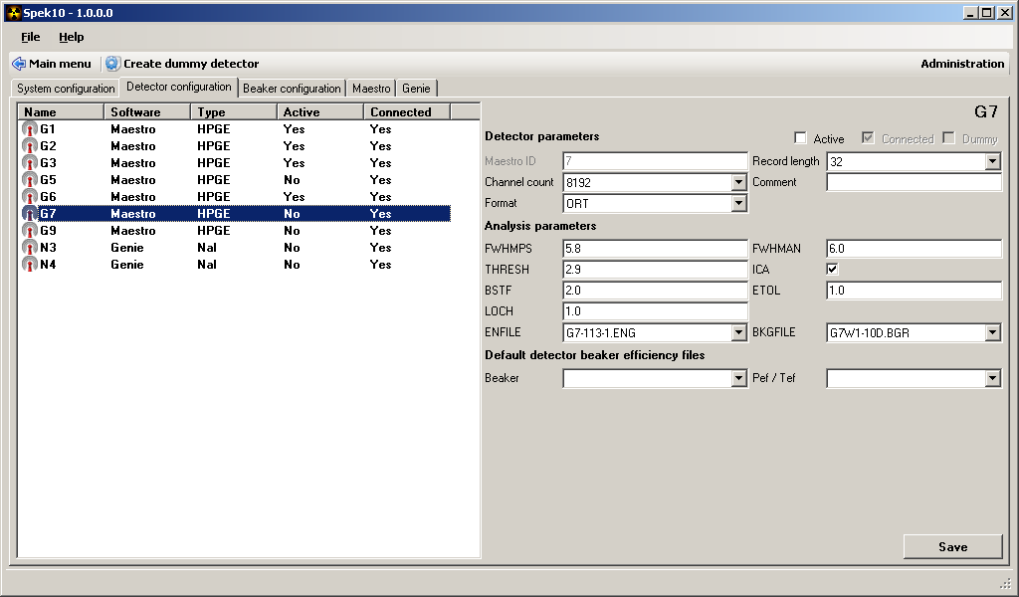
Figure 14: Detector configuration

The detector configuration window gives the operator the opportunity to change the default settings for each of the defined detectors in Spek10. To change any settings, first choose the detector from the list, and the default parameters will appear on the screen.
Remember to click the Save button to store the changes.

In the detector pick list there are 5 different parameters.

Name
This field displays the name of the detector.

Software
This field shows the software used by the detector.

Type
This field shows whether the detector is defined as an HPGe or a NaI detector. The software uses the program Gamma.exe to analyse the spectrum, and this program only works with HPGe spectrums. NaI analysis may be included later.

Active
This field shows whether the current detector is busy with an analysis or ready to start an analysis. This checkbox can be toggled by the operator if the detectors state is not in sync with Spec10.

Connected
This field indicates whether or not the detector is currently connected to the system. Old detectors that are removed from the system will show in this pick list, but for these detectors the Connected field will read No.

The right side of the screen shows all the default parameters for the detector chosen from the pick list.

Maestro ID
This field shows the detector ID for Maestro detectors. For Genie this field should be ignored.

Record length
This is the number of bits allocated for each channel in the spectrum. For CHN spectrum files this should be set to 32.

Channel count
This is the number of channels in the spectrum. Set this to 8192 for HPGe detectors.

Comment
This is an optional comment for each detector.

Format
This is the file format of the spectrum file. This should be set to Ortec (ORT).

FWHMPS
Full width half maximum peak search. This value is used when gamma10.exe is searching for peaks.

FWHMAN
Full width half maximum analysis. This value is used when gamma10.exe calculates the integration width.

ICA (ECAL)
Toggle energy calibration on/off.

BSTF
Base stiffness. The stiffness parameter of the background.

ETOL
Energy tolerance for nuclide identification.

LOCH
Low channel. Start channel for the analysis.

ENFILE
Energy calibrations file for the detector.

BKGFILE
The background file for the detector.

Beaker and Pef/Tef
Not all detectors are calibrated for all the beakers available. In this field the operator can assign beakers and the corresponding peak and total efficiency files (pef/tef) to the selected detector. Simply select the detector then the beaker and then what pef/tef files to use. Remember to click Save.

Note: The files described above are detected by Spek10 when it starts. If new files are added while Spek10 is running, the program must be restarted.

Defining the default energy file
In this field the operator may set the default energy file to be used with the detector. This file will then be used every time a new measurement is started. It does not change the energy file used by the previous analysis.

Defining the default background file
In this field the operator may set the default background file to be used with the detector. This file will then be used every time a new measurement is started. It does not change the background file used by previous analysis.

Note that when the Detector configuration tab is selected, the menu on top of the screen changes to the one shown in figure 15.

Figure 15: Detector configuration menu

Create dummy detector
The button Create dummy detector gives the operator the opportunity to create a non-existing detector, see Appendix 3.

Main menu
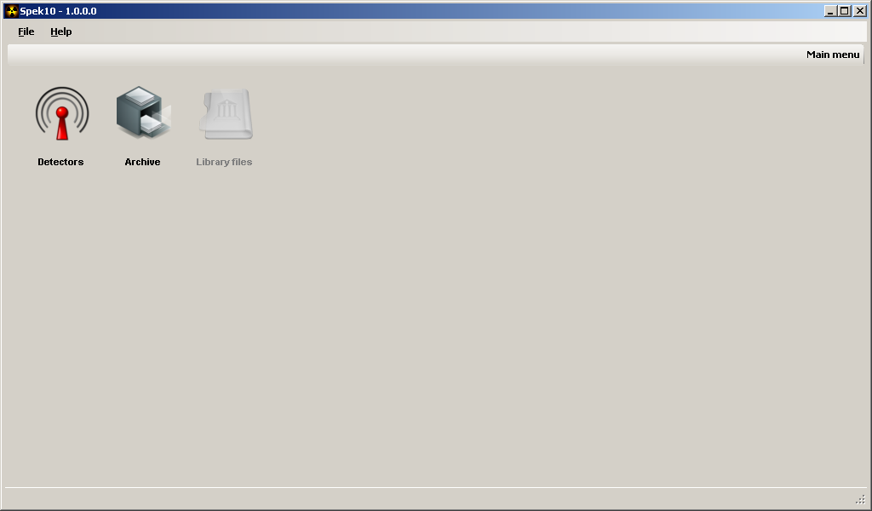
Figure 16: Main menu

The Main menu consists of 3 icons, Detectors, Archive and Library files. The last one has not yet been implemented in the software and will appear as an inactive icon.

Operating the detectors
Clicking on the icon Detectors will give the operator the opportunity to choose one of the detectors installed on the system.

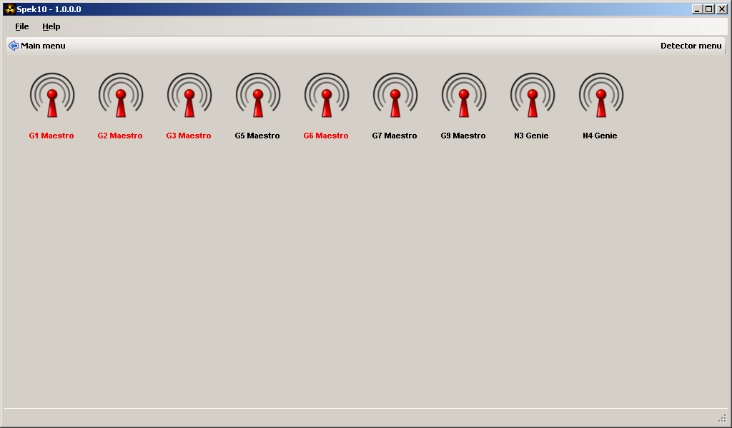
Figure 17: Detector menu

The colour of the icon text indicates if the detector is running or stopped. Red means that the detector is running. Black means that the detector is stopped. The text also indicates if the software used by the detector is Maestro or Genie.

Starting a measurement
Before starting the first measurement, edit the file BIN\Labinfo.$$$, and update the laboratory name. The laboratory name is set to “Østerås” as default.
Also make sure to read Appendix 1.

Clicking on one of the detector icons shown in figure 17 will display the sample input window.

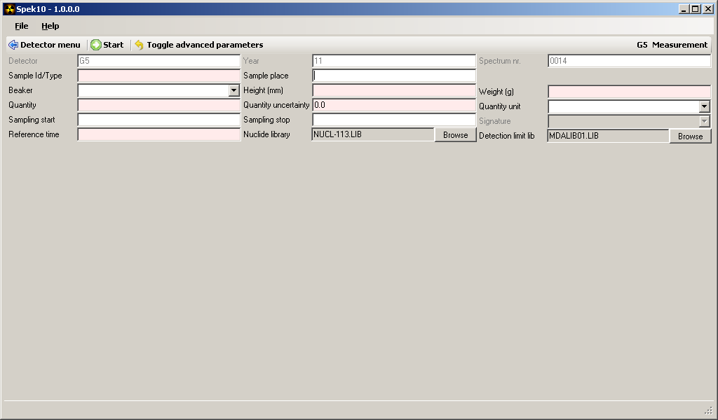
Figure 18: Sample data input screen

Clicking Toggle advanced parameters will display the default detector parameters and presets for the selected detector. These parameters are usually not necessary to adjust.
Inactive preset fields are not yet implemented.

Density and volume
The fields Density and Volume on the bottom on the Advanced parameters page are by default set to blank. If the operator starts the measurement without filling in these fields, the software will calculate and fill them in automatically based on the information given in the sample input. If the operator fills in the density and volume manually, the software uses these inputs for the analysis. If desired, the operator may click the button Calculate density and volume to force the software to calculate these values based on the sample input. This will overwrite any information already present in these fields.

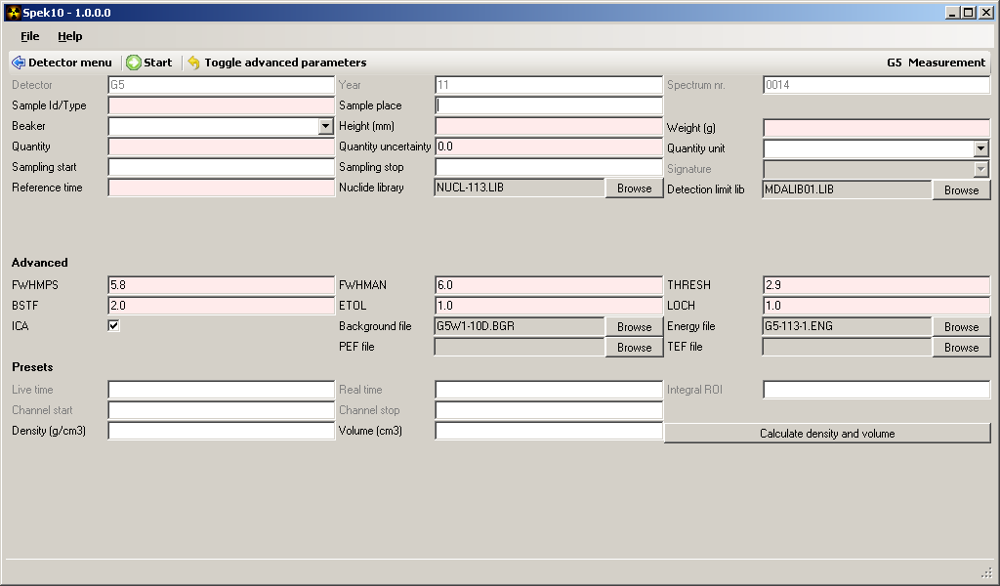
Figure 19: Sample input screen with advanced parameters

Fields with a red background, including drop downs and browse buttons, are required.
For a detailed description of each field, see Appendix 5.

Clicking the Start button will start a new measurement for the selected detector. The input data is stored temporarily on disk so that the information is not lost if the program is closed or restarted.

Once a measurement is started, the menu will display the buttons Stop and Peek instead of Start (see figure 20).

Figure 20: Toolbar menu for a running detector

Stopping a measurement and running the analysis
Clicking Stop will stop the current measurement, run a complete analysis on the spectrum, display the result on the screen, and allowing the operator to print and/or store the result to the archive.
The spectrum is always saved during this process, so if the analysis fails the spectrum can be found and reanalysed through the Archive if necessary.
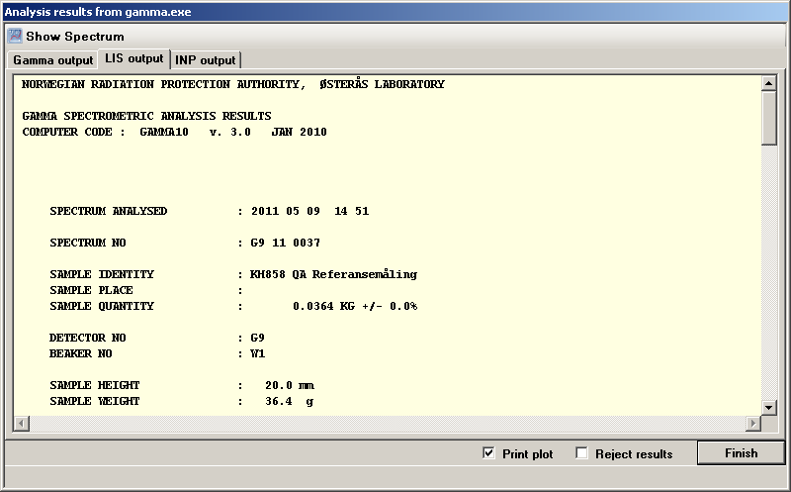
Figure 21: Analysis output

The LIS output sheet shows the analysis results, Gamma output shows messages from gamma.exe and INP output shows the input parameters used for this analysis.

If gamma.exe fails to complete the analysis, the Gamma output sheet will be highlighted by default, and the results will be rejected.
If gamma.exe succeeds the LIS output sheet is highlighted by default.

All files related to an analysis are stored in the archive with the same filename. The filename is composed of the detector name, year and the spectrum number.

The Reject results checkbox allows the operator to reject or accept the analysis. Rejected results will not be stored to the archive, and printing will be disabled. The operator will be prompted with the option to either store the spectrum to the archive or delete it permanently. If the spectrum is deleted the spectrum number will not be updated.

The Print plot checkbox allows the operator to choose whether to send the result and spectrum plot to the printer.

Running the analysis without stopping the measurement
Clicking Peek will run a complete analysis on the current measurement without stopping it. The result is displayed as described in Stopping a measurement and running the analysis, except that the results displayed can not be stored to the archive.

Using the Archive
When the Archive icon is selected from the Main menu, the following window will appear.

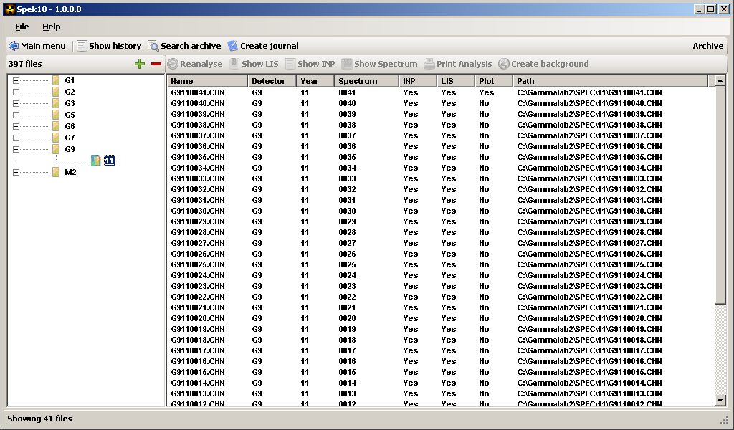
Figure 22: Archive window

The software will show all the spectrums that exist in the folder SPEC, sorted by year and the detector used to collect the spectrum.

Show history
Displays an overview of all completed measurements stored.

Search archive
This function will allow the operator to search the archive for analysis results with specific input parameters. Input parameters that can be searched for includes spectrum year, detector name, sample ID/type and geometry used.

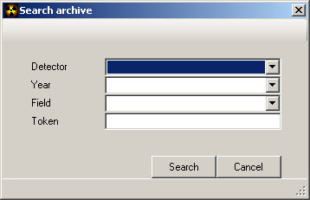
Figure 23: Archive search function

Input for Field and Token is required.
The search function will look up the text entered in the field Token in the parameter given in the Field selection box.

Create journal
It is possible to create a journal for a specific detector and year. To create a new journal select the detector and the year in the left panel, then click the button Create journal. A PDF file will be created containing sample data for the chosen combination. The journal will also list any missing and/or invalid input files at the bottom of the page.

Reanalyse
In order to reanalyse a spectrum, select a spectrum in the archive list. Clicking the Reanalyse button will show the sample input window with all the input data used in the original analysis. If there is no INP file associated with the selected spectrum, the operator must fill in the missing input data. If the spectrum is collected with a detector that is not defined in Spek10, it is necessary to use a dummy detector to complete the analysis. See the chapter Dummy detector for instruction on how to do this.

In the sample input window the operator may adjust the input parameters before re- running the analysis. When the analysis completes the result is displayed as described in chapter Stopping a measurement and running the analysis. If the operator does not reject the result, the result will be stored in the archive and any previous results will be overwritten.

Show LIS
The Show LIS button will display the analysis result of the selected spectrum.

Show INP
The Show INP button will display the sample input data of the selected spectrum.

Show Spectrum
The Show spectrum button will display the spectrum plot for the selected spectrum.

Print Analysis
The Print analyse button will print the complete analysis, including the result and spectrum plot for the selected spectrum. This function is only available when the spectrum has a corresponding INP, LIS and plot (ZIP) file.

Create background
For the gamma analysis software (Gamma.exe) to correct for the radiation already present in the background, it needs a background file with a specific format. To create such a file, simply click on the spectrum from a background measurement and then click the Create background button. The software automatically suggests a filename and directory to store the file.

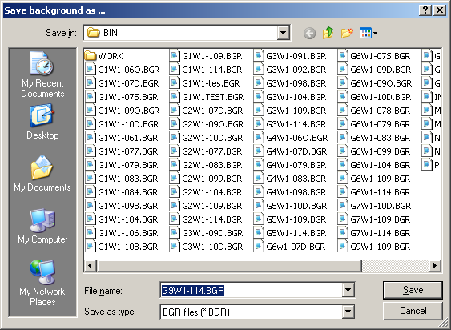
Figure 24: Creating a background file

Note that to create a valid background file the analysis must have been completed with NUCL-DUM.LIB as the library.

Note also that creating a new background file does not automatically define it as the default file to be used with the selected detector. To learn how to define the default background file for a detector see the chapter Defining the default background file.

Log
The log can be found in the File menu. The log shows events that have happened while running the software. The log has a Save to file option that the operator can use to save the current log to a disk file. When the software is closed, the log is discarded.

Appendix:

Appendix 1: Importing old analysis data from spek.exe
Spek10 can analyse spectrums and analysis data created by the old spek.exe software.

- Copy all .CHN, .DAT and .LIS files to their respective folders. E.g., files in SPECH-09 will be copied to SPEK\09, etc.
- Copy the program dat2inp.exe to each folder containing .DAT files that should be converted. (dat2inp.exe should be available in the BIN directory after running Spek10 the first time)
- Start a command line by clicking Start -> Run, type “cmd” into the text box, and press enter. This will display a black MS-DOS window with a command prompt.
- Use the “cd” command to navigate to the folder containing the DAT files to be converted, and type “dat2inp.exe”. Note that old DAT files do not contain a detection limit library parameter. If this parameter is to be included in the generated INP files, use the following command instead:
“dat2inp --default-detection-limit-library <filename>”, where filename is the name of the default detection limit library (This library must exists in the BIN directory).
- If all went well, the old DAT files can be deleted with the command “del *.DAT” since they are no longer needed.

To import files from the current year, care must be taken to update the spectrum counter located in the detector configuration file CFG\detectors.xml.
Open this file in an editor like Notepad, and adjust the parameters called specnum for each detector to the last spectrum number used for that detector for the current year.
For earlier years this step is not necessary.

Appendix 2: Run fixchn.exe in each spectrum folder
There is a problem with older versions of the Maestro software (older than 6.08). Version 6.08 has introduced an extra variable in the parameter year, to separate between spectrums collected before and after the year 2000. If the operator uses version 6.08 to open a spectrum collected with an earlier version, the collection date will appear as for example 1911 instead of 2011. To fix this issue permanently the operator can run the program fixchn.exe for all CHN files in a directory as follows:

Copy the fixchn.exe file to all folders containing spectrum files to be fixed. Start a command line by clicking Start -> Run, type “cmd” into the text box, and press enter. This will display a black MS-DOS window with a command prompt. Use the “cd” command to navigate to each folder containing the CHN files to be fixed, and type “fixchn.exe”.

Appendix 3: Dummy detector
A dummy detector is a non-existent detector that can be used to import HPGe spectrums that are not part of the Spek10 archive, or to reanalyse existing spectrums created with detectors that are not defined by Spek10. Such a detector can be defined in the system by the following procedure.

From the Main menu select File -> Administration, select the Detector configuration tab and click the Create dummy detector button on the tool bar. The following window will appear:

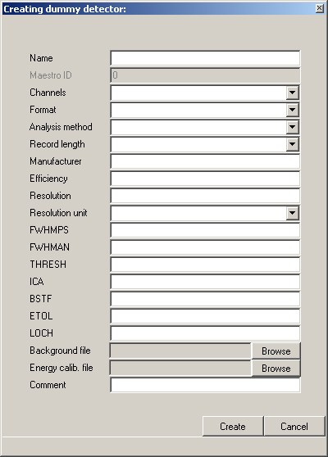
Figure 25: Creating a dummy detector

Start by selecting a unique name for the detector, then fill in the rest of the empty fields with suitable data for the detector. These data will be used as default for the detector, but they are all changeable for each analysis.

The system needs a background and energy calibration file with the same name as the detector. These files must be stored in the folder BIN.

To perform an analysis, the software also needs a peak and total efficiency file. These files must be created, named with the detector name at the beginning and placed in the folder BIN.

When all the fields are filled inn, click Create, and the detector will be available from the Detector menu in Spek10.

Appendix 4: Analysing an external spectrum
To analyse an external spectrum, a dummy detector is needed. See Appendix 3 on how to create and configure dummy detectors.

Choose a dummy detector from the detector menu.

When selecting a dummy detector, the following window appears, prompting the operator for a CHN spectrum file.

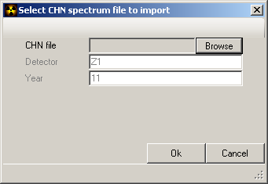
Figure 26: Importing a CHN spectrum file

Clicking Ok will store the CHN spectrum file in the archive and display the sample input parameter window for reanalysing.

Filling in the input parameters and clicking Reanalyse will create input and result files for the imported spectrum.

Appendix 5: Sample input parameters

Detector
The name of the selected detector

Year
For a new measurement, this is the current year; for a reanalyse this is the year the measurement was started.

Spectrum nr.
This shows the next spectrum number. The spectrum number is a four-digit number that increases by one for each measurement started. Each detector has its own spectrum number.

Sample Id/Type
This field should contain a description of the sample. Preferably this field should start with a unique sample identifier like a LIMS ID, followed by information about the sample type or material.

Sample place
This field should contain the location where the sample has been collected.

Beaker
The beaker geometry used for the sample.

Height (mm)
The preparation height of the sample contained in the beaker.

Weight (g)
The preparation weight of the sample contained in the beaker.

Quantity
This field can represent volume or weight depending on the sample type. The analysis result is divided by this quantity to present the final result in Becquerel per unit.

Quantity uncertainty
The uncertainty in the sample quantity

Quantity unit
The sample quantity unit (KG, M3, etc).

Sampling start
The date/time when the sampling was started.

Sampling stop
The date/time when the sampling was stopped.

Signature
<Not implemented>

Reference time
The sample reference time. The activity is decay-corrected to this moment in time.

Nuclide library
The nuclide library to be used for the analysis. The nuclides in this library will be searched for and identified, if present in the spectrum.

Detection limit lib.
The detection limit library to be used for the analysis. The software will calculate the detection limits for all the nuclides in this library, regardless of whether they are present in the spectrum or not.

