Computer Hardware
Introduction to Cybersecurity

Purpose

Learn about the inner workings of computers by identifying hardware components and their functions within a real desktop PC.

Procedure

- Prior to getting to lab hour for this lab please go over each of the components listed below and write a brief description on what they are, what purpose it serves, and one potential way the system could be attacked either physically or virtually and how one might defend the system. You will need to have the sheet filled out before completing the lab in class.

- Components
  - Central Processing Unit (CPU)
  - Random Access Memory (RAM)
  - Motherboard
    - Chipset
    - CMOS battery
    - PCI-e expansion slots and associated add-in cards
  - Storage
    - Hard disk drive (HDD)
    - Solid state drive (SSD)
    - Optical disk drive
  - Heatsink
  - Power supply
- Connectivity
  - Universal Serial Bus (USB) generations (1 – 3) and types (A, B, C, mini, micro)
  - Storage
    - M.2
    - Serial Advanced Technology Attachment (SATA)
  - Display
    - Display Port (DP) and MiniDP
    - High Definition Multimedia Interface (HDMI) and MiniHDMI and MicroHDMI
    - Digital Visual Interface (DVI)
    - Video Graphics Array (VGA)
  - Ethernet (RJ45)
  - Serial (DB9)
  - Audio
  - Headers

- Use this document to complete this lab. Work in pairs.
- You will be given a working computer. The computer has been tested prior to it being assigned to you.
- Taking apart the computer:

Note: Be careful to make sure you do not shuffle your feet and become electrically charged. Proper procedure would require that a grounding wrist strap be used to work inside a computer. In the absence of a grounding strap, frequently touch the chassis metal box to safely discharge any static electricity.

  - Remove the case cover. This is accomplished by simultaneously pressing the two buttons on the sides of the chassis. The front and top of the computer will slide forward and can be lifted for removal.
  - Lift but do not remove the power supply. It will rotate on a hinge at the back of the computer.
  - Slide the drive tray forward. There is a green button near the middle of the front of the computer that will release the drive tray and allow it to slide forward. Do not remove the drive.

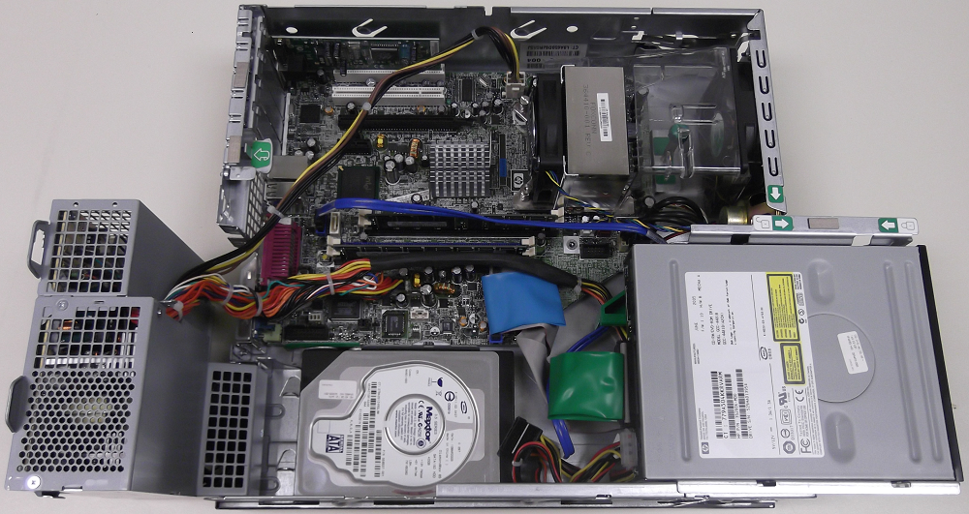

- You will need to identify the previously researched components of the computer and their purpose to a TA.

Pass Off

You will need to demonstrate to a TA that you have researched and identified the parts, components, and connectors listed above.

Submission

Submit this writeup in LearningSuite after completing the research and passing off the lab.

