Security Controls
IT&C 101 - Intro to Cybersecurity

Purpose

As an IT&C student, gaining a deep understanding of security controls is essential, as they form the foundation of protecting information systems. These controls—ranging from administrative policies to advanced technical implementations—will be tools you rely on extensively during your time at BYU and throughout your career in the cybersecurity field.
This lab is designed to introduce you to the principles and application of security controls through an interactive Security Information and Event Management (SIEM) tutorial and lab. In this exercise, you will analyze a simulated environment to identify and evaluate implemented security controls. By investigating logs, alerts, and system configurations, you will gain practical experience in detecting, responding to, and mitigating security threats. You may not understand all of the

Objective

Before beginning review the security controls found at https://www.cisecurity.org/controls/cis-controls-list

You will complete the SIEM simulation, at the end take a screenshot of the congratulations page to record completion.

After completing the simulation answer the questions listed at the bottom of the lab file.

Procedure
SIEM Simulation
Go to https://tryhackme.com/room/introtosiem and make an account. After making your account in the search bar search Introduction SIEM. You should see this:
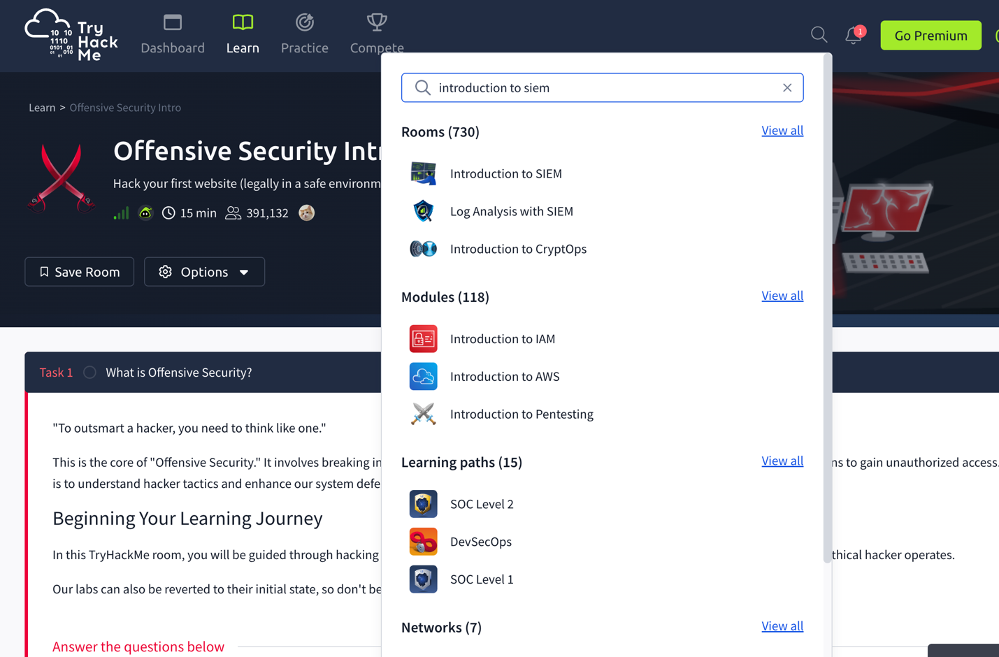

Click on the lab and complete it. Take a screenshot of the completion with Room Progress at 100% (after you finish). After completing the simulation answer the questions listed at the bottom. Don’t worry that you don’t know all of the language and terminology found in the simulation. This lab is to introduce you to the kinds of risks, threats, and associated alerts you might experience as a defender and the security controls that you might implement as protections.

Submission

Submit a single Word docx file or pdf file that includes screenshots of showing your completion along with answers to the following questions. You can copy and paste these questions and enter your responses after each one:

- What is a security control that you could implement to deter an attacker who was trying to install an unwanted file or program on your network like the one found in the simulation?
- How would you implement a security control to protect against such a threat?
- What are examples of physical security controls? What are some real-world examples in which you could implement said security controls?
- What are examples of technical security controls? What are some real-world examples in which you could implement said security controls?
- What did you most enjoy about this lab, and is there anything you'd suggest to improve it?

