Usability and Security by Design
IT&C 101 – Introduction to Cybersecurity

Purpose

Making products and services usable and secure is critical in reducing frustration and risk for users. Creating such solutions is best done when usability and security are considered from the start, not “tacked on” after a product is nearly ready to release. The purpose of this assignment. Is to give you experience with the user experience design and prototyping process with a security mindset.

Lab Requirements

This assignment should be done as a pair assignment (with 2 people), though if there is an odd number 3 people can join together. The basic steps are to find a partner, choose an activity that you can observe/interview other people doing (to identify opportunities for technical interventions), brainstorm possible technical solutions based on your observations, create 2 low-fidelity prototypes of a technology to help with the activity, evaluate risk and security controls to mitigate them, and get feedback on your prototype from potential users. Details are provided below. Note that all bolded text below will become part of your write up that you turn in for the assignment.

Procedure

- Choose a partner to work with to complete this lab. If there is an odd number of students, please talk to the instructor. We suggest choosing a partner that you do not know, but it’s up to you.
- Choose an everyday activity that people around you accomplish regularly with or without the use of technology. Write a 1-sentence description of your activity. (e.g., “Ordering and receiving food at the Wilk food court”). For this assignment you’ll want to choose an activity that meets the following criteria:
  - It’s not too complicated (e.g., designing an airplane; filling out your taxes) or too simple (e.g., crossing the street, looking out a window). If there are several steps or related tasks involved, but not dozens or hundreds then you’re probably good.
  - It’s common enough that you can find people around you (ideally who are not just like you – i.e., Cyber majors, …) who you can observe and interview about the activity.
  - There is some security-related component. This could relate to physical security, personal data security, opportunities of adversaries to manipulate results, etc.
  - If you can’t think of anything, check the list in Appendix 1 for some inspiration.
- Observe and interview at least 4 individuals (2 each) to identify user needs. These people cannot be part of the class and shouldn’t be people just like you (i.e., same major, ways of doing things…). The point is to have empathy for others who may do things differently than you do. If possible, observe them performing the activity that you are studying. If needed, you can ask them to perform the activity with you watching, but make sure they do what they would normally do, and don’t change what they’re doing too much because of your observation. Take observational notes on what you see including written notes and, if appropriate, photos. Don’t video them, since then you won’t be forced to narrow your focus to the key observations. After your observations (which may last from 5-10 minutes per person), ask the person some questions about what you observed and the activity in general. You should write up some of the questions beforehand so you are prepared. The questions should help you identify what is frustrating about the activity for them, what they like about the activity, potential risks associated with the activity, how the activity relates to the rest of their life, what technologies they use to help them with the activity, and/or why they don’t use other technologies. Take notes on how they respond to your questions. Summarize your observations and interview notes in at least 4 key “takeaway” messages that will help you remember the users’ perspective in your future work.
- Brainstorm technological “interventions” with your partner that could help those you observed have a better user experience while performing their activity. This should take into consideration the interviews and observations. During the brainstorming phase there are no bad ideas! Feel free to brainstorm with others as well, as there are never too many people for brainstorming. List at least 12 different ideas from your brainstorming activity. After brainstorming is complete, choose the idea that you agree on as the best potential “intervention.” Describe the core of your idea in a 2-3 sentence summary (e.g., “We will design a mobile app that allows users to find and join Ultimate Frisbee pickup games. It will include pickup game times, locations, and keep track of who commits to come and actually shows up.”)
- Identify 3 possible attacks on the system, one of which relates to Confidentiality, on related to Integrity, and one related to Availability. For each attack identify who a likely threat actor would be (i.e., who would have reason to perform such an attack), why they would want to attack, and how they would attack it. Then, for each possible attack, identify at least one technique you will use to minimize the risk of a successful attack.
- Design a technological solution that is as usable and secure as possible. Create a 6-8 frame storyboard (i.e., comic strip) of your activity being completed using your technological intervention. You can do this using online tools or, more likely, just hand-drawn. You should have a sentence underneath each frame that conveys the core idea of the particular frame. An example from Interaction Design Foundation is included below:

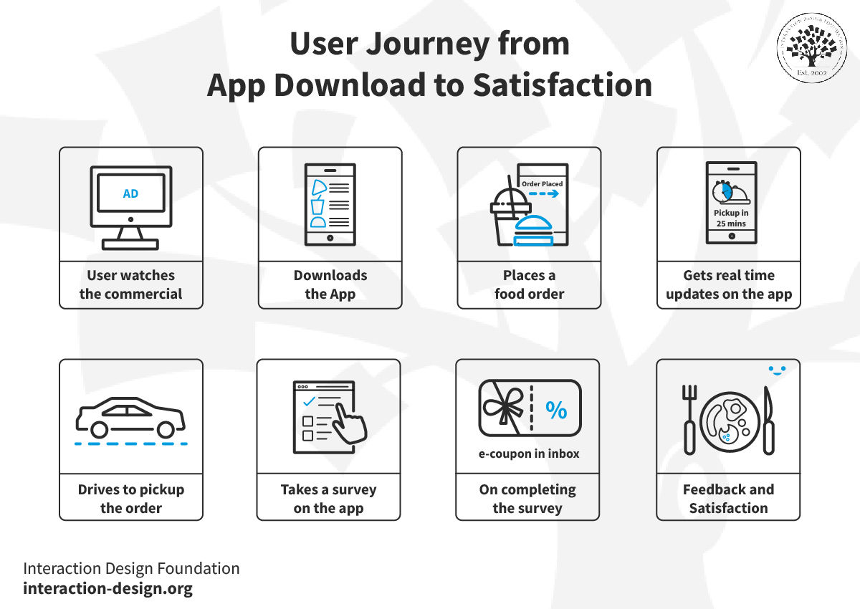

- Create 2 low-fidelity prototypes of a technological “interface” (e.g., mobile app, website, large-display, gesture-based interface, car dashboard,…) that would be used in your technological “intervention.” Paper prototypes are great, though if you get ambitious you could use a low-fidelity prototyping tool such as Balsamiq or even Powerpoint. The two interfaces should perform the exact same functionality, but do so in a different way (i.e., one may have a drop-down menu, while the other may list the items as buttons; one may be designed as a large display mounted on the wall, while another would be for a mobile device). Creating multiple prototypes allows you to keep your thinking from getting too constrained by a single one and allows others to give more meaningful feedback (see next bullet).
- Get feedback on your 2 prototypes from at least 2 people. List at least 4 things they liked and 4 things they didn’t like about your prototypes. List at least 2 ways you would improve one of your prototypes based on that feedback. You do not need to actually make the improvements to the designs, as that is beyond the scope of this lab.

Submission

Submit a Word or PDF document that includes the following information:

- The 1-sentence description of the activity you chose in step 2 of the procedure.
- The summarization of your observations and interview notes in 4 key “takeaway” messages that will help you remember the users’ perspective in your future work (step 3 of the procedure).
- A list of your 12 different ideas from the brainstorming activity (step 4 of the procedure).
- The core of your idea in a 2-3 sentence summary (step 4 of the procedure).
- The 3 possible CIA attacks, threat actor, reason they would attack, and how they would attack, and one way you would minimize risk of successful attack (step 5 of the procedure).
- A picture or screenshot of your storyboard (step 6 of the procedure).
- A picture or screenshot of your 2 low-fidelity prototypes (step 7 of the procedure).
- 4 things users liked and 4 things they didn’t like about your prototypes (step 8 of the procedure).
- 2 ways in which you would improve your designs based on their feedback (step 8 of the procedure).
- Appendix: Include images and notes you took during your observation and interviews.

Appendix 1: Activities You Can Use for this Assignment

Below are some possible ideas, though you can choose your own as well. These are about the right scope.

- Ordering and receiving food at a restaurant
- Parking on campus
- Disseminating information about events (e.g., via fliers with QR codes)
- Managing physical access to high security areas
- Organizing pickup sports games or social events (and ensuring people come if they committed to it)
- Voting for the best idea in a competition
- Buying and selling items (e.g., via Facebook Marketplace or a physical billboard)
- Buying books at the bookstore
- Accessing instruments (e.g., pianos) on campus
- Checking out books at the library
- Grocery shopping
- Managing your valuables on campus throughout the day

