

本 科 生 毕 业 论 文

题 目：A compiler to C++ for LabVIEW Comms
院 系： 数据科学与计算机学院
专 业： 计算机科学与技术
学生姓名： 王樾
学 号： 12348121
指导教师： 副教授 （教授/副教授/讲师）

二〇一六 年 四 月

摘 要

LabVIEW Communications(LabVIEW Comms)系统设计套件是由National instrument公司为通信系统开发者设计的一款强大的原型设计的集成软件。它为用户提供可以直接拉拽和放置结点的简易界面，使用数据流语言G设计virtual instrument (VI)。数据流语言G是一种图形编程语言，图形里的一个结点需要等到所有需要的输入都得到的时候才可以被执行。
然而，当代主流的编程语言一直都是基于文本的语言而不是基于图形。因为文本编程语言可以更方便的传输还有移植在不同平台上，它被许多用户所采用。所以如果能够构建一座连接图形编程语言G和文本编程语言的桥梁，这是一件非常重要而且对LabVIEW Comms来说意义重大的事。或者说，设计一个能实现这个转换的编译器有着很大的需求。
在LabVIEW Comms里面，它使用数据流中间表示形式（DFIR）去表示VI里面的由一系列互相连接在一起的节点组成的图形（diagram）。同时它提供了一个叫DfirExport的基于C#编程语言的用户接口，让用户能够访问DFIR里面的各种结点。但是因为它只能在C#的平台上使用，所以这对于不熟悉C#的用户来说很难使用它。更糟糕的是这个DFIR比较复杂而且一定程度上包含了冗余的信息，使它更难使用。
所以在论文里我为DFIR开发了一种基于XML的中间表示形式（XML IR）并且设计了XML schema去对它进行验证。我使用用户接口DfirExport去访问DFIR里面的不同节点并且设计一系列基于通用性、简洁性和可重用性的规则去决定如何在XML里面展示它们。这个XML IR是DFIR的一个子集，但它有着和DFIR一样的表示VI里面图形的能力。它更简洁而且因为XML本身的在网络上和各种平台上的简单性，通用性和可实用性，它也更容易被使用。更重要的是，这个XML IR为程序员们打开一扇大门，让他们可以在此基础上设计更多有用的工具和插件，有利于LabVIEW Comms这个软件的繁荣发展。
在XML IR的基础上，一个能把LabVIEW Comms的G代码转化C++的文本代码的编译器被设计出来。它现在能够处理配置在FPGA上的VI里面的大部分结点，比如算数计算，嵌套的for循环，case结构，反馈节点和一系列IPimitive的结点和数组操作结点。它是按着拓扑顺序处理各个结点，并且根据每个结点的类型和位置把它转换为相应的C++代码。另外，一些子系统，比如命名系统，变量声明系统和代码管理系统也被用来帮助产生形式完备而且正确的C++代码。许多实验也评估和证明了这个编译器的正确性和有效性。结尾还将给出本文的总结还有还需要完善改进的工作进行讨论。

关键词：LabVIEW Comms；数据流中间表示形式；XML中间表示形式；编译器

ABSTRACT

The LabVIEW Communications System Design Suite (abbreviated as LabVIEW Comms), developed by National Instruments (NI), is a powerful integrated prototyping software for communications designer. It uses G dataflow (G) to design virtual instruments (VIs) by providing a drag-and-drop canvas interface for the user. G is graphical programming language in which nodes on a diagram execute when data is available for all required inputs.
However, the contemporary mainstream programming language is always based on text instead of graph. Textual programming language widely adopted by tons of programmers can be conveniently transferred and ported easily in multiple platforms. Therefore, building a bridge from the graphical programming language G to textual programming language is significant and means a lot for LabVIEW Comms. In other words, a compiler to implement this IR is demanded and of great importance.
In LabVIEW Comms, it uses the data flow IR (DFIR) to represent the diagram in VI, which is organized as a collection of nodes which are connected together. Besides, it provides a C# API called DfirExport for the user to have access to the various nodes in the DFIR. However, since it can only be programmed in C# platform, it is hard to be used for the programmer who are not familiar with C#. Worse still, the Dfir is complicated with a large collection of classes which contain redundant information to some degree, making it more difficult to be used.
Therefore, in my paper I create a XML IR (IR) for the DFIR and design a XML schema to validate it. I use DfirExport API to access to the classes for nodes in the DFIR and design a set of rules of how to display them in XML according to several principles, such as generality, simplicity and reusability. My XML IR is subset of the DFIR but has the same capability to represent the diagram in VI as the DFIR. It is more concise and much easier to be widely used thanks to XML’s simplicity, generality and usability across the Internet as well as various platforms. Most importantly, this XML IR can open the door for programmers to build more useful tools or plugins based on it, benefiting the prosperity of LabVIEW Comms.
Based on my XML IR, a compiler is designed to convert the G code in LabVIEW Comms into textual codes in C++. It can currently handle a large subset of nodes in the VI targeted on FPGA, such as arithmetic computation, nested for loop, case structure, feedback nodes and a set of IPrimitive nodes and array operation nodes. It processes all the nodes in the diagram in topological order and convert them into corresponding C++ code according to the type and occurring position of each node. What’s more, several component systems are involved to help generate well-formed and proper C++ code output, such as labeling system, declaration system and code management system. Experiments have been done to evaluate and prove the accuracy and effectiveness of this compiler. In the end, a conclusion will be given and future work needed to improve the work will be discussed.

Keywords: LabVIEW Comms; the DFIR; XML IR; Compiler
Contents
摘 要 i
ABSTRACT ii
Keywords: LabVIEW Comms; the DFIR; XML IR; Compiler ii
第一章 Overview 5
1.1 Background of this work 5
1.2 The existing problem to be solved 6
1.3 Previous work 7
1.4 My contribution 7
1.5 Paper structure 8
第二章 Proposed method 9
2.1 Problem statement 9
2.1.1 Why a prevalent IR is demanded 9
2.1.2 Why a compiler to convert this IR into C++ code is demanded 10
2.1.3 How to design a prevalent IR for LabVIEW Comms 10
2.1.4 How to design a compiler to convert this IR into C++ code 10
2.2 My solution 11
2.2.1 IR design 11
2.2.2 Compiler design 17
第三章 Detail algorithms 20
3.1 My DFIR representation 20
3.1.1 JNode 20
3.1.2 ITerminal 22
3.1.3 IDataType 22
3.1.4 Some derived classes of JNode 24
3.2 My DFIR parser 29
3.2.1 GetITerminal 29
3.2.2 GetIDiagram 30
3.3 Convertor 30
3.3.1 Topological sort 31
3.3.2 Process all nodes in topological order 33
3.3.3 Different component systems 40
3.4 My compiler 42
第四章 Experiments and analysis 43
4.1 Arithmetic computation 43
4.2 Nested for loop with feedback pair nodes 44
4.3 Multiple Cases 46
第五章 Conclusion and expectation 48
5.1 Conclusion 48
5.2 Expectation 48
Acknowledgements 49
Reference 50

Overview

Background of this work
The LabVIEW Communications System Design Suite (abbreviated as LabVIEW Comms), developed by National Instruments (NI), is a powerful integrated prototyping platform for communications designer. It offers a design environment closely integrated with NI software designed radio (SDR) for rapidly prototyping communications systems. Easily deploy to processors and FPGAs, jump-start research LTE and 802.11 applications, and drive innovation. It aims at providing the fastest path from design to prototype and best running performance for communications systems as well.
In LabVIEW Comms, G Dataflow (G) that is a graphical programming language in which nodes on a diagram execute when data is available for all required inputs[1]. A node in G executes only when it receives data for all required inputs. When a node finishes executing, it passes data along the wire to the next node in the dataflow path. The movement of data along the wires and through the nodes is called dataflow and determines the execution order of nodes on the diagram. FIG.1-1 is an example of a simple diagram in LabVIEW Comms.
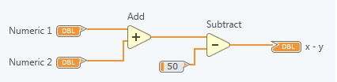
FIG.1-1 An example of a diagram
Besides, it provides a drag-and-drop canvas interface for you to interact with your designs by creating virtual instruments (VIs). Each VI is composed of three parts, a block diagram, a front panel and a connector panel used to represent the VI in the block diagrams of other[2].
LabVIEW Comms uses a genetic, platform independent internal representation of VIs called DFIR[3], which is an abbreviation for data flow intermediate representation. The DFIR is organized as a collection of nodes which are connected together. Each node has at least one terminal, which can be connected to other terminals. Some nodes like loops contain diagrams, which may in turn contain other nodes. The DFIR offers two significant advantages to the LabVIEW Comms compiler. For one thing, it decouples the editor from the compiler representation, making it easy to introduce more compiler optimizations. For another thing, it serves as a common hub for the multiple compiler front and back ends, facilitating reuse between the various combinations.
FIG.1-2 is a snapshot of the structure of the DFIR. As you see in this figure, the top level abstract class is the INode, which all other classes derive from. A collection of nodes is encapsulated in a IDiagram. An IStructure is an abstract class which contains one or more IDiagrams. Since the IDiagrams in an IStructure can contain nodes that implement IStructures, recursive nesting of IDiagrams is possible, like what are shown in the FIG.1-2.
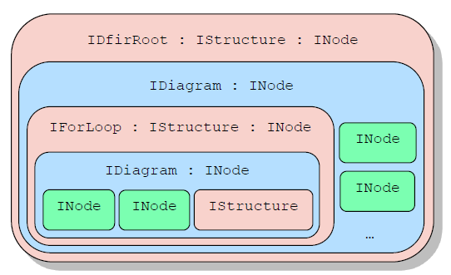
FIG. 1-2 Hierarchy structure of the DFIR

The existing problem to be solved
LabVIEW Comms provides a DFIR API that give users access to read-only internal objects inside the DFIR. However, this DFIR API, called as DfirExport, is only programmed in C# and runs on .NET4.5. It introduces lots of problems related to its portability and attempt of building additional tools or plugins on it.
Besides, since graphical programming language[4] is not that standard and widespread language, there is usually an increasing need to convert this graph-based language into text-based language, which is much more prevalent programming language in the field of both academics and industries. By translating it into some text-based programming language (i.e. C++), it can be understood easily by a programmer who do not know anything about graphical programming language but is familiar with textual programming language, making it easier to share your LabVIEW Comms designs with a larger group of people. Therefore, a compiler to convert this graphical language in LabVIEW Comms to another textual high-level programming language is demanded.
There are two urgent works needed to accomplished for the existing problems listed above in LabVIEW Comms: First, create another common intermediate representation (IR) for the DFIR which is widely accepted by various platforms, not just C#. Second, design a compiler to convert the G language in LabVIEW Comms into a textual high-level programming language.
However, several significant challenges will be encountered when coping with those planned works. First, it is hard to choose the ideal IR for the DFIR considering a variety of existing alternatives. Second, it is even tougher to decide what necessary information needed to be displayed and how to concisely and accurately demonstrate them in your chosen IR. There are bare standards for you to decide whether you have extracted adequate information from the DFIR. Third, when comes to a compiler, it brings lots of tough work and designing problems. For example, how to do type propagation or how to handle compiler optimizations, such as loop unrolling, loop invariant code motion and deadlock elimination, etc. Forth, how to evaluate this compiler and give a performance report for it is also an uneasy problem. Finally, since the DFIR has a large set of nodes and complicated structure of class inheritance, it is difficult to cover all the nodes and design a proper structure to organize them in my designed IR and compiler.

Previous work
Since LabVIEW Comms targets a very specific group of people, the graphical programmers or the communication systems designers, actually there are rare plugins or tools built on it. Besides, it is an encapsulated software and export little internal details. Thus it is hard to gain more insights of the internal structure LabVIEW Comms, although you may use it lot. For example, there is a C generator for Labview instead of LabVIEW Comms. But it is not open source and you have no access to the implementation of that C generator. To sum up, there is little previous work I can refer to when creating an IR for LabVIEW Comms as well as designing my own compiler.

My contribution
In this paper, I choose to use extensible markup language (XML) to generate the IR for the DFIR, on which I design a compiler to convert the DFIR into C++ code based.
XML is a widespread markup language that defines a set of rules for encoding documents in a specific format which is both human-readable and machine-readable according to some free open standards[5]. It is widely used in lots of web services and various developing platforms, emphasizing simplicity, generality and usability across the Internet. Due to its prevalence, there are lots of existing tools to parse the XML file and validate it, which offers convenient access and manipulations to XML file. For example, there are some built-in packages like DOM parser in java for you to process XML file, which is also what I choose to use in my work.
By diving into the DFIR deeply and tons of experiments I have made, I generate a collection of rules to extract necessary information in the DFIR and decide how to display them properly. In order to make it simpler and easier to be reused, I create different separated elements to simulate different nodes in the DFIR. Also, to make sure that not only it can accept the well-formed and validate XML file but also to refuse the inaccurate input XML file, I design a detail and strict XML schema to validate the input XML file.
As for the compiler, I use java as the programming language to write this compiler and C++ as the target language to convert into. Actually, this project is built on the XML IR for the DFIR because I use the necessary information stored in it to generate my compiler. I design four packages in my java project, one Dfir_representation package to store different classes I create for various node in the DFIR, one Dfir_parser package to take the designed XML file as input and generate the objects according to the class type, one Converter package to convert the information of the XML into a list of C++ codes, and a Main package to invoke this program. Actually, the class structure I design is similar to that in the DFIR. The significant difference between them is that I remove lots of unnecessary fields, methods or classes and add some useful fields or methods especially for my compiler implementation.
My compiler can handle a large subset of nodes in the VI targeted on FPGA, such as arithmetic computation, nested for loop, case structure, feedback nodes and a set of IPrimitive nodes and array operation nodes. Converting them to accurate C++ code. The output C++ code is evaluated to have the same output and identical expression capability as the G language inside VI.
Most importantly, the XML IR I create for the DFIR can have more usages apart from for my compiler. For example, developers can use to create compiler to convert the DFIR into Verilog language, java language and python etc. Furthermore, it allows people to design more tools and plugins on the LabVIEW Comms to satisfy their need and thus accelerate innovations on this platform. In other words, this XML VI open a door for the users who want to do more work based on the LabVIEW Comms.

Paper structure
The paper consists of five chapters. Chapter one is the overview of the paper, which describe the general background and existing problems of this topic, the meaning of this work and my contribution to it. Chapter two will discuss the proposed method to solve the existing problem this paper focus on. It describes the existing problems in more detail and propose the methods to solve it in general. Chapter three focuses on elaborating the detail algorithm of my solution for designing a compiler, which is the core part of this paper. Chapter four will do some experiments to evaluate and analyze the designed compiler’s accuracy and effectiveness. Chapter five will lead to a conclusion of this paper and discuss some expectations for the improvement of this paper in the future.

Proposed method
In this chapter, I am going to elaborate the existing problems that my paper strives to solve, including the importance, urgency and expected work needed to do for these problems as well as the challenge involved of it. Then I will introduce my solution for these problems in detail. For the solution for creating my own IR for LabVIEW Comms, I will demonstrate the whole descriptions, including what the result of this IR is and how to generate it. But for the solution for designing a compiler to convert this proposed IR into C++ code, as it consists of more complicated algorithms and a large collection of nodes and process procedure needed to be explained, I will just give an overview of my proposed solution for it and leave the detail introduction and analysis in the next chapter.

Problem statement
LabVIEW Comms is a pretty popular prototyping design platforms for communications systems developers. Its data flow programming language called G make it easy for inexperience programmer make a start to do some designs and its powerful parallel capability significantly boost the performance for designing communications systems[6]. However, its data flow capability, which brings significant benefits in terms of easiness to use and performance advance, also has a great impact on its portability and prevalence because the mainstream programming language is text-based language like C++ or java. Therefore, constructing a connection between this G language and currently popular textual language may bridge the gap between them and thus make a very difference for LabVIEW Comms.
In order to achieve this goal, two primary problems need to be addressed firstly. One is how to design an intermedia representation (IR) between the G language and the target textual programming language while another is how to convert from this IR into the target language. In other words, how to design a compiler to accomplish this IR. In my work I choose C++ as the target language.

Why a prevalent IR is demanded
Why a prevalent IR is demanded? It is because it can bring great extensibility and flexibility to the attempt of conversion. Remember that LabVIEW Comms only provide a C# API called DfirExport for developers have access to the read-only DFIR. If you do not know C#, you have no way to do some work based on this DfirExport. Besides, the DfirExport contains a large amount of complicated information about the DFIR, most of which are unnecessary for attempt of conversion. Furthermore, its fixed and encapsulated class structure bring plenty of obstacles when you are doing your own design on it. For example, you cannot add some useful fields or methods to them to help ease the complexity of your work. Finally, after we succeed in generating this popular IR, developers have a number of alternatives to choose the language they master to parse this IR and design more tools and plugins base on this information, such as converting the G language in LabVIEW Comms into any language they like. To sum up, a prevalent IR play an important role in improving the portability and extensibility for LabVIEW Comms.

Why a compiler to convert this IR into C++ code is demanded
As I describe above, the contemporary mainstream programming language is text-based language instead of graph-based language. This situation makes it difficult for graphical programmers to convey their ideas and share their designs with textual programmers, which accounts for a much larger percentage. Since textual programming language is more conveniently transferred online and more easily ported in various platforms, converting the graphical codes to textual codes helps to preserve these codes better and you can run it easily without LabVIEW Comms, which has much less users than those popular textual programming language like C++ or java. Besides, LabVIEW Comms is comprehensive platform which take more time to install and deploy it, while the running environment for popular textual programming language is much easier to be configured. Finally, by designing a compiler based on the proposed IR, we can have more criteria to determine what is the necessary information we should include in the IR. In other words, this compiler brings lots of insights about how to design the IR and can also serve as an excellent evaluation for this IR design.

How to design a prevalent IR for LabVIEW Comms
The first question needed to be answer is what format should be used to apply to this IR. When doing the selection from a big collection of possibilities, simplicity, prevalence, generality should be emphasized on primarily.
After determining the format, it is important to consider how to collect the entire necessary information needed to fully represent the DFIR and cut down some unnecessary information. For example, in the DFIR, it has a class called IWire to represent the connection between nodes. But this connection information can be got from the terminals of the connected nodes, thus we have no need incorporate that IWire information into the desired IR.
Another problem to be addressed is that how to evaluate this IR and validate the right one and detect the errors for the wrong one. All these are required when designing a robust and mature IR.

How to design a compiler to convert this IR into C++ code
Building a compiler always comes with a big project due to lots of factors needed to be taken into consideration during this process. For example, the processing logic for different kinds of states and nodes, the accuracy validation and performance optimization. All these cannot be neglected for creating an effective compiler.
For my compiler, the very first problem is that how to parse the IR as an input and store it in the memory. Obviously, it would be better if there exists some built-in parser for the IR because you save lots of energy and time to write a correct and efficient parser by yourself. Then you should consider what kinds of data structure or class structure will be used to store the parsed result. Second, the main logic of how process and manipulate this data in the memory into target C++ code should be determined. Since the collection of node in LabVIEW Comms is comparatively big, you should pay attention to cover all these nodes and decide the most general and useful processing logic for them. Keep the principle of reuse in mind. For instance, the IDiagram class can occur in the top level of the DFIR and also inside a IForLoop class, you should strive to develop a general method to handle both of scenarios.

My solution

IR design
In my work, I choose XML as a format for my designed IR for its generality and prevalence around multiple platforms and web service.

Designing the XML IR
In order to get the classes in the DFIR, the first step to do is to use the C# API called DfirExport to have access to the inside of the DFIR.
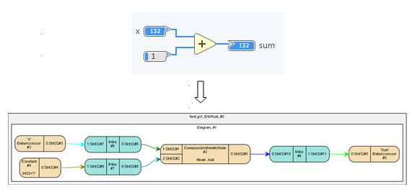
FIG.2-1 An example of a dot graph
How to use the DfirExport? Thanks to the National Instruments, they provide several significant documents and a project called DotStringPrinter to print the DFIR in a dot graph. It is pretty helpful for me to gain more insights of the DFIR and make an easier start to use the DfirExport. Above FIG.2-1 shows an example of how DotStringPrinter generate a dot graph for a simple diagram in LabVIEW Comms.
To use the DfirExport, you should include relevant system references firstly and create your class which must implement IDFirRootAcceptor. Then there is an AcceptDfirRoot method, which is the entry point to this API, should be created in this class. After that, you can use the methods provided by this API to access the information you want.
The goal of the part is to create XML IR for the all the nodes occurring in VI targeted on FPGA. Thus we should decide how to traverse all the nodes before considering of how to demonstrate information as IR format. Here I write a collection of overriding printing subroutines to recursively traverse all the nodes. Typically, when writing subroutines for IStructure type nodes like IForLoop, you should traverse all the nodes both inside the IDiagram and IBorderNode set of IForLoop.
In order to eliminate the redundancy of the code, creating subroutines especially for some common operations is pretty helpful and increase the level of reuse, such as printing information of ITerminals and IDataTypes. Besides, since it is naturally formal to display XML file according to strict requirement of indention, an indention rule system should be designed and obeyed when printing the information of XML IR.
When comes to the selection of what kinds of information should be displayed in the IR or removed, it is a process of struggling. Actually, there are rare standard to make sure what should be or should not be chosen definitely. What I have done is to follow a couple of principles. First, the most basic properties of the nodes should be selected, such as the node id which is the identification number of this node, parent id which can help you to determine the nesting information, and terminals information. Second, remove some properties information which are redundant. For instance, there is IWire in the DFIR which store the connection information of two nodes. But we can get this information from other channel, which is the connection information of the connected nodes’ terminals. By removing these redundant information, it demonstrates necessary information clearly and concisely, which is of great importance when designing a big and complicated project where small optimizations at the beginning can make a difference in the final result. Finally, choose the needed information by thinking of what its value is in the compiler based on it. If it is not used in the compiler, we can ignore this temporarily. It can be added back when we find its usage.
Another issue is how to display them in XML IR. XML has two main ways to store information in an element: sub element and attribute. Technically, you can use either of them to store and display the information. However, there are some differences between them. Usually, people tend to use attribute less than element. They use attribute typically when this information is more related to itself or the description of that data, which can be called as meta data. Subelements are often used to store that information that its parent element contains and has little relationship with the internal or identity-perspective information of its parent element.

Result of my proposed XML IR
According to the principles described in the last subsection above, I design a XML IR for the LabVIEW Comms. Below Table.2-1 is a whole list of my XML IR.
Table.2-1 The XML IR
Node Type | SubElement (* represent it can occur from 0 to unbounded times) | Attribute
IDiagram | ICompoundArithmeticNode*  IDataAccessor*  IConstant*  IForLoop*  ICaseStructure*  IMethodCall*  IPrimitive*  {IFeedbackInputNode,IFeedbackOutputNode}*  IBlackBoxNode*  IArrayIndexNode*  IReplaceArraySubsetNode*  IInsertIntoArrayNode*  IDeleteFromArrayNode*  IInitializeArrayNode*  IBuildArrayNode*  IArraySubsetNode* | NodeId (byte)  ParentId (byte)  DiagramIndex (byte)
IDataType | ISignedInt  IUnsignedInt  ISignedFixedPoint  IUnsignedFixedPoint  IArray  IVariableSizedArray  IComplex  IFixedSizeArray  IBit  IBoolean  IDouble  IIncorrect  ISingle  IString  IUnknown  IUnsupported  IVoid | NodeId (byte)  ParentId (byte)
ISignedInt  IUnsignedInt | WordLength (byte)
ISignedFixedPoint  IUnsignedFixedPoint | LeftLength (byte)  RightLength (byte)
IArray  IVariableSizedArray | Dimensions (byte)  Element
IComplex | Element
Element | IDataType
InputTerminals | ITerminal*
OutputTerminals | ITerminal*
ITerminal | IDataType  Connections | TerminalId (byte)  TerminalIndex (byte)
Connections | Connection(TerminalId, NodeId)*
ICompoundArithmeticNode | InvertedInputs  InvertedOutput  InputTerminals  OutputTerminals | NodeId (byte)  ParentId (byte)  Mode(Add || Multiply || Or || And || Xor)
IDataAccessor | Name (String)  Direction (INPUT || UTPUT)  InputTerminals || OutputTerminals | NodeId (byte)  ParentId (byte)
IConstant | Value (String)  IDataType  OutputTerminals | NodeId (byte)  ParentId (byte)
IForLoop | ILoopIndex  ILoopMax  ITunnel*  {ILeftShiftRegister,IRightShiftRegister}*  IDiagram | NodeId (byte)  ParentId (byte)
ICaseStructure | ICaseSelector  ITunnel*  IDiagram | NodeId (byte)  ParentId (byte)
IMethodCall | TargetName (String)  SubVI  InputTerminals  OutputTerminals | NodeId (byte)  ParentId (byte)
IPrimitive | InputTerminals  OutputTerminals | NodeId (byte)  ParentId (byte)  Mode (pattern = “Ex[a-zA-Z0-9]+Primitive”)
IFeedbackInputNode | Delay (byte)  FeedbackTerminal(TerminalId)  OutputNode(NodeId, ParentId)  InputTerminals  OutputTerminals | NodeId (byte)  ParentId (byte)
IFeedbackOutputNode | InitTerminal(TerminalId)  InputNode(NodeId, ParentId)  InputTerminals  OutputTerminals | NodeId (byte)  ParentId (byte)
ILeftShiftRegister | AssociatedRightShiftRegister(NodeId, parentId)  InputTerminals  OutputTerminals | NodeId (byte)  ParentId (byte)
IRightShiftRegister | AssociatedLeftShiftRegister (NodeId, parentId)  InputTerminals  OutputTerminals | NodeId (byte)  ParentId (byte)
ITunnel | IsInput (True || False)  GetInnerTerminal (TerminalId)  GetOuterTerminal (TerminalId)  IndexingMode (NonIndexing || Indexing)  InputTerminals  OutputTerminals | NodeId (byte)  ParentId (byte)
ICaseSelector | DefaultDiagramIndex (byte)  Ranges  InputTerminals  OutputTerminals | NodeId (byte)  ParentId (byte)
Ranges | Range{(LowValue, HighValue) || SingleValue }
SubVI | Pair<TerminalId, SubVIDataAccessorId > | NodeId (byte)  ParentId (byte)
IBlackBoxNode  IArrayIndexNode  IReplaceArraySubsetNode  IInsertIntoArrayNode  IDeleteFromArrayNode  IInitializeArrayNode  IBuildArrayNode  IArraySubsetNode  ILoopIndex  ILoopMax | InputTerminals  OutputTerminals | NodeId (byte)  ParentId (byte)

As you see, the top level of this IR is IDiagram, it consists of zero or multiple one of nodes in the above list regardless of the order. All nodes which derive from INode has two attributes and two conditional elements (when it has both input terminals and output terminals). For attribute, one is NodeId while another is ParentId. For element, they are InputTerminals and OutputTerminals. If this node has both terminals but is not connected, these two elements still exist but contain nothing.
For the ITerminal element, it consists of two attributes (TerminalId, TerminalIndex) and two elements (IDataType, Connections) as well. Connections store the information of the connection this node has with other nodes.
For the IDataType, it is one of the Table.2-1 The DFIR support 17 types of datatypes, all of which are wrapped under the tag name of IDataType. This information can be used to declare the variable in the designed compiler.
For the IPrimitive, since there are tons of IPrimitive nodes in the DFIR, it is impractical to design various elements for each one. Thus, I choose to use a unified format element for this kind of node. The element of Mode can distinguish the specific kind of this node among all the IPrimitive nodes.
For the IForLoop and ICaseStructure, they belong to the Structure class that can recursively has IDiagram inside. They are more complicated classes as they also have different kinds of IBorderNodes and nested structure. For example, IForLoop can have a list of ITunnels, ILeftShiftRegisters and IRightShiftRegisters plus one ILoopIndex and one ILoopMax all as its IBorderNodes. At the same time, it also contains one IDiagram to store the information of nodes inside the loop. For ICaseStructure, it can have an ICaseSelector and a set of ITunnels as its IBorderNodes and many IDiagrams according to the number of cases it has.
For the SubVI, not only it will display the information listed in the Table.2-1, but also it will create a new file to store the XML IR for the inside content of the IMethodCall. The Pair sub element wrapped in the SubVI element records the corresponding relationship between the terminalId of the IMethodCall node and the IDataAccessor’s NodeId inside it.
Since the collection of INodes above is very large and it is impractical to introduce all of them. Thus above I only give a brief introduction to a small set of nodes. If you want to know more detail information for all the classes in the DFIR, you would better refer to the help file given by National Instruments, covering all the classes in detail.

Validation of my proposed XML IR
After generating the XML IR, it is necessary to validate the XML file. Fortunately, XML, as a popular markup language, has its own validation method that is XML schema[8]. An XML schema is a description of a type of XML document, typically expressed in terms of constraints on the structure and content of documents of that type, above and beyond the basic syntactical constraints imposed by XML itself[9]. In XML schema, you can make sure the first element occur in the XML IR is IDiagram. Besides, you can put restrictions on the elements, such as deciding the showing order, occurring times and specific contents that can only occur in that field. For example, for the direction of a IDataAccessor, there are only two options which are INPUT and OUTPUT. If you pass another different content to this filed, the schema can detect this error and throw an error message. You can the data type for each element to set these restrictions[10]. Actually the rule or the type of my XML IR is revealed clearly in Table.2-1. By the way, the whole file of the schema for this XML IR is attached in the Appendix A.

Compiler design
My compiler is written in Java for it has convenient built-in XML DOM parser to help you process the XML file. I create four packages in my java project, one Dfir_representation package to store different classes I create for various node in the DFIR, one Dfir_parser package to take the designed XML file as input and generate the objects according to the class type, one Converter package to convert the information of the XML into a list of C++ codes, and a Main package to invoke this program.
As you see in the FIG.2-2, the class structure for my own DFIR representation is very similar to what is organized in the DFIR. The reason behind this is that the class which are arranged in the same derived class must have some similar methods and fields to share. Organizing the class structure according to this format is very helpful for you to design unified methods or fields for similar classes which are derived from the same super class.
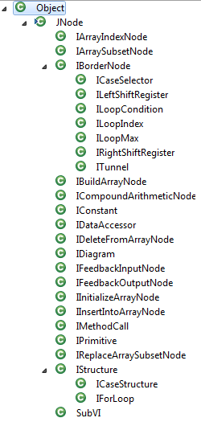
FIG.2.2 Type Hierarchy of my own DFIR representation
For the Dfir_parser package, it aims at building an object of IDiagram by parsing the XML IR. Remember that there are several built-in XML parser in java, which are DOM, SAX, JAXP and etc. Here I choose DOM XML parser because it can return a tree structure of the input XML file and offer access and manipulation to the elements. For example, after you import some packages like javax.xml.parsers.*, you use these following codes shown in FIG.2-3 to to parse the input XML file and validate it using the designed XML schema.
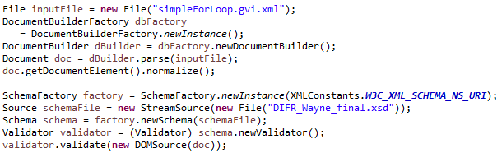
FIG.2-3 A code example of parse and validate XML file
After you parse the XML file, you can use some methods like getElementsByTagName or getAttribute to access to the information you want to gather inside the XML file. According to my DFIR representation, a IDiagram representing the diagram in LabVIEW Comms will be generated in the end.
For the Converter package, it is the core algorithm in this project. It takes a IDiagram created by the Dfir_parser package as input and convert it into C++ code which implement the same function as the G code in LabVIEW Comms. This core algorithm mainly involves two phases. The first phase is using the topological sorting algorithm to sort the order of the nodes. The second phase is to process sequentially the nodes that have been sorted by the second phase and output the C++ codes.
In the Main package, it has a main function which decide to take what XML file as input and parse the XML file. Then it invoke the Dfir_Parser to create an object of IDiagram and use the Converter to output the C++ codes.
For more detail information of these important algorithms, they will be elaborated in the next chapter.

Detail algorithms
Last chapter mainly discuss the reason and meaning of this paper and also the solution for designing a XML IR. At the same time, it has given a general description for the solution for designing a compiler. In this chapter, we will dive into an in-depth introduction for the details behind this compiler.

My DFIR representation
As you see in the FIG.2-2 in chapter three, the number of class to represent the DFIR inside my designed compiler is huge. Thus it is impractical to give detail introductions to each node. I choose a couple of important nodes to explain, which are JNode, ITerminal, IDataType, IDataAccessor, IConstant, ICompoundArithmeticNode, IPrimitive, IForLoop, IFeedback pair nodes, ICaseStructure JNode and IDiagram.

JNode
JNode is the superclass for all the other nodes inside my DFIR representation, which implement it and share lots of common fields and methods with JNode. The reason why it is named as JNode is that I want to distinguish it with INode in DFIR.
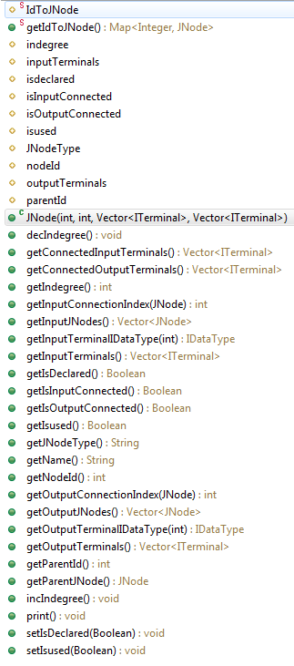
FIG.3-1 Type hierarchy of JNode
FIG.3-1 shows the type hierarchy of the JNode class. The yellow label of the fields indicates they are protected type, while the green label of the methods means they are public type. The two red ‘S’ behind the first two elements in the list show that they are static type and thus should be accessed by the JNode class itself instead of the specific JNode object. These two provide a map from its nodeId and itself.
The indegree field is used to indicate how many input connections this node has. Besides, it provides decIndegree and getIndegree public methods to decrement this field and get it from the outside. The main purpose for them is that as we will use topological sorting algorithm to sort the order of nodes, it is necessary to know this information and then manipulate this field.
In order to make sure the process order in my designed compiler, I add two fields, which are isused and isdeclared, to indicate whether this node has been used or declared in my processing system.
It has isInputConnected and isOutputConnected two Boolean type to represent whether its input terminal and output terminal have connections with other nodes, JNodeType to tell what is its type, and nodeId, parentId, inputTerminals, outputTerminals to refer to its identity and terminal information. Also, it has corresponding public get methods to provide access to them from the outside. FIG.3-2 is the construction function for JNode
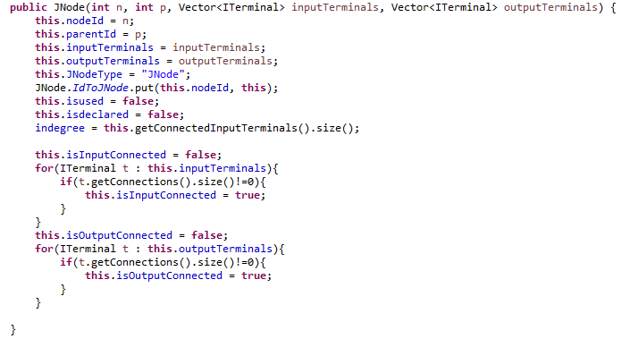
FIG.3-2 The constructor function of JNode
Aiming at simplifying the processing system, JNode also provides some helpful public methods for the compiler.
This getName method is used to get the label for this name inside the compiler. For example, sometimes a temporary variable need to be declared for the result of an add computation, we can use getName method in this add node to name this temporary variable. Usually, it returns a string of its node type plus nodeId.
The getConnectedInputTerminals and getConnectedOutputTerminals methods will return terminals which have connections with other nodes. Because in some case it is possible and allowed to leave a terminal without connected. For example, for the IFeedbackOutputNode, its init terminal can have no connections legally, for which we will use the default value 0.
The getInputConnectionIndex and getOutputConnectionIndex methods are used to get the connection index which is connected with JNode n. Notice the implementation for these two methods is different. The reason behind this is that for an input terminal, it can have only one connection with another node, while an output terminal can have multiple connections with many other nodes
The getInputTerminalIDataType and getOutputTerminalIDataType methods is to get the datatype for the terminal given the specific index, which will be used to declare the node that own this terminal.

ITerminal
ITerminal class represent the terminal information in my DFIR representation. It stores terminalId and terminalIndex to refer to its identity, iDataType to indicate which data type it is, connections vector to record its connections information with other node, and a map IdToITerminal to construct a corresponding relationship between its terminalId and itself. FIG.3-3 is the constructor for ITerminal.
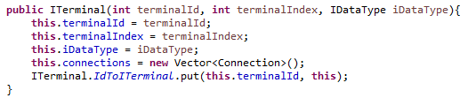
FIG.3-3 The constructor for ITerminal

IDataType
In the DFIR, it supports a collection of data types, which are shown in Table.2-1.
For ISignedInt and IUnsignedInt, they have an field WordLength to indicate the length of itself. For ISignedFixedPoint and IUnsignedFixedPoint, they have LeftLength and RightLength to show how many bits they have before the decimal points or after. For IArray and IVariableSizedArray, they have Dimensions and ElementType, which is the data type of the element of this array. For IFixedSizeArray, it has one more field, which is ArraySize. For IComplex, it has ElementType to indicate the data type for its real value and imag value, which have the same datatype. Apart from the above, other IDataTypes have no fields but only the name to record corresponding information for its data type.
My designed compiler focuses on the VIs which are targeted on FPGA and thus have less supported nodes when compared to the VIs which are targeted on PC. For example, when targeted on FPGA, it supports fixedpoints instead of double or single for decimal number, one-dimension array instead of multi-dimension array.
When translating the data type in the DFIR into data type in C++, I decide some rules to do it.
For the ISignedInt, I change it into short, int or long according to the WordLength. For the IUnsignedInt, I change it into unsigned short, unsigned int or unsigned long according to the WordLength. Their implementation is shown in FIG.3-4.
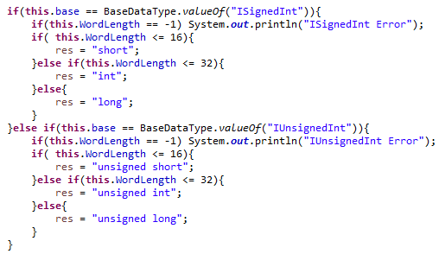
Fig.3-4 Type transformation for ISignedInt and IUnsignedInt
Besides, I change all the fixedpoints into double and IBoolean into bool. For IComplex, I decide to use complex inside the C++ libraries. For the array, I decide to create an Array class shown in FIG.3-5 to represent it.
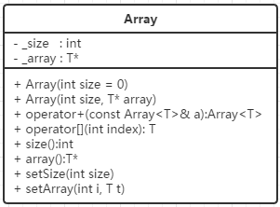
FIG.3-5 UML of Array class
It is because in LabVIEW Comms, the way to use array is a little bit different from that in C++. For example, in C++ when you declare an array you must specify the size of it which in LabVIEW Comms you have no need to set the size before you use it. Besides, by creating my own Array class I can override the input or output operator to handle the input or output for the array easily and simply. Furthermore, in LabVIEW Comms, two array with different size can be added together and the result is an array whose size is the minimum of those two array’s size. Thus operator + should be overridden for this special case.

Some derived classes of JNode

IDataAccessor
There are two types of IDataAccessor, which can be used as control or indicator. It can be seen as input or output for the VI and it will be called input IDataAccessor or output IDataAccessor according to the direction. It is also derived from the JNode and has its two own fields, which are name set by the user and the direction to reveal the type of this IDataAccessor.

IConstant
IConstant can only be used as a right value. It has its own field called value, which store the value of this IConstant. It can be a int, double, Boolean, complex or array. Usually we can use the value of it to represent itself when translated into C++ code. But if the data type of its value is complex or array, we should declare it first before using it.

ICompoundArithmeticNode
ICompoundArithmeticNode is the computation operator representation in the DFIR, which can have flexible number of input terminals from two to multiple and only one output terminal. It has a field named mode, which may be one of Add, Multiply, Or, And and Xor. Besides, it has invertedInputs, a vector of Boolean value, to indicate whether the corresponding input terminal is inverted or not and invertedOutput for the output terminal. Here you should be careful about the meaning of inverted. For addition operator, it means negating the value that is passed to that terminal, for which FIG.3-6 gives an example. For multiply operator, it means turning the value x into 1/x. For the Boolean operator, it turns false into true or true into false.
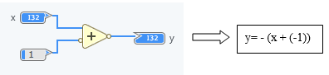
FIG.3-6 An example of inverted addition

IPrimitive
IPrimitve is very similar to JNode because the only difference between them is that it has one more field which is mode, a very important field to distinguish it from the other IPrimitives. Actually, the collection of IPrimitive is very big. The whole set of different IPrimitives are listed in the Table.3-1.
Table.3-1 All modes of IPrimitve
Category | Included modes
Numeric | ExSubtractPrimitive, ExDividePrimitive,  ExSelectPrimitive, ExIncrementPrimitive,  ExDecrementPrimitive, ExAbsoluteValuePrimitive,  ExAddArrayElementsPrimitive, ExScaleByPowerOf2Primitive,  ExSquareRootPrimitive, ExSquarePrimitive,  ExNegatePrimitive, ExReciprocalPrimitive,  ExMaxAndMinPrimitive,
Complex | ExComplexConjugatePrimitive, ExPolarToComplexPrimitive,  ExComplexToPolarPrimitive, ExReOrImToComplexPrimitive,  ExComplexToReOrImPrimitive, ExReOrImToPolarPrimitive,  ExPolarToReOrImPrimitive,
Comparison | ExIsEqualPrimitive, ExIsEqualTo0Primitive,  ExIsNotEqualPrimitive, ExIsNotEqualTo0Primitive,  ExIsGreaterPrimitive, ExIsGreaterThan0Primitive,  ExIsGreaterOrEqualPrimitive, ExIsGreaterOrEqualTo0Primitive,  ExIsLessPrimitive, ExIsLessThan0Primitive,  ExIsLessOrEqualPrimitive, ExIsLessOrEqualTo0Primitive,
Boolean | ExNumberToBooleanArrayPrimitive, ExBooleanArrayToNumberPrimitive,  ExBooleanTo0Or1Primitive, ExNotPrimitive,  ExImpliesPrimitive, ExAndArrayElementsPrimitive,  ExOrArrayElementsPrimitive,
Array | ExRotate1DArrayPrimitive, ExReverse1DArrayPrimitive,  ExArrayMaxAndMinPrimitive, ExSplit1DArrayPrimitive,  ExArraySizePrimitive,
Trigonometric | ExSinePrimitive, ExCosinePrimitive,  ExInverseTangent2InputPrimitive, ExSineAndCosinePrimitive,
Data manipulation | ExSplitNumberPrimitive, ExJoinNumbersPrimitive,  ExSwapBytesPrimitive, ExSwapWordsPrimitive,  ExRotateLeftWithCarryPrimitive, ExRotateRightWithCarryPrimitive,  ExLogicalShiftPrimitive, ExRotatePrimitive,  ExReinterpretNumberPrimitive,
Conversion | ExToSigned8BitIntegerPrimitive, ExToSigned16BitIntegerPrimitive,  ExToSigned32BitIntegerPrimitive, ExToSigned64BitIntegerPrimitive,  ExToUnsigned8BitIntegerPrimitive, ExToUnsigned16BitIntegerPrimitive,  ExToUnsigned32BitIntegerPrimitive, ExToUnsigned64BitIntegerPrimitive,  ExToFixedPointPrimitive, ExToComplexFixedPointPrimitive

IForLoop
IForLoop is a IStructure type in the DFIR, which can have IBorderNodes and IDiagrams inside. To be more specific, it can have only one IDiagram as its direct child and one ILoopIndex, one ILoopMax and a set of ITunnels, ILeftShiftRegisters and IRightShiftRegisters.
In addition, for ITunnel, it has direction to indicate whether it is input or output while ILeftShiftRegisters can only be input and IRightShiftRegisters can only be output. Thus I create inputBorderNodes to store input ITunnels and ILeftShiftRegisters and outputBorderNodes to store output ITunnels and IRightShiftRegisters. Since IForLoop actually has no input terminals or output terminals, the indegree of IForLoop should have another way to compute, which equals to the sum of indegree of its input border nodes. FIG.3-7 is the constructor function for IForLoop.
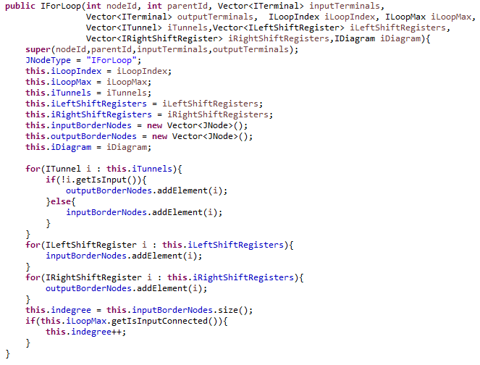
FIG.3-7 The constructor function of IForLoop
For ITunnel, it has a Boolean field named isInput to show its direction, innerTerminal and outerTerminal represent its specific terminal connected to nodes inside or outside this IStructure. Furthermore, it has two IndexingMode, which are Indexing and NonIndexing. What do they mean? For the Indexing input ITunnel inside an IForLoop, if the value passed to its outerTerminal is an array of int, the value for its innerTerminal will be int. in the contrary, for the Indexing output ITunnel inside an IForLoop, if the value passed to its innerTerminal is int, the value for its outerTerminal will be an array of int. For the NonIndexing, the value for its innerTerminal or outerTerminal is in the same type. As FIG.3-8 shows, the tunnel on the left and the upper tunnel on the right is Indexing mode while the lower tunnel on the right is NonIndexing mode. For the former, its inner terminal’s data type is int while its outer terminal’s data type is array. For the latter, the data type of both of inner terminal and outer terminal is the same.
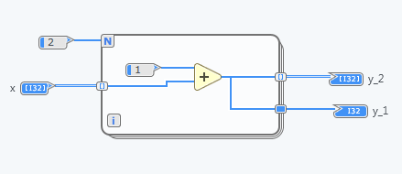
FIG.3-8 An example of Indexing ITunnel and NonIndexing ITunnel
For ILeftShiftRegister and IRightShiftRegister, they always occur in pair. Member of a pair of terminals that passes a value from one iteration of a loop to the next iteration. After the initial loop iteration, the left shift register in the pair returns the value it receives from the right shift register from the previous iteration. There is an AssociatedRightShiftRegister for ILeftShiftRegister and AssociatedLeftShiftRegister for IRightShiftRegister to relate them together as a pair
One special feature for ILeftShiftRegister is that it can have many input terminals, which will introduce some difficulty when designing the compiler.

IFeedback pair nodes
In the DFIR, there are two nodes in fact to represent one feedback node in the LabVIEW Comms, which are IFeedbackInputNode and IFeedbackOutputNode. These feedback pair nodes usually appear in the IDiagram of IForLoop. It stores data from one execution or loop iteration to the next by default. You can set the Delay of this node to store n samples of data by delaying the output of the node for multiple executions or iterations. If you increase Delay to more than one execution or iteration, the node outputs only the initial value.
Each of them has a field to relate to the other, which are inputNode for IFeedbackOutputNode and outputNode for IFeedbackInputNode. For the IFeedbackInputNode, it has two more fields than that in IFeedbackOutputNode, which are delay and isFeedbackDeclared.
Also, the terminals of them are different. IFeedbackInputNode has one input terminal to get the input for these IFeedback pair nodes and no output terminal which IFeedbackOutputNode has one input terminal to pass the initial value and one output terminal to give the output of these IFeedback pair nodes

ICaseStructure
ICaseStructure is another IStructure node in the DFIR. Compared with the IForLoop, it has less types of IBorderNodes and more IDiagrams. In other words, it can have one ICaseSelector, a set of ITunnels as its border nodes and a set of IDiagram according to the number of cases it has. Its constructor function is displayed in FIG.3-9.
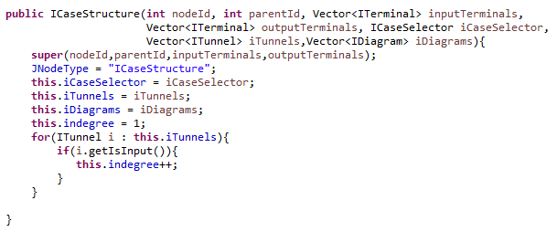
FIG.3-9 The constructor function of ICaseStructure
ICaseSelector is the IBorderNode type that only ICaseStructure can uniquely have. It stores the information of how to map the case expression into corresponding IDiagram which represents each case for ICaseStructure. It has a field named defaultDiagramIndex to indicate which IDiagram is default, and a set of Range to store the mapping information.
One special feature for the output ITunnel in the ICaseStructure is that it can has more than one innerTerminals, which should be considered when designing the compiler.

IDiagram
IDiagram can be regarded as a container for nodes. Every VI in LabVIEW Comms has one and only one IDiagram as its top level element. However, IDiagram can occur nested when this VI contains IForLoop or ICaseStructure, which can have IDiagram as its sub element. Therefore, although IDiagram is also derived from JNode, but it has lots of different characteristics. For example, it does not have any input terminals or output terminals. It can contain zero or multiple nodes which can be one of ICompoundArithmeticNode, IDataAccessor, IConstant, IForLoop, ICaseStructure, IMethodCall, IPrimitive, IFeedbackOutputNode, IFeedbackInputNode, or the set of array operation nodes (IArrayIndexNode, IReplaceArraySubsetNode, IInsertIntoArrayNode, IDeleteFromArrayNode, IInitializeArrayNode, IBuildArrayNode, IArraySubsetNode). Also it has its own attribute which is diagramIndex. This information will be used in ICaseStructure that can contains a set of IDiagrams. Its constructor function is shown in FIG.3-10.
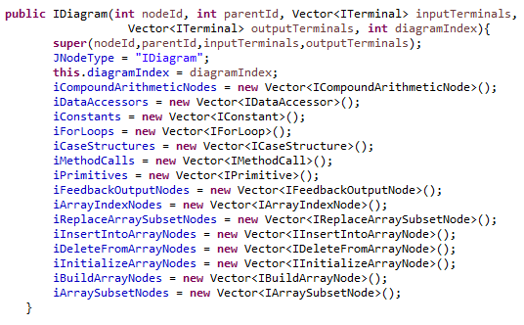
FIG.3-10 The constructor function of IDiagram

My DFIR parser
My DFIR parser aims at parsing the XML input file and then generating the corresponding DFIR representation in my compiler. As I have described above, every VI in LabVIEW Comms can be regarded as an IDiagram and IDiagram can occur nested. Therefore the main function here is GetIDiagram(Node n) while several subroutines are also provided to help parse the specific part of the XML file, such as GetIDataType (Element e), GetITerminal (Element e), getNodeId(Element eElement), getParentId(Element eElement) and getBothTerminals (Vector<ITerminal> InputTerminals, Vector<ITerminal> OutputTerminals, Element eElement). Below I will demonstrate GetITerminal(Element e) and GetIDiagram(Node n)

GetITerminal
Apart from some IStructure type nodes, all the nodes have terminals to be connected with other nodes. Thus ITerminal is a pretty prevalent class and it is helpful to create a subroutine to parse it. FIG.3-11 shows the details of this subroutine. Here I use GetIDataType to generate the data type of this terminal.
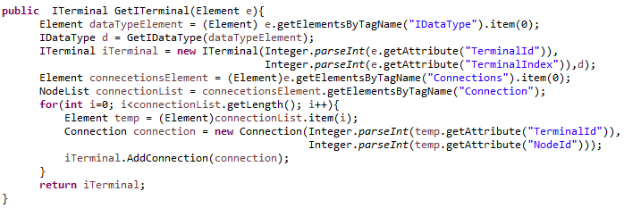
FIG.3-11 The implementation of GetITerminal (Element e)

GetIDiagram
IDiagram is big container holding a variety of nodes. It has three simple attributes and a flexible set of various nodes. Thus in order to declare it, it is necessary to declare the nodes that it has in advance. After we have a long list of nodes needed to be declared and implemented. FIG.3-12 is an example of how to get a set of nodes of a specific type.
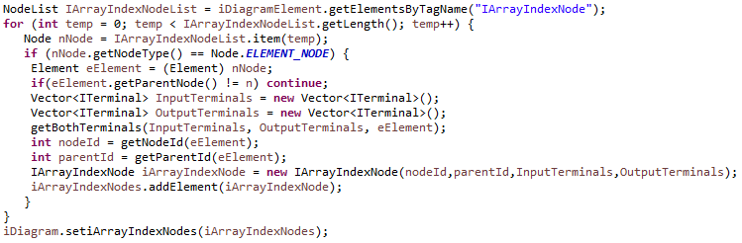
FIG.3-12 An example of how to get a set of IArrayIndexNodes
In FIG.3-12, I use getBothTerminals subroutine to generate the input terminals and output terminals for the given node. The important point here is that we should make sure that this node is the direct children of this IDiagram. Because the given function in java’s DOM parser getElementsByTagName can get the NodeList of all the sub elements having the corresponding tag name under the current element, which may be great children of the current element instead of the direct children. Here I use the expression (if (eElement.getParentNode()! = n) continue;) to fulfill this purpose. Remember that eElement is the node under IDiagram n.

Convertor
After generating the DFIR representation, the next step to do is to convert the information stored in IDiagram to C++ code, which has the same function. This is the most difficult and challenging part of my designed compiler. The G language, which is a graphical programming language, greatly differs from textual programming language like C++. For example, a node in G executes only when it receives data for all required inputs. But in C++ you cannot find this logic.
In order to simulate the running order of nodes in G, we should decide the sequence of code in C++ carefully. As G is represented a graph in LabVIEW Comms, the most proper way to process it should be using some classical graph algorithms. Remember that the characteristic of data flow G is that a node executes only when it receives data for all required inputs. Therefore, it is natural to use topological sorting algorithm to sort the order of nodes to be processed.
In fact, I have tried to use the processing logic of from back to front, which is the opposite of topological sort. However, it is hard to be managed when the collection of node processed become large. Worse still, you should create lots of subroutines to handle some special cases. In the end, it is proved to be impractical to use.
In my convertor, there are two main parts which are the topological sort for the nodes and the processing method using the result given by the topological sort.

Topological sort
As the FIG.3-13 shows, the first step of topological sort is to get the nodes which have no indegree. In our case, it means to get the nodes which have no input terminals, such as IConstants, input IDataAccessor and ILoopIndex inside the IForLoop. Then the second step is to process every node to get the sorting result according to the algorithm shown in FIG.3-13. The proper data structure to be used here is queue.
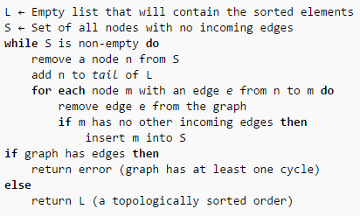
FIG.3-13 Pseudocode of topological sort
Remember that the IDiagram can occur nested, thus the designed algorithm should handle both the top level IDiagram and the nested IDiagram. I use isTopIDiagram, a Boolean type, to indicate whether it is the top level IDiagram or the nested IDiagram.

Get the list of zero indegree nodes
For the top level IDiagram, we just need to consider the IConstant, input IDataAccessor and IFeedbackOutputNode (if needed) to get the list of zero indegree nodes. Although the IStructure like IForLoop and ICaseStructure also have no input terminals, they cannot be included because they cannot appear before their input border nodes have been connected. In other words, the occurring order of them should be decided by other nodes. So even though they have no input terminals, they have virtual input connections
For the nested IDiagram, we should consider of more nodes except the above nodes considered for the top level IDiagram. Specifically, for the IDiagram in IForLoop, we should add input ITunnels and ILeftShiftRegister to list of zero indegree nodes. Besides, ILoopIndex and ILoopMax should be added when they have output connnections. For the IDiagram in ICaseStructure, we should incorporate ICaseSelector and input ITunnels when they are connected with the nodes inside this IDiagram. It is because of that sometimes they have no connections with the nodes inside the specific IDiagram.

Sort order by the list of zero indegree nodes
After getting the list of zero indegree nodes, we should apply the topological sorting algorithm to sort the order of this list. For the general nodes like IDataAccessor or IConstant, the processing method is pretty simple. It is important to note that some special nodes should be taken into careful consideration, which are IForLoop, ICaseStructure and their border nodes, which are ITunnel, ILeftShiftRegister, IRightShiftRegister and ICaseSelector. Another three special nodes should be added are IFeedbackInputNode, IFeedbackOutputNode and the output tunnel for ICaseStructure.
Technically, we can regard IForLoop and ICaseStructure have virtual input connections. The indegree of them should equal to the sum of indegree of all their input border nodes. Thus when we apply decIndegree method to the input border nodes of IForLoop or ICaseStructrue, we should decrement the indegree of the IForLoop or ICaseStructrue. When the virtual indegree for them equal to zero, they should be added into the list.
Similarly, there are also virtual outdegree for IForLoop or ICaseStructrue. So when the queue pop one of them, we should add its output border nodes into the list.
Importantly, we should notice that when popping the input border nodes before entering the IForLoop and ICaseStructure, it is not allowed to decrement the indegree of its connected nodes. Since they belong to the IDiagram inside the IForLoop and ICaseStructure instead of outside them, these nodes should be processed when entering the IForLoop and ICaseStructure. Similarly, when popping the output border nodes after entering the IForLoop and ICaseStructure, we should not decrement the indegree of its connected nodes which are outside the structure and should be handled outside.
When popping the IForLoop or ICaseStructure, it is necessary to add its output border nodes into the sorting list, ensuring the sorting procedure can move on and cover the nodes at the back of the IForLoop or ICaseStructure.
Therefore, when computing the indegree of the IFeedbackOutputNode, we should automatically add one for the virtual connection with IFeedbackInputNode. Similarly, when popping the IFeedbackInputNode in topological sort, it is necessary to decrement the indegree of the IFeedbackOutputNode
For the output tunnel in ICaseStructure, it usually has multiple input terminals whose number is the same as the number of cases this ICaseStructure has. For example, one ICaseStructure has four cases and one output terminal which is connected in all the four cases. Thus the indegree of this output tunnel is four. But actually it has only one indegree in every case or in other words IDiagram. Thus we should design another rule to decide the indegree of this special node.

Process all nodes in topological order
After we apply the topological sorting algorithm and get the list of nodes in topological order, it is time to process them in this order and convert them into a sequence of C++ code.
Since the collection of all the nodes appear in a IDiagram is large, we should classify them into several categories shown in TABLE.3-2, which have similar process logic for each categories. In order to tell whether this node is declared or used into C++ code, we use two Boolean values isdeclared and isused which are fields of JNode class. Here the definition of right value and left value is similar to that in C++. A right value can only appear in the right part in an expression and cannot be assigned value. Instead, a left value can only appear in the left part in an expression and can be assigned value. Usually, a node which can serve as left value also can be served as a right value.
TABLE.3-2 Categories for process
Category | Class included
Only right value | IConstant, ILoopIndex
Both right value and left value | IDataAccessor, ITunnel, ILeftShiftRegister, IRightShiftRegister, ILoopMax, ICaseSelector,
Operator | ICompoundArithmeticNode, IPrimitive(mode=ExSubtractPrimitive), IPrimitive(ExDividePrimitive)
Encapsulated function | All the other IPrimitives, all the array operation nodes
Feedback pair nodes | IFeedbackInputNode, IFeedbackOutputNode
For loop | IForLoop
Case | ICaseStructure

Only right value
Usually there is no action happening for these nodes and they will be used when processing its sink connected nodes. But for IConstant whose type is IArray, IVariableSizedArray, IFixedSizeArray and IComplex, we should declare them and set the isdeclared field into true.

Both right value and left value
Since nodes in this category can serve as both right value and left value, there are two different actions happening when they are processed as right value or left value. When these nodes are processed as right value, they will not be used until their sink connected nodes are processed. When one node named A is processed as a left value, there is a C++ code “A = B;” generated from itself and its source connected node named B.
However, since different nodes in this category have their own characteristics and various function, there are some special cases needed to be aware of.
For the ITunnel, it owns two special cases when it is an indexing ITunnel or an output ITunnel for ICaseStructure. Remember that ITunnel has a mode to decide whether it is indexing or not. When it is an indexing ITunnel, the dimension of data type for its inner terminal and outer terminal are different. Thus we should declare them into different types. When it is an output ITunnel for ICaseStructure, since it has many input terminals, we should decide which its source connected node ought to be used under the given IDiagram. There is a helpful fact that the terminal index is in the same order of the IDiagram index, so we can get the right source connected node by using the IDiagram index.
For the ILeftShiftRegister, it can have many input terminals which can hold different value passed from the same IDiagram. So when processing this node as left value, we should traverse all its input terminals and generate the C++ code for each terminal which is not used. It is important to note that here instead of having a field of isused for ILeftShiftRegister, it has one isused for every input terminal of this node.
For the IDataAccessor name A, when it is processed as a right value, we should declare it and create C++ input code “cin >> A;”. When it is processed as a left value, we should create C++ output code “cout << A;” for it after it is processed or its isused field is true.

Operator
There are ICompoundArithmeticNode, IPrimitive (mode=ExSubtractPrimitive), IPrimitive (ExDividePrimitive) included as operator. Interestingly, the subtraction and division nodes are separated from the other operator like addition or multiplication. The reason behind this is that for addition or multiplication, the order of operands can be random and have no impact on the result and thus it can be extended into multiple input terminals. However, the order of operands for operator like subtraction and division really matters and also cannot be extended as the former. In general, they are all the common operators, for which I combine them into the same category and use a unified method to process them. There are one more difference between them is that for terminals of ICompoundArithmeticNode, they can be inverted, while the terminals do not have this feature.
The process action for operator is a little bit complicated when compared with other nodes. It should serve as a left value firstly and then as a right value. Thus there are two main actions happening here, which are tracing back to get the left value and tracing front to get the operands.
There are two ways to get left value. One is to use the name of one of its sink nodes as the variable name for left value when this sink node can serve as a left value, such as an output IDataAccessor, ITunnel and so on. For example, in FIG.3-14 the multiply node trace back will encounter an IDataAccessor named y and thus it will y as its left variable. Another is to create a temporary variable name for this operator when all its sink nodes cannot serve as left value alone. After getting the variable name for the left value, the mapping information of from this operator to this name will be recorded into a map called JNodeToName. For example, in FIG.3-14 the addition node trace back will face the multiply node, which is also an operator and cannot serve as left value alone. It will create a temporary name (i.e. ICompoundArithmeticNode1) for itself as its left variable. Then the mapping information from the addition node to this name will added into JNodeToName.
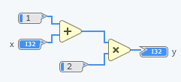
FIG.3-14 An example for operator node
There are three ways to get operands. We should be aware of that the operator node have more than one input terminal which can only be connected with only one nodes, and only one output terminal which can be connected with many nodes. For each of its source connected node, if it is an IConstant, its direct value or its name if it has been declared will be used as the operand, like the constant 1 and 2 in FIG.3-14. If it is a node that can serve as right value, its name will be used as the operand like and IDataAccessor named x. Actually there are diverse way to generate the name for different right value nodes, which will be elaborated in the next section. Finally, if it is also an operator node, the name mapped from this operator in the map named JNodeToName will be used. For example, in FIG.3-14 when the multiply node trace back, it will get one input node which is the addition node, then it will use the name that is mapped by this addition node in JNodeToName as one of the right variable.
After getting the names for all the operands and left variable, the next step is to combine them into an expression in C++. I create a map the mode of this operator to its corresponding character. For example, map the mode “Add” into “+”. Then use this operator character to combine all the operands to get the whole right expression. Finally use the “=” to connected left variable with the whole right expression. Please note that if the terminal of ICompoundArithmeticNode is inverted, remember to invert that value related to that terminal. In FIG.3-14, it will be converted into ICompoundArithmeticNode1 = 1 + x and y = ICompoundArithmeticNode1 * 2.

Feedback pair nodes
IFeedbackInputNode and IFeedbackOutputNode represent the same feedback node in the LabVIEW Comms and thus they share some same features. In my compiler, I use a vector to store the data from the current iteration to former iterations and add a field to tell whether this vector has been declared. This information is stored in IFeedbackInputNode but can be accessed by IFeedbackOutputNode as well thanks to its inputNode field.
Feedback pair nodes are processed separately. When IFeedbackInputNode is processed, it will declare the vector first and then process it as a left value to trace front to generate an expression in C++. Then this input will be pushed into the back of that vector. When IFeedbackOutputNode is processed, its initial terminal will be used as a left value to get an expression if it is connected. If it is not connected, the default value for the initial value is zero. Then it will call getValueFromFeedback subroutine in the FIG.3-15 to get the value for the output of this feedback pair. Before using this subroutine, the name of the variable to store the value of this output should be declared firstly. If this feedback pair does not appear in the IDiagram of IForLoop, we should set the current loop index into zero.
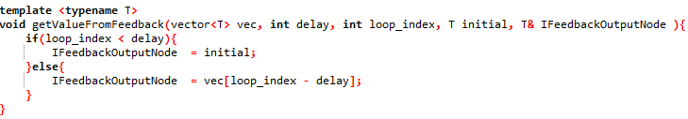
FIG.3-15 The implementation of getValueFromFeedback
It is important to note that when this feedback pair appear in the IDiagram of the IForLoop, we should declare the vector, which will store the data over many iterations, outside the for loop. FIG.3-16 is an example of a feedback node inside a for loop. As it shows, the vector Feedback16 should be declared in front of the for loop.
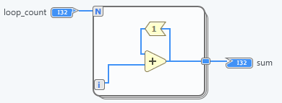
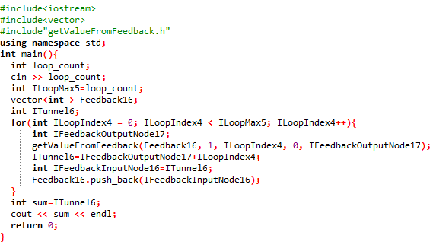
FIG.3-16 An example for feedback pair nodes

Encapsulated function
All the other IPrimitives except those whose mode is ExSubtractPrimitive or ExDividePrimitive and all the array operation nodes (IArrayIndexNode, IReplaceArraySubsetNode, IInsertIntoArrayNode, IDeleteFromArrayNode, IInitializeArrayNode, IBuildArrayNode, IArraySubsetNode) will be treated unified as an encapsulated function. Their implementations are written in a separate file, which will be included in the output C++ code when at least one of them is used inside the IDiagram.
When calling one of these function in the output C++ code, it is necessary to create a unified calling sentence. The key task here is to generate the list of parameters passed into that function. Since a node in this category may have many input terminals and many output terminals, we should treat them differently. For the input terminals, the variables or constants passed to them have been declared or generated and thus there is no need to declare them in front of the calling sentence. For the output terminals, at this point they have not been declared or generated, so declaring them first in front of the calling sentence is necessary. The unified function declaration for an IPrimitive node is that:
void mode (T& p0, T&p1,…,T&pn, T&q0, T&q1,…,T&qm);
Mode is the mode field of IPrimitive, which has n+1 input terminals and m+1 output terminals. T stands for the data type for this terminals and the parameter is passed by reference.
Below FIG.3-17 gives an example of a conversion of a diagram with some primitive nodes.
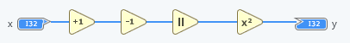

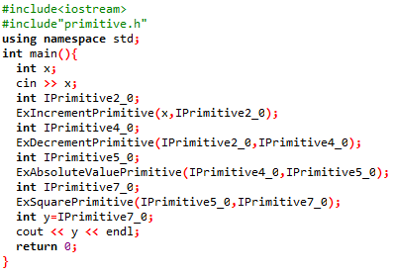
FIG.3-17 An example of a conversion for primitive nodes

For loop
IForLoop is an IStructure that can contain other IStructures nested in many levels. Thus it is helpful to recursively call the function for processing IDiagram for different IStructures and always be aware of what level of IDiagram it is currently.
Before entering the for loop, we should declare some nodes that are in the for loop but its value will be used outside the loop, which are output ITunnels and IRightShiftRegister. For the input ITunnels and ILeftShiftRegister, they will be declared before entering the for loop naturally. Also, if this IForLoop contains feedback pair nodes, we need to declare the vector for them first.
When entering the for loop, we should generate the for head expression first, which is “for (int ILoopIndex = 0; ILoopIndex < ILoopMax; ILoopIndex++)”. Actually the loop index and loop max will be labeled as the name of the ILoopIndex and ILoopMax in the IForLoop. Then the sentences inside the IForLoop will be generated by recursively calling the function for processing the IDiagram. After that, keep in mind that we should output the information of ILeftShiftRegister and IRightShiftRegister. FIG.3-18 is an example of how to print this information.
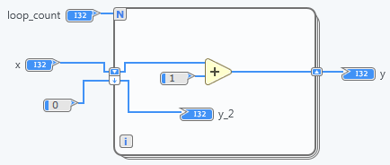

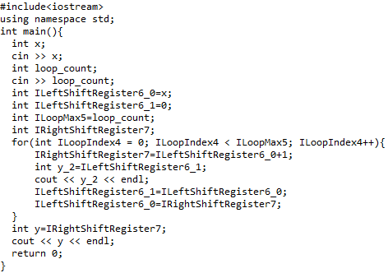
FIG.3-18 An example for IForLoop

Case
ICaseStructure is also an IStructure that can contain other IStructures nested in many levels. Therefore, recursively calling the function for processing IDiagram in it will be used for ICaseStructure as well.
Before entering the case structure, it is also necessary to declare some output border nodes similar to IForLoop. For ICaseStructure, it only has output ITunnels as its output border nodes.
How to translate the case structure in LabVIEW Comms into corresponding codes in C++? In fact, there is a switch sentence to implement the case structure in C++ like FIG.3-19.
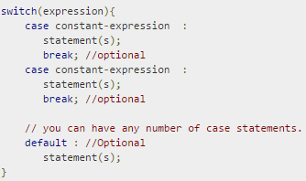
FIG.3-19 Case in C++
But there are some gaps between case structure in LabVIEW Comms and in C++. In LabVIEW Comms, you can set a range as a condition judgement mapped to a specific case, or many single values as a condition judgement mapped into to the same case, which is not compatible directly in C++. What’s more, the condition judgement is an expression which must be a constant or a literal in C++.
Therefore, in my design I choose to use if-else statement to implement the case structure.
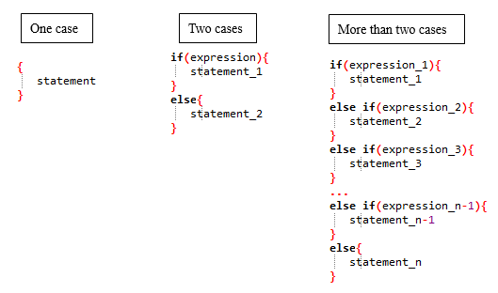
FIG.3-20 if-else statement in C++
If there is one case, I use the left structure in FIG.3-20 because if there is only one case in the ICaseStructure, it must be default and happen regardless of what the value passed to the ICaseSelector is. The middle structure in FIG.3-20 will be used for two cases and the right structure will be used for more than two cases. Here the number of cases equal to the number of IDiagram that this ICaseStructure has.
For the ICaseStructure that has only one case, you just need to call the function for processing the IDiagram for that case and wrap the result in a pair of brace. For the ICaseStructure that has n cases (n>1), the first step is to find default case by using a field defaultDiagramIndex of ICaseSelector and then print the information of the corresponding IDiagram in the else case. Next, we should generate the other n-1 expressions and print the information of the corresponding IDiagram under each case.

Different component systems
In last subsection I elaborate the actions when processing all the nodes sorted in topological order, this subsection will focus on some component systems used in this compiler design, which are labeling system, declaration system and code management system.

Labeling system
There are a variety of nodes in the LabVIEW Comms. So a unique name to distinguish one from the others is needed to be made. In the DFIR representation, every node has a field called nodeId to uniquely refer to its identity. However, it is illegal to use a number as a name for a variable in C++. Thus I create a public method of JNode getName () to return the name which can be used for its corresponding variable in C++, which is “JNodeType + nodeId”. This naming strategy can handle most of cases except some special cases. Table.3-3 shows whole labeling methods for different type of nodes.
Table.3-3 Labeling methods for different type of nodes
Targeted nodes | Naming method | Reason
Indexing ITunnel in the IForLoop | getName() + [ILoopIndex.getName()] (ILoopIndex has the same parentNode IForLoop as this ITunnel. | When an ITunnel is indexing inside a for loop, the dimension of the data type of its inner terminal and outer terminal is different.
ILeftShiftRegister | getName() + ”_” + Index (Index is the index in the vector of inputTerminals or outputTerminals, not the terminalIndex field of Terminal class.) | The ILeftShiftRegister can be extended into have many input terminals and many output terminals.
IDataAccessor | IDataAccessor.name | IDataAccessor hase a field of name set by the user.
Feedback pair nodes | “Feedback” + IFeedbackInputNode.nodeId | Feedback pair nodes share the same vector.
All the other nodes | getName() | The common strategy for nodes

Declaration system
Before using a variable in C++, you must declare it firstly. There are different ways to declare the nodes in the IDiagram. For example, you can declare all the nodes at the beginning. But in most cases we prefer to declare it when we are about to using it, especially for the temporary variable. Besides there are some nodes having no need to be declared. For example, when an ICompoundArithmeticNode is connected backward to an output IDataAccessor, we have no need to create a temporary variable name for this ICompoundArithmeticNode but to declare and use the name of that IDataAccessor. Furthermore, there are some special cases like the output border nodes for IForLoop or ICaseStructure, which should be declared before entering the structure. Table.3-4 show the declare methods for different nodes. Assuming the basic data type is int and the name from the getName () is “a” for the declaring example.
Table.3-4 Declaring methods for different nodes
Targeted nodes | Declaring example | Remark
Array IConstant | int a[] = {1,2,3} | Normal way to declare constant array in C++
Fixed size array IConstant | int a[3] = {1,2,3} | Normal way to declare constant array in C++
Complex IConstant | complex<int> a(1,2) | Complex is included from C++ library
Fixed size array variable | Array<int> a(3) | Array is a data type I create by myself
Array variable | Array<int> a | Array is a data type I create by myself
Complex variable | complex<int> a | Complex is included from C++ library
Feedback pair nodes | vector<int> a | If they are inside the IForLoop, remember to declare it before entering the loop
Indexing ITunnel in the IForLoop | Array<int> a | The data type of the outer terminal of an indexing ITunnel is Array.
ILeftShiftRegister | int a_0, a_1,…,a_n | Because ILeftShiftRegister can be extended into multiple input terminals and output terminals
Output border nodes for IForLoop or ICaseStructure |  | Declare it before entering the IForLoop or ICaseStructure
ICompoundArithmeticNode | int a | When it is backward connected a node which cannot serve as left value.
Nodes serving as left value | int a | There are two occasion when it is declared. One is when the compiler process an operator node which is connected to it. Another is when the compiler process it
I create a subroutine: String getDeclaration (JNode n, Boolean isInput, int index, String label, Boolean isReference) to implement the declaration. The first three parameters are used to get the data type of the terminal which has the corresponding index and direction in JNode n. Label is the variable name and isReference is used to decide the declaration mode whether it is a reference declaration or not.

Code management system
To output a sequence of neat and well-formed C++ code, we need pay attention to the indention and necessary part of a complete C++ program.
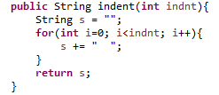
FIG.3-21 Indention subroutine
I use the subroutine listed in the FIG.3-21 to set the indention for the code. In my compiler, different levels of codes have its own certain indention.
A complete C++ program consists of included header file, using namespace statement and main function. I insert the list of C++ codes generated from the processing procedure into the main function. Then decide whether to include header file if necessary.
When the IDiagram processed includes IPrimitives node which are treated as an Encapsulated function, we should include primitive.h file into the output C++ file. Besides, when it includes array operation nodes, it is necessary to include array_operation.h.

My compiler
This package includes main function to execute the compiler. It decides which XML file and corresponding XML schema will be taken. Then a built-in XML DOM parser will be invoked to parse the file and return a Document object. Next a XML schema validator object will be generated and validate the Document object generated from the XML file. If it is validated, it will be passed to the DFIR parser and an IDiagram will be generated. If it fails to be validated, an error will be reported and abort the program. After an IDiagram was created, a Converter object will be generated and take that IDiagram as an input and then convert it into C++ codes. The procedure is shown in FIG.3-22.
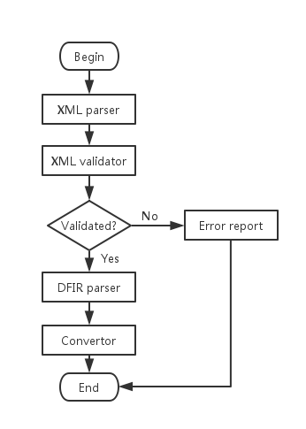
FIG.3-22 Procedure of the main function for compiler

Experiments and analysis
Last chapter, we have elaborate the details of designing the compiler to convert the G code in the LabVIEW Comms into C++ codes. In this chapter, we are going to do several experiments to evaluate the accuracy and effectiveness of this designed compiler.

Arithmetic computation
Arithmetic computation is a kind of popular type which appear in the diagram frequently and commonly. Apart from the computation for the Boolean data type, it consists of addition, subtraction, multiplication and division totally. In this section, a complex example about arithmetic computation in LabVIEW Comms will be given in FIG.4-1. This diagram includes different arithmetic operator nodes, the extension for an addition node, some inverted cases for addition nodes and multiplication nodes and different connection combination among nodes.
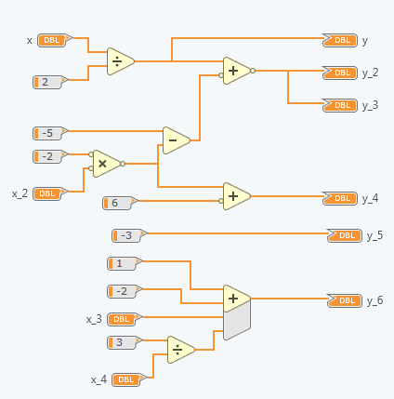
FIG.4-1 The diagram of arithmetic computations
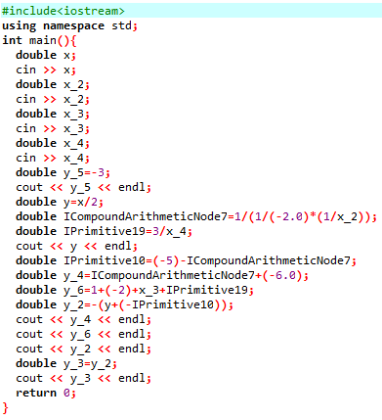
FIG.4-2 Output C++ codes for arithmetic computation
As FIG.4-2 shows, the output C++ codes declare the variable name according to the name of the IDataAccessor or the name of the operator nodes. After it declares a variable, it creates input sentence for it. Also, after the IDataAccessor has been used, it will generates output sentence for it. In this codes, we can find that it handles the inverted situation for addition nodes and multiplication nodes very well.
Since the LabVIEW Comms just output the result inside, we can only do the accuracy test manually. Below Table.4-1 shows 5 test for this compiler and we can find that the output of the generated C++ codes is the same of the output inside the LabVIEW Comms, which proves the accuracy of this compiler.
Table.4-1 The experiment result of arithmetic computation
Index | Input for both |  |  |  | Output in LabVIEW Comms |  |  |  |  |  | Output in C++
Index | x | x_2 | x_3 | x_4 | y | y_2 | y_3 | y_4 | y_5 | y_6 | y | y_2 | y_3 | y_4 | y_5 | y_6
1 | 1 | 3 | -2 | 5 | 0.5 | 0.5 | 0.5 | -12 | -3 | -2.4 | 0.5 | 0.5 | 0.5 | -12 | -3 | -2.4
2 | 0 | 2 | 1 | 4 | 0 | -1 | -1 | -10 | -3 | 0.75 | 0 | -1 | -1 | -10 | -3 | 0.75
3 | -2 | 3 | -3 | -1 | -1 | 2 | 2 | -12 | -3 | -7 | -1 | 2 | 2 | -12 | -3 | -7
4 | -6 | -3 | 1 | 2 | -3 | -8 | -8 | 0 | -3 | 1.5 | -3 | -8 | -8 | 0 | -3 | 1.5
5 | 5 | -3 | 4 | -2 | 2.5 | -13.5 | -13.5 | 0 | -3 | 1.5 | 2.5 | -13.5 | -13.5 | 0 | -3 | 1.5

Nested for loop with feedback pair nodes
For loop is another popular node in a diagram, which will be used frequently when comes to repeatedly computation or array. For the feedback pair nodes, they usually appear inside a loop, which can store the data from the last iteration or my iterations ago. In FIG.4-3, it gives an example of both for loop and the feedback pair nodes. The nested for loop inside is used to compute the sum of the index for each iteration pass to the outside, where there are shift registers and feedback node to accumulate this value again. The expected result should satisfy the equaling relation between the output value of shift registers and feedback node, since here they work in the same function.
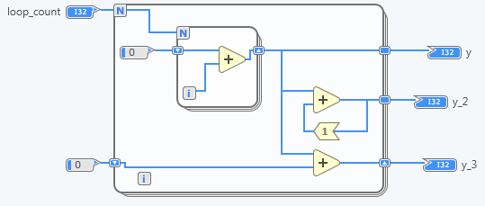
FIG.4-3 The diagram of a nested for loop feedback node

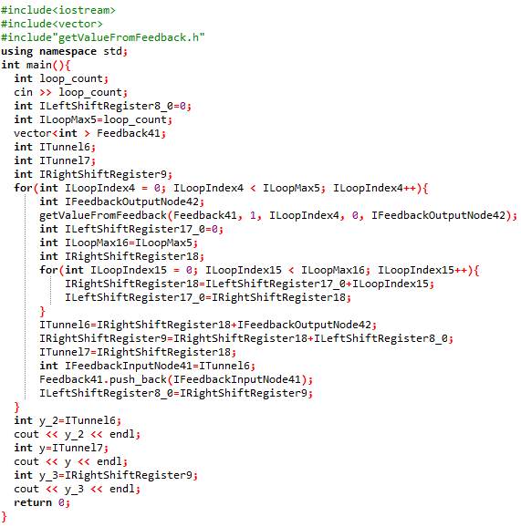
FIG.4-4 The generated C++ code for the nested for loop with feedback node
As FIG.4-4 shows, before entering the for loop, it declares the vector to store the data for the feedback node. Also, it includes the header file “getValueFromFeedback.h” to invoke that subroutine for the feedback node. The nested for loop is displayed neatly and clearly, which handles the codes for shift registers at the end of the body of the loop very well. Below Table.4-2 is the result of 5 experiments for this case, which can validate the correctness of this conversion to some degree.
Table.4-2 The result of experiments for nested for loop with feedback node
Index | Input | Output in LabVIEW Comms |  |  | Output in C++
Index | Loop_count | y | y_2 | y_3 | y | y_2 | y_3
1 | 2 | 1 | 2 | 2 | 1 | 2 | 2
2 | 5 | 10 | 50 | 50 | 10 | 50 | 50
3 | 11 | 55 | 605 | 605 | 55 | 605 | 605
4 | 49 | 1176 | 57624 | 57624 | 1176 | 57624 | 57624
5 | 101 | 5050 | 510050 | 510050 | 5050 | 510050 | 510050

Multiple Cases
Case structure is used usually for multiple judgement statements. Below FIG.4-5 gives an example of a case structure which has three cases. The top diagram is the default case. We can find that although the diagrams inside different cases are various, the outside of the case structure is the same. There are two types of case expression here. One is the range as the first and second diagram while another is the multiple single value in the third diagram in FIG.4-5.
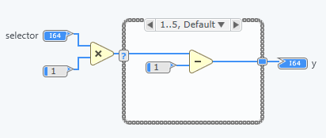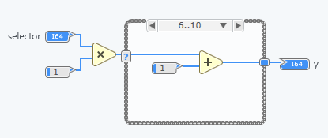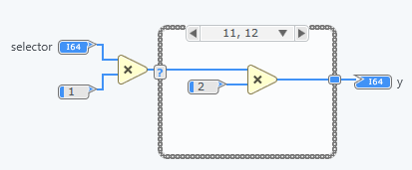
FIG.4-5 The diagram of case structure
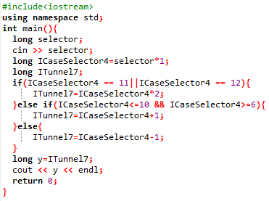
FIG.4-6 The generated C++ codes for case structure
In FIG.4-6 we can find that the default case is put under the else statement, while the other two cases is put under two case expressions. It handles the range case expression and the multiple single value case expression very well. Several experiments have been done and give the same output. Since this VI is much simpler and I neglect to display the experiment result here.

Conclusion and expectation
Last chapter, we have done several experiments to evaluate and prove the accuracy and effectiveness of this designed compiler. In this chapter, we will lead to a conclusion and reflect the drawback of this paper and expectation for improvement of this work in the future.

Conclusion
In this paper, I succeed in creating a XML IR for the DFIR in LabVIEW Comms and design a compiler to convert the G code in the diagram into the C++ code based on it. The XML IR can represent the enough information of the diagram and thus can be used to design more useful tools of plugins for the LabVIEW Comms, which allow more programmers who do not know the C# API called DfirExport can do some work based on it. My designed compiler can be a good example of the application of this XML IR. Currently, it can handle a large subset of nodes in the VI targeted on FPGA, such as arithmetic computation, nested for loop, case structure, feedback nodes and a set of IPrimitive nodes and array operation nodes.
However, there are also some disadvantages for my work. Firstly, since the collection of nodes in the VI is very large, I have not covered all of them. Secondly, as the data type in the LabVIEW Comms and C++ is a little different, it is difficult to convert the data type in the LabVIEW Comms to that in C++ identically. For example, in LabVIEW Comms you can use the fixed point data type but you cannot find that in C++. Thirdly, as LabVIEW Comms only output the result in the diagram and lack the tools to pass it outside, it is hard to do the evaluation automatically instead of manually. Thus it is hard to prove the accuracy absolutely. Finally, my compiler just a very basic version and it lacks optimizations to improve its performance.

Expectation
For the expectation of improvement of my work in the future, I need to come up with a better strategy to handle the type casting problems when converting the G code into C++. Besides, I need to cover the whole set of nodes in the LabVIEW Comms. Further more, a better way to do the evaluation should be considered of. Finally, several necessary and common optimizations should be added into this compiler to improve its performance.

Acknowledgements
First I express my sincere gratitude to my supervisors, Prof. Zhang Dong in Sun Yat-sen University (SYSU) and Prof. Brent Nelson in the Brigham Young university (BYU), for their dedicated guidance to my paper. They have walked me through all the stages of the writing of this paper. This paper could not have reached its present form without their help.
Second, I would like to extend my heartful gratitude to my semi mentor, Thomas Townsend who is a graduate student in Brigham Young university. He offered me valuable suggestions on how to design the compiler and what is the standard way to develop a big C# project and java project.
Third, I would thank Jiaxin Chen who work in a similar program with me. She has been accompanying me during the whole period of working on this paper and inspired me with some useful discussions.
Last my thanks would go to my beloved family for their loving care, great confidence and significant support to me all through these years. I also owe my sincere gratitude to my university (SYSU) which offered me tons of knowledge and give me the great opportunity to finish my paper partly in BYU. Besides, I would thank my friends and fellow classmates who make my life rich and colorful.

Reference
- Higa, M. L., and D. M. Tawy, "Introduction to LabVIEW", September 2001.
- Beyon, J. Y., LabVIEW Programming, Data Acquisition and Analysis, Prentice Hall PTR (Upper Saddle River, NJ), 2001.
- “NI LabVIEW Compiler: Under the Hood” Jul 29, 2010, [Online], Available:http://www.ni.com/tutorial/11472/en/.
- Wells, L.K. and T. Jeffrey, LabVIEW for Everyone: Graphical Programming Made Even Easier, Prentice Hall PTR, (Upper Saddle River, NJ), 1996.
- "Extensible Markup Language (XML) 1.0 (Fourth Edition)," 2006, [Online], Available: http://www.w3.org/TR/2006/REC-xml-20060816/
- Higa, M. L., D. M. Tawy, and S. M. Lord, "An Introduction to LabVIEW Exercise for an Electronics Class", Session T1D, 2002 Frontiers in Education Conference, Boston, Massachusetts, November 2002.
- E. Rahm, Hong-Hai Do, Sabine Maßmann - "Matching large XML schémas", ACM. SIGMOD vol. 33 , issue 4, Dec. 2004
- W3C, XML Schema Part 0: Primer Second Edition, http://www.w3.org/TR/ xmlschema-0/, 2004.
- W3C, XML Schema Part 1: Structures Second Edition, http://www.w3.org/TR/ xmlschema-1/, 2004.
- W3C, XML Schema Part 2: Datatypes Second Edition, http://www.w3.org/TR/ xmlschema-2/, 2004.

Appendix A

The schema of my XML IR
<?xml version="1.0" encoding="UTF-8" ?>
<xs:schema xmlns:xs="http://www.w3.org/2001/XMLSchema">

<xs:complexType name="ElementType">
<xs:sequence>
<xs:element name="IDataType" type="IDataTypeType"/>
</xs:sequence>
</xs:complexType>

<xs:complexType name="ISignedIntType">
<xs:sequence>
<xs:element type="xs:byte" name="WordLength"/>
</xs:sequence>
</xs:complexType>

<xs:complexType name="IUnsignedIntType">
<xs:sequence>
<xs:element type="xs:byte" name="WordLength"/>
</xs:sequence>
</xs:complexType>

<xs:complexType name="ISignedFixedPointType">
<xs:sequence>
<xs:element type="xs:byte" name="LeftLength"/>
<xs:element type="xs:byte" name="RightLength"/>
</xs:sequence>
</xs:complexType>

<xs:complexType name="IUnsignedFixedPointType">
<xs:sequence>
<xs:element type="xs:byte" name="LeftLength"/>
<xs:element type="xs:byte" name="RightLength"/>
</xs:sequence>
</xs:complexType>

<xs:complexType name="IArrayType">
<xs:sequence>
<xs:element type="xs:byte" name="Dimensions"/>
<xs:element name="Element" type="ElementType"/>
</xs:sequence>
</xs:complexType>

<xs:complexType name="IVariableSizedArrayType">
<xs:sequence>
<xs:element type="xs:byte" name="Dimensions"/>
<xs:element name="Element" type="ElementType"/>
</xs:sequence>
</xs:complexType>

<xs:complexType name="IComplexType">
<xs:sequence>
<xs:element name="Element" type="ElementType"/>
</xs:sequence>
</xs:complexType>

<xs:complexType name="IFixedSizeArrayType">
<xs:sequence>
<xs:element type="xs:byte" name="Dimensions"/>
<xs:element type="xs:byte" name="ArraySize"/>
<xs:element name="Element" type="ElementType"/>
</xs:sequence>
</xs:complexType>

<xs:complexType name="IDataTypeType">
<xs:choice>
<xs:element name="ISignedInt" type="ISignedIntType"/>
<xs:element name="IUnsignedInt" type="IUnsignedIntType"/>
<xs:element name="ISignedFixedPoint" type="ISignedFixedPointType"/>
<xs:element name="IUnsignedFixedPoint" type="IUnsignedFixedPointType"/>
<xs:element name="IArray" type="IArrayType"/>
<xs:element name="IVariableSizedArray" type="IVariableSizedArrayType"/>
<xs:element name="IComplex" type="IComplexType"/>
<xs:element name="IFixedSizeArray" type="IFixedSizeArrayType"/>
<xs:element name="IBit"/>
<xs:element name="IBoolean"/>
<xs:element name="IDouble"/>
<xs:element name="IIncorrect" />
<xs:element name="ISingle" />
<xs:element name="IString" />
<xs:element name="IUnknown" />
<xs:element name="IUnsupported" />
<xs:element name="IVoid"/>
</xs:choice>
</xs:complexType>

<xs:complexType name="ConnectionType">
<xs:simpleContent>
<xs:extension base="xs:string">
<xs:attribute type="xs:byte" name="TerminalId" use="required"/>
<xs:attribute type="xs:byte" name="NodeId" use="required"/>
</xs:extension>
</xs:simpleContent>
</xs:complexType>

<xs:complexType name="ConnectionsType">
<xs:sequence>
<xs:element name="Connection" type="ConnectionType" minOccurs="0" maxOccurs="unbounded"/>
</xs:sequence>
</xs:complexType>

<xs:complexType name="ITerminalType">
<xs:sequence>
<xs:element name="IDataType" type="IDataTypeType"/>
<xs:element name="Connections" type="ConnectionsType" minOccurs="0"/>
</xs:sequence>
<xs:attribute type="xs:byte" name="TerminalId" use="required"/>
<xs:attribute type="xs:byte" name="TerminalIndex" use="required"/>
</xs:complexType>

<xs:complexType name="InputTerminalsType">
<xs:sequence>
<xs:element name="ITerminal" type="ITerminalType" maxOccurs="unbounded" minOccurs="1"/>
</xs:sequence>
</xs:complexType>

<xs:complexType name="OutputTerminalsType">
<xs:sequence>
<xs:element name="ITerminal" type="ITerminalType" maxOccurs="unbounded" minOccurs="1"/>
</xs:sequence>
</xs:complexType>

<xs:complexType name="IDataAccessorType">
<xs:sequence>
<xs:element type="xs:string" name="Name"/>
<xs:element type="direction" name="Direction"/>
<xs:choice minOccurs="0">
<xs:element name="InputTerminals" type="InputTerminalsType"/>
<xs:element name="OutputTerminals" type="OutputTerminalsType"/>
</xs:choice>
</xs:sequence>
<xs:attribute type="xs:byte" name="NodeId" use="required"/>
<xs:attribute type="xs:byte" name="ParentId" use="required"/>
</xs:complexType>

<xs:simpleType name="direction">
<xs:restriction base="xs:string">
<xs:pattern value="INPUT|OUTPUT"/>
</xs:restriction>
</xs:simpleType>

<xs:complexType name="RangeType" >
<xs:choice>
<xs:sequence>
<xs:element type="xs:byte" name="LowValue" />
<xs:element type="xs:byte" name="HighValue" />
</xs:sequence>
<xs:element type="xs:byte" name="SingleValue"/>
</xs:choice>
<xs:attribute type="xs:byte" name="DiagramIndex" use="required"/>
</xs:complexType>

<xs:complexType name="RangesType">
<xs:sequence>
<xs:element name="Range" type="RangeType" maxOccurs="unbounded" minOccurs="0"/>
</xs:sequence>
</xs:complexType>

<xs:complexType name="ICaseSelectorType">
<xs:sequence>
<xs:element name="DefaultDiagramIndex">
<xs:complexType>
<xs:simpleContent>
<xs:extension base="xs:string">
<xs:attribute type="xs:byte" name="DiagramIndex"/>
</xs:extension>
</xs:simpleContent>
</xs:complexType>
</xs:element>
<xs:element name="Ranges" type="RangesType"/>
<xs:element name="InputTerminals" type="InputTerminalsType" minOccurs="0"/>
<xs:element name="OutputTerminals" type="OutputTerminalsType" minOccurs="0"/>
</xs:sequence>
<xs:attribute type="xs:byte" name="NodeId" use="required"/>
<xs:attribute type="xs:byte" name="ParentId" use="required"/>
</xs:complexType>

<xs:complexType name="ITunnelType">
<xs:sequence>
<xs:element type="xs:string" name="IsInput"/>
<xs:element name="GetInnerTerminal">
<xs:complexType>
<xs:attribute type="xs:byte" name="TerminalId"/>
</xs:complexType>
</xs:element>
<xs:element name="GetOuterTerminal">
<xs:complexType>
<xs:attribute type="xs:byte" name="TerminalId"/>
</xs:complexType>
</xs:element>
<xs:element type="IndexingModeType" name="IndexingMode"/>
<xs:element name="InputTerminals" type="InputTerminalsType" minOccurs="0"/>
<xs:element name="OutputTerminals" type="OutputTerminalsType" minOccurs="0"/>
</xs:sequence>
<xs:attribute type="xs:byte" name="NodeId" use="required"/>
<xs:attribute type="xs:byte" name="ParentId" use="required"/>
</xs:complexType>

<xs:simpleType name="IndexingModeType">
<xs:restriction base="xs:string">
<xs:pattern value="NonIndexing|Indexing"/>
</xs:restriction>
</xs:simpleType>

<xs:complexType name="ICaseStructureType">
<xs:sequence>
<xs:element name="ICaseSelector" type="ICaseSelectorType"/>
<xs:element name="ITunnel" type="ITunnelType" maxOccurs="unbounded" minOccurs="0"/>
<xs:element ref="IDiagram" maxOccurs="unbounded" minOccurs="0"/>
</xs:sequence>
<xs:attribute type="xs:byte" name="NodeId" use="required"/>
<xs:attribute type="xs:byte" name="ParentId" use="required"/>
</xs:complexType>

<xs:complexType name="IConstantType">
<xs:sequence>
<xs:element type="xs:string" name="Value"/>
<xs:element name="IDataType" type="IDataTypeType"/>
<xs:element name="OutputTerminals" type="OutputTerminalsType" minOccurs="0"/>
</xs:sequence>
<xs:attribute type="xs:byte" name="NodeId" use="required"/>
<xs:attribute type="xs:byte" name="ParentId" use="required"/>
</xs:complexType>

<xs:complexType name="IBlackBoxNodeType">
<xs:sequence>
<xs:element name="InputTerminals" type="InputTerminalsType" minOccurs="0"/>
<xs:element name="OutputTerminals" type="OutputTerminalsType" minOccurs="0"/>
</xs:sequence>
<xs:attribute type="xs:byte" name="NodeId" use="required"/>
<xs:attribute type="xs:byte" name="ParentId" use="required"/>
</xs:complexType>

<xs:complexType name="PairType">
<xs:simpleContent>
<xs:extension base="xs:string">
<xs:attribute type="xs:byte" name="TerminalId" use="required"/>
<xs:attribute type="xs:byte" name="SubVIDataAccessorId" use="required"/>
</xs:extension>
</xs:simpleContent>
</xs:complexType>

<xs:complexType name="SubVIType">
<xs:sequence>
<xs:element name="Pair" type="PairType" maxOccurs="unbounded" minOccurs="0"/>
</xs:sequence>
<xs:attribute type="xs:byte" name="NodeId" use="required"/>
<xs:attribute type="xs:byte" name="ParentId" use="required"/>
</xs:complexType>

<xs:complexType name="IMethodCallType">
<xs:sequence>
<xs:element type="xs:string" name="TargetName"/>
<xs:element name="SubVI" type="SubVIType"/>
<xs:element name="InputTerminals" type="InputTerminalsType" minOccurs="0"/>
<xs:element name="OutputTerminals" type="OutputTerminalsType" minOccurs="0"/>
</xs:sequence>
<xs:attribute type="xs:byte" name="NodeId" use="required"/>
<xs:attribute type="xs:byte" name="ParentId" use="required"/>
</xs:complexType>

<xs:complexType name="InitTerminalType">
<xs:simpleContent>
<xs:extension base="xs:string">
<xs:attribute type="xs:byte" name="TerminalId" use="required"/>
</xs:extension>
</xs:simpleContent>
</xs:complexType>

<xs:complexType name="InputNodeType">
<xs:simpleContent>
<xs:extension base="xs:string">
<xs:attribute type="xs:byte" name="NodeId" use="required"/>
<xs:attribute type="xs:byte" name="ParentId" use="required"/>
</xs:extension>
</xs:simpleContent>
</xs:complexType>

<xs:complexType name="OutputNodeType">
<xs:simpleContent>
<xs:extension base="xs:string">
<xs:attribute type="xs:byte" name="NodeId" use="required"/>
<xs:attribute type="xs:byte" name="ParentId" use="required"/>
</xs:extension>
</xs:simpleContent>
</xs:complexType>

<xs:complexType name="IFeedbackOutputNodeType">
<xs:sequence>
<xs:element name="InitTerminal" type="InitTerminalType"/>
<xs:element name="InputNode" type="InputNodeType"/>
<xs:element name="InputTerminals" type="InputTerminalsType" minOccurs="0"/>
<xs:element name="OutputTerminals" type="OutputTerminalsType" minOccurs="0"/>
</xs:sequence>
<xs:attribute type="xs:byte" name="NodeId" use="required"/>
<xs:attribute type="xs:byte" name="ParentId" use="required"/>
</xs:complexType>

<xs:complexType name="FeedbackTerminalType">
<xs:simpleContent>
<xs:extension base="xs:string">
<xs:attribute type="xs:byte" name="TerminalId"/>
</xs:extension>
</xs:simpleContent>
</xs:complexType>

<xs:complexType name="IFeedbackInputNodeType">
<xs:sequence>
<xs:element type="xs:byte" name="Delay"/>
<xs:element name="FeedbackTerminal" type="FeedbackTerminalType" minOccurs="0"/>
<xs:element name="OutputNode" type="OutputNodeType"/>
<xs:element name="InputTerminals" type="InputTerminalsType" minOccurs="0"/>
<xs:element name="OutputTerminals" type="OutputTerminalsType" minOccurs="0"/>
</xs:sequence>
<xs:attribute type="xs:byte" name="NodeId" use="required"/>
<xs:attribute type="xs:byte" name="ParentId" use="required"/>
</xs:complexType>

<xs:complexType name="ICompoundArithmeticNodeType">
<xs:sequence>
<xs:element name="InvertedInputs" type="InvertedInputsType"/>
<xs:element name="InvertedOutput" type="xs:string"/>
<xs:element name="InputTerminals" type="InputTerminalsType" minOccurs="0"/>
<xs:element name="OutputTerminals" type="OutputTerminalsType" minOccurs="0"/>
</xs:sequence>
<xs:attribute type="xs:byte" name="NodeId" use="required"/>
<xs:attribute type="xs:byte" name="ParentId" use="required"/>
<xs:attribute type="compoundMode" name="Mode" use="required"/>
</xs:complexType>

<xs:complexType name="InvertedInputsType">
<xs:sequence>
<xs:element name="InvertedInput" type="xs:string" maxOccurs="unbounded"/>
</xs:sequence>
</xs:complexType>

<xs:simpleType name="compoundMode">
<xs:restriction base="xs:string">
<xs:pattern value="Add|Multiply|Or|And|Xor"/>
</xs:restriction>
</xs:simpleType>

<xs:complexType name="IRightShiftRegisterType">
<xs:sequence>
<xs:element name="AssociatedLeftShiftRegister">
<xs:complexType>
<xs:simpleContent>
<xs:extension base="xs:string">
<xs:attribute type="xs:byte" name="NodeId"/>
<xs:attribute type="xs:byte" name="ParentId"/>
</xs:extension>
</xs:simpleContent>
</xs:complexType>
</xs:element>
<xs:element name="InputTerminals" type="InputTerminalsType" minOccurs="0"/>
<xs:element name="OutputTerminals" type="OutputTerminalsType" minOccurs="0"/>
</xs:sequence>
<xs:attribute type="xs:byte" name="NodeId" use="required"/>
<xs:attribute type="xs:byte" name="ParentId" use="required"/>
</xs:complexType>

<xs:complexType name="ILeftShiftRegisterType">
<xs:sequence>
<xs:element name="AssociatedRightShiftRegister">
<xs:complexType>
<xs:simpleContent>
<xs:extension base="xs:string">
<xs:attribute type="xs:byte" name="NodeId"/>
<xs:attribute type="xs:byte" name="ParentId"/>
</xs:extension>
</xs:simpleContent>
</xs:complexType>
</xs:element>
<xs:element name="InputTerminals" type="InputTerminalsType" minOccurs="0"/>
<xs:element name="OutputTerminals" type="OutputTerminalsType" minOccurs="0"/>
</xs:sequence>
<xs:attribute type="xs:byte" name="NodeId" use="required"/>
<xs:attribute type="xs:byte" name="ParentId" use="required"/>
</xs:complexType>

<xs:group name="shiftRegister">
<xs:sequence>
<xs:element name="ILeftShiftRegister" type="ILeftShiftRegisterType"/>
<xs:element name="IRightShiftRegister" type="IRightShiftRegisterType"/>
</xs:sequence>
</xs:group>

<xs:complexType name="IForLoopType">
<xs:sequence>
<xs:element name="ILoopIndex" type="ILoopIndexType" maxOccurs="unbounded" minOccurs="0"/>
<xs:element name="ILoopMax" type="ILoopMaxType" maxOccurs="unbounded" minOccurs="0"/>
<xs:element name="ITunnel" type="ITunnelType" maxOccurs="unbounded" minOccurs="0"/>
<xs:group ref="shiftRegister" maxOccurs="unbounded" minOccurs="0"/> <xs:element ref="IDiagram"/>
</xs:sequence>
<xs:attribute type="xs:byte" name="NodeId" use="required"/>
<xs:attribute type="xs:byte" name="ParentId" use="required"/>
</xs:complexType>

<xs:complexType name="IWhileLoopType">
<xs:sequence>
<xs:element name="ILoopCondition" type="ILoopConditionType" maxOccurs="unbounded" minOccurs="0"/>
<xs:element name="ILoopIndex" type="ILoopIndexType" maxOccurs="unbounded" minOccurs="0"/>
<xs:element name="ITunnel" type="ITunnelType" maxOccurs="unbounded" minOccurs="0"/>
<xs:group ref="shiftRegister" maxOccurs="unbounded" minOccurs="0"/>
<xs:element ref="IDiagram"/>
</xs:sequence>
<xs:attribute type="xs:byte" name="NodeId" use="required"/>
<xs:attribute type="xs:byte" name="ParentId" use="required"/>
</xs:complexType>

<xs:complexType name="ILoopIndexType">
<xs:sequence>
<xs:element name="InputTerminals" type="InputTerminalsType" minOccurs="0"/>
<xs:element name="OutputTerminals" type="OutputTerminalsType" minOccurs="0"/>
</xs:sequence>
<xs:attribute type="xs:byte" name="NodeId" use="required"/>
<xs:attribute type="xs:byte" name="ParentId" use="required"/>
</xs:complexType>

<xs:complexType name="ILoopMaxType">
<xs:sequence>
<xs:element name="InputTerminals" type="InputTerminalsType" minOccurs="0"/>
<xs:element name="OutputTerminals" type="OutputTerminalsType" minOccurs="0"/>
</xs:sequence>
<xs:attribute type="xs:byte" name="NodeId" use="required"/>
<xs:attribute type="xs:byte" name="ParentId" use="required"/>
</xs:complexType>

<xs:complexType name="ILoopConditionType">
<xs:sequence>
<xs:element name="InputTerminals" type="InputTerminalsType" minOccurs="0"/>
<xs:element name="OutputTerminals" type="OutputTerminalsType" minOccurs="0"/>
</xs:sequence>
<xs:attribute type="xs:byte" name="NodeId" use="required"/>
<xs:attribute type="xs:byte" name="ParentId" use="required"/>
</xs:complexType>

<xs:complexType name="IArrayIndexNodeType">
<xs:sequence>
<xs:element name="InputTerminals" type="InputTerminalsType" minOccurs="0"/>
<xs:element name="OutputTerminals" type="OutputTerminalsType" minOccurs="0"/>
</xs:sequence>
<xs:attribute type="xs:byte" name="NodeId" use="required"/>
<xs:attribute type="xs:byte" name="ParentId" use="required"/>
</xs:complexType>

<xs:complexType name="IReplaceArraySubsetNodeType">
<xs:sequence>
<xs:element name="InputTerminals" type="InputTerminalsType" minOccurs="0"/>
<xs:element name="OutputTerminals" type="OutputTerminalsType" minOccurs="0"/>
</xs:sequence>
<xs:attribute type="xs:byte" name="NodeId" use="required"/>
<xs:attribute type="xs:byte" name="ParentId" use="required"/>
</xs:complexType>

<xs:complexType name="IInsertIntoArrayNodeType">
<xs:sequence>
<xs:element name="InputTerminals" type="InputTerminalsType" minOccurs="0"/>
<xs:element name="OutputTerminals" type="OutputTerminalsType" minOccurs="0"/>
</xs:sequence>
<xs:attribute type="xs:byte" name="NodeId" use="required"/>
<xs:attribute type="xs:byte" name="ParentId" use="required"/>
</xs:complexType>

<xs:complexType name="IDeleteFromArrayNodeType">
<xs:sequence>
<xs:element name="InputTerminals" type="InputTerminalsType" minOccurs="0"/>
<xs:element name="OutputTerminals" type="OutputTerminalsType" minOccurs="0"/>
</xs:sequence>
<xs:attribute type="xs:byte" name="NodeId" use="required"/>
<xs:attribute type="xs:byte" name="ParentId" use="required"/>
</xs:complexType>

<xs:complexType name="IInitializeArrayNodeType">
<xs:sequence>
<xs:element name="InputTerminals" type="InputTerminalsType" minOccurs="0"/>
<xs:element name="OutputTerminals" type="OutputTerminalsType" minOccurs="0"/>
</xs:sequence>
<xs:attribute type="xs:byte" name="NodeId" use="required"/>
<xs:attribute type="xs:byte" name="ParentId" use="required"/>
</xs:complexType>

<xs:complexType name="IBuildArrayNodeType">
<xs:sequence>
<xs:element name="InputTerminals" type="InputTerminalsType" minOccurs="0"/>
<xs:element name="OutputTerminals" type="OutputTerminalsType" minOccurs="0"/>
</xs:sequence>
<xs:attribute type="xs:byte" name="NodeId" use="required"/>
<xs:attribute type="xs:byte" name="ParentId" use="required"/>
</xs:complexType>

<xs:complexType name="IArraySubsetNodeType">
<xs:sequence>
<xs:element name="InputTerminals" type="InputTerminalsType" minOccurs="0"/>
<xs:element name="OutputTerminals" type="OutputTerminalsType" minOccurs="0"/>
</xs:sequence>
<xs:attribute type="xs:byte" name="NodeId" use="required"/>
<xs:attribute type="xs:byte" name="ParentId" use="required"/>
</xs:complexType>

<xs:complexType name="IPrimitiveType">
<xs:sequence>
<xs:element name="InputTerminals" type="InputTerminalsType" minOccurs="0"/>
<xs:element name="OutputTerminals" type="OutputTerminalsType" minOccurs="0"/>
</xs:sequence>
<xs:attribute type="xs:byte" name="NodeId" use="required"/>
<xs:attribute type="xs:byte" name="ParentId" use="required"/>
<xs:attribute type="primitiveMode" name="Mode" use="required"/>
</xs:complexType>

<xs:simpleType name="primitiveMode">
<xs:restriction base="xs:string">
<xs:pattern value="Ex[a-zA-Z0-9]+Primitive"/>
</xs:restriction>
</xs:simpleType>

<xs:complexType name="INodeType">
<xs:sequence>
<xs:element name="InputTerminals" type="InputTerminalsType" minOccurs="0"/>
<xs:element name="OutputTerminals" type="OutputTerminalsType" minOccurs="0"/>
</xs:sequence>
<xs:attribute type="xs:byte" name="NodeId" use="required"/>
<xs:attribute type="xs:byte" name="ParentId" use="required"/>
<xs:attribute type="xs:string" name="Mode" use="required"/>
</xs:complexType

<xs:element name="IDiagram" type="IDiagramType"/>

<xs:complexType name="IDiagramType">
<xs:choice maxOccurs="unbounded" minOccurs="0">
<xs:element name="ICompoundArithmeticNode" type="ICompoundArithmeticNodeType" maxOccurs="unbounded" minOccurs="0"/>
<xs:element name="IDataAccessor" type="IDataAccessorType" maxOccurs="unbounded" minOccurs="0"/>
<xs:element name="IConstant" type="IConstantType" maxOccurs="unbounded" minOccurs="0"/>
<xs:element name="IForLoop" type="IForLoopType" maxOccurs="unbounded" minOccurs="0"/>
<xs:element name="IWhileLoop" type="IWhileLoopType" maxOccurs="unbounded" minOccurs="0"/>
<xs:element name="ICaseStructure" type="ICaseStructureType" maxOccurs="unbounded" minOccurs="0"/>
<xs:element name="IMethodCall" type="IMethodCallType" maxOccurs="unbounded" minOccurs="0"/>
<xs:element name="IPrimitive" type="IPrimitiveType" maxOccurs="unbounded" minOccurs="0"/>
<xs:element name="IFeedbackInputNode" type="IFeedbackInputNodeType" maxOccurs="unbounded" minOccurs="0"/>
<xs:element name="IFeedbackOutputNode" type="IFeedbackOutputNodeType" maxOccurs="unbounded" minOccurs="0"/>
<xs:element name="IBlackBoxNode" type="IBlackBoxNodeType" maxOccurs="unbounded" minOccurs="0"/>
<xs:element name="IArrayIndexNode" type="IArrayIndexNodeType" maxOccurs="unbounded" minOccurs="0"/>
<xs:element name="IReplaceArraySubsetNode" type="IReplaceArraySubsetNodeType" maxOccurs="unbounded" minOccurs="0"/>
<xs:element name="IInsertIntoArrayNode" type="IInsertIntoArrayNodeType" maxOccurs="unbounded" minOccurs="0"/>
<xs:element name="IDeleteFromArrayNode" type="IDeleteFromArrayNodeType" maxOccurs="unbounded" minOccurs="0"/>
<xs:element name="IInitializeArrayNode" type="IInitializeArrayNodeType" maxOccurs="unbounded" minOccurs="0"/>
<xs:element name="IBuildArrayNode" type="IBuildArrayNodeType" maxOccurs="unbounded" minOccurs="0"/>
<xs:element name="IArraySubsetNode" type="IArraySubsetNodeType" maxOccurs="unbounded" minOccurs="0"/>

</xs:choice>
<xs:attribute type="xs:byte" name="NodeId"/>
<xs:attribute type="xs:byte" name="ParentId"/>
<xs:attribute type="xs:byte" name="DiagramIndex"/>
</xs:complexType>
</xs:schema>

