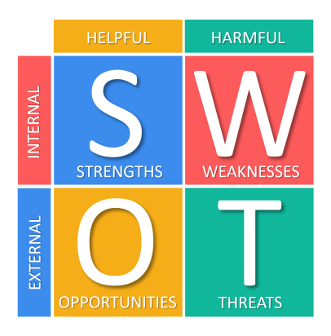
SWOT Analysis for Study Group Web App

 | Helpful | Harmful
Internal | Strengths  - Solves a clear student need by organizing study groups in one place.  - Simple, focused features that are realistic for a freshman-level team.  - Beginner-friendly tech stack (HTML, CSS, JavaScript, Firebase).  - Clear 8-week project timeline that fits within a semester. | Weaknesses  - Limited experience with backend tools, especially Firebase.  - Basic messaging system may feel less useful than Discord or WhatsApp.  - Risk of time-management issues with other coursework.  - Small team skill set may make advanced features (search, database queries) challenging
External | Opportunities  - High demand among college students, especially freshmen who need help forming study groups.  - Opportunity to learn practical web development tools (authentication, database, hosting).  - Room for future expansion (chat, notifications, LMS integration, reminders).  - Potential support or adoption by campus clubs or academic departments. | Threats  - Strong competition from existing platforms that students already use for communication.  - App usefulness depends on a large number of students joining—risk of low adoption.  - Technical configuration problems (e.g., authentication or database issues) may cause delays.  - Scope creep could stretch the project beyond what the team can complete in a semester.

