Advanced Scripting   
Intro

Last Updated: 11/30/2023 1:36 PM Version 2  
Document Prepared for: CYBER360 Student

# Name Click here to enter name ID Click here to enter id

# Instructions

Save a copy of this document. Use Microsoft Word to edit and answer all questions directly in this document. You will save and upload this completed document as your homework submission. Make sure you fill out your **Name** and **ID** at the top of the page.

# Overview

Hi! I’m your instructor, and I have tried to write these exercises in a friendly tone, to read like a good-natured conversation between you and me.

This is a test exercise to get you used to working with this format. To answer questions, click in between the red tags and type your answer.

# Setup

If you need a specific setup to do the exercise it will be listed here.

* You will need Microsoft Word to edit this document, which you can obtain at no cost:

<https://www.byuistore.com/electronics/downloads/download-microsoft-office>

# Task 1—Explore the course outline.

## Steps

1. Read the course outline in I-Learn Canvas. Then answer the following questions.
   1. What percentage of your grade comes from Exercises? Click or tap here to enter text.
   2. Do I allow extra credit? Click or tap here to enter text.
   3. If yes, what are the conditions for extra credit? Click or tap here to enter text.
   4. What is the late homework policy? Click or tap here to enter text.
2. To view my profile, tap People in the I-Learn Canvas course menu, then among the list of your classmates’ names, find my name and click on it. (If you cannot find my profile in I-Learn Canvas, I might have posted it in Teams instead. Finish Task 2 below, then come back to answer these.)
   1. How many kids do I have, if any? Click or tap here to enter text.
   2. List two of my interests:
      1. Click or tap here to enter text.
      2. Click or tap here to enter text.

# Task 2—Using Teams

For this course we will use Teams to communicate with each other. Here are a few things to keep in mind:

1. Post any questions you have in Teams (not as a chat but as a post). This way other classmates can help. If you need to get a classmate’s attention @tag them in the post.
2. If you need to communicate with me privately use a chat.
3. Install the Windows or mobile app to make life smoother.

## Steps

1. Open teams and select our class team.
2. If you don’t see our team let me know and I’ll make sure you are added.
3. Introduce yourself in Teams.
   1. Create a post in the General channel. It must contain:
      1. A bit about yourself.
      2. Tag me.
      3. At least one picture.
   2. Record the link to your post here Click or tap here to enter text.  
      To get the link from your post, click on your post then select the ellipsis: 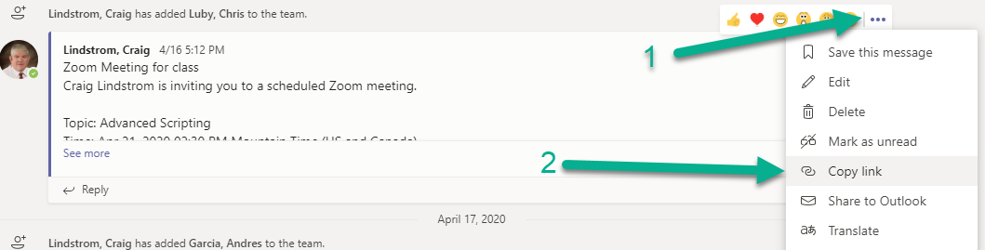

# Deliverable

Upload this document with completed answers to I-Learn Canvas.