Advanced Scripting   
Interactive CLI

Last Updated: 3/14/2024 4:58 PM Version 1  
Document Prepared for: CYBER360 Student

# Name Click here to enter name ID Click here to enter id

# Instructions

Answer all questions directly in this document. You will save and upload this completed document as your homework submission.

# Overview

In this exercise, you will use Windows PowerShell to start programs, perform simple calculations, and practice some convenient command-line history shortcuts.

# Setup

## Requirements

* Windows PowerShell

# Task 1—Running programs in your path

Use PowerShell to run programs. You can run any program that is in your path by simply typing the name of the program in the shell and pressing Enter.

## Steps

1. Start Windows PowerShell
2. Start Notepad by entering the following command:  
   notepad
3. This should start notepad. The reason this works is that **notepad.exe** is in the system’s search path.
4. Let’s find your default gateway. Enter the command  
   route print
5. Look for a line that starts with 0.0.0.0. It will look something like this:   
     
   What is address of the gateway on your computer? Click or tap here to enter text.
6. There are many programs (commands) included in your search path. Here is a link to a list of Windows commands: <https://docs.microsoft.com/en-us/windows-server/administration/windows-commands/windows-commands>.
7. Browse that list. Choose and explore two commands that seem interesting. Fill in the following table

|  |  |
| --- | --- |
| Command | Description |
| Click or tap here to enter text. | Click or tap here to enter text. |
| Click or tap here to enter text. | Click or tap here to enter text. |

# Task 2—The search path

In this task, you will explore your Windows search path.

## Steps

1. To view your search path from PowerShell, enter the following command:  
   $env:path -split ";"
2. How many directories are in your search path? Click or tap here to enter text.
3. Did you count them by hand? Let’s let PowerShell count them for you:   
   $env:path -split ";"|measure   
   It’s easier to let PowerShell do the work!
4. To change your search path, you may use the control panel’s System Properties. You can easily start the applet by entering this command:  
   sysdm.cpl
5. You should see the System Properties applet:  
   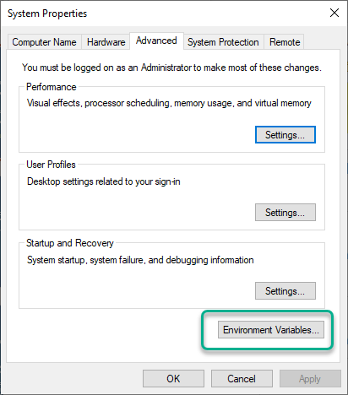
6. If you click on the Environment variables button, you can edit your system’s environment variables (one of which is the path variable). There are two path variables: one that is used for all users on the system, and one that is used just for your user. The search path is a combination of both paths.  
   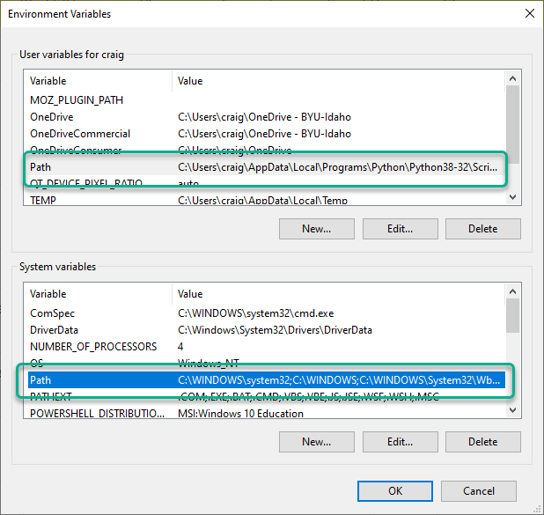

# Task 3—Expressions

PowerShell will evaluate any expression that you give it as soon as you press enter.

## Steps

1. Enter a simple arithmetic formula and press enter to see the results:  
   42 * 17   
   Record the answer here Click or tap here to enter text.   
   (*This expression used the multipy operator,* **\*** . *It also works without spaces:* **42*17**. *Try it!*)
2. You can also evaluate logical test conditions. Enter:  
   'red' -eq 'Red'   
   Record the result Click or tap here to enter text.   
   (*This expression used the equality comparison operator,* **-eq** .)
3. Let’s manipulate a string by replacing a word with another word: Enter  
   'my rat has fleas' -replace 'rat','dog'   
   Record the result Click or tap here to enter text.   
   (*This expression used the substring replacement operator,* **-replace** .)
4. We can use flexible numbers in expressions. How many megabytes are in a gigabyte?   
   1gb/1mb  
    Record the answer here Click or tap here to enter text.

# Task 4—History

In a *module* named **PSReadline**, Microsoft collected some handy command-line history tricks. These PowerShell features make life a lot easier.

## Steps

1. Use the history feature of PowerShell to retrieve a previous command.
   1. Press the up arrow key until you see the line  
      **'my rat has fleas' -replace 'rat','dog'**
   2. Using the left/right arrow keys and delete key, change the word dog to rabbit, then press Enter.
   3. Record the result: Click or tap here to enter text.
2. You can search your history as well. Find the **route** command we entered earlier using the search history feature.
   1. Press **[Ctrl] + R**
   2. Now press r; this will take you back to the most recent command that has a letter r in it. This is not the command we want.
   3. Press o; this will find the most recent command that has the letters **ro** in it. This is probably still not the command you want.
   4. Type u; now you probably are seeing the **route** command. If you do, just press enter to execute that command again. (If not, keep spelling **route** until you find it.)
3. It’s sometimes helpful to clear your history. Give it a try.
   1. Press **[Alt]+[F7]**
   2. Now try using up/down arrow keys to scroll through your command history. It should be gone.

# Task 5—Clear it up

When a command line terminal’s scrolling output gets messy, clear it up.

## Steps

1. There are several ways to clear the screen. The easiest is just to press **Ctrl** + **L**. Give it a try.
2. You can also use the following command:  
    Clear-Host   
   or even this short alias:  
    cls   
   Give them a try.

# Deliverable

Upload this document with completed answers to I-Learn Canvas.