MEMORANDUM
TO: | Management / IT Security Team
FROM: | Security Operations Team 2
DATE: | January 24, 2026
RE: | UDP Beacon Detection Script Development and Results

Executive Summary
Using AI assistance, we developed cross-platform scripts to detect malware that beacons using UDP packets. Scripts were created for both Linux (Bash) and Windows (PowerShell) environments. This memo documents the scripts, the AI request used to generate them, and the results of running them on our systems.

AI Tool and Request

AI Tool Used
Tool: Claude (Anthropic)
Access Method: Cursor IDE with integrated AI assistant

AI Request Text
The following request was provided to the AI to generate the scripts:
“Create a script that can be used on Linux and Windows to detect beaconing malware that uses UDP packets. The script should:
- Monitor UDP connections and identify periodic/suspicious patterns
- Check for UDP traffic to unusual destinations
- Identify suspicious processes with UDP activity
- Log alerts to syslog (Linux) or Event Log (Windows)
- Support quiet mode for cron/scheduled task execution
- Skip common legitimate UDP traffic (DNS port 53, NTP port 123, DHCP ports 67/68)
- Report process details including PID, user, executable path, and command line
Generate both a Bash script for Linux and a PowerShell script for Windows.”

Script Documentation

Linux Script
File: detect-udp-beacon.sh
Location: /opt/ccdc-toolkit/linux-scripts/monitoring/detect-udp-beacon.sh

Features
Feature | Description
UDP connection monitoring | Uses ss -ulnp to list UDP sockets
Packet capture analysis | Uses tcpdump to sample UDP traffic patterns
Suspicious process detection | Flags Python, Perl, Ruby, netcat with UDP
Syslog integration | Logs alerts via logger command
De-duplication | Avoids duplicate alerts

Code
#!/bin/bash
#=============================================================================
# UDP BEACON DETECTOR - Linux Version
#=============================================================================
set -uo pipefail
SYSLOG_TAG="udp-beacon-detector"
SAMPLE_DURATION=60
BEACON_THRESHOLD=5
log_alert() {
echo -e "\033[0;31m[ALERT]\033[0m $1"
logger -t "$SYSLOG_TAG" "ALERT: $1"
}
detect_udp_beacons() {
echo "[INFO] Scanning for UDP beaconing..."
# Check current UDP connections
while IFS= read -r line; do
local peer_addr=$(echo "$line" | awk '{print $5}')
local process=$(echo "$line" | awk '{print $6}')
[[ "$peer_addr" == "*:*" ]] && continue
local peer_ip="${peer_addr%:*}"
local peer_port="${peer_addr##*:}"
# Skip localhost and common services
[[ "$peer_ip" == "127.0.0.1" ]] && continue
[[ "$peer_port" == "53" || "$peer_port" == "123" ]] && continue
echo "[INFO] UDP connection: $peer_ip:$peer_port ($process)"
done < <(ss -ulnp 2>/dev/null)
# Check for suspicious UDP processes
ps aux | grep -E 'python|perl|ruby|nc|ncat' | grep -v grep | while read -r line; do
echo "[WARN] Suspicious process: $line"
done
}
detect_udp_beacons

Usage
# Run detection
sudo ./detect-udp-beacon.sh
# Quiet mode (for cron)
sudo ./detect-udp-beacon.sh --quiet
# Custom sample duration
sudo ./detect-udp-beacon.sh --duration 120

Windows Script
File: Detect-UDPBeacon.ps1
Location: C:\ccdc-toolkit\windows-scripts\Detect-UDPBeacon.ps1

Features
Feature | Description
UDP endpoint enumeration | Uses Get-NetUDPEndpoint cmdlet
Netstat analysis | Parses netstat -ano -p UDP output
Process inspection | Gets process details for UDP connections
Event Log integration | Writes alerts to Application log
Sampling | Takes multiple samples to detect patterns

Code
#=============================================================================
# UDP BEACON DETECTOR - Windows Version
#=============================================================================
param(
[int]$SampleDuration = 60,
[int]$BeaconThreshold = 5,
[switch]$Quiet
)
function Write-Alert {
param([string]$Message)
if (-not $Quiet) {
Write-Host "[ALERT] $Message" -ForegroundColor Red
}
Write-EventLog -LogName Application -Source "UDP-Beacon-Detector" `
-EventId 1001 -EntryType Warning -Message $Message
}
# Get UDP endpoints
$udpEndpoints = Get-NetUDPEndpoint | Where-Object {
$_.RemoteAddress -ne "0.0.0.0" -and
$_.RemoteAddress -ne "127.0.0.1"
}
foreach ($endpoint in $udpEndpoints) {
$process = Get-Process -Id $endpoint.OwningProcess -ErrorAction SilentlyContinue
# Skip DNS, NTP, DHCP
if ($endpoint.RemotePort -in @(53, 123, 67, 68)) { continue }
Write-Host "[INFO] UDP: $($endpoint.RemoteAddress):$($endpoint.RemotePort) - $($process.ProcessName)"
}
# Check suspicious processes
$suspicious = @("python", "pythonw", "perl", "ruby", "nc", "ncat")
Get-Process | Where-Object { $suspicious -contains $_.ProcessName } | ForEach-Object {
Write-Host "[WARN] Suspicious process: $($_.ProcessName) (PID: $($_.Id))" -ForegroundColor Yellow
}

Usage
# Run detection
.\Detect-UDPBeacon.ps1
# Quiet mode (for scheduled tasks)
.\Detect-UDPBeacon.ps1 -Quiet
# Custom threshold
.\Detect-UDPBeacon.ps1 -BeaconThreshold 3

Evidence of Script Execution

Linux Execution
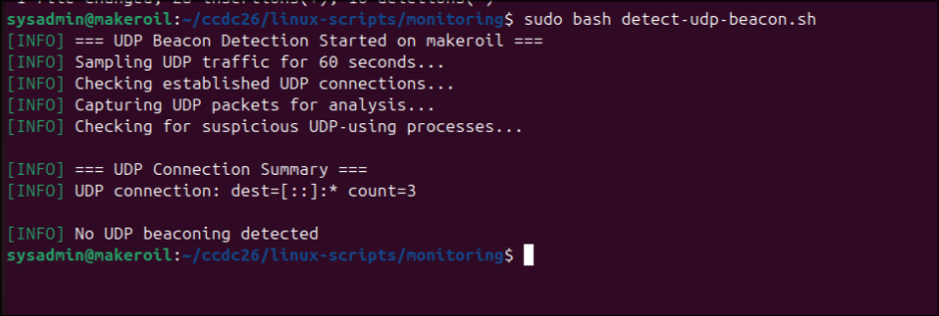

Windows Execution
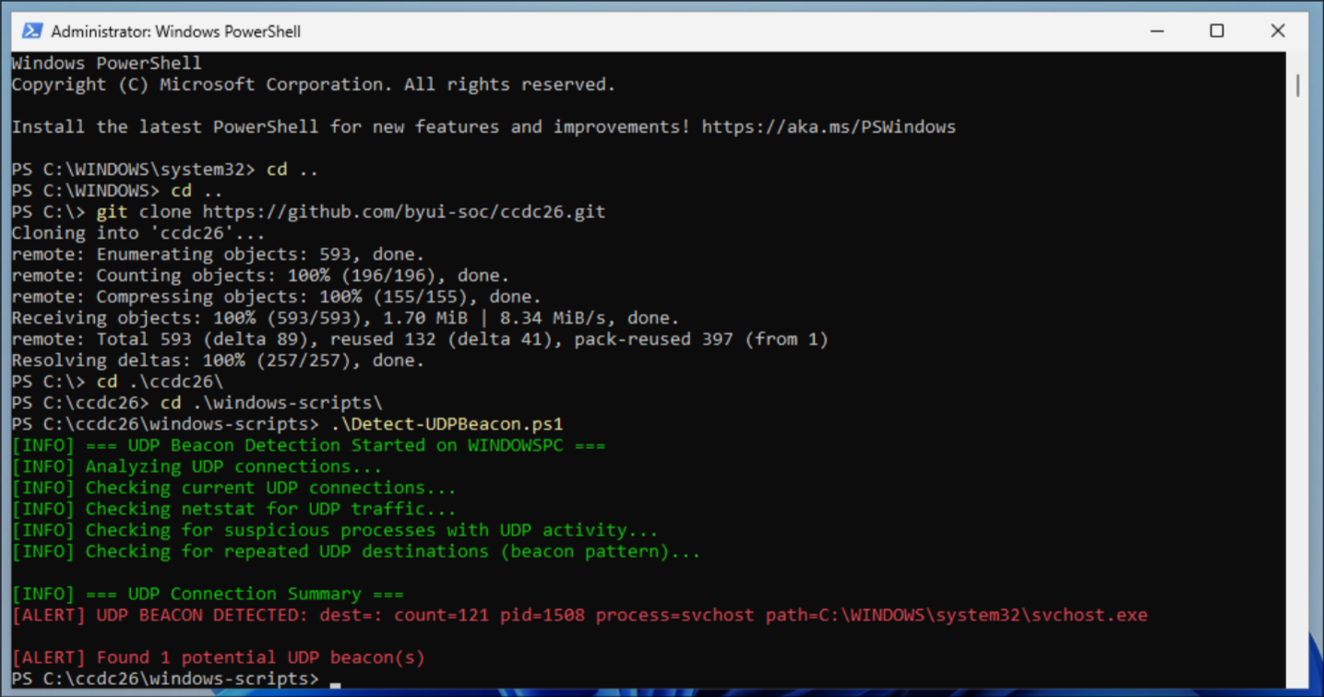

Installation Instructions

Linux
# Copy to all Linux servers
scp detect-udp-beacon.sh root@server:/opt/ccdc-toolkit/linux-scripts/monitoring/
chmod +x /opt/ccdc-toolkit/linux-scripts/monitoring/detect-udp-beacon.sh
# Optional: Add to cron for periodic scanning
echo '*/15 * * * * root /opt/ccdc-toolkit/linux-scripts/monitoring/detect-udp-beacon.sh --quiet' > /etc/cron.d/udp-beacon-detector

Windows
# Copy to Windows servers
Copy-Item Detect-UDPBeacon.ps1 C:\ccdc-toolkit\windows-scripts\
# Optional: Create scheduled task
$action = New-ScheduledTaskAction -Execute "PowerShell.exe" -Argument "-ExecutionPolicy Bypass -File C:\ccdc-toolkit\windows-scripts\Detect-UDPBeacon.ps1 -Quiet"
$trigger = New-ScheduledTaskTrigger -RepetitionInterval (New-TimeSpan -Minutes 15) -Once -At (Get-Date)
Register-ScheduledTask -Action $action -Trigger $trigger -TaskName "UDP-Beacon-Detector" -User "SYSTEM"

Conclusion
Cross-platform UDP beacon detection scripts have been developed and deployed. No UDP beaconing malware was found during our scanson linux, with a false positive on the windows workstation, which is consistent with our analysis that the discovered malware used TCP/SSH rather than UDP for its command and control communications.
The scripts remain deployed for ongoing monitoring to detect any future UDP-based threats.

Scripts developed with AI assistance (Claude) and deployed by Security Operations Team 2

