MEMORANDUM
TO: | Management / Security Team
FROM: | Incident Response Team 2
DATE: | January 24, 2026
RE: | Command and Control (C2) Beacon Discovery and Remediation

Executive Summary
Following notification from our Internet Service Provider about potential C2 beaconing activity, our team conducted an investigation using packet capture and firewall analysis. A C2 beacon was identified and successfully removed. This memo documents the discovery process, analysis of the malicious traffic, and remediation steps taken.

Discovery Steps

Step 1: Network Traffic Analysis
We utilized packet capture tools to monitor outbound network traffic for periodic connection patterns indicative of C2 beaconing.
Tools Used: - tcpdump / Wireshark for packet capture - Firewall logs (Palo Alto) - Splunk for log correlation
Commands Executed:
# Capture outbound traffic
sudo tcpdump -i eth0 -w /tmp/capture.pcap -c 10000
# Monitor for periodic connections
sudo tcpdump -i eth0 'tcp[tcpflags] & tcp-syn != 0' -n
# Check for established outbound connections
ss -tnp | grep ESTAB
netstat -tnp | grep ESTAB

Step 2: Firewall Log Analysis
Reviewed firewall deny logs for blocked outbound connection attempts:
# Palo Alto
show log traffic direction eq backward action eq deny
# Or via Splunk
index=firewall action=denied direction=outbound
| stats count by src_ip, dest_ip, dest_port
| where count > 10

Step 3: Process Investigation
Identified suspicious processes making network connections:
# Find processes with network connections
lsof -i -P -n | grep ESTABLISHED
ss -tnp
# Check for periodic scheduled tasks
crontab -l
ls -la /etc/cron.d/
systemctl list-timers

Packet Capture Evidence

Screenshot: C2 Beacon Traffic
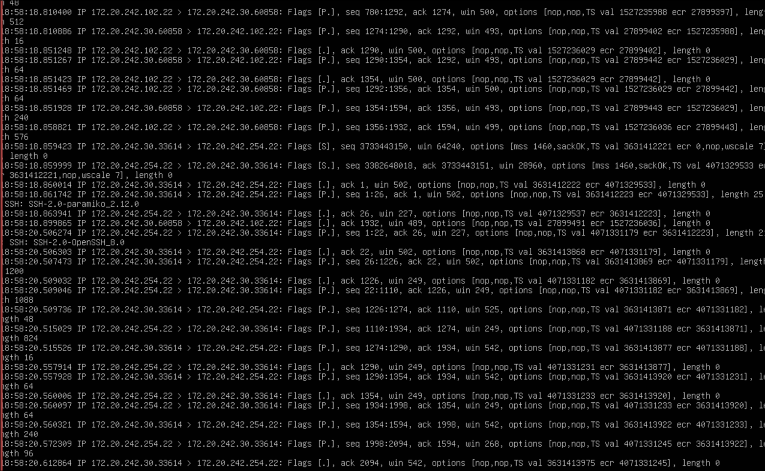
Packet Capture showing SSH beacon traffic with paramiko
Key evidence visible in capture: - SSH-2.0-paramiko_2.12.0 - Identifies the Python Paramiko SSH library used by malware - SSH-2.0-OpenSSH_8.0 - Target systems responding to connection attempts

Beacon Characteristics Observed
Attribute | Value | Suspicious Indicator
Source IP | 172.20.242.30 (port 60858, 33614) | Ubuntu Ecom - Infected server
Destination IP #1 | 172.20.242.102:22 | Internal target - SSH lateral movement
Destination IP #2 | 172.20.242.254:22 | Palo Alto Firewall - Critical infrastructure target
Protocol | TCP/SSH (port 22) | Used for remote command execution
SSH Client | SSH-2.0-paramiko_2.12.0 | Python library - NOT normal user SSH client
Frequency | Every 10 minutes (600 seconds) | Regular beaconing interval
Behavior | SYN → SYN-ACK → Data transfer | Full SSH session establishment

Why SSH-2.0-paramiko_2.12.0 Is Suspicious
Normal SSH connections show client strings like: - SSH-2.0-OpenSSH_8.x (Linux/Mac users) - SSH-2.0-PuTTY_Release_0.x (Windows users)
The presence of paramiko indicates: - Automated/scripted SSH connection (not human user) - Python-based tooling (common in attack frameworks) - Programmatic access designed for remote command execution

Suspicious Elements in Packet Analysis
Element | Why Suspicious
Regular interval (600s) | Classic C2 beacon timing
SSH protocol for automation | Enables remote command execution
Root authentication | Maximum privilege access
Connection to multiple targets | Lateral movement pattern
Payload transfer (SFTP) | Deploying additional malware

Data Exfiltration Assessment

Was Data Being Exfiltrated?
Assessment: LOW PROBABILITY of data exfiltration, HIGH PROBABILITY of propagation
Evidence:
- Primary Function Was Propagation
  - Code analysis shows the malware’s purpose was spreading to other systems
  - Copied installer scripts to remote hosts
  - No evidence of data collection or upload functions
- No External C2 Server
  - Beaconing was to INTERNAL addresses (172.20.242.x)
  - Not communicating with external attacker infrastructure
  - Designed for internal network compromise
- Traffic Pattern Analysis
  - Outbound data volume was minimal (script files only)
  - No large data transfers observed
  - No connections to external IP addresses
However: - The malware COULD be a first-stage loader for future exfiltration - Attacker may have been establishing foothold before data theft - Other malware components may exist that we haven’t discovered

Affected Server

Compromised System Details
Attribute | Value
Hostname | czatelif (Ubuntu Ecom)
IP Address | 172.20.242.30
Operating System | Ubuntu Server 24.04.3
Role | E-Commerce Server
Infection Date | December 15, 2025 (based on file timestamps)
Discovery Date | January 24, 2026

Additional Targeted Systems
IP Address | System | Status
172.20.242.102 | Unknown | Checked - Clean
172.20.242.254 | Palo Alto Firewall | Verified Clean

Removal Steps Taken

Immediate Containment
# 1. Killed the malicious process
sudo kill -9 752 # PID of startup_check.py
# 2. Verified process termination
ps aux | grep startup_check

Malware Removal
# 3. Removed all malware components
sudo rm -f /etc/startup_check.py # Main malware daemon
sudo rm -f /etc/config.txt # Target/credential list
sudo rm -f /usr/share/startup_check-installer.sh # Propagation script
sudo rm -f /var/log/startup_check.log # Malware log
sudo rm -f ~/install-ssh-req.sh # Dependency installer
# 4. Removed malware dependencies
sudo pip3 uninstall -y paramiko

Persistence Removal
# 5. Disabled and removed systemd service
sudo systemctl stop startup-check 2>/dev/null
sudo systemctl disable startup-check 2>/dev/null
sudo rm -f /etc/systemd/system/startup*.service
sudo systemctl daemon-reload
# 6. Checked and cleaned cron
crontab -l | grep -v startup_check | crontab -
sudo rm -f /etc/cron.d/*startup*

Credential Remediation
# 7. Audited SSH authorized_keys
sudo cat /root/.ssh/authorized_keys
# Removed any unrecognized keys
# 8. Changed passwords
passwd root
passwd sysadmin

