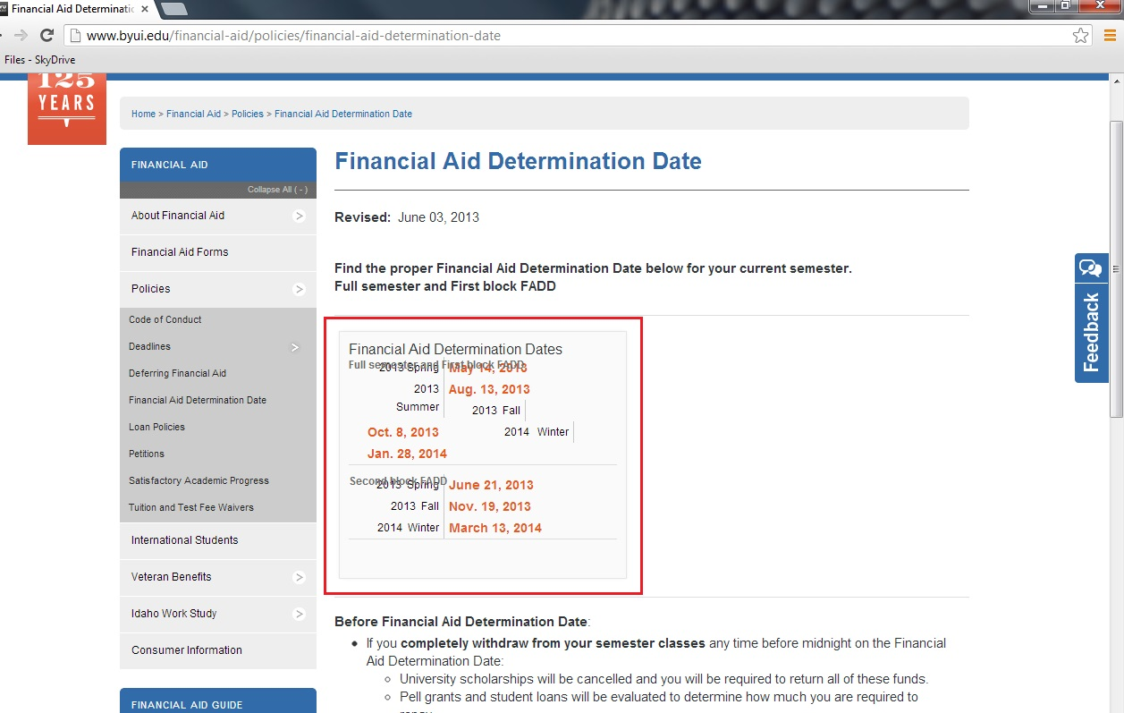

**I think this chart is messed up on the other page “Deadlines” So it might need adjusted on both pages.**