July 24, 2021

Andrew Hazel,

Principal Editor

Computer Physics Communications

Dear Professor Hazel:

Please accept the following revision to our paper RaLib: a radiative property model library for CFD, submission COMPHY-D-21-00015R1. The three reviewers had a number of constructive criticisms of the paper and we have made a good-faith effort to modify the paper and code accordingly. A major revision of both was undertaken. In particular, the manuscript increased from 21 to 29 pages and most sections were heavily edited. A Fortran code interface was added alongside the C++ and Python interfaces. We coupled the code to the NIST Fire Dynamics Simulator (FDS) and ran a sample simulation. The build process and documentation were also improved. Around 60 commits were made to the git repository. An updated version of the installation and use example video is provided on [youtube](https://www.youtube.com/watch?v=z82ENE5fPoE). We have also submitted a revised Code Ocean capsule. I appreciate your consideration.

Sincerely,

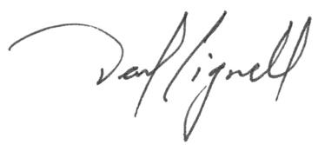

David O. Lignell

J.J. Christiansen Professor, Associate Chair

Chemical Engineering Department

Brigham Young University