Sound Is A Wave
Synopsis: What is sound, really? You work with sound every day — you record it, mix it, shape it — but have you ever stopped to ask what is actually traveling from a guitar string to your ear? In this note, I want to plant one big idea: sound is a wave. When physicists say “wave,” they don’t just mean ocean waves; they mean anything repetitive — a vibration, a repeating pattern, a cycle — that spreads through space over time. A plucked string wiggles back and forth, the wiggling shoves the air next to it, and that shove gets passed along from one chunk of air to the next, all the way to your eardrum. Notice what travels here: not the air itself, but the pattern — and with it, the energy. It’s just like the “Mexican wave” in a stadium: the wave sweeps around the whole arena, but no spectator ever leaves their seat. That is the essence of a wave: energy and pattern move; the material stays put. Everything in this course — pitch, loudness, timbre, room acoustics, even digital audio — is built on this one idea, so we start here, with intuition first. The math comes later.
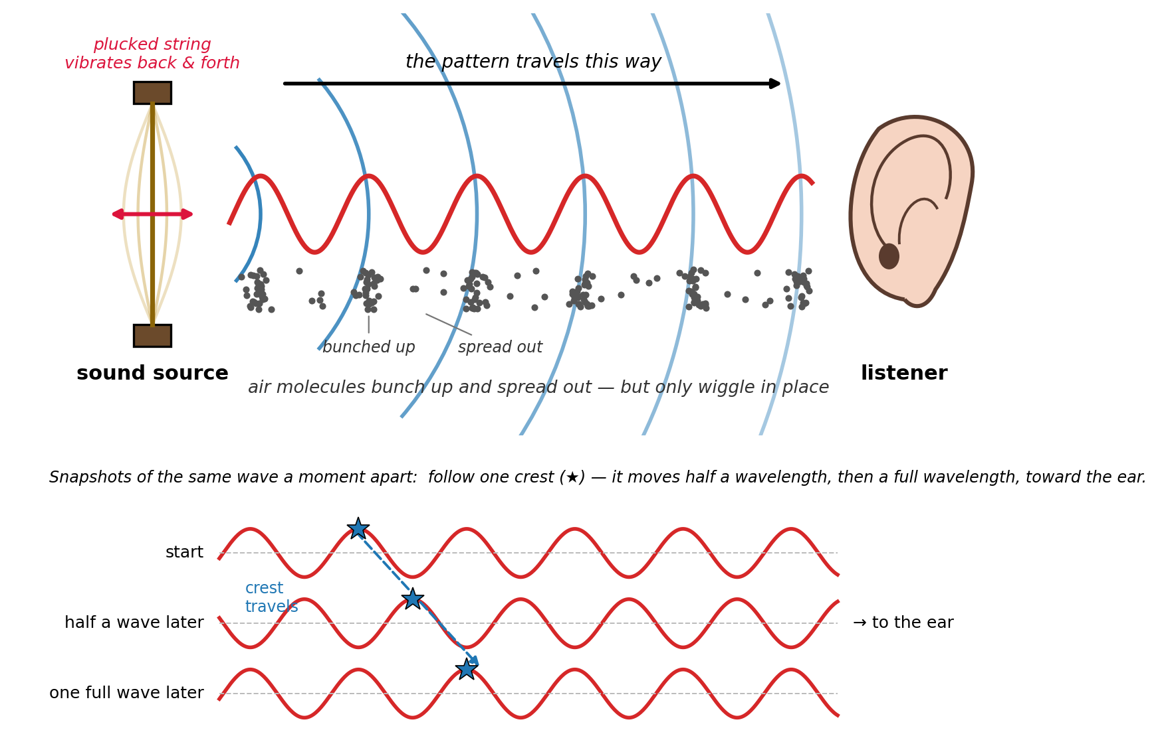
Fig 1. Sound as a traveling wave: a plucked string vibrates, the pattern spreads through the air toward the listener; the snapshots below show one crest moving half a wavelength, then a full wavelength.
Performance Expectations: Describe sound as a repeating pattern of disturbances in the air that travels away from a vibrating source. Explain that a wave is defined by repetition: the same disturbance shows up again and again, both from place to place (in space) and from moment to moment (in time). Describe the motion of a sound wave by following one crest as it moves from the source toward the listener, and distinguish the traveling pattern from the air that stays behind.
Preamble
Before answering anything, do these three things and jot down what you notice:
1) Stretch a rubber band (or use a guitar string if one is in the room) and pluck it. Watch it, not just listen to it. Pluck it once more, this time watching the edges — the string looks blurry. Why?
2) Hum a steady note with your fingers resting lightly on your throat. Now hum a higher note. What changes under your fingers?
3) Open the Phyphox app, choose Audio Oscilloscope, and hum the same steady note into the phone. Watch the screen. Change the pitch and watch again.
In all three, something is moving back and forth, again and again. Keep that picture in mind — it is the whole point of this note.
Instructions
Look at Fig. 1 and reread the Synopsis. Answer in your own words; there is no math here, only careful looking and thinking.
1) Before anything reaches your ear, something has to move. In Fig. 1, what is the very first thing that moves? Describe its motion in a few words.

2) The string does not move just once. Why does it matter that the string moves back and forth over and over? What would you hear if it moved only once?

3) The string pushes on the air right next to it. What happens to that chunk of air? What does that chunk of air then do to the chunk next to it?

4) Look at the dots in Fig. 1. Describe the pattern you see from left to right. How many times does the pattern repeat before it reaches the ear?

5) The red wiggly line, the blue arcs, and the dots are three ways of drawing the same thing. What one word describes what all three have in common? (Hint: it is the key idea of this note.)

6) Physicists call each “bunched up” region a disturbance — a spot where the air is not in its normal, resting state. In your own words, what is a wave, using the words “disturbance” and “repeat”?

7) Now look at the three snapshots at the bottom of Fig. 1. What is the only thing that changes from the top snapshot to the bottom one? What stays the same?

8) In the snapshots, the star marks one crest. Where is it “half a wave later”? Where is it “one full wave later”? What does this tell you about which direction the disturbance is moving?

9) Imagine you freeze time and walk from the string toward the ear with a pressure meter. What would the meter read as you walk — steady, or up-and-down? Now imagine instead you stand still at one spot and let time run. What would the meter read now? Explain why both give you a repeating reading.

10) Put it together: You are a microphone sitting in one spot. What arrives at you, and in what order? Why is it fair to say that what you “detect” as sound is a repeating pattern of disturbances arriving one after another over time — even though the pattern itself is spread out across space?

