**XNAT AND OSIRIX**

Monday, 1ST AUGUST 2016  
benjamin yvernault – b.yvernault@ucl.ac.uk  
Translational imaging group, UCL, London

# INSTALL XNAT OSIRIX PLUGIN

XNAT.osirixplugin is a plugin for OsiriX to allow the user to interact with XNAT database directly from OsiriX. You can download DICOM data, upload ROI, and do quality control on your processing.

You can download OsiriX from their website: <http://www.osirix-viewer.com/> or if you prefer, you can use the free version called Horos: <https://www.horosproject.org/> .

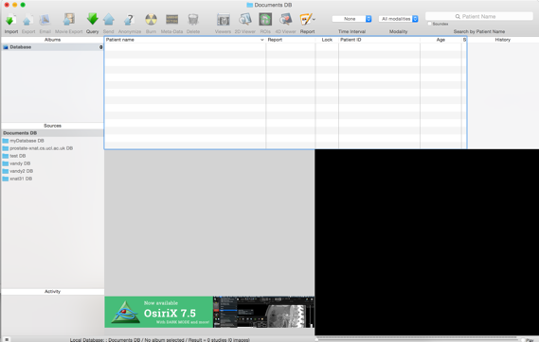 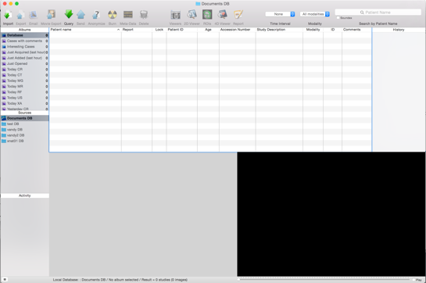

OsiriX is on the left and Horos on the right. They are basically the same software. Feel free to use the one you are the most comfortable with. The only difference is that Horos doesn’t have the clearance for clinical trials.

To install the plugin, two solutions:

* Right click on the XNAT.osirixplugin file and then *Open With* -> *OsiriX* or *Horos*
* Drag and drop the files on OsiriX or Horos Application Icon

The software will ask you if you want to install the file. Click ok and you might need to enter your password for your computer. When it’s done, restart your software. You should now see the tab *Plugins->Database->XNAT* in your menu. If it’s not the case, you might have a 64bit plugin version for a 32bit software version or vice versa. Contact me to get the other version.

The plugin offers different menus that you can see below:

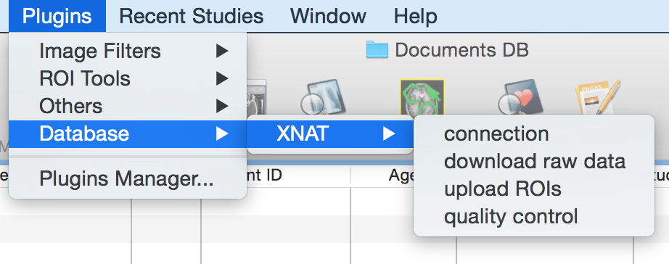

# Connection to XNAT

The first thing to do is to connect to XNAT. You will need to know the host URL for your XNAT instance, your username, and your password. You will also need to specify a name for your OsiriX database. It doesn’t have to be an existing name. You can specify a new name and it will create a new database. You can find you database on the left column in your software in the column *Sources*.

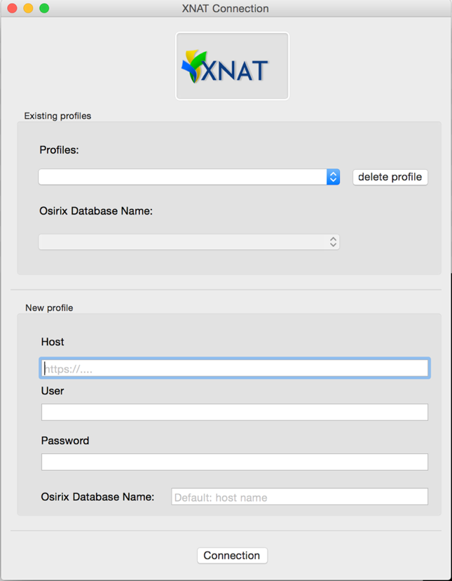

If you already have saved a profile, you can select it from the *Profiles* drop button. Do the same for your database. By clicking on connection, it will check that your credentials are good. It will load your right database on the software. By default, if you don’t specify a name for the database, it will use the host name. E.G: prostate-xnat.cs.ucl.ac.uk. You don’t need to log every time you use the plugin. You can just select your database on the left side and it will recognize the credentials. Your password will be saved in your MAC keychain.

# Download DICOM DATA from Scan

To download data from XNAT into your OsiriX database, you will select the *Plugins* -> *Database* -> *XNAT* -> *download raw data*. This will open the following window:

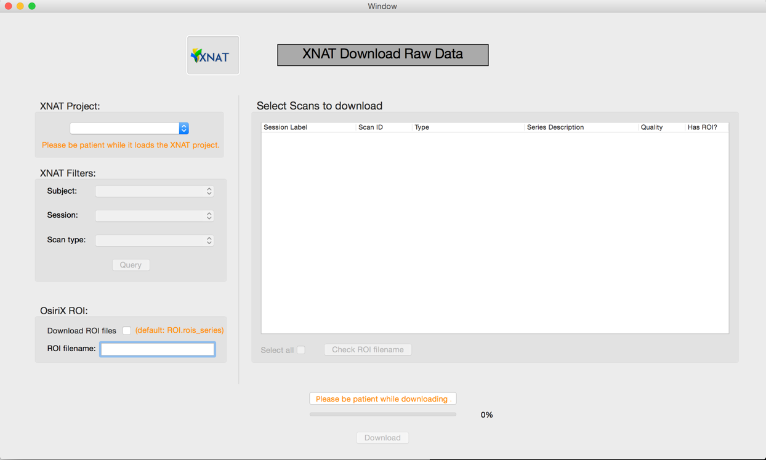

From this window, you can select the project on XNAT where you want to download data. It will display the list of project you have access to. By selecting a project, the software will load all the scans for your project. It will take from few seconds to some minutes depending on the size of the project. You can apply filters to the search (subject / session / scan type) and click on query to display the results in the tableview. (See below)

**WARNING**: if you can’t see anything, it might mean you don’t have any DICOM data on your project. OsiriX only works with DICOM files.

Some scans will have a ROI uploaded to XNAT. The last column indicates if your scan contains a ROI or not. You can verify the name of the files uploaded using the button “*Check ROI filename”*. By ticking the box “*download ROI*”, it will download the ROI as well for the scans selected.

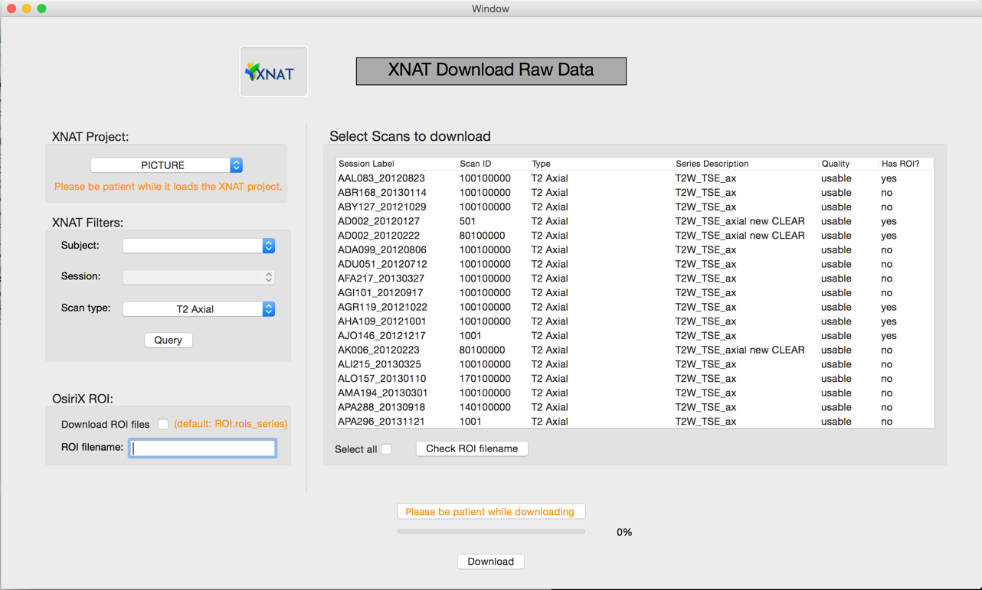

You can now select each scan (select rows) that you want to download. In this case, we filtered the search by the scan type T2 Axial and we can see all the scan T2 Axial on XNAT. *Download* will then start the process of downloading the scans and the ROI if selected.

# UPLOAD ROI TO XNAT

When downloading a scan, the plugin will store the destination where the scan comes from. When uploading, we read this information to know where to upload the data.

You can now start drawing ROI like you use to via OsiriX or Horos.

When you are done, you can select on your software each images where you drew ROI and that you want to upload to XNAT and select the menu *Plugins -> Database -> XNAT -> upload rois*. You will need to enter a name for your file and click *Upload*.

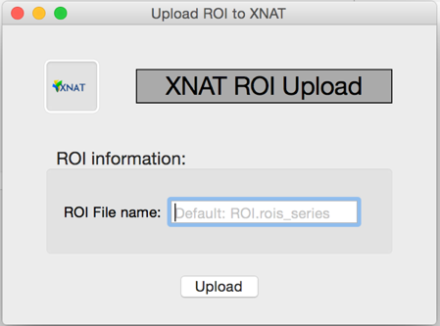

# Quality control

Via XNAT and a cluster, some processes can run automatically. The results will be stored on XNAT and be accessible via the plugin. All the data are stored in a datatypes developed at Vanderbilt University called proc:genProcData. To use this option, you will need to install those datatypes to your XNAT.

The processes might not have any results to display via OsiriX. You might need to log to XNAT and check the PDF or other resources to check the process. You can then edit the quality control status from OsiriX for the assessor or on XNAT directly.

Go to *Plugins -> Database -> XNAT -> quality control*.

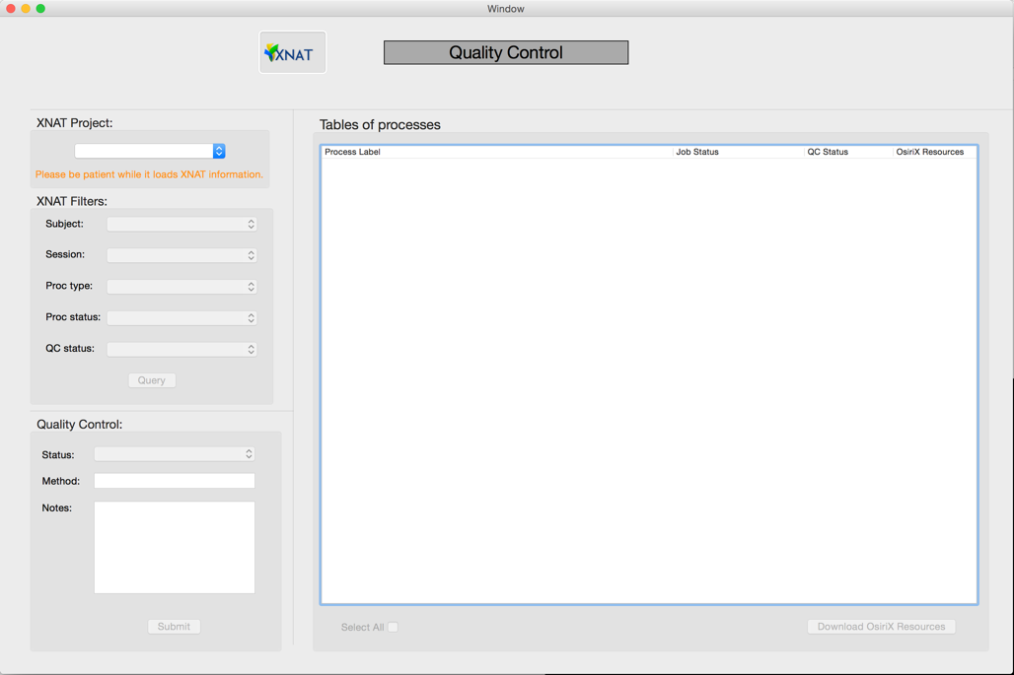

Same than for download, you can specify the project and apply filters to your research. See below on the next image for an example where we are looking for all assessors in the project PICTURE where the jobstatus is JOB_FAILED.

Again, it has been programmed the same way than download tab. You can see if there is a resource available for the assessor on the last column. If it’s written *yes*, you can use the “*Download* *OsiriX Resources*” button to see the data via OsiriX. The data will be added to your database.

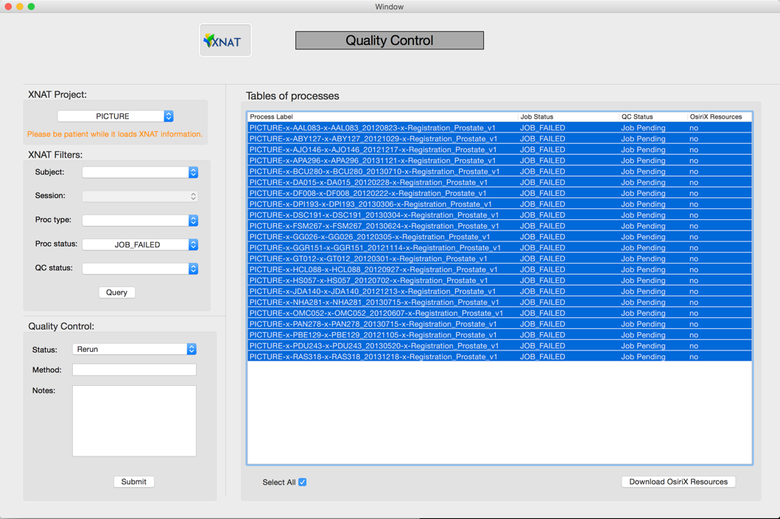

The last step is to edit the QC status via the box at the bottom of the left column. You can specify the status, the method you used if any, and a note if you want to add some information on the process you used to decide the QC.

If you have any comments or suggestions for this guide, don’t hesitate to send me an email at b.yvernault@ucl.ac.uk.