  - Cook’s Distance plot for model 1 (Corner Shot created)
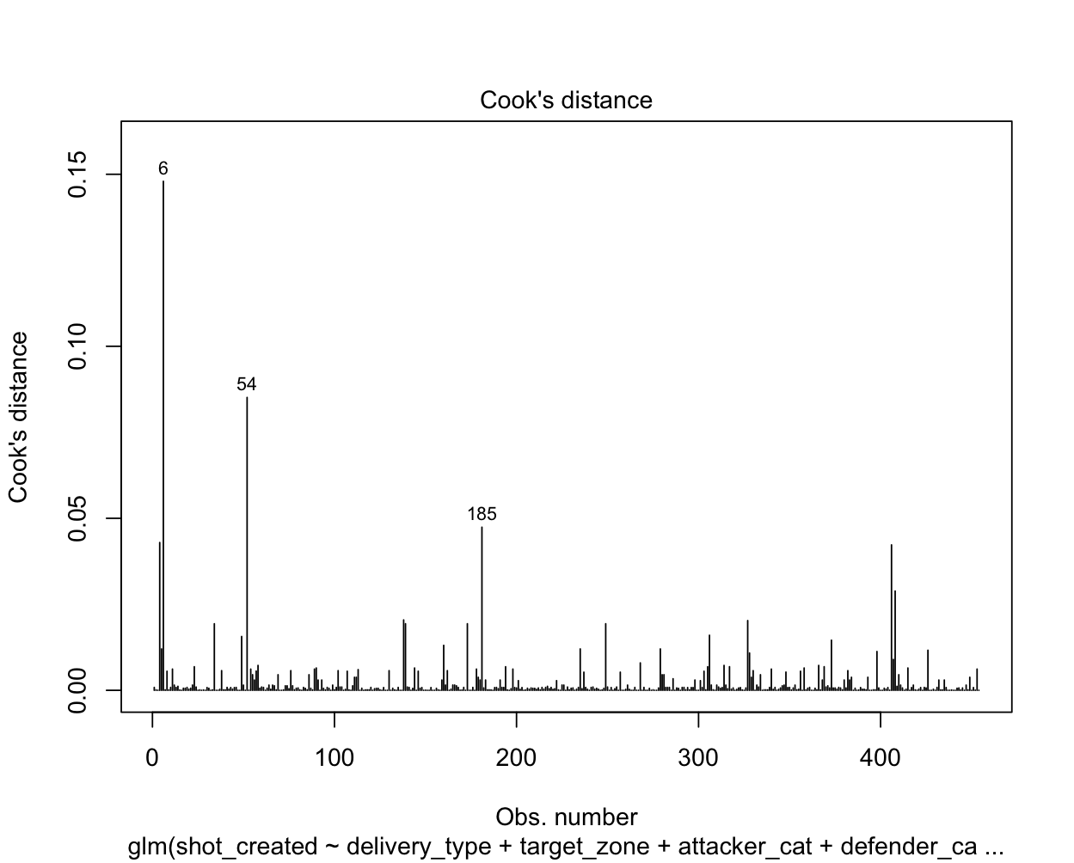
Figure 1. Cook's Distance plot for model 1

    - Cook’s Distance plot for model 2 (Corner possession retained)

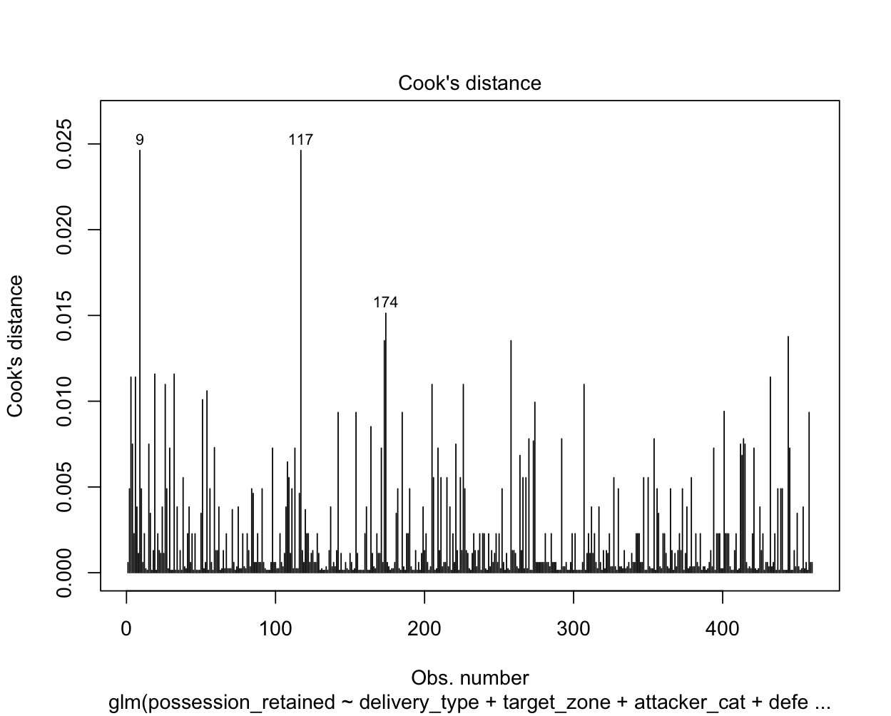

Figure 2. Cook's D plot for model 2

    - Cook’s Distance Plot for Throw-in Possession retained.

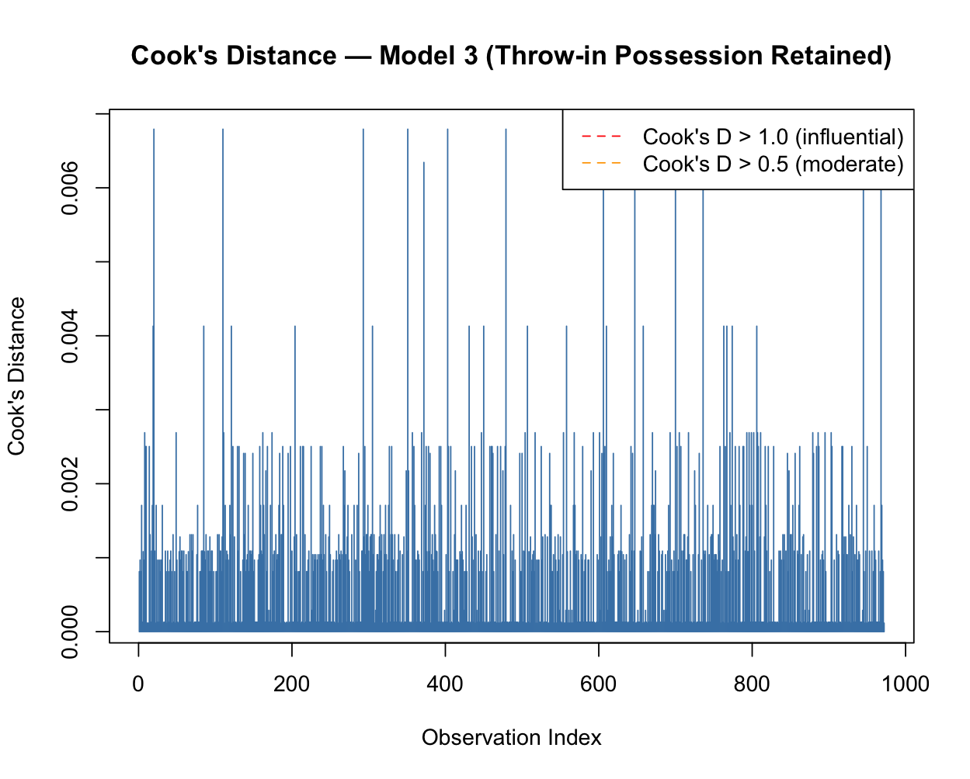
Figure 3. Cook's Distance plot for model 3

    - Random Forest Confusion matrix – RF 1, RF 2, RF 5 and RF6

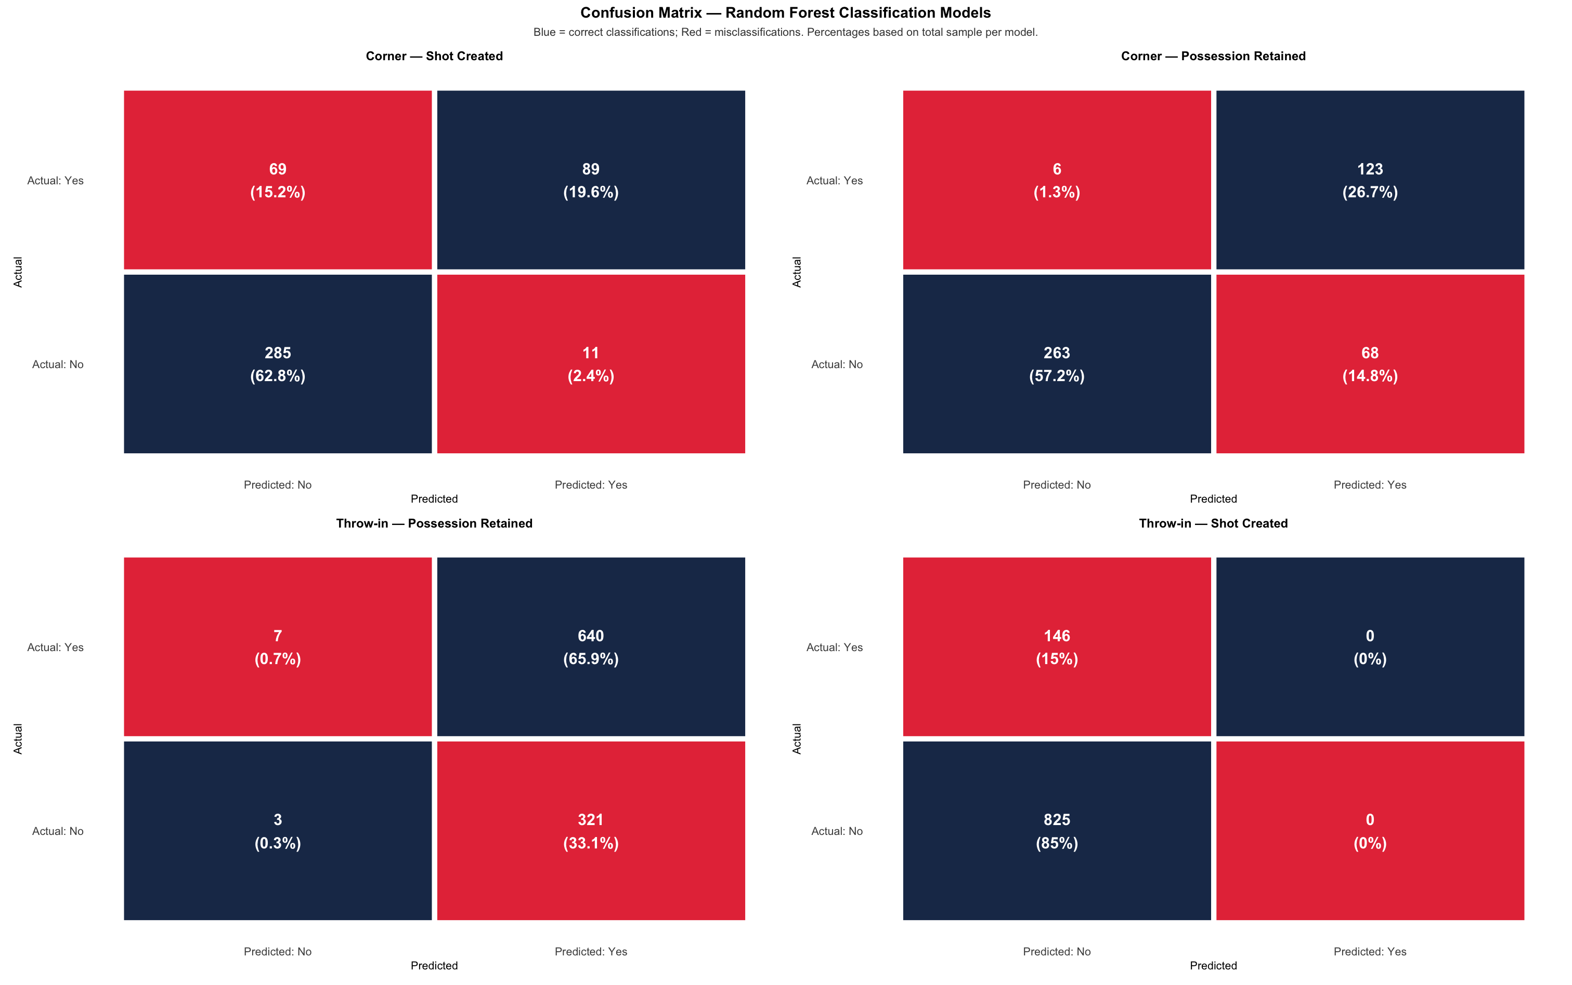
Figure 13. Random Forest confusion matrix for models

  - Appendix C: Predicted Probability Plots

Predicted probability plot – Corner kicks

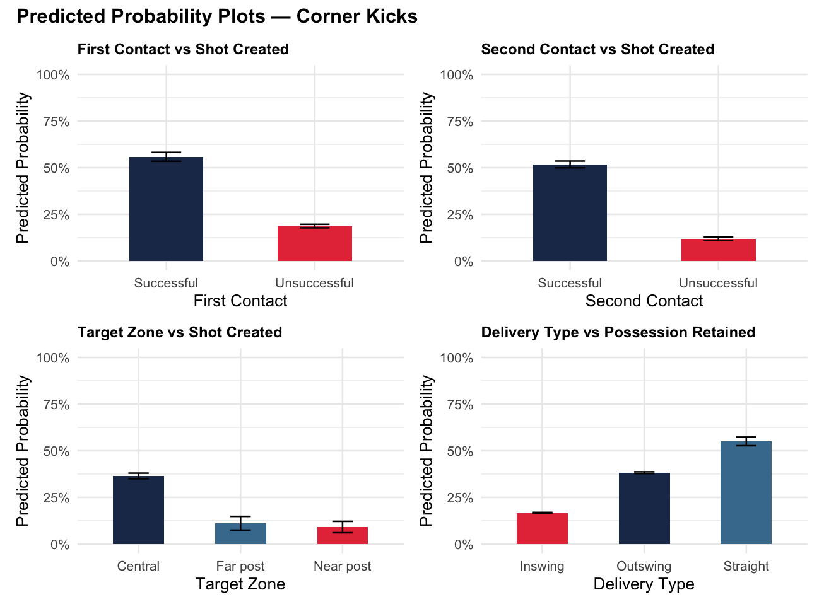
Figure 4. Predicted Probability Plot - Corner kick model

Predicted Probability Plot – Throw-ins

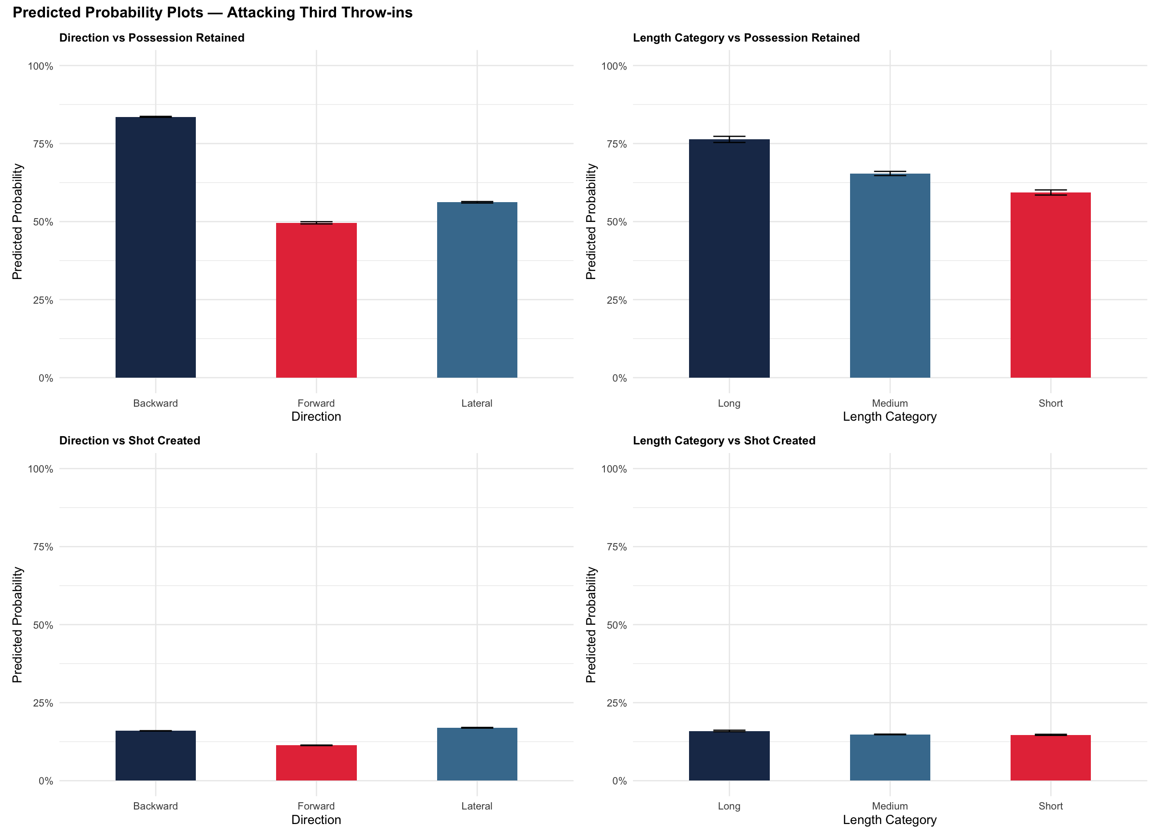
Figure 5. Predicted Probability Plot – Throw-in model

  - Appendix D: Supplementary Sequence Analysis - Corner Kick Outcomes Following Defensive First Contact (n = 263)

Table 1.. Supplementary Sequence Analysis - Corner Kick Outcomes following defensive first contact

Second Contact Outcome | Shot Created | Possession | n | %
Attackers win second contact | Yes | Lost | 43 | 16.3%
Attackers win second contact | No | Lost | 112 | 42.6%
Defenders win second contact | Yes | Lost | 5 | 1.9%
Defenders win second contact | No | Lost | 97 | 36.9%
N/A (sequence ended) | No | Lost | 6 | 2.3%
Total |  |  | 263 | 100%

