Bingyue Zeng, Haochen Xie, Erle Lei

Advanced Python for Finance

Final Project

**How COVID-19 Impacts Every Industry: A Stock Market Approach**

1. **Background**

“The notion that the flap of a butterfly's wing in Brazil can set off a cascade of atmospheric events that, weeks later, spurs the formation of a tornado in Texas''. We often talk about butterfly effects when we want to state that a small change in one state of a deterministic nonlinear system can result in large differences in a later state. It is definitely not accurate when we want to talk about the current ongoing pandemic around the globe, but it does explain how global economics nowadays works, and what effect it is going to cause us. COVID-19, the infectious disease caused by a novel coronavirus, is believed to be first identified in Wuhan, China in December, 2019, and has since spread globally. With symptoms such as fever, coughing, fatigue, etc., this strikingly infectious disease may progress to pneumonia, multi-organ failure and death. It is more deadly to elderly people and people with primary disease. Because of this, a large number of countries around the world have a significant decrease in all kinds of social events, which then leads to a disable economic environment. On March 18th, the stock market plunged so drastically and has since triggered the NYSE circuit breaker for the fourth time in 2 weeks. A circuit breaker is a market volatility regulatory tool that halts the trading starting from 15 minutes to the rest of the day if the nation’s market presents dramatic drops starting from 7% in the S&P 500 index. At the same time, investors are worrying about the upcoming economic recession, and the federal government has since issued a great amount of stimulus in order to increase the market liquidity and response to the drastically increased unemployment rate. We here as a team are interested in what impacts has the pandemic brought to each sector of the industry, since we believe, the impacts should vary among different industry sectors. It might hit hard on the hotel industry, but it might also provide a boost on the healthcare industry. We aim to observe the difference reflected by the stock price.

1. **Data**

Our project is mainly looking at the stock price of companies from S&P 500(as of 04/13/2020) to see if the pandemic has placed a large influence on the selected companies, and hopefully is able to observe the difference and give insights to investors. Besides company stocks, we are also looking at gold price, since gold is believed to be a great trading option to hedge market instability, therefore we hope gold price can serve as a “benchmark” here in our analysis. First, we randomly chose 10 companies from each sector of the S&P 500 (110 companies in total). We then gathered weekly historical stock price data from Yahoo Finance during 04/10/2017 to 04/13/2020, since the initial outbreak in China started in December 2019, we will be mainly comparing data from December 2018 to April 2020. We would like to compare if the stock return from December 2019 to April 2020 significantly differs from the stock return from December 2018 to April 2020. We choose the SPDR Gold Shares (GLD) as our gold price indicator, as it is the most popular one and has the largest volume. After collecting the data, we isolated the date as the index and weekly adjusted close price since we believe stock returns serve as a better indicator than solely price. Please refer to our stock process python file for details. We calculated the weekly return for each selected stock.

Here are the 110 companies we chose:

* Communication Service: GOOGL, T, CMCSA, EA, FB, NETFLIX, TWTR, TTWO, LYV, DIS
* Consumer Discretionary : EBAY, HLT, MAR, NKE,SBUX,TIF,AMZN, MCD, EXPE, RCL
* Consumer Staples: CLX, KO, GIS, COST, KMB, PG, WMT, WBA, CL, EL
* Energy: OKE, HFC, WMB, BKR, CVX, XOM, HAL, MPC, NOV, PSX
* Financials: AFL, AIG, BLK, BAC, GS, JPM, L, MCO, NDAQ, PRU
* Health Care: CVS, ANTM, GILD, JNJ, ZTS, ABC, BDX, BMY, CAH, CERN
* Industrials: AAL, BA, ALK, UAL, DAL, MMM, RSG, ROL, UPS, FDX
* Information Technology: AAPL, ADBE, ADP, IBM, JNPR, MSFT, PYPL, V, ORCL, MU
* Materials: MLM, FMC, NEM, AVY, DD, SHW, ECL, PKG, LIN, DOW
* Real Estate: SLG, PSA, IFF, MLM, EQR, CBRE, CCI, DLR, FRT, HST
* Utilities: ED, PEG, AWK, ES, ATO, AEE, SRE, WEC, FE, EXC

1. **Results**

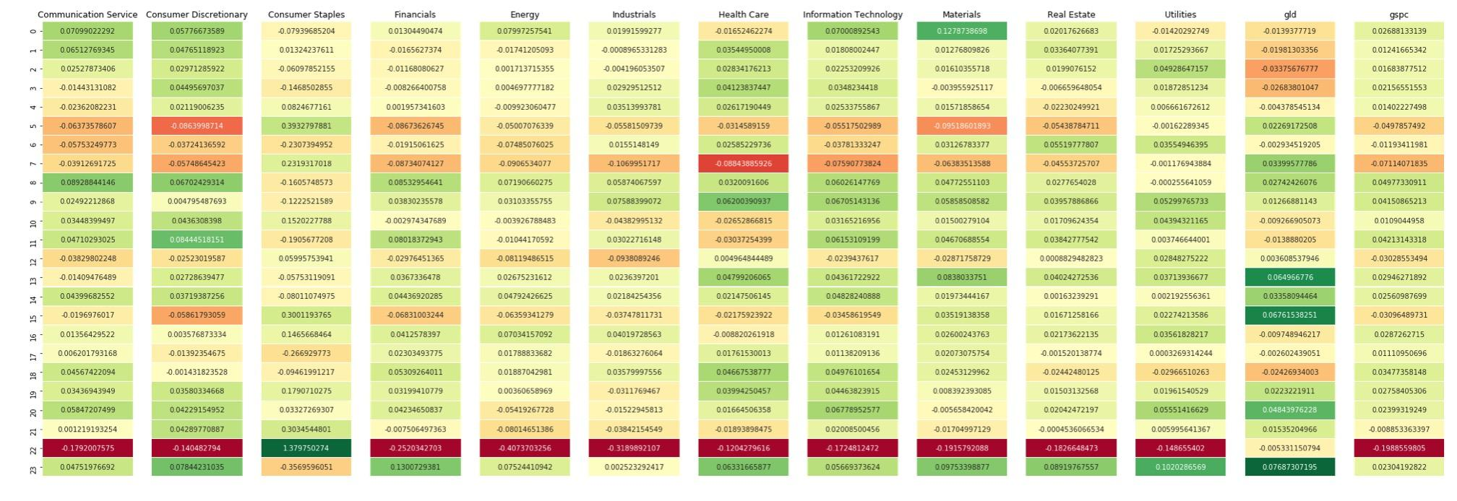

Heatmap from May,2018 to Apr, 2020

1. Financial Sector Analysis

From the heatmap, in general, we find evidence of a negative relationship between the extent of the outbreak of COVID-19 and the whole stock market(S&P 500), especially in the service industry(consumer discretionary) and financial industry(BLK and JPM). However, from the heatmap above, we can see the market does not fluctuate too much during COVID period except March(stock fuse). Compared with the S&P 500, the gold market is gradually rising in stability. Due to our data collecting time, the data are not able to reflect the most up-to-date trend. Therefore, the small spike since the beginning of April to April 6th does not reflect an increasing trend for the whole month. However, the volatility of the information technology, communication service(GOOGL) and health sector are so large, which follows with a constant increase in their returns during the pandemic.

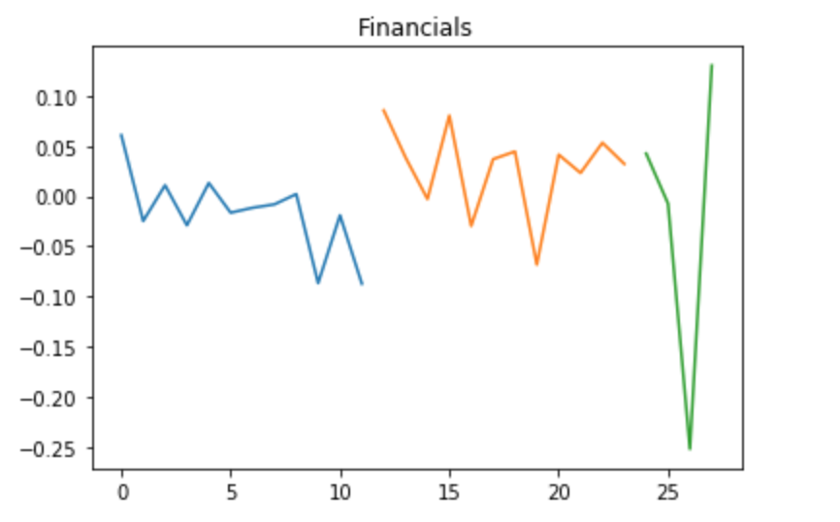

Financials sector return from Jan to Apr, 2018-2020

1. Consumer Discretionary Sector Analysis

But if we take a closer look at the Consumer Discretionary sector, there was actually a small increase in stock return. This sector mainly consisted of tech companies like Amazon, Ebay, Expedia, etc. This might be the reflection of people's expectation on replying on technology during a pandemic. What’s more, during January, the pandemic has not largely affected the western market yet.

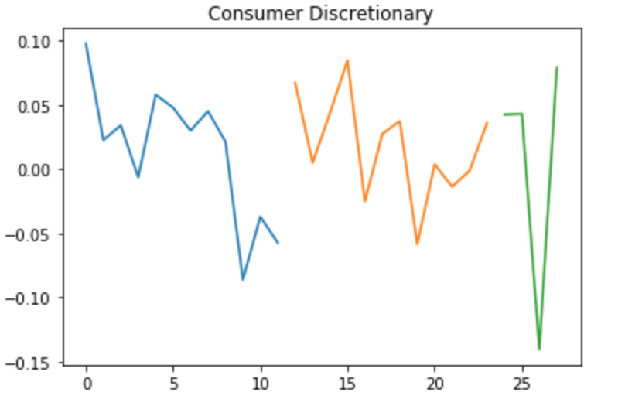

Consumer Discretionary sector return from Jan to Apr, 2018-2020

1. Health Care Sector Analysis

Due to the significant role of the healthcare industry during this pandemic, we are expecting a spike in the stock price since January. But in fact, the overall market still went down. It might be caused by the variety of companies within the sector.

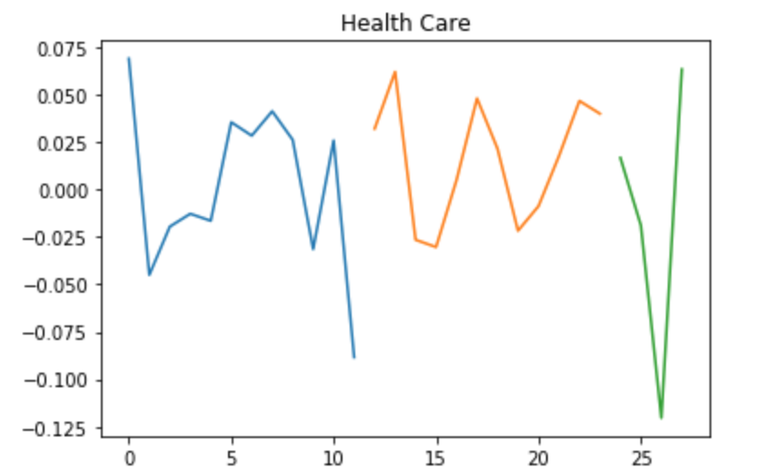

Healthcare sector return from Jan to Apr, 2018-2020

1. Consumer Staples Sector and Real Estate Analysis

In detail, there are some unusual data points, for instance, the whole stock market including the gold market in March shows a downward trend, however, the Consumer Staples goes up since consumers are more likely to have confidence in necessities market due to panic storage caused by the pandemic. By combining the sectors and gold percentage change compared with the same sector in previous years, the evidence shows that the public are more likely to invest in the precious commodity such as gold in order to avoid the unpredicted risks during the Corona period. Specifically, we can see within the same sector some particular companies can experience the positive return during the COVID-19 period. In the real estate sector, the whole market including rental companies and seller companies experience a significant loss.

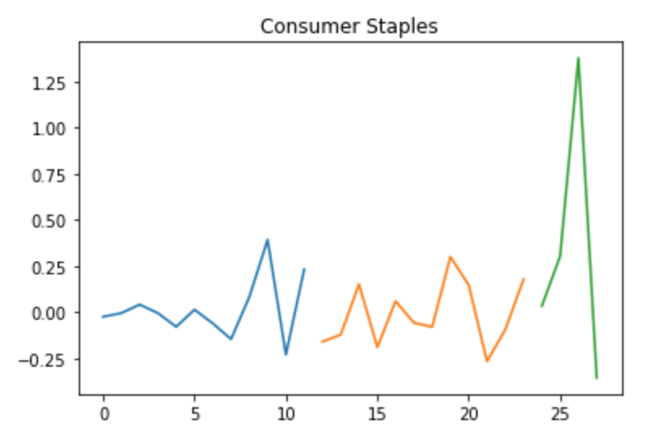

Consumer Staples return from Jan to Apr, 2018-2020

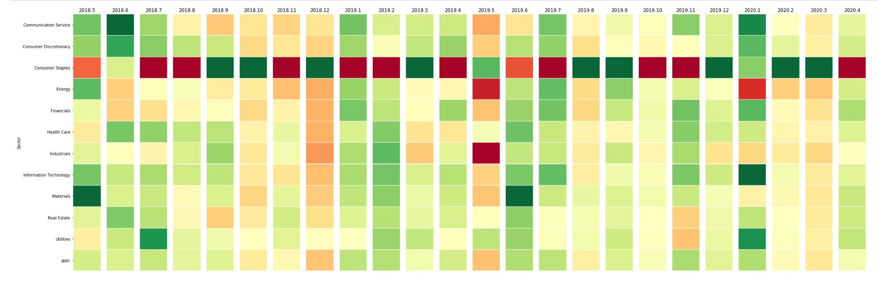Heatmap for each sector

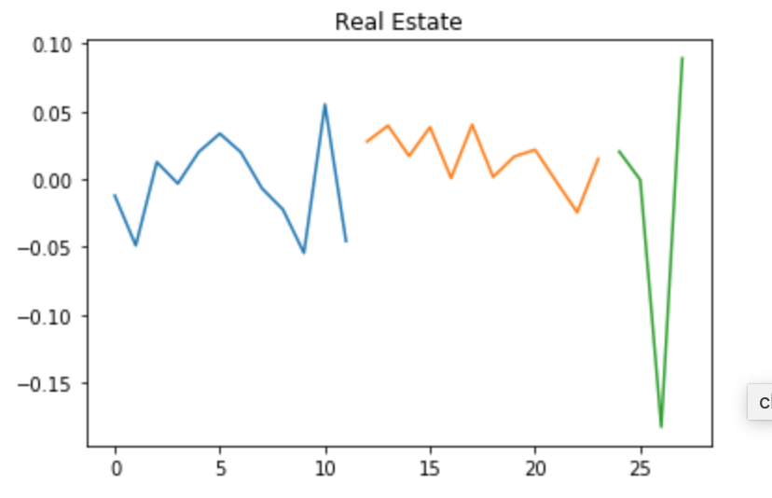

Real Estate sector return from Jan to Apr, 2018-2020

1. Energy Sector Analysis

The energy sector has been experiencing a constant increase except oil companies since this type of company is mainly affected by international policy and price rather than the COVID-19 fluctuation. It can be considered by the fact that the international price dropped too much because of increasing outputs of oil, which made a lot of shale oil companies suffer a great loss.

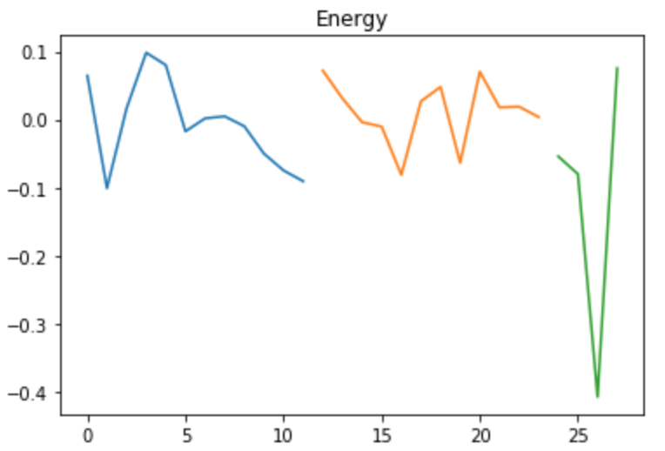

Energy sector return from Jan to Apr, 2018-2020

1. Industrials Sector Analysis

For industrials, it experienced a dramatic loss because of the “lockdown” policy across half part of the world. And due to the same reason, the delivery industry and online service platform industry like FEDEX and UPS obtain a huge increase because of the increasing demand of the people at home.

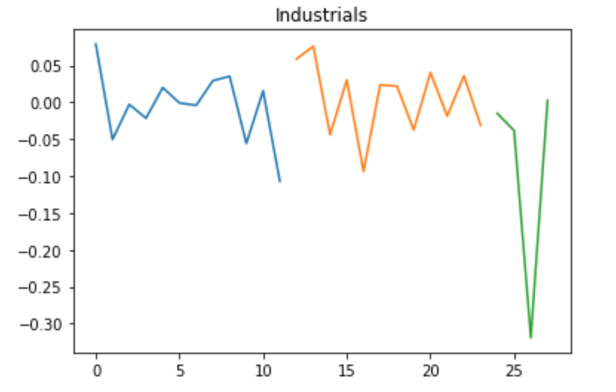

Industrials sector return from Jan to Apr, 2018-2020

Most airline industries like American Airlines have experienced constant decrease during Corona (2020/1 to 2020/4 ) , which accounts for about 37% decrease of the whole sector. In addition to that, the manufacturer industry also suffers a great loss since the workers can not work normally because of COVID-19.

**D. Conclusion**

In conclusion, we observed that there is an obvious downward trend in the overall stock market from January to April, 2020 compared to the same time period in the last 2 years. And it is clearly caused by the current ongoing COVID-19 crisis. The reasons are mainly in two parts. The first part is the decreasing confidence of the public in the stock market due to the incomplete and unstable public policy towards COVID-19 breakout. And the second reason is socioeconomics development pause caused by “PAUSE” policy. However, due to the significant role of consumer staples during a pandemic, the stock return actually is showing a positive trend, as opposed to the rest of the market.