15th June - Planning Day:

# Everyone

* Set up GitHub (by the end of the first meeting)
* Remember git **pull**, BEFORE commit and push. It saves a lot of trouble.
* On GitHub, read documentations/ DRC_Rules_2024.pdf
* Run the relevant examples under /example_code folder
  + You may need to pip install some libraries
  + Read the README.md in the home directory of the Git repository.

# Schedule (rough guide)

|  |  |
| --- | --- |
| Week 0  (10-16 June) | Starting on the GUI, mechanical design, colour mask and firmware. |
| Week 1  (17-23 June) | Mechanical + 3D printing. (Bryce)  Perspective transform. (Bryce)  Wireless connection + GUI. (Ib)  Colour masking: yellow, blue and purple. (JL)  Firmware for the car. (JZ)  Designing path planner (JL)  *Starting* to integrate UART thread into GUI (JZ).  By Saturday morning:   1. the GUI needs to show the **graph for perspective transform** with arrow indicating the path planner’s decision, since Bryce needs it. |
| Week 2  (24-30 June) | Before Monday:   1. **mechanical** needs to be finished. 2. perspective needs to be roughly tested **with the GUI** to make sure M matrix was generated correctly. Accuracy of +/- 10cm is fine. 3. **Playback_gui.py** implemented (spec is below)   On Monday’s meeting:   1. Build a test track in a 7X7 metre area. 2. Integrate everything. 3. **Record videos** of car’s camera view while manually remote controlling the car, so **mechanical** needs to be complete. 4. Test JL’s path planner, if it is ready.   Rest of the week:   1. Design path planners (JL, JZ and Bryce).    1. Have a couple of different designs, so we can pick the best one later    2. Test/simulate using the **playback_gui.py** and the **videos** recorded on Monday 2. **Integrate UART and scaffolding** for path planner into base_gui.py. (JZ) 3. Dashcam_gui.py (Ib)    1. A copy of the base_gui.py but save the raw video feed automatically. Name of the video is the time stamp. This handy for investigating crashes in the future. |
| Week 3  (1-7 July) | During the meeting:   1. test the different path planner options on the physical track, finetune and pick the best. (everyone) 2. The car should *start* to drive autonomously, so **UART** needs to be integrated with the path planner so the laptop can control the car. |
| Week 4  (8-10 July) | 1. Calibrate colour masking to match QUT’s environment (JL) 2. Test perspective transform (Bryce) 3. Fine-tune path planner (everyone) 4. Prep a short presentation (should be pretty easy if our car works and can sell itself). 5. Win the competition. |

# Tasks

## Wireless video feed and GUI

Maybe use this app and example code:

<https://www.youtube.com/watch?v=0hT2cGSqPfk&ab_channel=Iknowpython>

GUI proposed layout:

|  |  |
| --- | --- |
| Raw video feed | Annotated video feed |
|  | Bird’s eye video of the track  The desired direction and speed of the car |

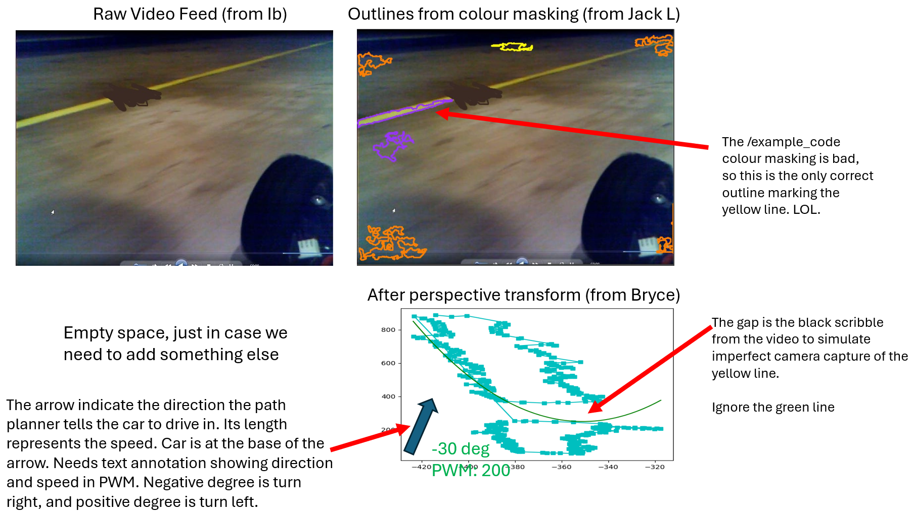

* The image above is just a very rough guide
* To get a **very rough** idea of how colour masking and perspective transforms are done, see ex_colour_mask.py and ex_perspective_transform.py under the example_code folder.
  + Remember we care about **three** colours: purple (for obstacles), yellow and blue (which marks the side of the track). See example_code/what_track_n_obstacles_look_like.mp4
* For perspective transform:
  + X and y axis need to have the same scale
  + This scale is consistent across all frames of the video (a video is made of a sequence of frames of image)
  + The location of the car on the graph is fixed, so it does not jump around when the frame changes

# Playback GUI

* Mostly the same as base_gui.py, but:
* The source video is a pre-recorded video instead of from IP Webcam.
* An interface to play/pause the video and select the timestamp to play like a YouTube video (the three parts circled below):

# Colour Masking

* Test using the yellow and blue tapes.
* Pay attention to documentations/ DRC_Rules_2024.pdf Appendix A
* Three colours: yellow, blue and purple (the obstacles). Mask each colour individually, since different colours mean different things.
  + See example_code/what_track_n_obstacles_look_like.mp4
* Input: a frame from a raw video feed
* Output: the outline/edges around areas of interested colours (blue, yellow and purple).
* Manage glare and improve reliability (this was an issue last year)
* **May** need to consider other characteristics on top of colour, e.g. brightness, contrast, width, geometry.

# Perspective transform

* Depends on the camera placement, so this depends on mechanical task.
* Converts the camera point of view to a bird’s eye view (so it is easy to analyse the position of the edge of the track.
* Similar to homogenous/GPS frame transform from METR3100, but **different**.
* Input: the edges/outline/contour from the colour masking task, NOT the raw video feed. The edges will be expressed as array of x and y-coordinates in camera frame.
* Output: x and y-coordinates in bird’s eye view in centi-metre.
* The centre/origin of frame is at the centre of the phone’s camera.
* See the folder example_code/from_zac_apelt, which has the instructions for perspective transform. Read the .jpg picture first. Zac did all of it last year, which is why I don’t know much about perspective transform.
  + To run the code in /from_zac_apelt, /from_zac_apelt needs to be **current** directory

# Mechanical and 3D printing

* Stability.
* Centre of gravity and reducing inertia, so it is easier for the car to turn.
* Camera placement: ensure a good field of view. (IMPORTANT)
  + Maybe hold the phone landscape???
  + Or tilt the phone???
* Phone:
  + Password: 123456
  + On the homescreen, IP webcam allows you to see the camera view remotely from a computer (might be handy). The instruction video (don’t worry about the Python part): <https://www.youtube.com/watch?v=0hT2cGSqPfk&ab_channel=Iknowpython>
* Bolts for securely attaching to the circuit boards (since gyroscope can’t wobble all the time)
* Needs to hold different configurations of power bank (since we need backup components)
* 3D print must be RED, since the majority of the car needs to be red (it is in the rules)
* Protection to damp the impact of a front-on collision. (Nice to have)
* Cable management (Nice to have)
* Preferable (**not necessary**) The corner of the board with resistor R3 and R4 is facing front right.

# Firmware

* Controls the motors on the car.
* reads from the gyroscope and control system.
* Receives the commands via Bluetooth using UART communication at 115200 baud rates.
* The car stops if UART/Bluetooth disconnected for a while.