Bichun Zhang

301430901

PointNet

To run the command below, please make sure you have the same structure, otherwise, you need to config the path to the data dir yourself.

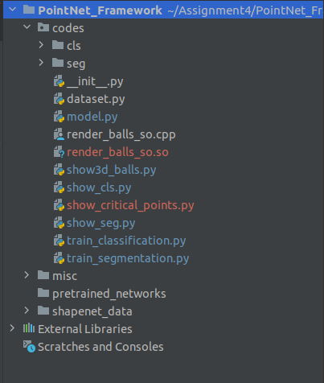

System: Ubuntu

GPU: RTX 3060

cd codes

1. Average Test Accuracy for classification with feature transformation of all classes

python show_cls.py --model cls/20_latest_classification_true.pt --feature_transform

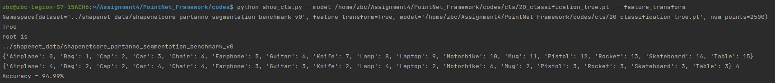

1. Average Test mIoU for segmentation with feature transformation on “Chair” > 0.8

python show_seg.py --model seg/19_latest_segmentation_true.pt

--feature_transform --task mIoU

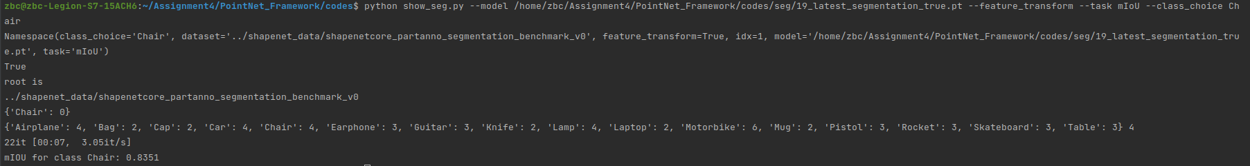

1. Report quantity results(Accuracy) without feature transformation in classification

python show_cls.py --model cls/latest_classification_false.pt



1. Report quantity results(mIoU ) with and without feature transformation in segmentation

python show_seg.py --model seg/19_latest_segmentation_false.pt --task mIoU

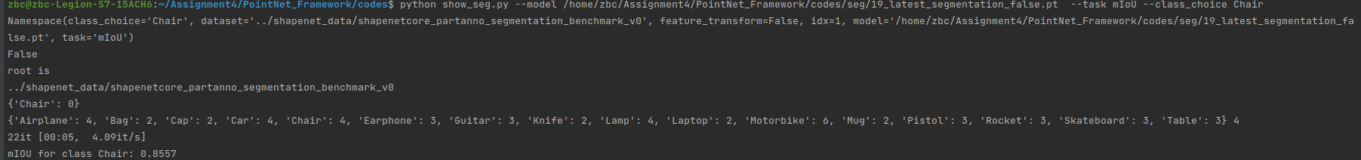

1. Visualization of at least 4 shape segmentation results from at least two classes.

python show_seg.py --model seg/19_latest_segmentation_true.pt --task seg

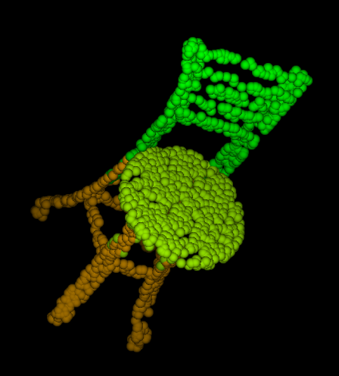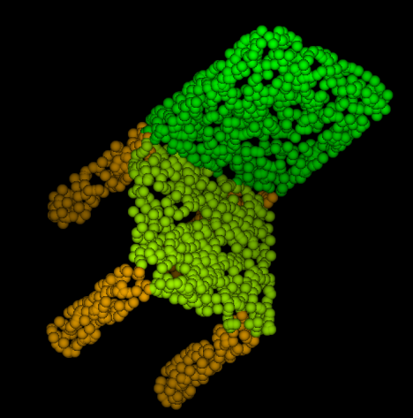

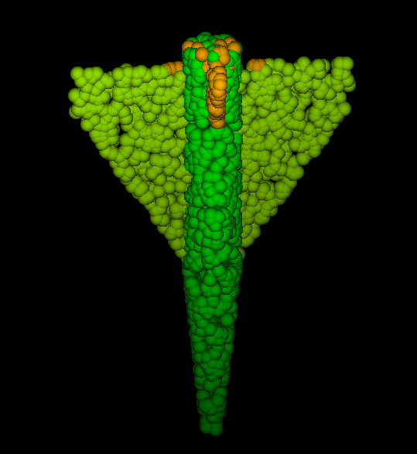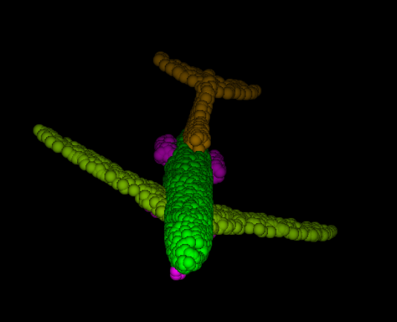

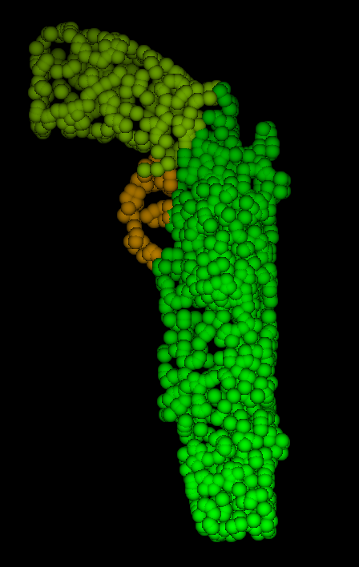

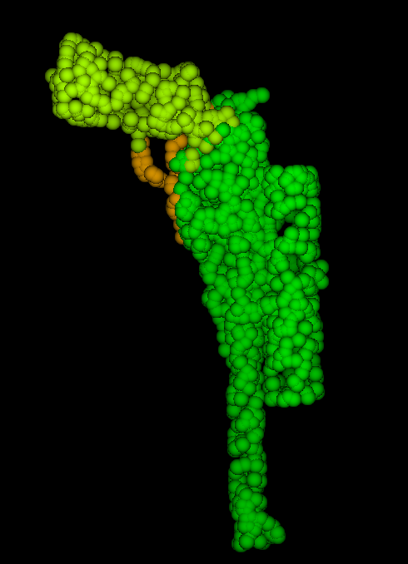

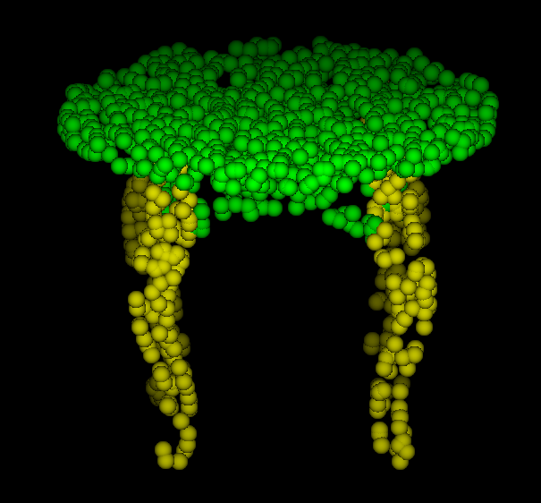

1. Visualization of critical points of 4 shapes in classification

python

