# Firewall Installation

## Introduction

This is a simple to use script that will install our fire wall and SQL rules.

## Step 1

1. Place the script in your home directory
2. Go to the terminal and use “sudo -I” then issue the following commands:

* cd /home/student (or what ever the account name is)
* chmod 755 firewall.sh
* ./firewall.sh

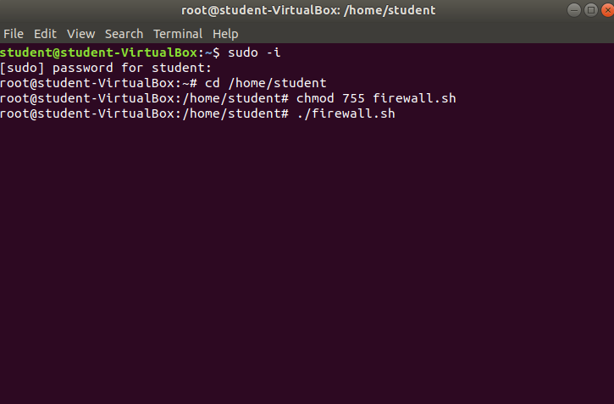

## Step 2

When prompted select options [1] “Enable UFW”, [3] “Create UFW rules’ and [4] “Display UFW rules”. Simply hit enter to complete.

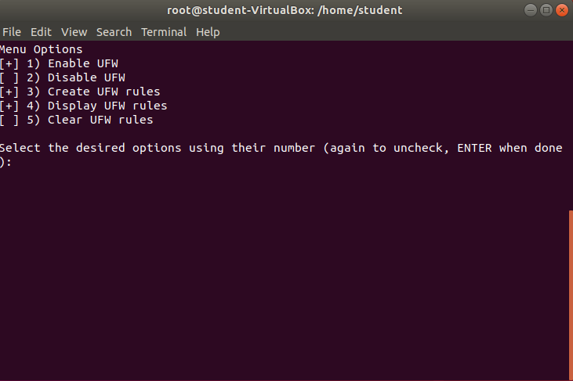

## Disable UFW

To disable these settings run ./firewall.sh again and select option [2] “Disable UFW”. To Enable them again select option [1] “Enable UFW”.

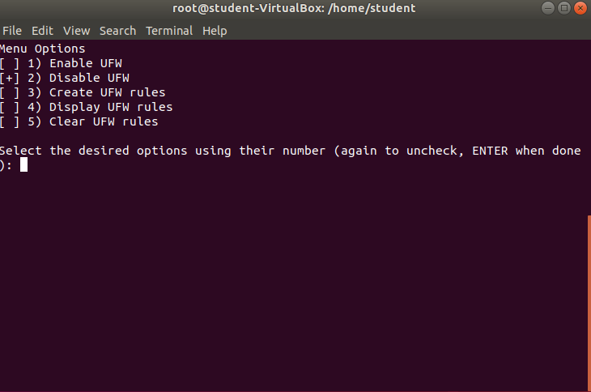

## Uninstall

In the event the installation fail’s or you just need to remove these settings, use ./firewall.sh again and select option [5] “Clear UFW rules”.

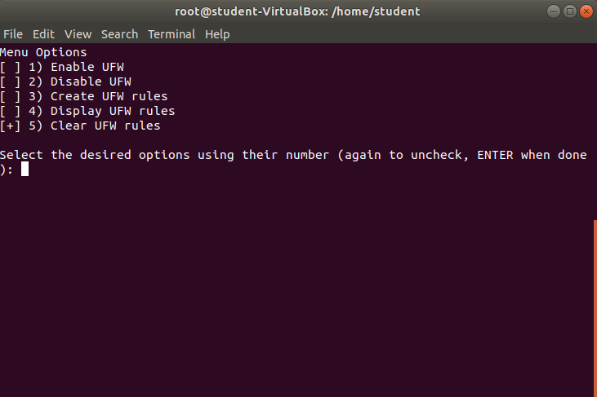

# SQL Installation

To install the SQL script, run the script in sudo -i. The process will be automatic.

# NAT Networking

Like our SQL install, you can run the script and it will be automated. The only difference is you will have to change the location of the file depending on your virtual box install location. If its on your C drive this won’t be an issue since that is the default for our script.

