1. **Direnc Okuma**

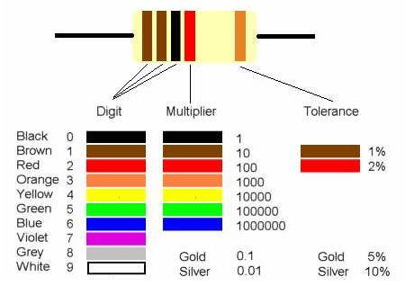

Direncler 3 ya da 4 renkli olur, okunma sekli de su sekilde;

**4 Renkli ;**

**Digit1 – Digit2 – Digit3 – Digit Carpan - Tolerans**



**3 Renkli ;**

**Digit1 – Digit2 – Digit Carpan – Tolerans**



1. **Direncler**
   1. **470 Ohm**

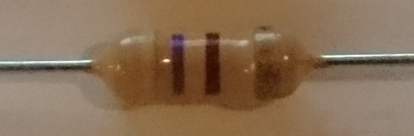

**Sari** – **Mor** – **Kahverengi** – Altin

4 – 7 – 1 Tolerans: %5

47*10 = 470

* 1. **1K Ohm**

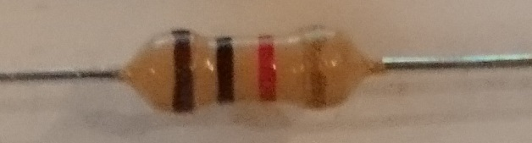

**Kahverengi – Siyah – Kirmizi –** Altin

1 – 0 – 2 Tolerans: %5

10*100 = 1000 = 1K

* 1. **2.2K Ohm**



**Kirmizi – Kirmizi – Kirmizi –** Altin

1 – 0 – 2 Tolerans: %5

10*100 = 1000 = 1K

* 1. **10K Ohm**

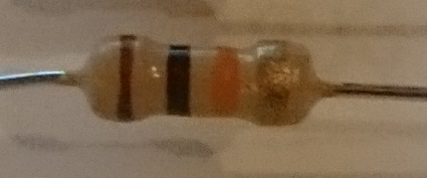

**Kahverengi – Siyah – Turuncu –** Altin

1 – 0 – 3 Tolerans: %5

10*1000 = 10000 = 10K

1. Kapasitorler
   1. 10 uF 25 V

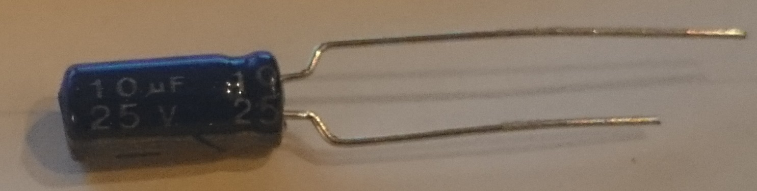

1. Transistorler
   1. BC337 NPN & BC327 PNP (Ya da BC556 PNP)

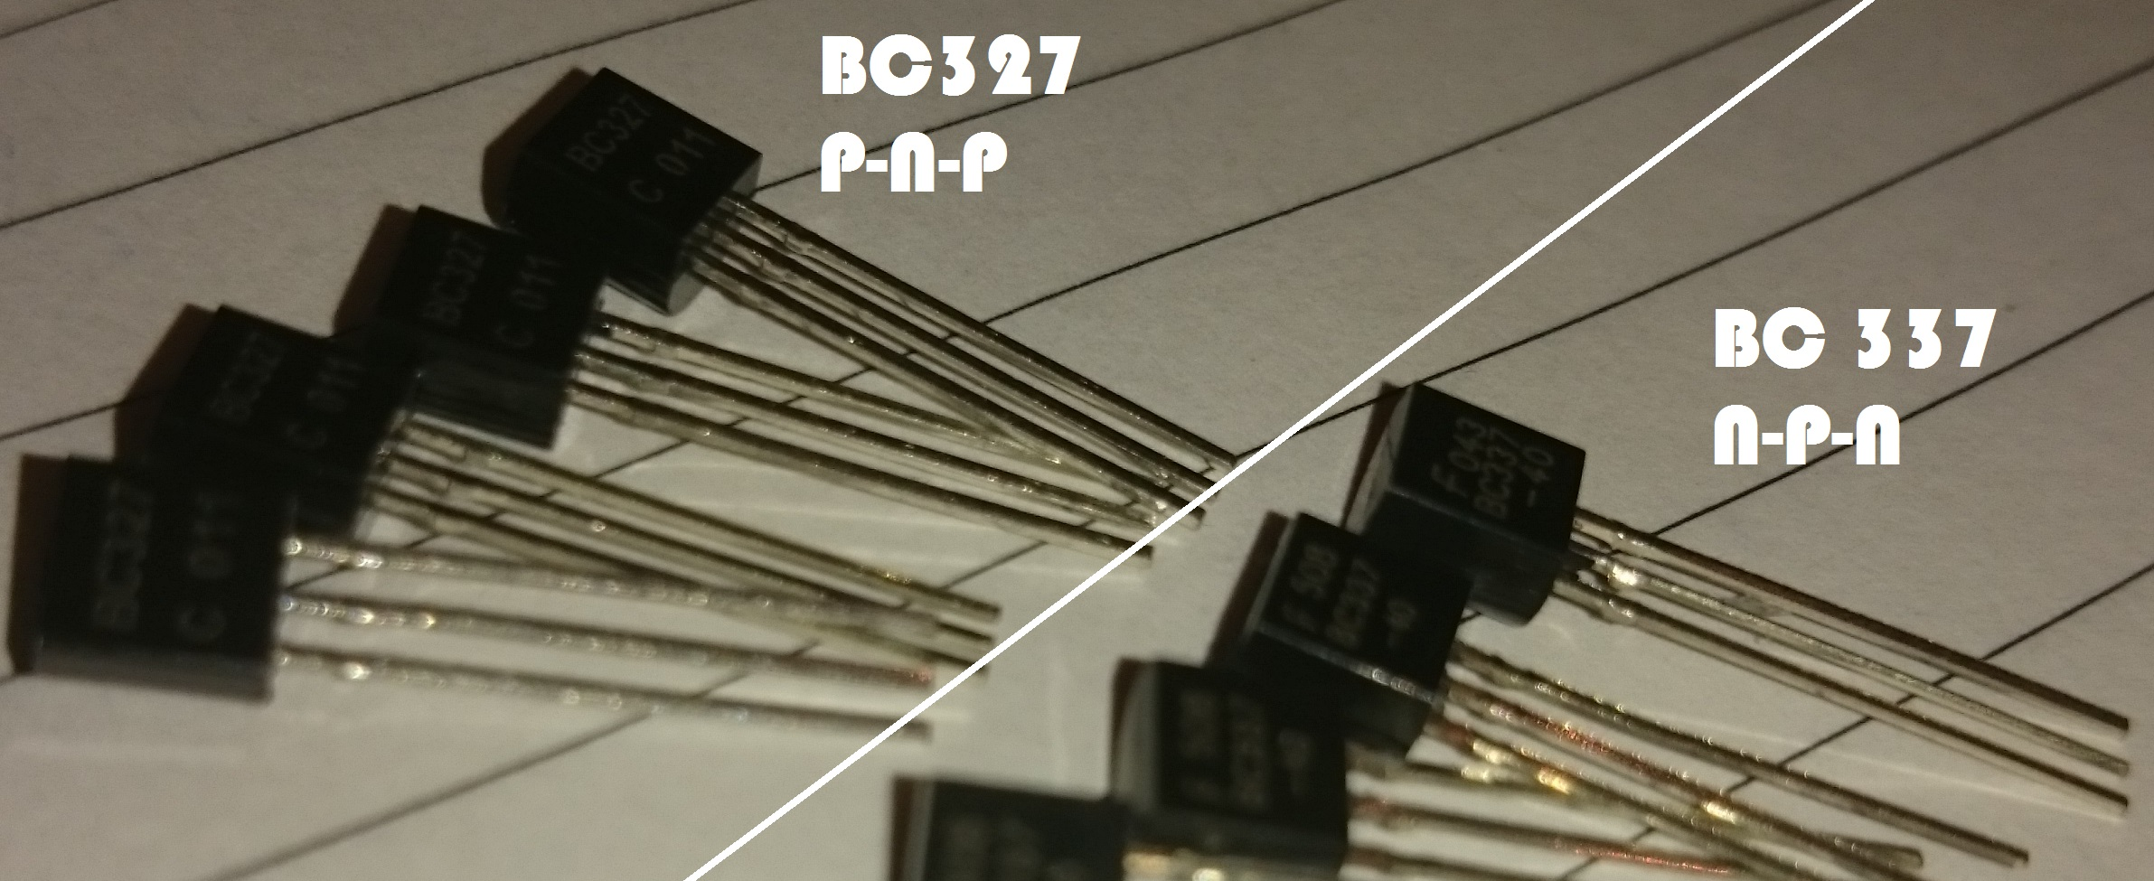

1. **Kapilar**
   1. **AND**
      1. 74HC08

**M74HCT08B1**

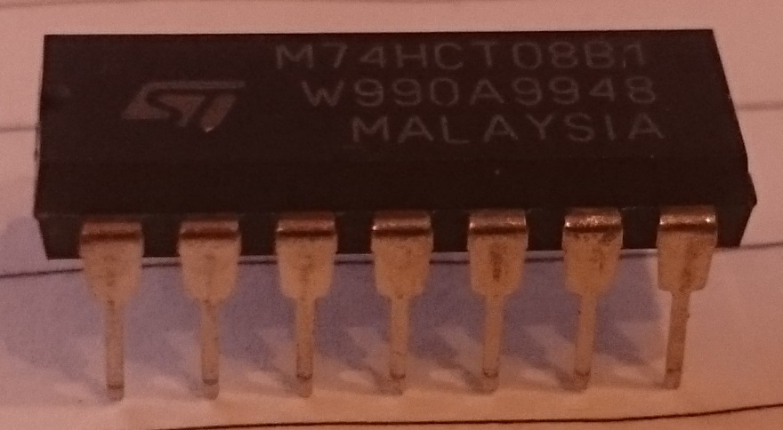

* 1. **OR**
     1. 74HC32

**SN74HC32N**

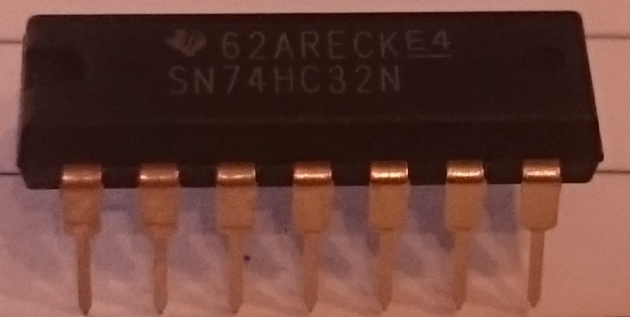

* 1. **NAND**
     1. 74HC20

**SN74HC20N**

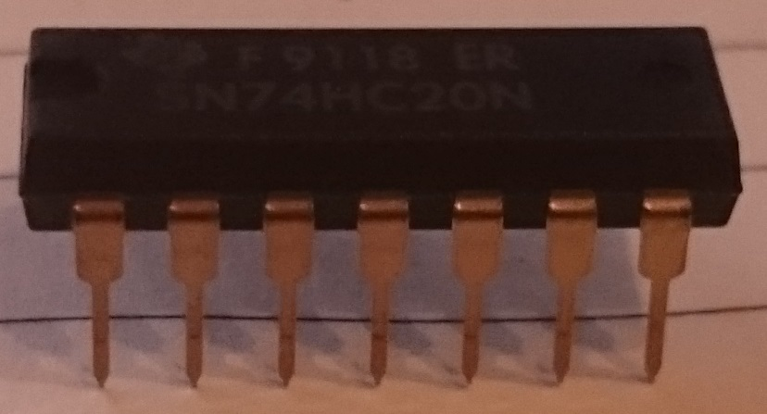

* 1. **NOR**
     1. 74HC02

**SN74F02N**

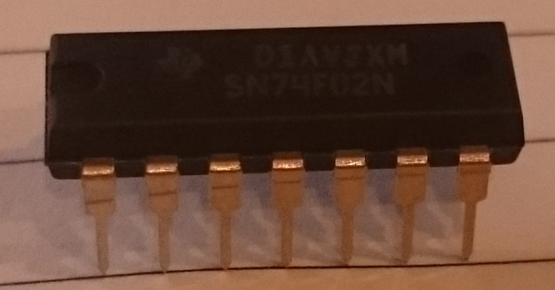

* 1. **NOT**
     1. 74HC04

**SN74HC04N**

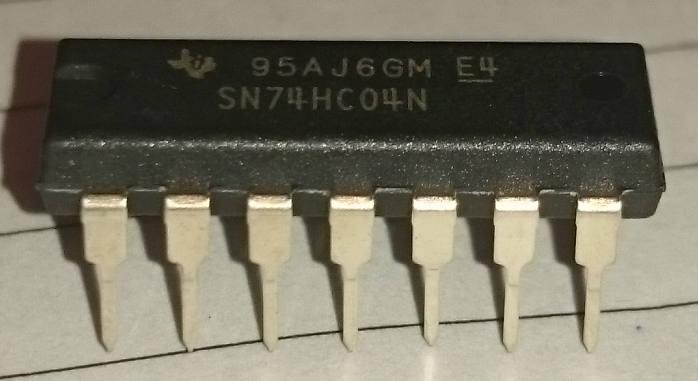

1. **Tumlesik Devreler**
   1. **LM555**

X

* 1. 4017 COUNTER

**HCF4017BE**

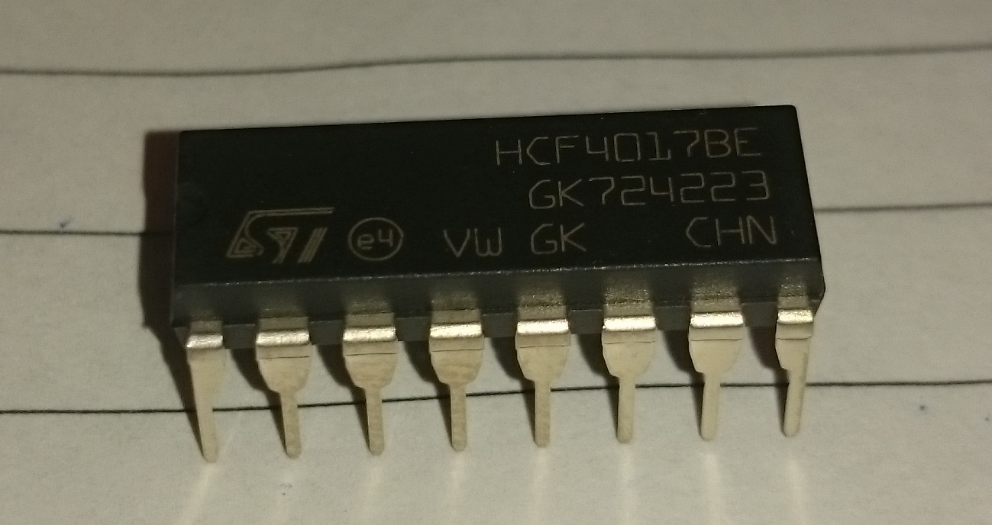

1. Guc Kaynaklari
2. Diger
   1. LED’ler

