Feasibility study
The feasibility study can provide data for enhanced decision-making and budgeting purposes. It is recommended that project sponsors perform this study in order to have a better understanding of the target population and local infrastructure. After financing approaches and program objectives have been delineated, other elements should be analyzed before moving on. The school (or education center) selection process should be based on the objectives of the program such as saturation based on grade levels, saturation based on region or district, or saturation based on specialized programs. Having schools involved from the early stages can drive school leaders to a positive response towards the program and can facilitate project ownership at the school level. A feasibility study should include:
- School surveys
- Power and connectivity status
- Allocation of laptops (warehouse and distribution process)
- Human resources (program implementation)
Once the schools are selected, a school survey should collect information including the number of classrooms, students, teachers, and administrators. It is important to keep in mind the accessibility of schools when planning the distribution of laptops and spare parts, as well as when designing the support and supervision structures of the program. Moreover, an assessment of power, infrastructure and connectivity at individual schools should be made as part of the feasibility study. The results of the assessment should be used to revise plans in terms of timelines and costs, and to mitigate any gaps in school readiness. The assessment should include availability of grid power (or alternative sources such as generators or solar panels) and power capacity (in watts), availability of sockets within each classroom, number of school servers needed, and internet availability (DSL, VSAT, or GSM).
The following equation can be used to estimate the power requirements for each school. (The Watt- hours are dependent on how long the children are in school, whether or not they are charging their batteries while they are working, and how many hours per day the school server and connectivity are operational.)
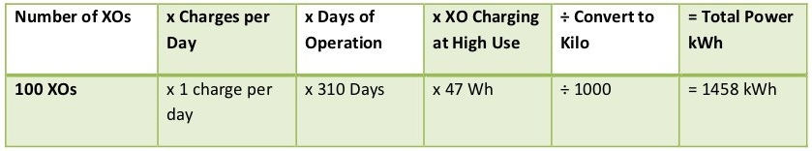
The total energy required to operate 100 laptops and a school server over an eight hour period is approximately 570 Watts times 8 hours, or 4560 Watt-hours. If, for example, this energy was to be generated and stored over the course of a two hour period, roughly 11,400 Watts of generating capacity would be needed to feed a battery system with adequate storage capacity, assuming 80% efficiency.

Solar Panels
If the location of deployment is remote and isolated, and no electrical power is available, solar panels can be an alternative solution. Panels of 10 and 15 Watt solar-panel solutions are compatible with the XO. The 10W panel at full output will fully charge a drained battery in just under three hours if the laptop is turned off. If the laptop is running, then full sun with the 10W panel will provide enough average power to run the laptop and slowly charge the battery (in about six hours).

