Deployment Phase
The deployment phase includes all events that occur between laptop order placement with the manufacturer and final distribution of XOs to schools and children. The lead time provides a term that can be allotted to conclude recruitment of local team members and to arrange technical and educational training with OLPC for core teams. In addition, this time can be used to fulfill infrastructure needs based on the results of the feasibility study.
Warehousing facilities should be prepared for the arrival of laptops, as should be the personnel in charge of inventory management and the distribution process.
Heads of schools, along with administrators, need to be informed about the goals and implications of the program from the early stages of a project. Formal meetings with these parties and with other relevant members of the school system or political figures should be organized toset up a timeline for teacher training and other activities at the school level.
Once laptops arrive in a country, the steps to follow include setting up logistics, training the core team with OLPC, setting up school infrastructure, preparing schools and community, and rolling out laptops.
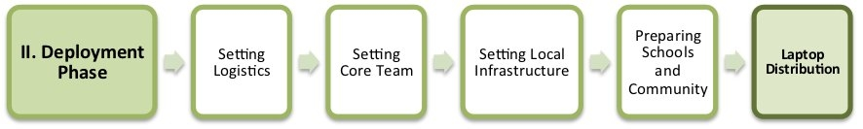

Setting Logistics
The logistics department of core team is responsible for managing the local logistics process once the shipment is delivered to the port of destination. This logistics manager will be responsible for facilitating the customs clearance process and local delivery of the shipment to its final destination. An efficient and speedy logistics process is not only important to maintain the proposed deployment schedule, but also it is also vital in order to avoid any charges or fees which may be applied to the shipment if there is a delay in customs clearance or unloading at the port of destination.
Once the laptops arrive in a country, clear customs and arrive at a sponsor warehouse, there are three key tasks that need to be performed:
- The laptops need to be individually inspected for damage suffered during transit, and any insurance claims need to be prepared
- The laptops may need to be loaded with the latest version of the operating system and any local content, if there have been changes to the software since the units were shipped. This procedure also serves as confirmation that the computers are in working order and are ready for students and teachers
- The laptop serial numbers should be entered into the inventory management system along with the identification numbers of each student and teacher. This procedure provides the basic information, which is then updated to reflect repair history, laptop transfers, or replacements.

Warehousing
When developing plans for local storage of XOs, it is important to consider the security of storage facilities, impact of weather on stored XOs, and possible insurance coverage required.
Final delivery of XOs to schools or distribution sites should be planned and budgeted for. If additional containers or trucking is needed to transport the laptops to their final destination, it is important to budget for such costs. The OLPC Operations department can provide information on packing dimensions and any other packing concerns.
Local warehousing enables stocks of laptops to be stored for configuration while the logistics infrastructure is prepared for laptop roll out. Strategic placement of regional warehouses can reduce the cost of logistics and improve efficiency of laptop repair and replacement.

Laptop Distribution Plan
In the experience of OLPC, most sponsors can only distribute a maximum of 60,000 machines per month. Machines are typically distributed by third party companies, the military, or multi-lateral relief agencies such as the World Food organization. These organizations have extensive experience in secure logistics. In many countries, one thousand laptops is a high value target for theft, and security should be a primary concern in selecting a logistics company. Any celebratory events should be timed to match the arrival of computers at schools (which should coincide with the availability of Internet).
OLPC’s experience shows that the best distribution plan is to start with easiest areas first, unless there are political considerations. Starting in the easiest areas allows for any last minute changes in plan to be identified and implemented. Staff also learns faster when they can focus on the simpler installations and do not have to install solar equipment or satellite earth stations.

Spare Parts Management
Spare parts management is an often overlooked but key part of a successful ongoing deployment.
Machines break as a result of use by kids; historically, repairs are higher in areas with the poorest children. Not surprisingly, these students lack experience with consumer electronics and the proper care and treatment of computers.
A project should plan for the receipt of a spare parts inventory within 6-9 months of the laptops reaching the children. Up until that time, the 1% of surplus units shipped with every order should be sufficient to handle repairs. OLPC logistics staff can provide advice on how to determine the composition of the initial repair order; with time, the project should be placing spare parts orders based on actual data.

Baseline study
Prior to starting a deployment it is advisable to have on record data that describes the scenario where the project will be implemented. The project manager and the core team can work in conjunction with evaluation experts or academic/research institutions to design an evaluation framework capable of measuring the project’s impact in relation to the objectives expected to achieve. The design has to be aligned with measures of students learning, therefore a careful analysis of indicators and tools need to be conducted.
The baseline information can serve as a valuable starting point to better understand the community involved in the project, and can even lead to formulation of objectives that stakeholders wish to achieve. It also grants the ability to measure the impact of a project, because it allows researchers to statistically analyze and compare baseline data with data collected throughout the years of a project’s implementation.
The goals and expected outcomes of the program should be the criteria for selecting the type of data to collect as a baseline. Institutional data can measure changes in school attendance, school enrollment rates, and drop-out rates. Measures of social and behavioral impact can include surveys or questionnaires related to attitudes, motivations, and opinions from parents, students and community members about the project itself or about students’ learning. Students’ performance can be measured by standardized local or national exams. Traditional exams fail to evaluate new skills that students develop as they incorporate technology into their learning. New dimensions of learning need to be assessed, such as problem-solving skills, critical thinking, management of multiple sources of information, the capacity for reflection, communication using multiple means (visual, auditory, interactive, etc.), individual and team work skills, and self-learning abilities; more complex dimensions include agency (Carlson & Earls, 2001) and effectiveness of children and young people at making significant changes to the environment in which they live (Kamo, N. et al., 2008). are. Deployments are encouraged to explore innovative ways of measuring student learning, and to attempt documenting and measuring new learning dimensions.
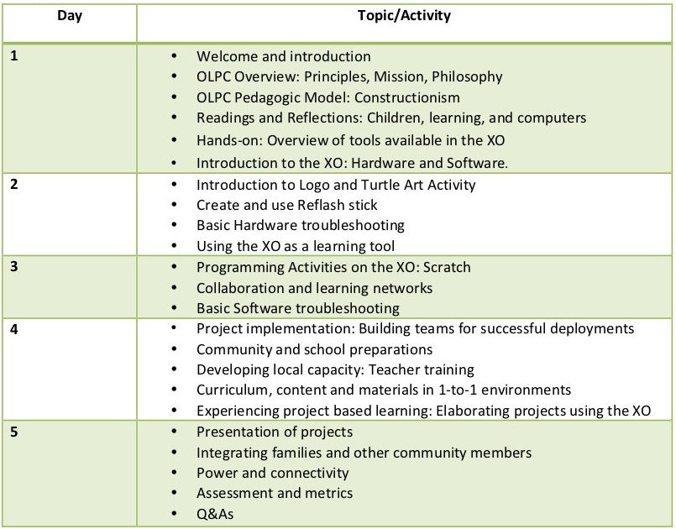

Setting Core Team
As we have explained in previous sections of this guide, the Core Team refers to the local team in charge of implementing different domains of a deployment. In this section we will focus on the technical and learning teams. Their work is crucial for a successful implementation of a deployment; the members need to be carefully recruited and supported financially and proactively for the duration of the program. At this point of the deployment phase it is crucial to have established the Core Team.
The size of these teams will depend on the number of units for the deployment. Although technical and learning teams both focus on very different areas, the ideal situation is that they constantly work as one team, communicating plans, challenges, and updates on a very regular basis. It is the responsibility of the project manager to facilitate the relationship these teams will institute. It is essential to provide constant guidance to the core team by someone with the appropriate area of expertise. Having a manager for each team is deeply advisable. These managers should maintain constant communication with OLPC technical and learning teams.
OLPC will facilitate a strategic workshop with the core team to:
- Build capacity in managing the XO, its activities and its uses as a learning tool.
- Build capacity in setting up infrastructure, connectivity and other technical requirements at school or community level.
- Determine the support structure (for technical and pedagogical aspects) that will run from the core team to the school or learning center.
- Determine and assist in the strategies for initial and ongoing teacher training, and in the development of content for schools and teachers.
- Define strategies to integrate community and family members in the project.
The duration of the workshop can vary between several days to several weeks. This will depend on the characteristics of the project: deployment size (amount of laptops, scaling and distribution plan), core team (background and size), project location, project objectives, and infrastructure status. The duration will also depend on the agreements reached during the planning phase with project manager and OLPC, and on the specific contextual needs of the project. The content and activities of this initial workshop also vary depending on the needs and experience of the participants. However, the approach/methodology and some content are common to all workshops for they revolve around the same principles we advocate: learn by doing, by constructing, by collaborating, and by reflecting.
We highly recommend the learning and technical managers of core team to start discussing content, length and timing of this workshop with enough time with OLPC through online webinars. This will allow OLPC and deployment to define the details of workshop and for the core team to advance in necessary preparations prior to training.

OLPC training description
The goals of the OLPC learning workshop can include:
- To develop an understanding of the OLPC Learning Theory and Pedagogy.
- To provide a hands on experience of the Sugar Learning Platform.
- To enable core team to use the XO in effective learning strategies through construction, expression, and collaboration.
- To integrate 1:1 computing to curriculum and to informal learning environments.
- To evaluate learning within 1:1 computing environments.
Some technical contents of the workshop can be covered simultaneously with learning team and technical team, while other advanced topics should be covered separately with technical team. The goals of the OLPC technical workshop can include:
- Basic Software and Hardware troubleshooting
- Create and use USB Re-flash stick
- Connecting and registering to School Server
- Configuring Access Point.
- Installing and configuring School Server
- Defining a tech support strategy
- Defining a maintenance and repair strategy wide scale and school based
The following agenda is a sample of the topics usually covered during a 1 week workshop with Core Team:
The workshop is a hands-on experience that will not only enable participants to become familiar with technical and pedagogical aspects of the project, but also enable them to reflect on the strategies that should be defined in the schools or learning centers.
OLPC offers follow up workshops that can be performed several months after deployment is operating or once the core team has acquired the basic experience, knowledge, and skills that benefit their deployment. This option of workshop can instead be performed during an initial training with OLPC if participants already demonstrate an advanced level of skills. Another option for follow up trainings consists on specialized workshops that focus on a specific topic of interest to the core team and to developed additional and specialized skills. Finally, OLPC offers Regional Workshops to address needs common to a specific region. For this OLPC selects a strategic location that will allow participants from multiple deployments to attend.
The following are examples of advanced workshop for Core Team:
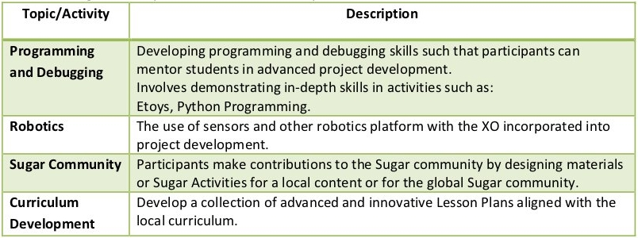

Content Development
Another recommended strategy for core teams to implement is the development of content for communities and schools. The following documents are examples of such content: a) How-to Guides for different uses of the laptop b) Ideas for projects that correspond to specific topics, which might be of interest and/or relevance in the environment where students and teachers live. c) Lesson plans that show how to use different Sugar Activities when teaching different parts of the national curriculum
We recommend the establishment of an initial library of projects that will help teachers to integrate the computer into their teaching practice while motivating them to create their own projects, focusing on the training approach described in the previous section. It may be that each teacher uses the computer in their individual class, or that teachers from different areas come together to design joint projects. Either way, this approach will help make explicit the concepts that the projects integrate and promote, highlighting especially those concepts that one can "manipulate" and understand by using the laptop, but which would be more difficult, or nearly, impossible, with pen and paper.

Preparing Schools and Community
When laptops are ready to be distributed, and assuming school infrastructure is ready, it is time to prepare teachers and other community members for this experience. Teacher training and community awareness can occur simultaneously but can also happen at different moments. Variables related to location, size, and readiness of each school or community need to be considered when deciding the order in which to implement each event.

Teacher Training
Teacher training is an essential component of an OLPC project and it should be an ongoing process. Teachers should be the first members of the educational community to receive information on and become involved in initiatives that have direct effects on their own professional practices. It is recommended to begin training teachers and provide them with XO laptops during early stages of a project; this approach will raise their level of trust and commitment to the initiative.
The most important aspect of teacher preparation is in regard to how children learn. Educators have long recognized that children learn best when they are active, when they pursue their own interests, and when they participate in cultures of knowledge and engagement. With 1-to-1 access to connected laptops, children actively engage in knowledge construction and are not limited to passive reception of information. Each child (and the teachers themselves) can pursue learning in areas of strong personal interest and the classroom is not limited to a pre-determined, one-size-fits-all approach.
Teachers benefit as well. Not only do they get to use the laptops at home for their own learning, but the connected laptop becomes a conduit for customized professional development. This enables the teachers to gain access to expertise and colleagues and allows them to pose and respond to practical questions. They can fully participate as producers of knowledge and not just as consumers of materials produced by others.
The core team should develop different strategies to develop teacher’s capacity:
- Training workshops: where teachers learn to use the computer, and, at the same time, to incorporate it into their pedagogical practice.
- Support mechanisms: Although the contents of the initiative constitute an important support mechanism to the practice of teaching, other mechanisms must be implemented, including in- class assistance, which can occur through agreements with universities, telephone help lines that can be set up with technical developers in the country, and Blogs or online forums where teachers can participate.
- Teachers' clubs: work spaces where teachers can meet regularly to share successes, problems, and solutions.
- Guides and Resources.
During the first teacher trainings teachers should learn basic uses of the laptop and how to incorporate it into their pedagogical practice. Training should be guided by the vision and goal of the overall initiative. We recommend that the appropriate approach is “learning by doing” and that the "doing" be focused on developing concrete projects within the classroom. The core team should adapt the content and length for the initial training based on the teachers’ skills.
It is recommended that the technical team performs training sessions along with the educational team, to prepare teachers for basic technical troubleshooting regarding software, hardware, and connectivity. During these first approaches with teachers, the core team can quickly identify participants who demonstrate leadership and that can be key contacts to support the project at the school level. Depending on the scale of the project, the core team can decide whether to train teachers directly or to train Teacher-Trainers that will later reproduce the trainings to other teachers. Some projects decide to perform wide-scale trainings, an approach organized for several schools to attend. Schools can select key members of their staff to participate in this training, with the intention that these trainees become leaders and multiply the training at their own school. Another approach consists in assigning to each member of the core team a specific school in which to perform training for the staff on site. Whichever approach is decided, the core team needs to constantly monitor the progress of each school and teacher.
The following agenda is a sample of the topics the core team can be covered during an initial teacher training:
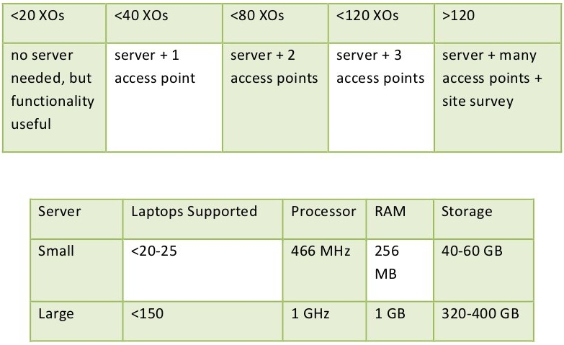
Deploying laptops to every child in an entire region or country cannot be managed by the core team alone. It must be led by the core team, and supported by regional teams. The core team will need to set the guiding principles of the program whilst the regional teams will be responsible for executing the deployment in their regions according to these principles, raising any concerns and coming up with viable alternatives where necessary. Various functions should be delegated to the regional teams for management where these functions are naturally distributed across the country or region.

Community Awareness
Prior to the arrival of laptops in a community, it is important to prepare different groups of people that will be impacted with the project: parents, teachers, school directors, families, and other active members of a community. The Minister of Education and Local Leaders should be involved in communications about the program, its goals, characteristics, benefits and derivative commitments.
Project coordinators must carefully plan awareness campaigns, by selecting appropriate tools (print outs, posters, signs, etc.) and communication strategies (radio or television spots, meetings, etc.) tailored to the unique characteristics of each community and the scale of each project. The timing of the campaigns should also be carefully thought through in order to allow communities to prepare for formal program launches. If national campaigns are created to inform different audiences about projects, such campaigns should be rolled out before laptop distribution or after more formal community awareness actions are taken by core team.
The preparation phase plays a significant role in creating positive expectations, attitudes, and involvement from all members. When communities understand the programs and their benefits, there are direct impacts on learning and on how well the laptops are taken care of. Both nationally and locally, communities must know what one laptop per child means. The children are the best ambassadors, but parent and community leader involvement is also influential. Fostering awareness is very important to the success of initiatives, both because it allows families and other community members to be involved in the learning process of children, and because it allows them to be active participants in the creation of a new culture and new learning experiences within their community. Parent meetings can be held at schools or community centers and should include, but not be limited, to the following topics:
- A description of responsibilities and roles involved in the different phases of the project. Tasks to be defined, organized and carried out by different action groups.
- Establishment of standards for sharing laptops among siblings and to older children.
- Security of the laptops. How and why to take care of the machines.
- Charging process.
- Internet access.
- Signing of agreement by parents
Other actors can be invited to the meetings so they can become part of the initiative and to materialize agreements with various consultants and / or volunteers of the project.

Setting Local Infrastructure
Prior to the arrival of laptops, the technical members of core team should evaluate, setup, test, and hold responsibility for the network and power infrastructure at schools and/or other community centers. OLPC can begin supporting the core team before in-country training takes place, thru online webinars or chats. During the OLPC in-country visit the hands-on training takes place, and the core team should be prepared for setting up the local infrastructure. OLPC will continue to support the technical teams online after the in-country training has concluded.

Power
The electrical infrastructure of schools has to be evaluated according to power demand generated by XO laptops, servers, and other devices. If the infrastructure is inadequate, it needs to be upgraded.

Connectivity
Although the OLPC ecosystem provides a self-configuring local-area wireless network, connectivity to the Internet needs to set up separately. OLPC can assist in the planning and integration of a laptop network into a national infrastructure. OLPC staff has experience with VSAT, DSL, etc. that it is happy to share. Many of the in-country teams have even more experience, especially in regard to rural deployments. Sharing best practices is in everyone’s interests. As with the laptop deployment, connectivity cannot happen everywhere at once. A phased effort carried out ahead of the laptop deployment is ideal. It should be noted that the wireless mesh network provides local “Ethernet”-like connectivity without any additional infrastructure.

School Server
Part of our deployment model is the utilization of school servers. School servers can be basic PCs that run Fedora, a variant of Linux. School servers are designed to provide gateways to the Internet, local content repositories, XO back-up platforms, school management solutions, etc. Large networks require servers designed for the size of the intended deployment to be placed in local school.
Some key benefits school servers bring to a deployment are:
Compatibility
The OLPC Server is a software stack that can be installed on any reasonable PC or server to complement the XO and help school environments provide a safe, well-managed and learning- oriented environment. No special hardware is required.
Backup
The XOs can all backup to an OLPC Server to ensure content isn't lost. All XO Journals are backed up to school servers, and teachers can view the Journals to gain an understanding of how the XOs are used, as well as to track students’ progress and identify where they may need help.
Digital Library
A Digital Library makes it easy for students to publish works (with teacher moderation) to other students and possibly to other schools. Teachers can easily add new resources to a Digital Library, which students can access at school (e.g. there are over 1.6 million free e-Books available)
Management and Security
Operators with high levels of technical skills can use school servers to manage network access, to lock laptops that get stolen or that aren’t returned to schools, and to provide local software repositories for laptop updates, etc.
Proxy Server
An OLPC Server can act as a network proxy. This saves Internet bandwidth, makes Internet access faster and provides a mechanism for content filtering that can be used to block inappropriate content.
Continuous Development
There are additional features coming to school servers, including Video conferencing, GPS and GIS functionality, Voice over IP, Instant messaging, and News services (blogging, forums, etc.) Servers are built on an Open Source platform, so they can be modified to suit particular needs of projects.
As important as all of the above-mentioned services are, the primary role of school servers is to facilitate the operation of local area networks. Without servers, XO laptops use multicast to communicate with each other, which puts heavy loads on wireless networks; multicast can only connect up to 20 laptops simultaneously School servers eliminate the need for much of the multicast traffic
Recommended minimum specifications for a school server are as follows:
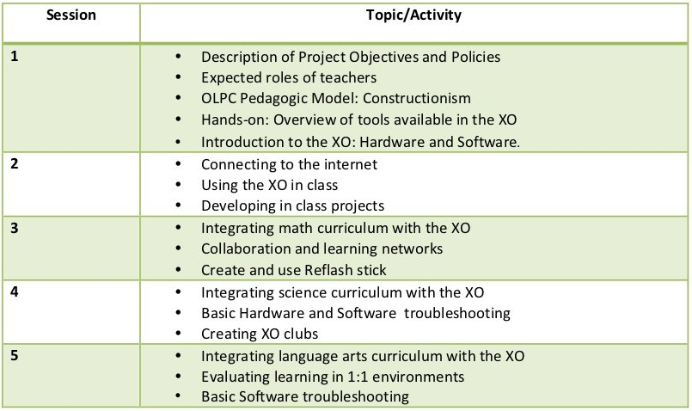
The amount of power required for school servers depends on the specifications of machines used. This needs to be taken into consideration during site preparation.

