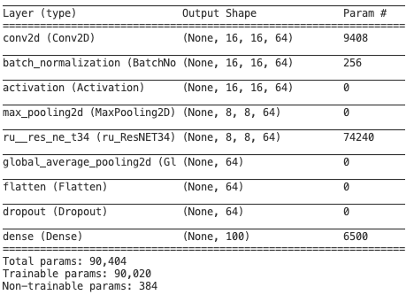
1 ResNet Unit [64] + L2 norm (0.01) in the Unit

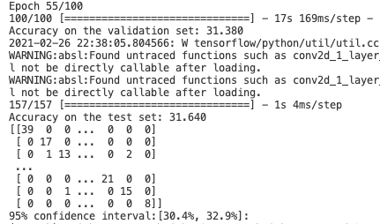
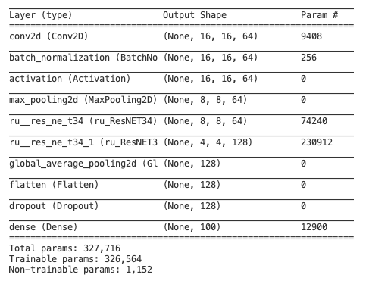
2 ResNet Unit [64][128]+ L2 norm (0.01) in the Unit

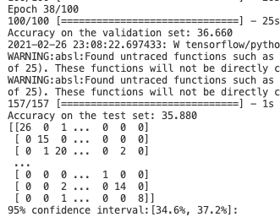
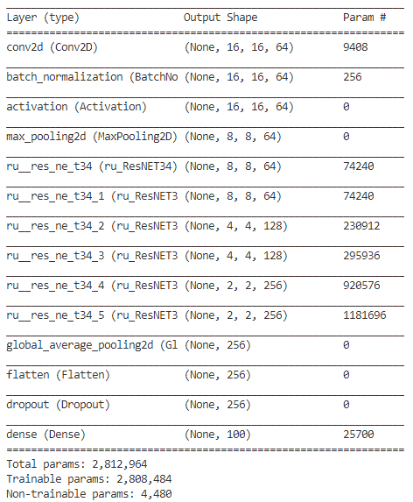
6 ResNet Unit [64]*2+[128]*2+256*2+ L2 norm (0.01) in the Unit
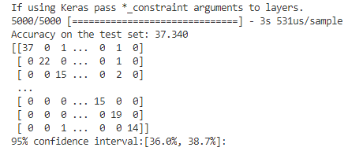
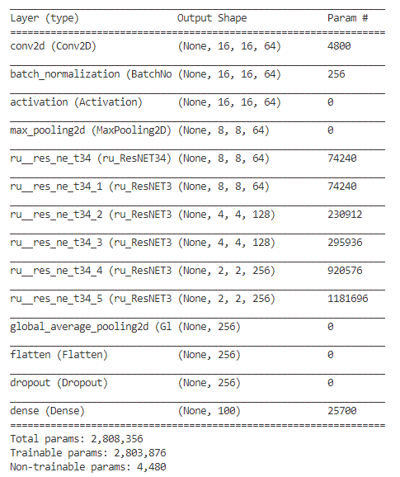
6 ResNet Unit [64]*2+[128]*2+256*2+ L2 norm (0.01) in the Unit
