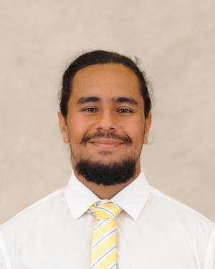

**Name: Gabriel Viruet-Quintero**

**Height: 5’10**

**Weight: 225**

**Class: First Year**

**Position: Prop**

**From: New York**

**Major: Undecided**

**Historical: 1st season with Oaks, appeared in 2 games during 2023 Carleton Cup**