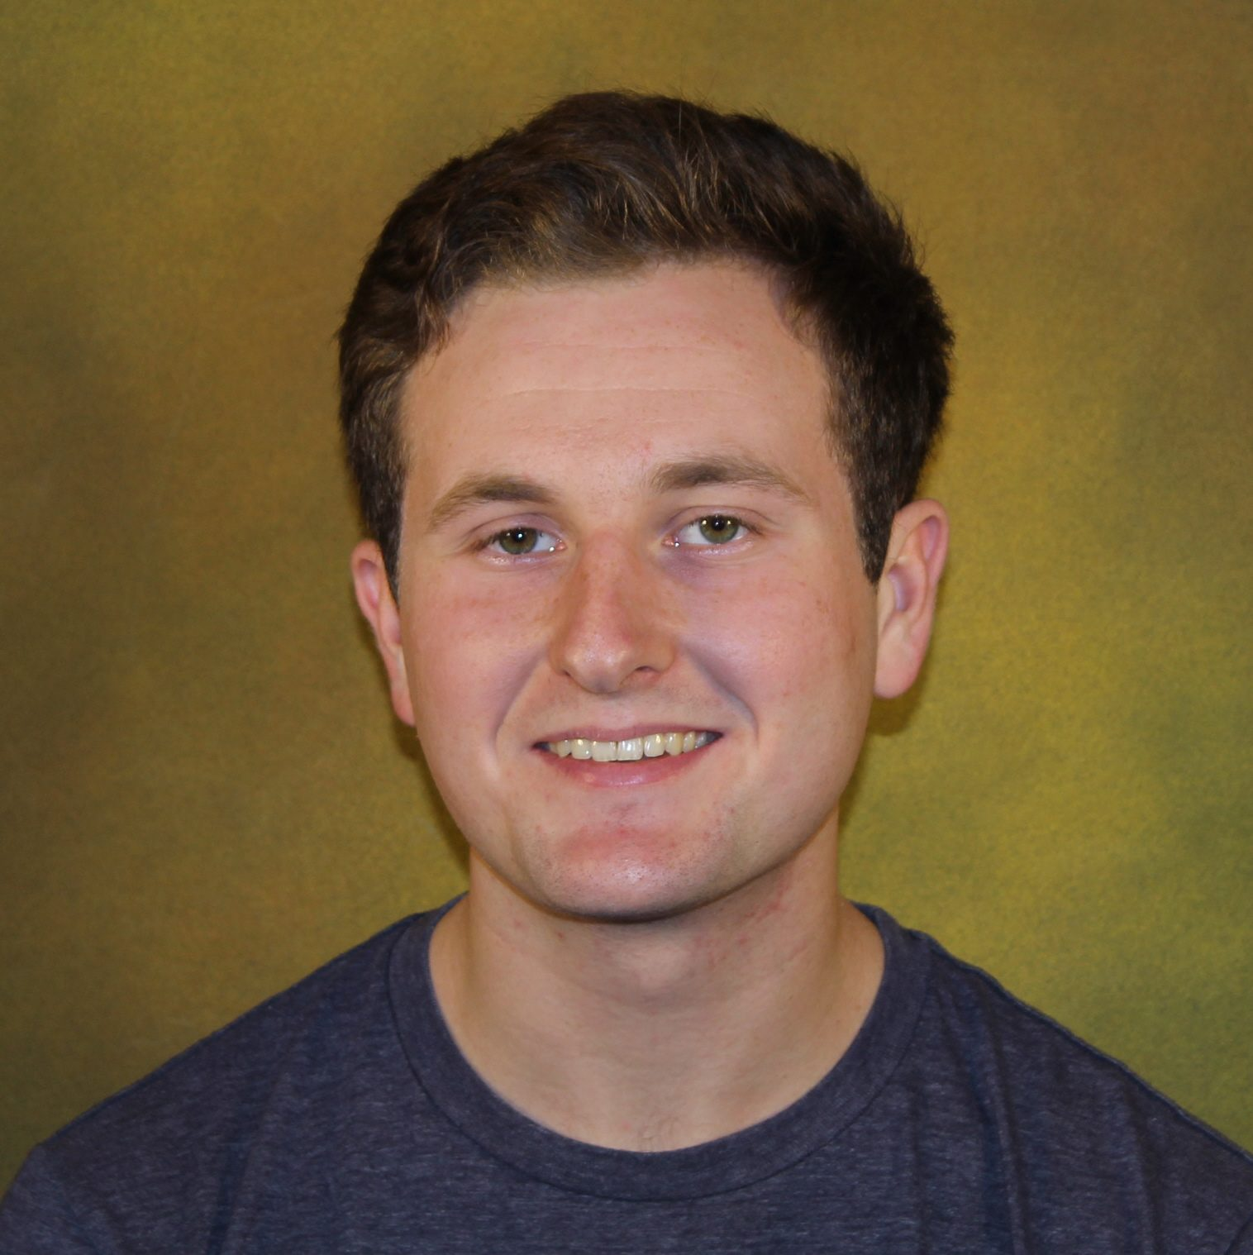

**Name: Jimmy Bice**

**Height: 5’10**

**Weight: 180**

**Class: Senior**

**Position: Scrumhalf/Flyhalf**

**From: Virginia**

**Major: Cinema and Media Studies**

**Historical: Appeared in all games last season for Oaks, scored opening try against SJU at Wayne State 7s, Previous captain and club president**