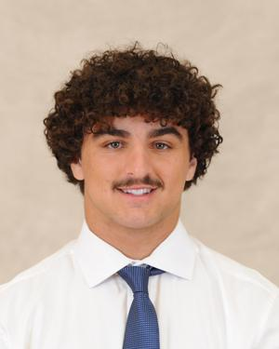

**Name: Jacob Ventura**

**Height: 6’1**

**Weight: 210**

**Class: First Year**

**Position: Second Row**

**From: New Jersey**

**Major: Undecided**

**Historical: 1st season with Oaks**