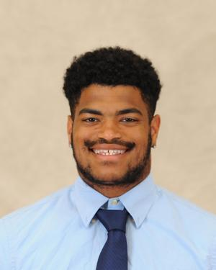

**Name: Luis Miranda**

**Height: 5’10**

**Weight: 210**

**Class: Junior**

**Position: Loose Forward**

**From: Connecticut**

**Major: Physics**

**Historical: Led team in scoring during Spring 2022 campaign, appeared in 5 games during 2023 Carleton Cup**