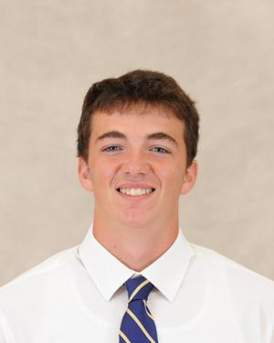

**Name: Nick Toole**

**Height: 6’3**

**Weight: 210**

**Class: First Year**

**Position: Loose Forward**

**From: Virginia**

**Major: Undecided**

**Historical: Appeared in 4 games during Carleton Cup**