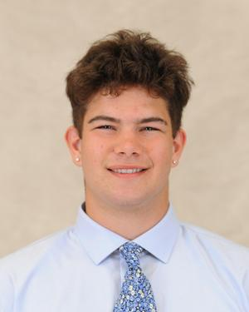

**Name: Rye Storrs**

**Height: 6’3**

**Weight: 225**

**Class: First Year**

**Position: Loose Forward**

**From: Portland**

**Major: Undecided**

**Historical: 1st season with Oaks**