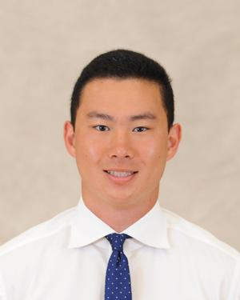

**Name: Sergio Yap**

**Height: 5’11**

**Weight: 200**

**Class: Sophomore**

**Position: Flyhalf**

**From: New Hampshire**

**Major: Chemistry**

**Historical: Club President, Appeared in 5 games during 2023 Carleton Cup**