

BME 364
MECHANISMS OF ALLERGIC DISEASE
Lab Manual

Group I

Paracellular flux of FITC-dextran 4 kDa

Contact
Huseyn Babayev
huseyn.babayev@siaf.uzh.ch

Can Zeyneloglu
can.zeyneloglu@siaf.uzh.ch

Ismail Ogulur
ismail.ogulur@siaf.uzh.ch

Paracellular flux of FITC-dextran 4 kDa (FD4)

Objective: To measure the paracellular permeability of Caco-2 monolayers exposed to polysorbate 80 (P80; 0.02, 0.1 and 0.5 % v/v) from the apical-to-basolateral passage of FITC-dextran 4 kDa (FD4), expressed as the apparent permeability coefficient (P_{app}).

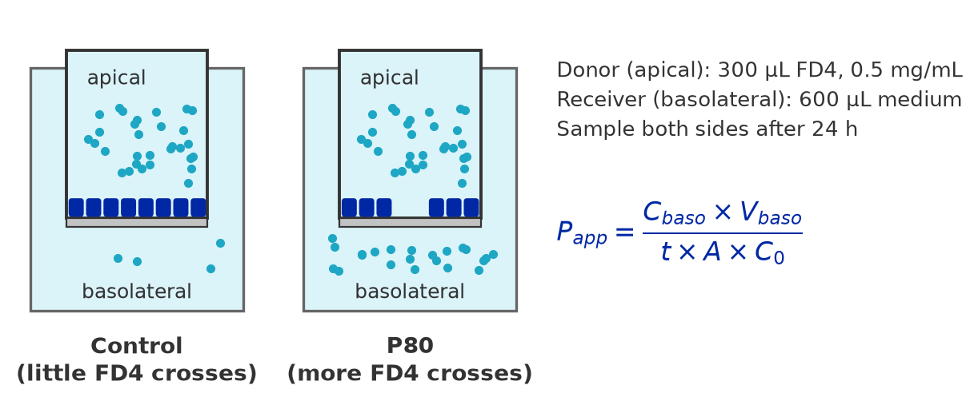

Materials
- The Caco-2 Transwell inserts of the TEER experiment (24-well plate: 4 inserts each of control, 0.02, 0.1 and 0.5 % P80, 1 blank), directly after the 24 h TEER reading.
- FITC-dextran, average MW 4,000 (FD4): light-sensitive, keep dark.
- Complete culture medium (DMEM + 10 % FBS + 1 % Pen/Strep) and the 0.02, 0.1 and 0.5 % P80 solutions (see the TEER manual).
- Black 96-well plate (flat bottom) for fluorescence.
- Fluorescence microplate reader: excitation ~490 nm, emission ~520 nm (e.g. 498/517 nm).
- 1.5 mL tubes, aluminium foil, multichannel pipette.

Solutions

FD4 Dosing Solutions (0.5 mg/mL = 500 µg/mL)

- Control FD4: dissolve 2.5 mg FD4 in 5 mL complete medium (inserts + standards).
- P80 FD4, one tube per concentration: dissolve 1 mg FD4 in 2 mL of the 0.02, 0.1 or 0.5 % P80 solution, so the P80 exposure continues until 48 h.
- Vortex, wrap the tubes in foil and keep them at 37°C until use.

Standard Curve (prepare on the sampling day, 48 h)

- Label 7 tubes: 25, 12.5, 6.25, 3.13, 1.56, 0.78 and 0.39 µg/mL, and one "BLK" tube.
- Top standard: 50 µL of Control FD4 (500 µg/mL) + 950 µL complete medium = 1 mL of 25 µg/mL (1:20).
- Add 500 µL of complete medium to the other six tubes and to BLK.
- Two-fold serial dilution: transfer 500 µL from 25 to 12.5 µg/mL, mix, and continue down to 0.39 µg/mL.
- Make standards and samples in the same medium; BLK is medium only.

Plate map

Black 96-well plate, 100 µL per well, every sample in duplicate.

 | 1 | 2 | 3 | 4 | 5 | 6 | 7 | 8 | 9 | 10 | 11 | 12
A | 25 | 25 | A1 | A1 | C1 | C1 | A1 | A1 | C1 | C1
B | 12.5 | 12.5 | A2 | A2 | C2 | C2 | A2 | A2 | C2 | C2
C | 6.25 | 6.25 | A3 | A3 | C3 | C3 | A3 | A3 | C3 | C3
D | 3.13 | 3.13 | A4 | A4 | C4 | C4 | A4 | A4 | C4 | C4
E | 1.56 | 1.56 | B1 | B1 | D1 | D1 | B1 | B1 | D1 | D1
F | 0.78 | 0.78 | B2 | B2 | D2 | D2 | B2 | B2 | D2 | D2
G | 0.39 | 0.39 | B3 | B3 | D3 | D3 | B3 | B3 | D3 | D3
H | BLK | BLK | B4 | B4 | D4 | D4 | B4 | B4 | D4 | D4

Columns 1–2, STD: standards in µg/mL (rows A–G) and BLK (row H, medium only).
Columns 3–6: basolateral samples, undiluted, in duplicate. Labels are the insert positions: A = control, B = 0.02 %, C = 0.1 %, D = 0.5 % P80.
Columns 7–10: apical samples diluted 1:50, same order.

Steps

FD4 Addition (directly after the 24 h TEER reading)
- Aspirate the basolateral medium of all inserts and add 600 µL of fresh, warm complete medium.
- Aspirate the apical medium with the tip at the insert wall. Add 300 µL of Control FD4 to A1–A4 and 300 µL of the matching P80 FD4 to B1–B4 (0.02 %), C1–C4 (0.1 %) and D1–D4 (0.5 %). The blank insert A5 gets 300 µL of medium without FD4 (it stays the TEER blank).
- Note the time, wrap the plate in aluminium foil and incubate for 24 hours at 37°C, 5 % CO₂.
Sampling (48 h, after the 48 h TEER reading)
- Prepare the standard curve.
- Basolateral: mix gently by pipetting up and down three times, then transfer 2 × 100 µL to the black plate (columns 3–6).
- Apical: mix gently, transfer 20 µL into 980 µL of medium (1:50), vortex, then transfer 2 × 100 µL to the plate (columns 7–10). Undiluted apical samples (~500 µg/mL) are far above the top standard.
- Add 2 × 100 µL of each standard and of BLK (columns 1–2).
- Read the plate immediately: excitation ~490 nm, emission ~520 nm, top reading. Set the gain on the 25 µg/mL standard so that it is not saturated, and keep the settings for the whole plate.
- Export the values with their well positions and fill in the two tables below.

conc_ug_ml | rfu
0 | 52
0 | 47
0.39 | 409
… | …
25 | 23401

insert | condition | side | dilution | replicate | rfu
A1 | ctrl | basolateral | 1 | 1 | 1087
A1 | ctrl | basolateral | 1 | 2 | 1103
A1 | ctrl | apical | 50 | 1 | 9852
A1 | ctrl | apical | 50 | 2 | 9716

Data analysis
Standard Curve and Concentrations
- Fit a straight line through the standards (RFU = a + b × concentration, 0.39–25 µg/mL). R² should be above 0.99.
- Check that every sample lies inside the standard range; otherwise dilute and read again (at 0.5 % P80 the basolateral samples come close to the top standard).
- Average the duplicate wells and convert RFU to concentration; multiply apical values by the dilution (50):
C (µg/mL) = (RFU − a) / b × dilution
Amount Crossed and Recovery
- Amount that crossed into the basolateral compartment, and the fraction of the dose (dose = 500 µg/mL × 0.3 mL = 150 µg):
Q (µg) = C_{baso} × V_{baso} = C_{baso} × 0.6 mL % of dose = Q / 150 µg × 100
- Recovery = (Q + C_{api} × 0.3 mL) / 150 µg × 100. It should be close to 100 %; much less means FD4 was lost or sampled wrongly.
- Sink conditions: the transported fraction should stay below ~10 % of the dose so the gradient stays constant.
Apparent Permeability
- Calculate P_{app} (cm/s) for every insert:
P_{app} = Q / (t × A × C₀) t = 86,400 s, A = 0.33 cm², C₀ = 500 µg/mL (= µg/cm³)

Example: C_{baso} = 1.12 µg/mL → Q = 1.12 × 0.6 = 0.672 µg → P_{app} = 0.672 / (86,400 × 0.33 × 500) = 4.7 × 10⁻⁸ cm/s
Statistical Analysis & Visualization
- P_{app} values spread over orders of magnitude: analyse log₁₀ P_{app}. Compare every P80 concentration with the control by one-way ANOVA followed by Dunnett's test (n = 4 inserts per condition); 10^{difference} is the fold change. Games–Howell when the SDs differ, Kruskal–Wallis + Dunn (Holm) as the rank-based check.
- Relate the two barrier read-outs: Spearman correlation of P_{app} with the 48 h TEER of the same inserts. Knitting 04_flux.Rmd (folder R/mac_linux or R/windows) runs all steps (knit 03_teer.Rmd first).
- Plot P_{app} (log scale) per condition, or against TEER, one point per insert.
- Report the tracer (FD4), incubation time, area and C₀ with P_{app}, and read it together with TEER: TEER down with unchanged FD4 flux points to the pore (ion) pathway; more FD4 flux points to the leak pathway or lesions.

