

BME 364
MECHANISMS OF ALLERGIC DISEASE
Lab Manual

Group I

Transepithelial electrical resistance (TEER)

Contact
Huseyn Babayev
huseyn.babayev@siaf.uzh.ch

Can Zeyneloglu
can.zeyneloglu@siaf.uzh.ch

Ismail Ogulur
ismail.ogulur@siaf.uzh.ch

Transepithelial electrical resistance (TEER)

Objective: To follow the barrier integrity of Caco-2 monolayers on Transwell inserts before and during exposure to polysorbate 80 (P80; 0.02, 0.1 and 0.5 % v/v) by measuring the transepithelial electrical resistance at 0, 24 and 48 hours.

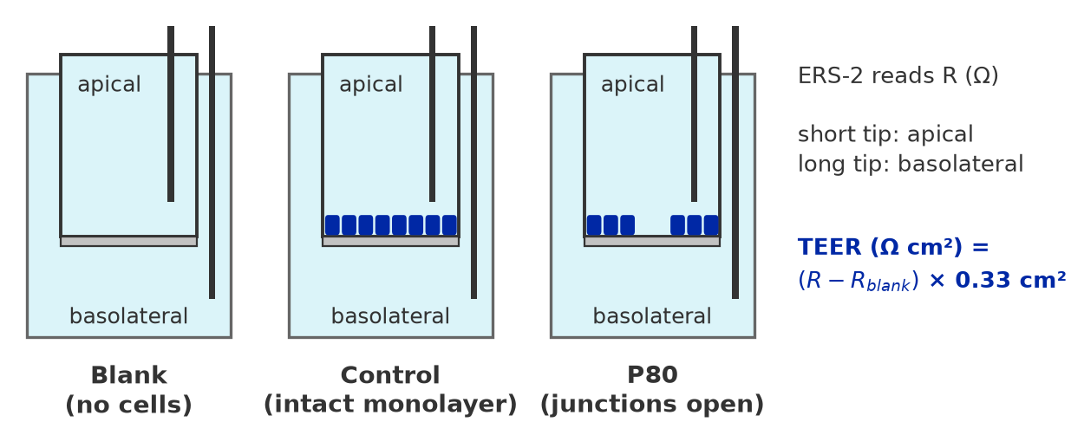

Materials
- Confluent Caco-2 monolayers on 24-well Transwell inserts (6.5 mm, 0.33 cm², 0.4 µm pores) in a 24-well Transwell plate: 16 inserts (4 per condition) + 1 cell-free insert (blank).
- Complete culture medium (DMEM + 10 % FBS + 1 % Pen/Strep), warmed to 37°C.
- P80 (Polysorbate 80 / Tween 80): sterile, cell-culture grade.
- Millicell ERS-2 voltohmmeter with the STX01 chopstick electrode.
- 70 % ethanol and sterile 1X PBS for the electrode.
- Recording sheet or laptop with the table below.

Solutions

P80 Treatment Solutions (0.02, 0.1 and 0.5 % v/v)

For 10 mL of 1 % (v/v) P80 stock solution:
- In a sterile laminar flow hood, add 9.9 mL of sterile complete culture medium (warmed to 37°C) to a 15 mL sterile conical tube.
- Add 100 µL of sterile P80 to the medium. (Calculation: 1 % of 10 mL = 0.1 mL = 100 µL.)
- Vortex vigorously until the P80 is completely dissolved.

Treatment solutions, 10 mL each, in complete culture medium (37°C):
- 0.5 %: 5 mL of the 1 % stock + 5 mL medium (1:2).
- 0.1 %: 1 mL of the 1 % stock + 9 mL medium (1:10).
- 0.02 %: 2 mL of the 0.1 % solution + 8 mL medium (1:5).
- Vortex well. Prepare fresh on the day of treatment; the control receives complete medium only (0 % P80).

Volumes per insert: 300 µL apical, 600 µL basolateral.

Plate map

24-well Transwell plate, one condition per row. The insert is named by its position (A1, B3, …). The same inserts are used for the FITC-dextran flux assay.

 | 1 | 2 | 3 | 4 | 5 | 6
A | CTRL | CTRL | CTRL | CTRL | BLK
B | 0.02 % | 0.02 % | 0.02 % | 0.02 %
C | 0.1 % | 0.1 % | 0.1 % | 0.1 %
D | 0.5 % | 0.5 % | 0.5 % | 0.5 %

CTRL (A1–A4): Caco-2 insert + complete medium (0 % P80).
0.02 % (B1–B4), 0.1 % (C1–C4), 0.5 % (D1–D4): Caco-2 insert + P80 at that concentration, apical.
BLK (A5): Insert without cells, medium only: resistance of the filter and the medium. Measure it at every time point.

Steps

Electrode Preparation
- Switch on the ERS-2 and check it with the test electrode supplied with the meter (see the manufacturer's manual).
- Sterilise the electrode in 70 % ethanol for 15 minutes and let it air-dry in the hood.
- Rinse the electrode in sterile PBS, then in warm complete medium.
Measuring One Time Point
- Take the plate out of the incubator and measure all inserts within 10 minutes. TEER changes with temperature: use the same timing at every time point.
- Hold the electrode vertically: the short tip in the apical compartment, the long tip in the basolateral compartment through the opening of the insert. Do not touch the cell layer.
- Let the value settle and read it three times. Write down the 2nd and the 3rd reading (Ω).
- Measure the blank insert first, then the controls, then the P80 inserts from the lowest to the highest concentration. Rinse the electrode in sterile PBS between rows so no P80 is carried over.
- Enter the values in the recording table (one row per reading, see below).

insert | condition | time_h | reading | r_ohm
A1 | ctrl | 0 | 2 | 1533
A1 | ctrl | 0 | 3 | 1539
C1 | P80-0.1 | 0 | 2 | 1315
A5 | blank | 0 | 2 | 180
A5 | blank | 0 | 3 | 184

Baseline and Treatment (0 h)
- Measure all 17 inserts before treatment: this is the baseline (0 h).
- Calculate the baseline TEER of every insert (see Data analysis). Decide before treatment which value counts as an intact monolayer (e.g. > 250 Ω cm²) and note inserts below it.
- Carefully aspirate the apical medium with the tip at the insert wall. Add 300 µL of 0.02 % P80 to B1–B4, 0.1 % P80 to C1–C4, 0.5 % P80 to D1–D4, and complete medium to A1–A4 and to the blank A5.
- Return the plate to the incubator (37°C, 5 % CO₂).
24 h and 48 h
- At 24 hours, measure all inserts as above.
- Directly after the 24 h reading, add FITC-dextran as described in the FITC-dextran flux manual.
- At 48 hours, measure all inserts again before you take the flux samples.
- Clean the electrode: rinse in distilled water, then 70 % ethanol, and store it dry.
Data analysis
From Ohm to Ω cm²
- Average the 2nd and 3rd reading of each insert at each time point.
- Subtract the blank insert measured at the same time point:
R_{cells} (Ω) = R_{insert} − R_{blank}
- Multiply by the membrane area (0.33 cm²): resistance falls as area grows, so Ω cm² makes inserts comparable.
TEER (Ω cm²) = R_{cells} × 0.33 cm²

Example:
(1548 Ω − 175 Ω) × 0.33 cm² = 1373 Ω × 0.33 cm² = 453 Ω cm²

- Express each insert relative to its own baseline:
% of baseline = TEER_{t} / TEER_{0 h} × 100
Statistical Analysis & Visualization
- Calculate the mean ± SD of the 4 inserts per condition at each time point. n = 4 inserts from one experiment.
- End-point (48 h): compare the % of baseline of every P80 concentration with the control: one-way ANOVA followed by Dunnett's test (three comparisons with one control). If the SDs differ (Levene), use Welch ANOVA + Games–Howell; Kruskal–Wallis + Dunn (Holm) as the rank-based check.
- At 0.5 % P80 the MTT shows no living cells: a TEER drop there reflects cell death, not only opened junctions.
- Time course: the same insert is measured at 0, 24 and 48 h, so the time points are not independent. Use a linear mixed model (condition × time, insert as random effect). Knitting 03_teer.Rmd (folder R/mac_linux or R/windows) runs all steps on data/teer_raw.csv.
- Plot % of baseline against time: single inserts as thin lines, mean ± SD per condition on top.
- A p-value < 0.05 is typically considered statistically significant; report the difference with its 95 % CI and the exact p.

