

BME 364
MECHANISMS OF ALLERGIC DISEASE
Lab Manual

Group I

ZO-1 immunofluorescence and confocal imaging

Contact
Huseyn Babayev
huseyn.babayev@siaf.uzh.ch

Can Zeyneloglu
can.zeyneloglu@siaf.uzh.ch

Ismail Ogulur
ismail.ogulur@siaf.uzh.ch

ZO-1 immunofluorescence and confocal imaging

Objective: To visualise the tight-junction protein ZO-1 in Caco-2 monolayers exposed to polysorbate 80 (P80; 0.02, 0.1 and 0.5 % v/v) and to quantify ZO-1 per cell as the ZO-1/DAPI ratio from confocal z-stacks.

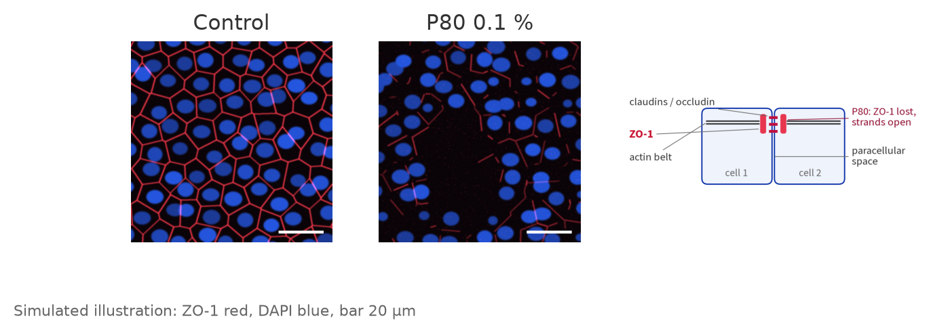

Reagents
- Caco-2 cells and complete culture medium (DMEM + 10 % FBS + 1 % Pen/Strep).
- P80 (Polysorbate 80 / Tween 80): sterile, cell-culture grade.
- 1X PBS, sterile.
- 4 % paraformaldehyde (PFA) in PBS: toxic, work in the fume hood.
- Permeabilisation buffer: 0.1 % Triton X-100 in PBS.
- Blocking buffer: 3 % BSA in PBS.
- Primary antibody: rabbit anti-ZO-1 (e.g. Invitrogen 61-7300), 1:100 in blocking buffer.
- Secondary antibody: goat anti-rabbit IgG, Alexa Fluor 546, 1:500 in blocking buffer.
- DAPI: 1 µg/mL in PBS (nuclei).

Equipment
- Sterile 96-well glass-bottom plate (#1.5 cover glass, black walls).
- Humidified CO₂ incubator (37°C, 5 % CO₂), aluminium foil, fume hood.
- Confocal microscope with 405 nm and 561 nm lasers and a 63× oil objective.
- Fiji with the macro fiji/measure_zo1.ijm and R (RStudio) with 05_if_analysis.Rmd (folder R/mac_linux or R/windows) (course folder).

Solutions

P80 Treatment Solutions (0.02, 0.1 and 0.5 % v/v)

For 10 mL of 1 % (v/v) P80 stock solution:
- In a sterile laminar flow hood, add 9.9 mL of sterile complete culture medium (warmed to 37°C) to a 15 mL sterile conical tube.
- Add 100 µL of sterile P80 to the medium. (Calculation: 1 % of 10 mL = 0.1 mL = 100 µL.)
- Vortex vigorously until the P80 is completely dissolved.

Treatment solutions, 10 mL each, in complete culture medium (37°C):
- 0.5 %: 5 mL of the 1 % stock + 5 mL medium (1:2).
- 0.1 %: 1 mL of the 1 % stock + 9 mL medium (1:10).
- 0.02 %: 2 mL of the 0.1 % solution + 8 mL medium (1:5).
- Vortex well. Prepare fresh on the day of treatment; the control receives complete medium only (0 % P80).

Antibody and DAPI solutions (prepare fresh, keep on ice and dark)

- Primary (1:100): 15 µL anti-ZO-1 + 1485 µL blocking buffer = 1.5 mL (20 wells × 50 µL + spare).
- Secondary (1:500): 3 µL Alexa Fluor 546 antibody + 1497 µL blocking buffer = 1.5 mL (21 wells × 50 µL + spare).
- DAPI (1 µg/mL): 2 µL of 1 mg/mL DAPI stock + 2 mL PBS.

Check the dilutions against the datasheet of the antibody lot you use.

Plate map

96-well glass-bottom plate. Five wells per condition are the replicates (n = 5); the no-primary well measures the background. The wells around them hold PBS against evaporation.

 | 1 | 2 | 3 | 4 | 5 | 6 | 7 | 8 | 9 | 10 | 11 | 12
A | PBS | PBS | PBS | PBS | PBS | PBS | PBS | PBS
B | PBS | CTRL | CTRL | CTRL | CTRL | CTRL | NP | PBS
C | PBS | 0.02 % | 0.02 % | 0.02 % | 0.02 % | 0.02 % | PBS | PBS
D | PBS | 0.1 % | 0.1 % | 0.1 % | 0.1 % | 0.1 % | PBS | PBS
E | PBS | 0.5 % | 0.5 % | 0.5 % | 0.5 % | 0.5 % | PBS | PBS
F | PBS | PBS | PBS | PBS | PBS | PBS | PBS | PBS
G
H

CTRL (B2–B6): Cells + complete medium (0 % P80). Full staining.
0.02 % (C2–C6), 0.1 % (D2–D6), 0.5 % (E2–E6): Cells + P80 at that concentration. Full staining.
PBS: 200 µL sterile PBS, no cells.
NP (B7), no-primary control: Control cells, blocking buffer instead of the primary antibody, then secondary antibody and DAPI. Its ZO-1 signal is the background that is subtracted from every field.

Steps

Cell Seeding and Treatment
- Harvest and count Caco-2 cells as described in the MTT manual (Harvest Cells to Calculate Cell Concentration).
- Seed 2 × 10⁴ cells in 100 µL complete DMEM into wells B2–B7, C2–C6, D2–D6 and E2–E6 (C₂ = 200,000 cells/mL; 21 wells × 100 µL = 2.1 mL, prepare 3 mL). Fill the PBS wells with 200 µL PBS.
- Grow at 37°C, 5 % CO₂ until the monolayer is confluent; change the medium every 2 days.
- Aspirate the medium. Add 100 µL of 0.02 % P80 to C2–C6, 0.1 % P80 to D2–D6, 0.5 % P80 to E2–E6 and complete medium to B2–B7.
- Incubate for 48 hours at 37°C, 5 % CO₂ (same exposure as the TEER end-point).
Fixation
- Aspirate the medium and wash twice with 200 µL PBS. Pipette slowly against the well wall: P80-treated monolayers detach easily, at 0.5 % most cells are dead.
- Add 100 µL of 4 % PFA per well (fume hood) and fix for 15 minutes at room temperature.
- Wash three times with 200 µL PBS, 5 minutes each. (Pause point: the sealed plate can be kept in PBS at 4°C for up to one week.)
Permeabilisation and Blocking
- Add 100 µL of 0.1 % Triton X-100 for 10 minutes at room temperature.
- Wash three times with 200 µL PBS.
- Add 100 µL of blocking buffer for 1 hour at room temperature.
Antibody and DAPI Staining
- Aspirate the blocking buffer. Add 50 µL of primary antibody to B2–B6, C2–C6, D2–D6 and E2–E6, and 50 µL of blocking buffer only to the no-primary well B7.
- Incubate overnight at 4°C in a sealed, humidified box.
- Wash three times with 200 µL PBS, 5 minutes each.
- Add 50 µL of secondary antibody to all 21 wells, including B7. Wrap the plate in aluminium foil and incubate for 1 hour at room temperature. From now on, keep the plate dark.
- Wash three times with 200 µL PBS, 5 minutes each.
- Add 50 µL of DAPI for 10 minutes at room temperature.
- Wash twice with PBS and leave 200 µL PBS in each well. Store at 4°C in the dark and image within 3 days.
Confocal Imaging
- Use the 63× oil objective with a pixel size of about 0.1 µm (e.g. 900 × 900 pixels = 90 × 90 µm field).
- Record two channels in this order: C1 = DAPI (405 nm) and C2 = ZO-1 (561 nm). The macro expects this order.
- Set laser power, gain, offset and pinhole (1 AU) on a control well, where ZO-1 is brightest. Use the range indicator (HiLo LUT): no saturated pixels in either channel: the ZO-1/DAPI ratio needs real DAPI values too.
- Keep these settings identical for every well, including the no-primary well B7. Never use auto-adjust between wells.
- Record a z-stack of 5 slices, 0.5 µm apart, that includes the apical junction plane.
- Choose 3 random, non-overlapping fields per well using the DAPI channel only, before you look at ZO-1.
- Save every field as a 16-bit, 2-channel TIFF z-stack (.tif). Check one file in Fiji (Image › Show Info): 2 channels, 5 slices, pixel size ~0.1 µm. If the pixel size is missing, enter it under Image › Properties. Never save as JPEG or as an RGB snapshot.
- While imaging, fill in image_metadata.csv: one row per image, written immediately (see the table below).

file | plate_well | condition | p80_pct | well | field | primary_ab
zo1_001.tif | B2 | ctrl | 0 | well1 | 1 | ZO-1
zo1_031.tif | D2 | P80-0.1 | 0.1 | well1 | 1 | ZO-1
zo1_061.tif | B7 | noprimary | 0 | well1 | 1 | none

Data analysis
Measurement in Fiji
- Put all .tif images of the experiment in one folder (two channels, all z-slices). The macro reads only files ending in .tif.
- Test the macro on one control and one P80 image first: DAPI and ZO-1 not saturated. Then keep the acquisition settings fixed.
- Run fiji/measure_zo1.ijm (Plugins › Macros › Run…) and select the folder. It writes results.csv with one row per field: Label, DAPI_Mean (whole field, raw), and ZO1_Mean (whole field, raw).
- To do one field manually, follow the "Fiji manually" slides of the Confocal Part II workshop: they show every menu click.
Statistics in R
- Copy results.csv to data/fiji_results_zo1.csv and your metadata table to data/image_metadata.csv. Knit 05_if_analysis.Rmd (folder R/mac_linux on macOS/Linux, R/windows on Windows) in RStudio: it joins the two tables by file name.
- ZO-1/DAPI ratio (main ZO-1 read-out) for every field:
ZO-1/DAPI = (ZO1_Mean − mean ZO1_Mean of the no-primary fields) / DAPI_Mean
- Average the 3 fields of each well. The well means are your replicates (n = 5 per condition); fields are not independent.
- Compare every P80 concentration with the control: one-way ANOVA on the well means followed by Dunnett's test, or keep all fields in a linear mixed model with a random intercept per well (Dunnett contrasts).
- At 0.5 % P80 the MTT shows no living cells: read ZO-1 there as the result of cell death, not of a junction-specific effect.
- Plot a SuperPlot: all fields in the background, well means on top.
- Report the mean difference with its 95 % CI, the exact p-value, the test and n = 5 wells from one experiment. Show representative images with the same display range for all conditions.

