Two examples show that atari takes precedence over having liberty. So if your piece will have liberty after taking the pieces in atari, then you can play that move.
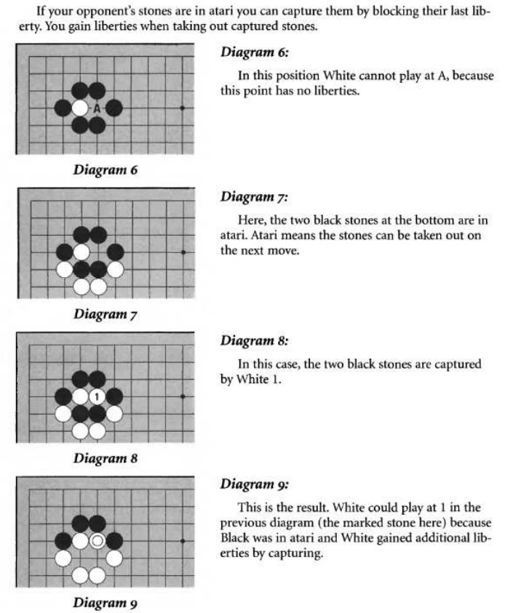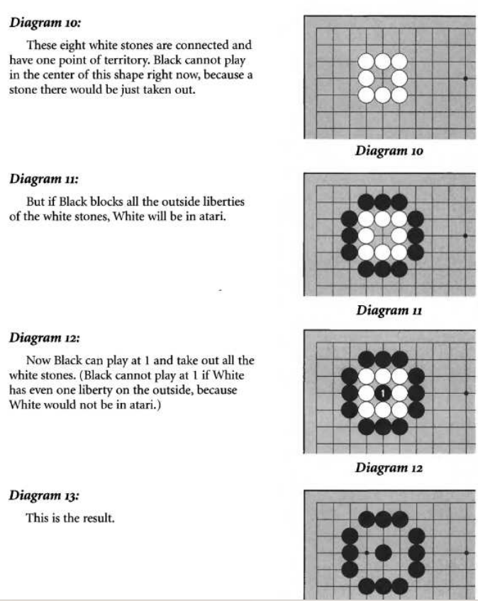

Another example:
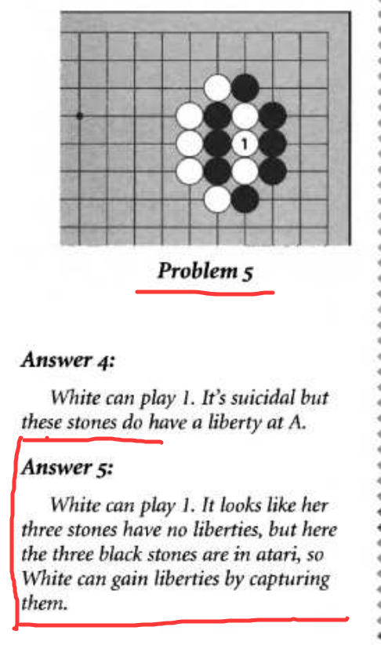

Another example of the rule, White’s 1 is in atari, so Black can play 2, because he can capture White’s 1 and give himself a liberty, but then his whole group will be in atari, then White can play 3 to capture the whole group.
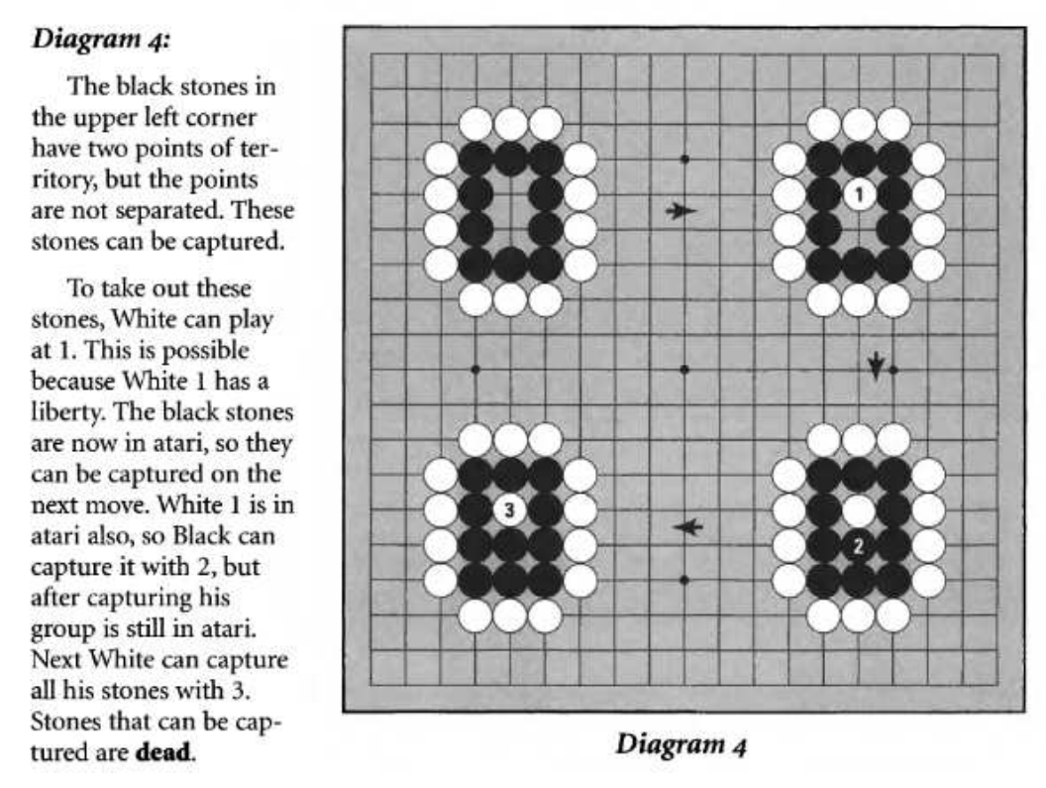

🧨 Can Black play on that last liberty?

Case 1:
If placing the black stone does not capture any white stones, and it fills the last liberty of the black group...
👉 No, Black cannot play there — it would be self-capture, which is illegal under normal rules (Japanese, Korean, Chinese, etc.).
This rule is called the "no suicide" rule. You can't play a move that immediately kills your own group, unless it captures something in the process.
One cannot play self-capture or suicide

